DIRECTORATE OF BAGYURDU ORGANIZED INDUSTRIAL ZONE
BAGYURDU ORGANIZED INDUSTRIAL ZONE
WASTEWATER TREATMENT PLANT PROJECT
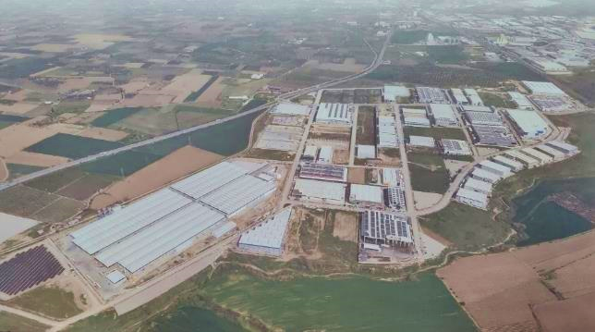
ENVIRONMENTAL AND SOCIAL MANAGEMENT PLAN
(ESMP)
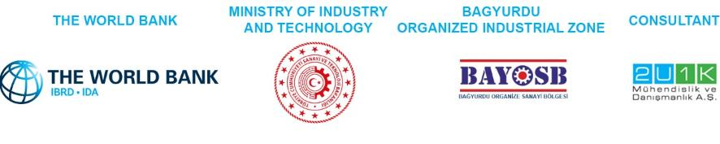
OCTOBER 2025
ANKARA

BAGYURDU ORGANIZED INDUSTRIAL ZONE WASTEWATER TREATMENT PLANT PROJECT
ENVIRONMENTAL AND SOCIAL MANAGEMENT PLAN (ESMP)
Version | Revision | Date | Prepared By |  |  | Quality Management By | Checked By | Approved By
Draft | A.0 | January 2025 | Eray Özen | Deniz Dirier | Celal Denizli | Esra Okumuşoğlu | Günal Özenirler | D. Emre Kaya
Draft | A.0 | January 2025 | Environmental Engineer B.Sc. | Sociologist | Biologist | Geological Engineer | Environmental Engineer, M.Sc. | Environmental Engineer, M.Sc.
Draft | A1 | July 2025 | Eray Özen | Deniz Dirier | Celal Denizli | Esra Okumuşoğlu | Günal Özenirler | D. Emre Kaya
Draft | A1 | July 2025 | Environmental Engineer B.Sc. | Sociologist | Biologist | Geological Engineer | Environmental Engineer, M.Sc. | Environmental Engineer, M.Sc.
Draft | A.2 | August 2025 | Eray Özen | Deniz Dirier | Celal Denizli | Esra Okumuşoğlu | Günal Özenirler | D. Emre Kaya
Draft | A.2 | August 2025 | Environmental Engineer B.Sc. | Sociologist | Biologist | Geological Engineer | Environmental Engineer, M.Sc. | Environmental Engineer, M.Sc.
Draft | A.3 | September 2025 | Eray Özen | Deniz Dirier | Celal Denizli | Esra Okumuşoğlu | Günal Özenirler | D. Emre Kaya
Draft | A.3 | September 2025 | Environmental Engineer B.Sc. | Sociologist | Biologist | Geological Engineer | Environmental Engineer, M.Sc. | Environmental Engineer, M.Sc.
Final | C.0 | October 2025 | Eray Özen | Deniz Dirier | Celal Denizli | Esra Okumuşoğlu | Günal Özenirler | D. Emre Kaya
Final | C.0 | October 2025 | Environmental Engineer B.Sc. | Sociologist | Biologist | Geological Engineer | Environmental Engineer, M.Sc. | Environmental Engineer, M.Sc.
REVISION CODES: A: DRAFT, B: FINAL DRAFT, C: FINAL
PROJECT NO: 24/015
OCTOBER 2025

CLIENT: | CONSULTANT:
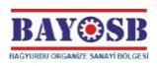 | 
Halilbeyli OSB Mahallesi,  Izmir Ankara Caddesi No:5,  Kemalpaşa/- Izmir / Türkiye  : 444 72 29  : +90 0 (232) 880 70 32  : +90 0 (232) 880 70 45 | Tepe Prime İş ve Yaşam Merkezi  Mustafa Kemal Mahallesi Dumlupınar  Bulvarı No: 266 B Blok Kat: 2 Daire: 38  Çankaya - Ankara / Türkiye  : +90 (312) 287 25 07/08  : +90 (312) 287 25 09

TABLE OF CONTENTS
Page
Table of Contents i
List of Tables vi
List of Figures viii
List of Abbreviations ix
EXECUTIVE SUMMARY 1
1 INTRODUCTION 9
1.1 Purpose of Environmental and Social Management Plan 11
1.2 Review of ESMP 12
2 PROJECT DESCRIPTION 14
2.1 Objectives of the Project 14
2.2 Project Location 14
2.3 Project Components and Timeline 15
2.4 Associated Facilities 18
2.5 Permits and Management System of the OIZ 18
2.5.1 Management Systems of the OIZ 18
2.5.2 Permits 19
3 LEGAL FRAMEWORK 20
3.1 National Legal Framework 20
3.2 International Standards 21
3.3 Project Standards 23
4 METHODOLOGY 33
4.1 Kick-off meeting 33
4.2 Desktop Study 33
4.3 Data Collection 33
4.4 Area of Influence 34
4.4.1 Social Area of Influence 37
4.5 Impact Assessment Methodology 37
5 ENVIRONMENTAL BASELINE OF THE PROJECT 40
5.1 Project Location and Topography 40
5.2 Land Use 41
5.3 Geology 41
5.3.1 General Geology 41
5.3.2 Tectonics 42
5.4 Soil and Soil Quality 43
5.5 Hydrogeology 44
5.6 Noise 47
5.7 Air Quality and Odour 47
5.8 Waste Management 49
5.8.1 Solid Waste 49
5.8.2 Liquid Waste 50
5.9 Water Resources 53
5.10 Climate and Vegetation 54
5.11 Natural Disaster Potential 55
5.12 Biodiversity and Protected Areas 56
5.12.1 Flora 59
5.12.2 Fauna 60
6 SOCIAL BASELINE OF THE PROJECT 66
6.1 Demography and Population 66
6.2 Livelihood and Employment 66
6.2.1 Major Economic Activities in Settlements Located in the Project AoI 67
6.3 Education and Health Services 67
6.4 Vulnerable Groups and Social Equity 68
6.5 Infrastructure Services 68
6.6 Traffic and Transportation 68
6.7 Cultural Heritage 69
7 ENVIRONMENTAL AND SOCIAL IMPACTS OF THE PROJECT 70
7.1 Environmental Risks and Impacts of the Project 70
7.1.1 Land Use 71
7.1.2 Geology 71
7.1.3 Hydrogeology 71
7.1.4 Climate and Vegetation 72
7.1.5 Soil Quality 72
7.1.5.1 Pre-Construction Phase 72
7.1.5.2 Construction Phase 72
7.1.5.3 Operation Phase 73
7.1.6 Air Quality and Odour 73
7.1.6.1 Pre-Construction Phase 74
7.1.6.2 Construction Phase 74
7.1.6.3 Operation Phase 75
7.1.7 Noise 76
7.1.7.1 Pre-Construction Phase 76
7.1.7.2 Construction Phase 77
7.1.7.3 Operation Phase 77
7.1.8 Water Resources and Use 78
7.1.8.1 Pre-Construction Phase 78
7.1.8.2 Construction Phase 78
7.1.8.3 Operation Phase 78
7.1.9 Wastewater Management 79
7.1.9.1 Pre-Construction Phase 79
7.1.9.2 Construction Phase 79
7.1.9.3 Operation Phase 79
7.1.10 Waste Management 80
7.1.10.1 Pre-Construction Phase 81
7.1.10.2 Construction Phase 81
7.1.10.3 Operation Phase 81
7.1.11 Natural Disaster Potential 82
7.1.12 Biodiversity and Protected Areas 82
7.1.12.1 Pre-Construction, Construction and Operation Phases 82
7.1.13 Pesticide Use and Management 82
7.2 Social Impacts of the Project 83
7.2.1 Population/Demography 83
7.2.1.1 Construction Phase 84
7.2.1.2 Operation Phase 84
7.2.2 Cultural Heritage 84
7.2.3 Economy/ Employment 84
7.2.3.1 Construction Phase 84
7.2.3.2 Operation Phase 85
7.2.4 Vulnerable/ Disadvantaged Groups 85
7.2.5 Land Requirement 86
7.2.6 Working Conditions and Labour Management 86
7.2.6.1 Construction Phase 88
7.2.6.2 Operation Phase 88
7.2.6.3 Training 88
7.2.7 Community Health and Safety 89
7.2.7.1 Construction Phase 89
7.2.7.2 Operation Phase 90
7.2.8 Occupational Health and Safety 90
7.2.8.1 Pre-Construction Phase 90
7.2.8.2 Construction Phase 90
7.2.8.2.1 Working at Height 94
7.2.8.2.2 Working with Chemicals 95
7.2.8.2.3 Rotating and Moving Equipment 95
7.2.8.2.4 Electrical 96
7.2.8.2.5 Eye Hazards 96
7.2.8.2.6 Industrial Vehicle Driving and Site Traffic 97
7.2.8.2.7 Ergonomics, Repetitive Motion, Manual Handling 97
7.2.8.2.8 Illumination 98
7.2.8.2.9 Fire and Explosion 98
7.2.8.2.10 Noise 99
7.2.8.2.11 Vibration 100
7.2.8.3 Operation Phase 100
7.2.8.3.1 Working at Height 102
7.2.8.3.2 Working with Chemicals 103
7.2.8.3.3 Rotating and Moving Equipment 103
7.2.8.3.4 Electrical 104
7.2.8.3.5 Eye Hazards 105
7.2.8.3.6 Industrial Vehicle Driving and Site Traffic 105
7.2.8.3.7 Ergonomics, Repetitive Motion, Manual Handling 106
7.2.8.3.8 Air Quality 106
7.2.8.3.9 Fire and Explosion 107
7.2.8.3.10 Noise 109
7.2.8.3.11 Vibration 110
7.2.8.3.12 Corrosive, Oxidizing and Reactive Chemicals 110
7.2.9 Traffic and Transportation 111
7.2.9.1 Construction Phase 111
7.2.9.2 Operation Phase 111
8 ENVIRONMENTAL AND SOCIAL ASPECTS, AND BEST PRACTICE MITIGATION MEASURES 112
8.1 Mitigation Plan for the Pre-Construction Phase of the Project 113
8.2 Mitigation Plan for the Construction Phase of the Project 115
8.3 Mitigation Plan for the Operation Phase of the Project 126
9 ENVIRONMENTAL AND SOCIAL MONITORING PLAN 136
9.1 Monitoring Plan for the Pre-Construction Phase 137
9.2 Monitoring Plan for the Construction Phase 139
9.3 Monitoring Plan for the Operation Phase 148
10 INSTITUTIONAL ARRANGEMENT AND TRAINING 153
10.1 Roles and Responsibilities 154
10.2 Reporting 158
10.3 Training 159
11 STAKEHOLDER MANAGEMENT UNDER ESMP 162
11.1 Previous Stakeholder Engagement Activities 163
11.2 Disclosure and Consultation of the ESMP 164
11.3 Grievance Mechanism 164
11.4 Grievances Related GBV/SH/SEA 166
12 REFERENCES 168
13 APPENDICES 169
Appendix-A Land Title Deed Records 170
Appendix-B Layout Plan, Spatial Plan, 1/25,000 and 1/100,000 Environmental Plans 173
Appendix-C EIA Out-of-Scope Official Letter for the Project 180
Appendix-D Other Permits, Licenses, Certificates and Agreements 182
Appendix-E Official Environmental Fine Minute 211
Appendix-F Photographs of the Project Area and BOIZ 217
Appendix-G National Environmental and Social Legal and Policy Framework Table 225
Appendix-H Analysis Reports 233
Appendix-I Calculations of Environmental Impact of the Project 236
Appendix-J Chance Find Procedure 252
Appendix-K Gap Analysis of the World Bank ESSs and the National Legislation 256

LIST OF TABLES
Page
Table 0-1. The WB ESSs Applicable to the Project 3
Table 0-2. Required Management Plans and Procedures for the Project 4
Table 0-3. Pre- and Post-Impact Significance for the Project 5
Table 0-4. Expected High Impacts of the Project Phases before Mitigation Measures 6
Table 1-1. E&S Documents Required for the Project 10
Table 2-1. Distances of the Project Area to the Urban Built-up Areas 15
Table 2-2. Project Component Details 16
Table 2-3. Project Design Flowrate Details 17
Table 2-4. Timeline of the Project Work Programme 18
Table 3-1. Project Standards 24
Table 4-1. Sensitive Environmental and Social Receptors within the Project’s AoI 34
Table 5-1. Air Quality Values for the Parameters Measured in Turgultu District of Manisa 48
Table 5-2. WHO Ambient AQGs Thresholds and Limits for Key Air Pollutants That Pose Health Risks 49
Table 5-3. The Facilities in the Operation Phase within the BOIZ 50
Table 5-4. Discharge Standards to be Provided for the WWTP of the Kemalpaşa OIZ 52
Table 5-5. According to the Months and Annual Average Precipitation and Temperature Values of Izmir 54
Table 5-6. Plant Species Found or Possible to be Found in the Project Area 59
Table 5-7. Amphibian Species Found or Possible to be Found in the Project Area 61
Table 5-8. Reptile Species Found or Possible to be Found in the Project Area 61
Table 5-9. Bird Species Found or Possible to be Found in the Project Area 62
Table 5-10. Mammal Species Found or Possible to be Found in the Project Area 64
Table 6-1. Vulnerable Groups in the Settlements 68
Table 6-2. Infrastructure Services of Settlements 68
Table 7-1. Air Quality Project Standards, and Calculated Emission Values 74
Table 7-2. Noise Project Standards 77
Table 7-3. Effluent Project Standards 80
Table 8-1. Activities to be performed in the Scope of the Project 112
Table 8-2. Mitigations for the Pre-Construction Phase of the Project 113
Table 8-3. Mitigations for the Construction Phase of the Project 115
Table 8-4. Mitigations for the Operation Phase of the Project 126
Table 9-1. Monitoring Plan for the Pre-Construction Phase of the Project 137
Table 9-2. Monitoring Plan for the Construction Phase of the Project 139
Table 9-3. Monitoring Plan for the Operation Phase of the Project 148
Table 10-1. Project’s Organizational Management 156
Table 10-2. Reporting Process Requirements and Distribution of Roles 158
Table 10-3. Training Program 160
Table 11-1. Stakeholder Groups and Their Relevance to This Project 162
Table 11-2. Procedural Steps of Grievance Mechanism 164
Table 13-1. Dust Emission Factors Used in the Mass Flowrate 237
Table 13-2. Calculation of Dust Emission Flowrate that May Occur Regarding Topsoil 238
Table 13-3. Calculation of Dust Emission Flowrate that May Occur Regarding Excavation Material 239
Table 13-4. Mass Flowrate of Dust Emission from Land Preparation and Construction Phases 240
Table 13-5. Specification of Diesel 240
Table 13-6. Emission Factors Originating from Diesel Vehicles (kg/ton) 241
Table 13-7.Lower Limit Values of Modelling Study with Calculated Exhaust Emissions Mass Flowrates 242
Table 13-8. Number of Machinery/Equipment to be Used During the Construction Phase and Noise Levels 242
Table 13-9. Values of Noise Level from Machinery/Equipment according to Distance 244

LIST OF FIGURES
Page
Figure 2-1. The Project Location 15
Figure 2-2. Layout Plan of the Project 16
Figure 4-1. Environmental AoI of the Project 36
Figure 4-2. Social AoI of the ProjectProject 37
Figure 5-1. Topographic Map of the Project Area 41
Figure 5-2. Geology Map of the Project Area 42
Figure 5-3. Türkiye Earthquake Hazard Map 43
Figure 5-4. Earthquake Risk Map of the Project Area 43
Figure 5-5. The Well and Water Table Contour in the AoI of the Project 45
Figure 5-6. Map of Nitrate Sensitive Areas of Gediz Basin and Project Area 46
Figure 5-7. Map of Urban Sensitive Water Bodies and Drainage Areas in Gediz Basin and Project Area 47
Figure 5-8. The Closest Air Quality Monitoring Station to the Project Area 48
Figure 5-9. WWTP of Kemalpaşa OIZ and BOIZ Area Transport Route 51
Figure 5-10. Water Resources Near the Project Area 53
Figure 5-11. Landslides and Faults, and Active Faults Map of Kemalpaşa District of Izmir 56
Figure 5-12 Corine Habitat Map 57
Figure 5-13. Project Area and Surrounding Habitats 57
Figure 5-14. Nationally Protected and Internationally Recognized Areas 65
Figure 7-1. Hierarchy of the Controls 90
Figure 10-1. Organizational Chart of the Project for Both Construction and Operation Phases 152
Figure 10-2. Organizational Chart of Project Management Unit 154
Figure 13-1. The BOIZ Administrative Building 217
Figure 13-2. The Kick-off Meeting at the BOIZ Administration Building 217
Figure 13-3. The Project Area (North) 218
Figure 13-4. The Project Area (North-East) 218
Figure 13-5. The Project Area (East) 219
Figure 13-6. The Project Area (West) 219
Figure 13-7. The Project Area (South-West) 220
Figure 13-8. The Project Area (Transformer Building) 220
Figure 13-9. The Septic Tanks in the BOIZ Area 221
Figure 13-10. The DSI Canal Near the BOIZ Area 221
Figure 13-11. The Parking Area of the BOIZ 222
Figure 13-12. The SPP Area of the BOIZ 222
Figure 13-13. Waste Collection Centre of the BOIZ 223
Figure 13-14. Distribution of Noise from Machinery/Equipment by Distance 243

LIST OF ABBREVIATIONS
BOD | Biological Oxygen Demand
BOIZ | Bagyurdu Organized Industrial Zone
CHS | Community Health and Safety
CoC | Code of Conduct
COD | Chemical Oxygen Demand
DO | Dissolved Oxygen
DSI | General Directorate of State Hydraulic Works
E&S | Environmental and Social
EIA | Environmental Impact Assessment
EPSA | Ex-Post Social Audit
EPRP | Emergency Preparedness and Response Plan
ESF | Environmental and Social Framework
ESIA | Environmental and Social Impact Assessment
ESMF | Environmental and Social Management Framework
ESMP | Environmental and Social Management Plan
ESS | Environmental and Social Standard
GBV | Gender-Based Violence
IBRD | International Bank for Reconstruction and Development
KBA | Key Biodiversity Area
LMP | Labour Management Plan
ILO | International Labour Organization
MoIT | Ministry of Industry and Technology
MoEUCC | Ministry of Environment, Urbanization and Climate Change
NGOs | Non-Governmental Organizations
OG | Official Gazette
OHS | Occupational Health and Safety
OIZ | Organized Industrial Zone
PAD | Project Appraisal Document
PFD | Personal Flotation Device
PGA | Peak Ground Acceleration
PIR | Project Information Report
POP | Persistent Organic Pollutant
PPE | Personal Protective Equipment
RP | Resettlement Plan
SBR | Sequencing Batch Reactor
SEA/SH | Sexual Exploitation and Abuse/Sexual Harassment
SEP | Stakeholder Engagement Plan
SPP | Solar Power Plant
TOIZsP | Türkiye Organized Industrial Zones Project
WB | World Bank
WB | World Bank Group
WW | Wastewater
WWTP | Wastewater Treatment Plant

EXECUTIVE SUMMARY
Bagyurdu Organized Industrial Zone (hereinafter referred to as “the BOIZ or “the Project Owner”) plans to implement ‘Bagyurdu Organized Industrial Zone Wastewater Treatment Plant’ (hereinafter referred to as “the Project”). The Project will be constructed on the land of the Bagyurdu Organized Industrial Zone (BOIZ) Area (hereinafter referred to as “the Project Area”) be in the possession of the BOIZ.
The Project’s aim is to is to construct a Wastewater Treatment Plant (WWTP) for the treatment of wastewater (WW) generated by the facilities and employees within the BOIZ area including the area that will later become the future expansion area. Currently, Domestic and industrial wastewater generated within the BOIZ is directed to septic tanks through the wastewater line within the BOIZ area and sent to the WWTP of Kemalpaşa OIZ, 20.4 km away, at certain frequencies. Also, about 3,500 people work in the BOIZ Area. By the end of 2026, this number is expected to reach 5,000. For an on-site solution to this situation, the realisation of the BOIZ's own WWTP, i.e. the Project, is of vital importance. It is also vital for the BOIZ that the Project becomes operational prior to the start of the operational activities of the facilities in the BOIZ area planned to be opened for new allocation with the expansion.
While WWTP construction works are expected to start in October 2025, the total planned period including commissioning is one (1) year. 50 workers/employees are stipulated to work during the peak period of the Project construction. It is foreseen that no accommodation facilities will be constructed during the construction activities of the Project. However, containers can be placed on the Project Area for those who will work on the Project to rest, eat and for sanitary facilities. These containers will meet standards for worker accommodation prepared by International Finance Corporation (IFC) and European Bank for Reconstruction and Development (EBRD) and approved by the World bank (WB).
In the operation phase of the Project, four (4) people are expected to be employed. Currently there is not any site work ongoing on the Project area. There is one transformer building in the Project Area which will be removed and relocated to another area of the BOIZ.
The Project includes the following works:
- Construction of physical + chemical + biological WWTP with Sequencing Batch Reactor (SBR) technology with a capacity of 1,500 m³/day for the entire BOIZ area including the expansion area,
- Commissioning of the WWTP.
Detailed information about the Project area is as follows.
- Appendix-A Land Title Deed Records
- Appendix-B Layout Plan, Spatial Plan, 1/25,000 and 1/100,000 Environmental Plans
The Project will be established on land about 9,700 m² within the BOIZ area. The title deed dated 22 November 2017 of the Project area on an area of 29,491.62 m², including the Solar Power Plant (SPP) area registered as Sheet No: K19D-23D-3D, Block No: 110, Lot No: 1, is owned by the BOIZ. The title deed of the Project Area, including the SPP area is registered and owned by the BOIZ. The land on which the Project will be established was allocated as a treatment plant area on the spatial plan of the BOIZ. There will be no need for land acquisition.
"Türkiye Organized Industrial Zones Project" (“the Main Project” or TOIZsP) which is financed by World Bank (WB) was formulated to increase the efficiency, environmental sustainability, and competitiveness of the OIZs. Within the TOIZsP, a number of OIZs are planned to be developed within the defined criteria, and the aim is that these OIZs will set an example for other OIZs. In this context, the implementing agency for the TOIZsP is Republic of Türkiye Ministry of Industry and Technology (MoIT), whose Directorate General for Organized Industrial Zones is responsible for designing the policies to plan and develop OIZs including providing credits for OIZ managements.
For the TOIZsP, an Environmental and Social Management Framework (ESMF) that is the key document committed by MoIT to comply with national legislation and WB’s Environmental and Social Framework (ESF) has been prepared. ESMF is the framework document for the overall Project and forms the basis and guidance throughout the Project lifetime for the site-specific Environmental and Social Management Plan (ESMP) of the Project. The ESMF provides the environmental and social management framework and approach that will guide the preparation and implementation of the individual OIZ sub-projects funded under TOIZsP. According to the ESMF, before preparation of the Environmental and Social (E&S) documents, MoIT will prepare E&S Screening Reports or assign a Company to prepare these reports for all sub-projects and submitted them to WB Team for review and approval. As a result of the information obtained in the screening studies, a risk analysis was made as well as the E&S Screening Report.
Environmental and social (E&S) risks were determined in the E&S Screening report in line with the World Bank Group (WBG) ESSs and Environmental and Social Management Framework (ESMF) of the Project. The overall environmental and social risk of the Project were assessed as “Moderate”. Hence, this site-specific Environmental and Social Management Plan (ESMP) has been prepared for the Project. ESMP is considered as a living document that requires regular review and update with respect to the potential changes in E&S conditions as the project progresses. The BOIZ together with its sub-contractors are responsible for the implementation of the ESMP. The BOIZ is committed to follow WB Environmental and Social Standards (ESSs), as well as the Guidelines of the WBG (IFC Environmental, Health and Safety Guidelines (EHSs)). E&S documents that are required for the Project are given in Table 1-1.
In terms of national legislation, according to Annex I of the Regulation on Environmental Impact Assessment (EIA) (Official Gazette (OG) dated 29/07/2022 and numbered (No) 31907), only the specialized OIZs would conduct an environmental impact assessment process at the establishment phase. Since the BOIZ is a mixed-type OIZ, an EIA was not required to be undertaken. In addition, article 24, subparagraph c, of the EIA Regulation states that the method regarding the EIA process to be applied for the projects planned to be established in the OIZs shall be determined by the Ministry of Environment, Urbanization and Climate Change (MoEUCC). In this context, the Out of Scope of EIA Regulation Opinion Official Letter from for the Project was secured by the Provincial Directorate of Environment, Urbanization, and Climate Change (see Appendix-C).
Other permits, licences and certificates for the Project are in the Appendix-D. Meanwhile, in 2022, Izmir Governorship Provincial Directorate of Environment, Urbanisation and Climate Change imposed a fine of ₺328,819 for not having a WWTP installed in the BOIZ (see Appendix-E for the relevant official letter).
In conclusion, E&S risks are determined according to the WB ESSs and ESMF of the Project in the E&S Screening report. Table 0-1 summarizes the relation of the ESSs to be evaluated with the Project activities. The E&S documents required for the Project are given in Table 0-2.
Table 0-1. The WB ESSs Applicable to the Project
WB Standard | Applicable ESSs
ESS1: Assessment and Management of Environmental and Social Risks and Impacts | Applicable
ESS2: Labour and Working Conditions | Applicable
ESS3: Resource Efficiency and Pollution Prevention and Management | Applicable
ESS4: Community Health and Safety | Applicable
ESS5: Involuntary Resettlement | Not applicable as no land acquisition is required for the Project
ESS6: Biodiversity Conservation and Sustainable Management of Living Natural Resources | Applicable
ESS7: Indigenous Peoples/Sub-Saharan African Historically Underserved Traditional Local Communities | ESS 7 is not relevant to the Project since the Project area is not/has been used, inhabited, or utilized by communities with the characteristics given in paragraphs 8 and 9 of the ESMF ESS7.
ESS8: Cultural Heritage | The Project is not considered to have an impact on cultural heritage. However, any project involving excavation work may encounter unexpected cultural heritage elements. A Chance Find Procedure (see also in Appendix-J) has been prepared and annexed to this ESMP.
ESS9: Financial Intermediaries | ESS9 (Financial Intermediaries) is not relevant to this Project as the Project does not involve a Financial Intermediary. Furthermore, the Project does not trigger the WB’s Safeguard Policies OP/BP 7.50 – Projects on International Waterways and OP/BP 7.60 – Projects in Disputed Areas.
ESS10: Stakeholder Engagement and Information Disclosure | Applicable
The Project would be built on an existing technical assistance relationship between the MoIT and the WBG that helped develop a national framework for Green OIZs in Türkiye and carried out preliminary assessments of the potential impact of OIZ investments. In this context, as the implementing agency for the Project, MoIT will provide loans to borrowing OIZs, as a sub-borrower and the selected Project will use the loan. The BOIZ will contract out the Project through a tender process conducted and announced by the Ministry of Industry and Technology (MoIT).
BOIZ's Project Management Unit (PMU) is responsible for identifying nonconformities, notifying the MoIT Project Implementation Unit (PIU), and overseeing corrective actions. The BOIZ’s criteria will align with established standards for internationally funded projects, with evaluation conducted by the MoIT. The Construction Contractor tender will adhere to WB Procurement Regulations, excluding companies banned from public tenders. The tender results will be determined by a committee comprising members from the MoIT and BOIZ.
The ESMP outlines measures and controls for managing potential project impacts, including implementation schedules, roles, responsibilities, and reporting requirements in line with WB standards. The ESMP will be included in the tender package. The ESMF dictates that MoIT's PIU environmental and social experts monitor sites quarterly during construction and biannually during operation. BOIZ's PMU will report monthly monitoring activities for environmental and social compliance to PIU.
ESMP is a dynamic document requiring regular review and updates based on changing E&S conditions as the project progresses. BOIZ and its subcontractors are responsible for the ESMP implementation, pledging adherence to WB ESSs and WBG Guidelines. The ESMP established E&S baseline conditions of the Project area, identifies potential adverse impacts during construction and operation phases, proposing mitigation measures to ensure environmentally and socially sustainable project execution with no major or irreversible negative impacts when fully implemented.
In this ESMP, the risk and impact assessments of the Project and concerned mitigation measures were carried out for its three phases, i.e. pre-construction, construction, and operation phase. As part of the mitigation measures, management plans and procedures on different subjects should be developed. The list of required management plans for the phases of the Project are presented in Table 0-2.
Table 0-2. Required Management Plans and Procedures for the Project
Management Plans/Procedures | Phase to be prepared | Responsible Party
Pre-construction and Construction Phase
Dust Management Plan | Prior to construction | Contractor (to be included in the  contractor contracts)
Noise Management Plan | Prior to construction | Contractor (to be included in the  contractor contracts)
Waste Management Plan | Prior to construction | Contractor (to be included in the  contractor contracts)
Soil Management Plan | Prior to construction | Contractor (to be included in the  contractor contracts)
Transport and Traffic Management Plan | Prior to construction | Contractor (to be included in the  contractor contracts)
Chemical Spill Emergency Management Plan | Prior to construction | Contractor (to be included in the  contractor contracts)
Occupational Health and Safety Management Plan | Prior to construction | Contractor (to be included in the  contractor contracts)
Emergency Preparedness and Response Plan | Prior to construction | Contractor (to be included in the  contractor contracts)
Community Health, Safety, and Security Management Plan | Prior to construction | Contractor (to be included in the  contractor contracts)
Labour Management Plan | Prior to construction | Contractor (to be included in the  contractor contracts)
Operation Phase
Effluent Management Plan | Prior to  operation | BOIZ
Waste Management Plan | Prior to  operation | BOIZ
Sludge Management Plan | Prior to  operation | BOIZ
Pollution Prevention Plan | Prior to  operation | BOIZ
Odour Management Plan | Prior to  operation | BOIZ
Chemical Spill Emergency Management Plan | Prior to  operation | BOIZ
Sustainable Water Management Plan | Prior to  operation | BOIZ
Occupational Health and Safety Management Plan | Prior to  operation | BOIZ
Emergency Preparedness and Response Plan | Prior to  operation | BOIZ
Community Health, Safety, and Security Management Plan | Prior to  operation | BOIZ
Labour Management Plan | Prior to  operation | BOIZ
In this context, pre- and post-impact significance for the potential issues of the Project during its construction and operation phases have been summarized in Table 0-3.
Table 0-3. Pre- and Post-Impact Significance for the Project
Potential Issue | Project Phase | Corresponding Section | Impact Significance
Potential Issue | Project Phase | Corresponding Section | Before Mitigation Measures | After Mitigation Measures  (Residual Impact)
Wastewater Management | Construction Phase | 7.1.9.2 | medium | low
Wastewater Management | Operation Phase | 7.1.9.3 | high | low
Water Resources and Use | Construction Phase | 7.1.8.2 | high | low
Water Resources and Use | Operation Phase | 7.1.8.3 | high | low
Waste Management | Construction Phase | 7.1.10.2 | high | low
Waste Management | Operation Phase | 7.1.10.3 | high | low
Pesticide Use and Management | Construction Phase | 7.1.13 | high | low
Pesticide Use and Management | Operation Phase | 7.1.13 | high | low
Soil Quality | Construction Phase | 7.1.5.2 | high | low
Soil Quality | Operation Phase | 7.1.5.3 | medium | low
Air Quality and Odour | Construction Phase | 7.1.6.2 | medium | low
Air Quality and Odour | Operation Phase | 7.1.6.3 | medium | low
Noise | Construction Phase | 7.1.7.2 | medium | low
Noise | Operation Phase | 7.1.7.3 | low | negligible
Occupational Health and Safety | Construction Phase | 7.2.8.2 | medium | low
Occupational Health and Safety | Operation Phase | 7.2.8.3 | medium | low
Working Conditions and Labour Management | Construction Phase | 7.2.6.1 | medium | low
Working Conditions and Labour Management | Operation Phase | 7.2.6.2 | medium | negligible
Economy/ Employment | Construction Phase | 7.2.3.1 | low | negligible
Economy/ Employment | Operation Phase | 7.2.3.2 | medium | negligible
Vulnerable/ Disadvantaged Groups | Construction Phase | 7.2.4 | medium | negligible
Vulnerable/ Disadvantaged Groups | Operation Phase | 7.2.4 | low | negligible
Community Health and Safety | Construction Phase | 7.2.7.1 | low | negligible
Community Health and Safety | Operation Phase | 7.2.7.2 | low | negligible
Traffic and Transportation | Construction Phase | 7.2.9.1 | low | negligible
Traffic and Transportation | Operation Phase | 7.2.9.2 | negligible | negligible
Cultural Heritage | Construction Phase | 7.2.2 | negligible | negligible
Cultural Heritage | Operation Phase | 7.2.2 | low | negligible
Biodiversity | Construction Phase | 7.1.12.1 | medium | low
Biodiversity | Operation Phase | 7.1.12.1 | low | negligible
Expected high impacts before the proposed mitigation measures for potential issues during the Project phases has been assessed in the corresponding sections of Chapter 7 and summarized in Table 0-4.
Table 0-4. Expected High Impacts of the Project Phases before Mitigation Measures
Potential Issue | Project Phase | Corresponding Section | Expected High Impacts Before Mitigation Measures
Wastewater Management | Operation phase | 7.1.9.3 | Wastewater from BOIZ will be monitored in terms of quantity and quality.
Water Resources and Use | Lifetime of the Project | 7.1.8 | As the entire water requirement of BOIZ, including the Project, is met from the permitted well, it is necessary to monitor the water quality and quantity of the well within the BOIZ Area.
Waste Management | Construction Phase | 7.1.10.2 | Waste generation due to wastes of construction works by the contractor.
Waste Management | Operation Phase | 7.1.10.3 | Waste generation including operational activities of the Project and mainly sludge wastes during the operation phase of the Project.
Pesticide Use and Management | Lifetime of the Project | 7.1.13 | Groundwater and soil contamination potential due to pesticide use and mismanagement during the lifetime of the Project.
Soil Quality | Construction phase | 7.1.5.2 | Due to construction activities of the Project, there is a potential risk for soil quality together with the water quality
The monitoring process will cover construction and operation phases to monitor the implementation of E&S commitments of the ESMP requirements. Methods for monitoring will include activities such as on-site inspection, grievance mechanism records, training records, interviews with employees, review of documents prepared/implemented by the BOIZ and contractors.
During the pre-construction period: Documentations of Contractor, Biodiversity, and Trainings will be monitored.
During the construction period: Disclosure, Occupational Health and Safety (OHS), population/demography (social life), vulnerable groups, working conditions and labour management, Community Health and Safety (CHS), grievance mechanism, air quality, noise, waste management (including domestic waste, waste oils, waste batteries and accumulators, excavation soil, construction and debris demolition waste, and hazardous waste management), wastewater management, water resource and water use, cultural heritage, traffic and pedestrian safety, soil quality, pesticide use and management and biodiversity will be monitored.
During the operation period: Documentation of BOIZ, working conditions and labour management, OHS, CHS, grievance mechanism, stakeholder engagement and disclosure, vulnerable groups, waste management including dried waste sludge, treated wastewater, water resource and water use, odour and pesticide use and management will be monitored.
The BOIZ will regularly report its monthly environmental and social (E&S) compliance monitoring activities to the MoIT. MoIT, in turn, will conduct supervisory monitoring as needed and provide semi-annual progress and update reports to the WB. These monitoring reports will focus on identifying risks and impacts related to the environment, social aspects, and OHS. Grievances will also be addressed and included in these monitoring reports. According to ESMF of the TOIZsP, Project Implementation Unit (PIU) of MoIT E&S experts shall monitor the sites on quarterly basis during construction, and biannually during the operation phase. More frequent monitoring may be conducted if needed to ensure compliance with the mitigation measures and resolution of any issues that are noted. Monthly monitoring activities carried out by the BOIZ as Project Management Unit (PMU) for E&S compliance will be reported regularly to PIU. PIU will carry out its supervision monitoring as required and report to WB quarterly/biannually on the progress and updates.
The draft ESMP will be disclosed and subject to stakeholder consultations and the final ESMP will be publicly disclosed by the BOIZ. The ESMP will undergo regular reviews, updates, and necessary approvals. Upon approval of each updated version of the ESMP, the BOIZ will take responsibility for disclosing the updated documents.
The TOIZsP’s Stakeholder Engagement Plan (SEP) will be used for this Project, and all project parties (including contractor, BOIZ), and the MoIT as PIU will be responsible for ensuring compliance with the TOIZsP’s SEP.

INTRODUCTION
Türkiye Organized Industrial Zones Project (“the Main Project” or TOIZsP) will be financed by the World Bank/ International Bank for Reconstruction and Development (IBRD) through a loan for which Republic of Ministry of Industry and Technology (MoIT) has been designated as responsible for project implementation by the Ministry of Treasury and Finance. This main project aims to increase the efficiency, environmental sustainability, and competitiveness of Organized Industrial Zones (OIZs) in Türkiye. To achieve these objectives the following indicators are determined for the Main Project:
- Indicator 1: Energy savings from OIZ expenditures in basic and green infrastructure,
- Indicator 2: Water savings from OIZ investments in green infrastructure,
- Indicator 3: Reduction in CO₂ emissions due to financed investments,
- Indicator 4: Share of OIZs that attract new investments.
With a total budget of EUR 250.3 million, the main project will be implemented by the MoIT through the General Directorate of Industrial Zones.
This plan presents the Environmental and Social Management Plan (ESMP) for ‘Bagyurdu Organized Industrial Zone Wastewater Treatment Plant (hereinafter referred to as “the Project”) and is prepared by 2U1K Engineering and Consultancy Inc. for “Bagyurdu Organized Industrial Zone” (hereinafter referred to as 'Project Owner / BOIZ).
BOIZ as a Mixed OIZ was established in 2008 on an area of 80,000 m² located in Kemalpaşa district, 24 km east of Izmir city centre in the Aegean Region of Türkiye, has a front in the south on the D300 Izmir Ankara Highway at the 50th km and a front in the northeast on the D250 Manisa-Turgutlu Highway at the 25th km.
Currently, domesticd and industrial wastewater generated within the BOIZ is directed to septic tanks through the wastewater line within the BOIZ area and sent to the WWTP of Kemalpaşa OIZ, 20.4 km away, at certain frequencies. For an on-site solution to this situation, the realisation of the BOIZ's own WWTP, i.e. the Project, is of vital importance. Also, about 3,500 people work in the BOIZ Area. By the end of 2026, this number is expected to reach 5,000. It is also vital for the BOIZ that the Project becomes operational prior to the start of the operational activities of the facilities in the BOIZ area planned to be opened for new allocation with the expansion.
The Project Area is on the north-western border of the BOIZ Area. The title deed of the Project Area, including the SPP area is registered and owned by the BOIZ (see Appendix-A). The land on which the facility will be established was allocated as a treatment plant area on the spatial plan of the BOIZ. Layout Plan and Spatial Plan of the Project Area is presented in Appendix-B. Also, the 1/25,000 and 1/100,000 Environmental Plans where the OIZ and Project Area are located can be seen in Appendix-B.
‘Türkiye Organized Industrial Zones Project’ (“the Main Project” or TOIZsP) which is financed by World Bank (WB) was formulated to increase the efficiency, environmental sustainability, and competitiveness of the Organized Industrial Zones (OIZs). Within this TOIZsP, some OIZs are planned to be developed within the defined criteria, and it is aimed that these OIZs will set an example for other OIZs. In this context, the implementing agency for the TOIZsP is MoIT, whose Directorate General for Organized Industrial Zones is responsible for designing the policies to plan and develop OIZs including providing credits for OIZ Managements. For the TOIZsP, an Environmental and Social Management Framework (ESMF) that is the key document committed by MoIT to comply with national legislation and WB’s Environmental and Social Framework (ESF) has been prepared. ESMF is the framework document for the overall Project and forms the basis and guidance throughout the Project lifetime for the site-specific ESMP of the Project. The ESMF covers environmental and social management approach that will be implemented during the TOIZsP. According to the ESMF, before preparation of the Environmental and Social (E&S) documents, MoIT will prepare E&S Screening Reports or assign a Company to prepare these reports for all sub-projects and submitted them to WB Team for review and approval. As a result of the information obtained in the screening studies, thethe E&S risk level of the activity will be identified, and relevant E&S documents will be prepared.
For the national legislation, the activities under this Project are not included in Annex-1 and Annex-2 Lists of the Regulation on the Environmental Impact Assessment (EIA) in line with the Turkish EIA legislation, the Out of Scope of EIA Regulation Opinion Official Letter for the Project was secured by the Provincial Directorate of Environment, Urbanization, and Climate Change (see Appendix-C). On the other hand, environmental and social (E&S) risks are determined in the E&S Screening report in line with the WB Environmental and Social Standards (ESSs) and ESMF of the Project. The overall environmental and social risk of the Project was rated in “Moderate” risk group. Hence, this site-specific ESMP has been prepared for the Project. E&S documents that are required for the Project are given in Table 1-1.
Table 1-1. E&S Documents Required for the Project
E&S Document | Explanation | Required
EIA | According to national legislation, the Project is out of the scope of EIA Regulation. | X
ESMP | A site-specific ESMP will be required since the overall risk of the Project is “Moderate”. | ✓
ESIA | A detailed Environmental and Social Impact Assessment (ESIA) will not be required since the overall risk of the Project is “Moderate”. | X
SEP | Türkiye OIZs Project’s SEP will be used by the BOIZ.  The details of Project consultation will be disclosed on the Project’s and BOIZ’s web pages. | X
LMP | The current Labour Management Procedures of the Türkiye OIZ Project will be used. The Labour Management Plans (LMPs) for contractors will also comply with the Labour Legislation (4857 Labour Law), Occupational Health and Safety Plan and Procedures (6331 Occupational Health and Safety Law), and 5510 Social Insurance Law in addition to the Project's Labour Management Procedures. | ✓
RP/EPSA | A site-specific RP will not be required since there is no additional land take and resettlement. | X
Project’s construction works are expected to start in October 2025, the total planned period including commissioning is one (1) year. 50 workers/employees are stipulated to work during the peak period of Project construction. In the operation phase of the Project, four (4) people are expected to be employed. Within the scope of this Project, the Project components detailed in Section 2.3 will be implemented in the Project Area. The effluent of the plant will be discharged to Nif Stream (see Figure 4-1), which flows from south to the north direction, passing within 145 m south-west of the Project Area.
The Project would be based on an existing technical assistance relationship between the MoIT and the World Bank Group (WBG) that helped develop a national framework for Green OIZs in Türkiye and carried out preliminary assessments of the potential impact of OIZ investments.
In this context, as the implementing agency for the Project, MoIT will provide loans to borrowing OIZs, as a sub-borrower and the Project as a selected Project will use a loan.
Deviations from the E&S Screening Study
While the screening study for the Project includes initial findings from the E&S desktop study, this ESMP includes a more detailed assessment of potential risk and impacts, corresponding mitigation measures and monitoring. In this direction, no deviation has occurred due to the detailed information on the project provided during these studies. Nevertheless, BOIZ provides water supply from well water within the BOIZ area (see Figure 5-5) as industrial water for the facilities. At the same time, groundwater is not used as drinking water but as domestic water in the BOIZ. 2U1K ensured that water samples were taken to determine the quality of well water within the BOIZ Area ono 12 September 2024. The.T results of the analysis report of the sample taken from the well water is in compliance with the Regulation on Water Intended for Human Consumption (see Appendix-H).

Purpose of Environmental and Social Management Plan
The ESMP document is designed to identify potential risks and adverse E&S impacts that may arise during the construction and operation phases of the Project. Its purpose is to assess and evaluate these impacts, proposing actions to mitigate or prevent negative consequences. The ESMP also establishes the baseline for E&S aspects at the Project area, outlines the organizational structure, training, monitoring, and reporting requirements for ESMP implementation.
Furthermore, the ESMP outlines the responsibilities of the contractor and other relevant parties in addressing environmental and social issues. It is an integral part of the tender package, specifying the obligations of all relevant stakeholders, including the contractor.
Within the ESMP's scope, information is provided about planned work items in contract packages, methodologies to be applied, and working areas. It identifies potential social and environmental impacts during both construction and operation phases, describing measures to prevent or minimize negative effects. Continuous monitoring and control of the impacts identified in the ESMP are intended during the Project's implementation to prevent and minimize adverse effects. As part of this ESMP, stakeholders, both direct and indirect, are identified and consulted throughout the project regarding its E&S impact and risks, guided by a Stakeholder Engagement Plan (SEP).
The final version of the ESMP, approved by the Ministry of Industry and Technology (MoIT) and the WB, will be accessible to all stakeholders throughout the Project's duration. The ESMP will be updated, when necessary, especially in case of Project changes, and any updates resulting from consultations will be disclosed and consulted upon.
As part of the mitigation measures, management plans and procedures on various subjects will be developed. A list of required management plans for Project’s phases is presented in Table 0-2.
The Contractor will prepare the required management plans for the construction phase of the Project and presents them to the BOIZ Project Management Unit (PMU). The Contractor starts construction once the BOIZ PMU approves the required management plans for the construction phase of the Project. BOIZ PMU reviews and approves the management plans and then submits them to the MoIT Project Implementation Unit (PIU).
The BOIZ will adapt the required management plans for the operation phase of the Project with the commissioning prior to the operation phase. The BOIZ will present the required management plans for the commissioning of the Project to the MoIT PIU three (3) months before commissioning of the Project. Once MoIT approves these plans, the Project begins to operate all sub-project components.

Review of ESMP
The ESMP will be periodically reviewed to address changes in the responsible parties’ organization, process, or regulatory requirements.
The Project Management Unit (PMU), which will be formed by the BOIZ, and detailed in Section 10.1 will be responsible for the implementation of this ESMP and SEP. The MoIT Directorate General for Industrial Zones, WB Türkiye Organized Industrial Zones Project Implementation Unit (PIU) will continue to have environmental specialists, OHS specialist and social specialists to be responsible for coordinating the implementation of the project E&S documents to ensure compliance with ESF. Environmental specialists, OHS specialist and social specialists will supervise the BOIZ on WB E&S requirements, provide consultancy for the implementation of the ESMP, and monitor the implementation of the ESMP together with the opinion and grievance mechanism for affected groups.
Following any reviews, the BOIZ will provide coordination through the PIU to make any necessary amendments to the ESMP, with the updates communicated to all responsible parties and employees involved in the Project.

PROJECT DESCRIPTION

Objectives of the Project
Currently, Domestic and industrial wastewater generated within the BOIZ is directed to septic tanks through the wastewater line within the BOIZ area and sent to the WWTP of Kemalpaşa OIZ, 20.4 km away, at certain frequencies. Also, about 3,500 people work in the BOIZ Area. By the end of 2026, this number is expected to reach 5,000. The Project’s aim is to is to construct a Wastewater Treatment Plant (WWTP) for the treatment of wastewater (WW) generated by the facilities and employees within the BOIZ area including the area that will later become the future expansion area. For an on-site solution to this situation, the realisation of the BOIZ's own WWTP, i.e. the Project, is of vital importance.

Project Location
BOIZ as a Mixed OIZ was established in 2008 on an area of 80,000 m² located in Kemalpaşa district, 24 km east of Izmir city centre in the Aegean Region of Türkiye, has a front in the south on the D300 Izmir Ankara Highway at the 50th km and a front in the northeast on the D250 Manisa-Turgutlu Highway at the 25th km.
The BOIZ Area is located about 20 km north-east of Kemalpaşa district. The Project Area is on the north-western border of the BOIZ Area. Layout Plan and Spatial Plan of the Project Area, 1/25,000 and 1/100,000 Environmental Plans (see Appendix-B) where the OIZ and Project Area are located are in Halilbeyli Neighbourhood.
The Project Area is located in Kemalpaşa District of Izmir within the borders of the BOIZ, adjacent to the OIZ’s existing solar power plant (SPP.) The Project’s location is presented in Figure 2-1.
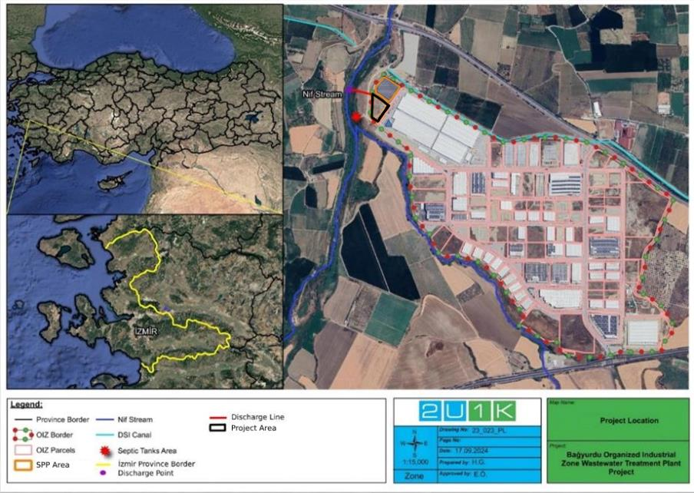
Figure 2-1. The Project Location
According to the Project Area, the closest urban settlement area is the Halilbeyli Neighbourhood. There are no socially sensitive receptors such as schools or hospitals within the Project AoIThe Project’s Area of Influence (AoI) includes all areas potentially affected by its activities. The Environmental AoI extends 2 km from the project center, covering nearby settlements, the Nif Stream (discharge point), and the entire BOIZ area. The Social AoI is defined as a 10 km radius, representing the wider area where social impacts and stakeholder interactions may occur.The Area of Influence and its surrounding land use, including relevant receptors and boundaries, are further illustrated in Figure 4-1 and Figure 42.
Table 2-1. Distances of the Project Area to the Urban Built-up Areas
Location | Approximate distance | Population (2023)
Halilbeyli Neighbourhood | 7 km | 1,413

Project Components and Timeline
The planned WWTP Project is designed as physical + chemical + biological treatment with Sequencing Batch Reactor (SBR) technology with a capacity of 1,500 m³/day for the entire BOIZ area including the expansion area. The effluent of the plant will be discharged to Nif Stream, which flows from south to the north direction, passing within 145 m south-west of the Project Area. The Layout Plan of the Project is illustrated in Figure 2-2.
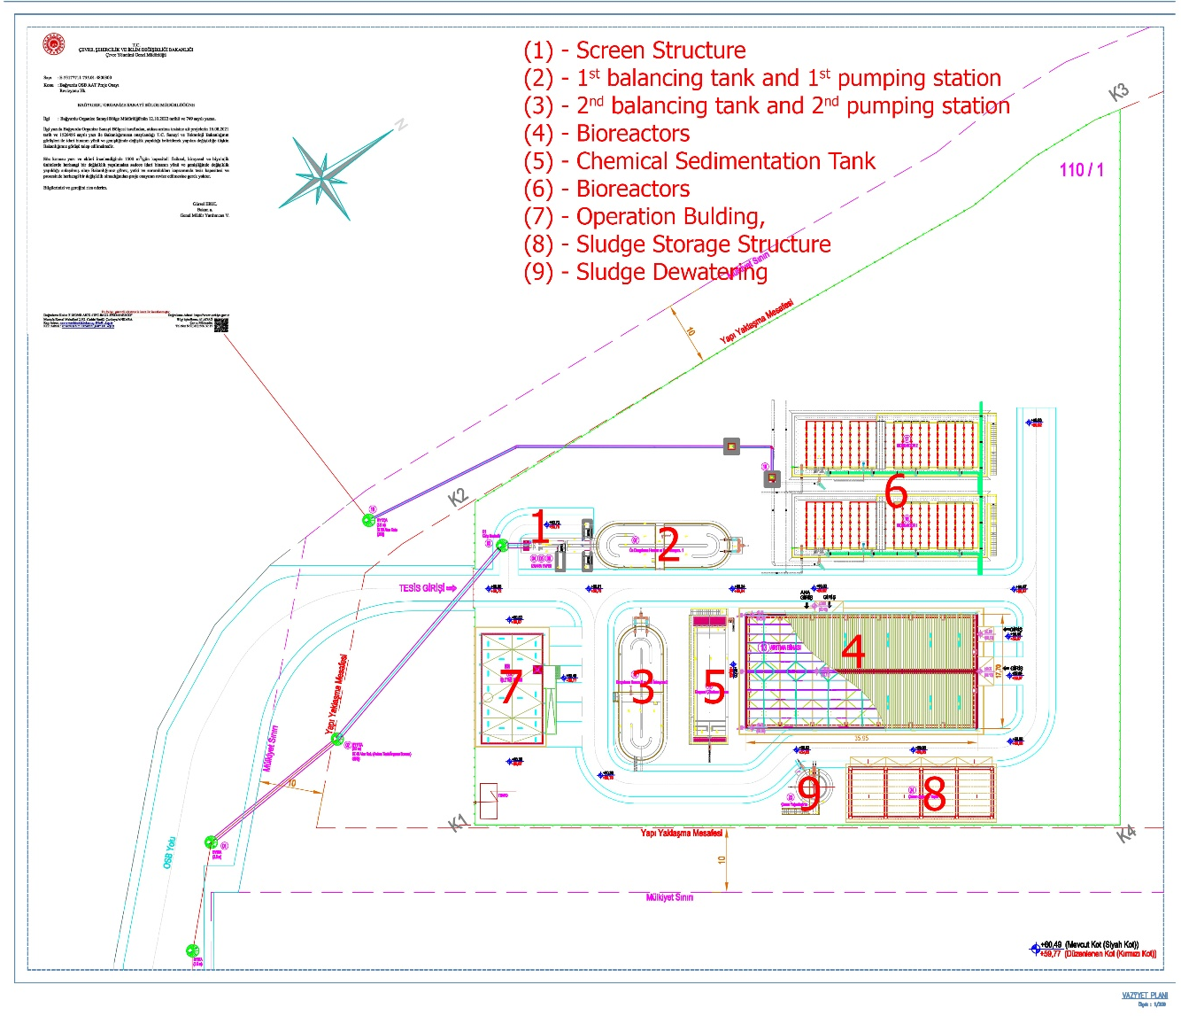
Figure 2-2. Layout Plan of the Project
According to the information in the Process Report of the Project, BOIZ domestic and industrial WWTP project component details are given in Table 2-2.
Table 2-2. Project Component Details
No | Structure | Piece | Material / Volume | Width  (m) | Length  (m) | Heigh  (m)
1 | Inlet Structure | 1 | Reinforced Concrete | 1.75 | 2.1 | 4
2 | Coarse Screen Channel | 1 | Reinforced Concrete | 1.75 | 4.25 | 4.1
3 | Fine Screen Channel | 1 | Reinforced Concrete | 1.75 | 4.35 | 4.2
4 | 1st balancing tank and 1st pumping station | 1 | Reinforced Concrete  (approx. wet volume is 400 m³) | 6.8  (Designed in the Carrousel Building style) | 20.65 | 3.65  (water height)  7.9  (total height)
5 | Treatment Building | 1 | Foundation: Reinforced Concrete,  Columns and Roof: Steel,  Side Surface : Sandwich Panel. | 17 | 37.15 | 7.873  (lowest under-truss height)  9.266  (maximum under-truss height)
6 | Chemical Sedimentation Tank | 1 | Reinforced Concrete  (approx. wet volume is 234.38 m³) | 5.8 | 20.9 | 3.26  (water height at the shallowest point)  5.21  (height at the deepest point)
7 | 2nd balancing tank and 2nd pumping station | 1 | Reinforced Concrete  (approx. wet volume is 438 m³) | 6.8  (Designed in the Carrousel Building style) | 20.65 | 4  (water height)  5.2  (total height)
8 | Bioreactors | 2 | Reinforced Concrete  (approx. wet volume is 1,553 m³ for each bioreactor) | 10.2 | 31.67 | 6.6  (water height)  8.5  (total height)
9 | Operation Building – (two (2) storeys) | 1 | Reinforced Concrete | 8.6 | 14.2 | 3  (height of each floor)
10 | Sludge Storage Structure | 1 | Foundation: Reinforced Concrete,  Lower Column: Reinforced concrete,  Upper Column and Roof: Steel. | 8.1 | 22.4 | 4.3
11 | Sludge Dewatering | 1 | Reinforced Concrete  (approx. wet volume is 85.57 m³) | Diameter: 5.8 |  | 4.36  (height at the shallowest point)
Source: (BOIZ, Process Report of the Project, 2021)
WW flowrate design details of the project, which will have 1,500 m³/day WW treatment capacity, are given in Table 2-3.
Table 2-3. Project Design Flowrate Details
WW Source | At 100% capacity with the filling of empty lots operational | New Allocation area to be opened | Total
Domestic Wastewater (m³/day) | 600 | 300 | 900
Industrial Wastewater (m³/day) | 350 | 175 | 525
Leak Flowrate (m³/day) |  |  | 75
Total Wastewater Flowrate (m³/day) |  |  | 1,500
After stabilization and dewatering processes, it is planned to dispose of the dried waste sludge, which will have a solid matter content of more than approximately 70%, with a licensed company.
On the other hand, the SPP of the BOIZ, (see Figure 13-12) which has been operational since April 2024 with a generation power of 1.6 MW on the land adjacent to the Project Area, is another WB loan project of the BOIZ through the MoIT, whose environmental social process started in 2022. The electricity generated here is designed to supply the lighting system of the BOIZ as well as the to be implemented BOIZ WWTP as Project.
Construction works of the Project are expected to start in October 2025, the total planned period including commissioning is one (1) year. 50 workers/employees are stipulated to work during the peak period of the Project construction. Hence, no worker accommodation will be built within the scope of the Project. In the operation phase of the Project, four (4) people are expected to be employed. The timeline of the Project is presented in Table 2-4.
Table 2-4. Timeline of the Project Work Programme
Months |  |  | 1 | 2 | 3 | 4 | 5 | 6 | 7 | 8 | 9 | 10 | 11 | 12
1 | Establishing Work Programme | Deadline
1 | Establishing Work Programme | Realization Date
2 | Construction Site Delivery | Deadline
2 | Construction Site Delivery | Realization Date
3 | Submission of the Brand List for the Approval of the Consultant and Obtaining Approval | Deadline
3 |  | Realization Date
4 | Ground Levelling and Excavation | Deadline
4 | Ground Levelling and Excavation | Realization Date
5 | Construction Works | Deadline
5 | Construction Works | Realization Date
6 | Application of Mechanical and Electrical Installations | Deadline
6 | Application of Mechanical and Electrical Installations | Realization Date
7 | Instrument Setups | Deadline
7 | Instrument Setups | Realization Date
8 | Test Processes | Deadline
8 | Test Processes | Realization Date
9 | Site Delivery | Deadline
9 | Site Delivery | Realization Date
NOTES
1 | Grey Areas Indicate the Estimated Time for the Work to be done
2 | Green Areas Indicate the Time of Completion of Work
3 | Yellow Areas Indicate Periods of Work in Progress
4 | Red Areas Indicate Prolonged Periods of Work.

Associated Facilities
Associated facilities can be defined as; facilitiesf or activities that are not funded as part of the project and, in the judgment of the Bank, are::
- Directly and significantly related to the project,
- Carried out, or planned to be carried out, contemporaneously with the project,
- Necessary for the project to be viable and would not have been constructed, expanded, or conducted if the project did not exist.
For facilities or activities to be Associated Facilities, they must meet all three (3) criteria.
In this Project, there is no facility or activity which can be defined as associated facility/facilities.

Permits and Management System of the OIZ

Management Systems of the OIZ
The BOIZ has been in the recertification process of ISO 9001:2015 (Quality Management System) certificate (valid until 27/02/2025) and plans to secure other certificates including ISO 14001:2015 (Environmental Management System), ISO 14064-1:2018 – (Greenhouse Gases), and ISO 50001:2011 (Energy Management System) by the end of 2025. Also, the OIZ Energy Distribution License from the Turkish Energy Market Regulatory Authority has been secured on 15.05.2014 (see Appendix-D for these certificates).
In addition to these quality systems, this project-specific Environmental and Social Management Plan (ESMP) is being developed for the construction and operation phases of the Project as a part of this Study. The ESMP identifies the environmental and social risks and adverse impacts and presents the mitigation measures for the expected environmental and social impacts of the Project. Accordingly, the ESMP identifies the need for the development and implementation of several management plans as part of the Management Systems of the BOIZ. In this respect, BOIZ will revise its own Environmental and Operational Management System in line with the requirements stipulated in the ESMP.
Likewise, previously, in 2022, ESMP studies for another project were carried out by the BOIZ for the establishment of a 1.6 MW capacity SPP, 2500 kVA transformer and fast charging station in adjacent to the Project Area within the scope of the TOIZsP. Hence, the adaptation of the ESMP system will be easily implemented for the Project.

Permits
The “EIA Out of Scope” letter for the Project from the Izmir Governorship Provincial Directorate of the MoEUCC on 22.10.2020 is presented in Appendix-CAppendix-CAppendix-C. In the scope of other national requirements, further permits via the opinions of the relevant official authorities were secured specifically for the Project.
In this context, 2U1K has determined that the following permissions have been secured.
- Project Approval Official Letter from MoEUCC (dated 16.8.2021),
- Project Approval Official Letter from MoIT (dated 6.1.2021),
- Zero Waste Certificate for the BOIZ (valid until 21.12.2025),
- OIZ Distribution License from Energy Market Regulatory Authority (dated 15.5.2014),
- One (1) Groundwater Utilization Certificate for usage as BOIZ industrial water by the DSI, and
- Wastewater Acceptance Protocol between Kemalpaşa OIZ and BOIZ (dated 24.6.2015),
- Waste Agreement between Süreko Waste Management Inc. and BOIZ.
All permits, opinion letters above mentioned and obtained within the scope of the existing BOIZ, and the Project and other official approval letters of the existing BOIZ are presented in Appendix-D.

LEGAL FRAMEWORK
This section outlines the regulatory framework for construction and operation phases the Project in line with national and international requirements which are given below.

National Legal Framework
The Environmental Law, which was published in the Official Gazette (OG.) No. 18132 and dated 11 August 1983 and amended in the OG. dated 29 Mays 2013 (by Law No. 6486), establishes the underlying legal framework of the environmental legislation in Türkiye and is supported by a large number of regulations. Article 10 of the Environmental Law constitutes the main framework of the Environmental Impact Assessment Regulation (EIA Regulation) published in the OG. No. 31907 and dated 29 July 2022.
Environmental Impact Assessment (EIA) encompasses the identification of potential positive and negative effects of the planned projects on the environment, the measures to be taken to avoid adverse effects or minimize them to a degree not harmful to the environment, the determination and assessment of the selected location and technology alternatives, and the efforts to be maintained for the monitoring and control of the implementation of projects.
The purpose of EIA Regulation is to regulate the administrative and technical procedures and principles to be followed throughout the EIA process. This Regulation covers the aspects for which type of projects the EIA Application File, EIA Report and Project Identification Document (PID) will be required and the issues addressed by these files, the administrative and technical procedures and principles to be followed during the EIA process, the monitoring and supervision of the projects covered by EIA during the application, pre-construction, construction, operational and post-operational phases, and the necessary training activities for the effective and widespread implementation of the EIA system in environmental management and for the strengthening of its organizational structure. Annex-1 to the Regulation includes the List of Projects Which EIA Applies to, while Annex-2 includes the List of Projects Which Selection Criteria Apply to. The Ministry of Environment, Urbanization and Climate Change (MoEUCC) has the authority to make “EIA Positive”, “EIA Negative”, “EIA Required” or “EIA Not Required” decisions about the projects subject to this Regulation. However, the Ministry may delegate, when deemed necessary, its authority to render an “EIA Required” or “EIA Not Required” decision to a Governor’s Office in line with the principle of the breadth of authority, with the limits of authority determined.
Pursuant to the Regulation, an EIA Report must be prepared for the projects included in Annex-1, for the projects included in Annex-2 and for which the “EIA Required” decision is rendered, and for the projects that are considered excluded from EIA, but whose new capacity is equal to or above the threshold value given in the list of Annex-1 but in case of any planned capacity increase.
Within the scope of EIA, for the projects included in the Annex-1 list, a public consultation meeting shall be held to inform the public about the investment and to receive their opinions and suggestions regarding the project with the participation of the project and the institutions and organizations authorized by the MoEUCC on the date determined by the MoEUCC and at the place and time determined by the Governorship. Public consultation meetings are not held for the projects included in the Annex-2 list.
In this context, as the Project activities are not included in the Annex-1 and Annex-2 lists of the EIA Regulation, the BOIZ made the related application and secured the “EIA Out of Scope” letter for the Project from the Izmir Governorship Provincial Directorate of the MoEUCC on 22.10.2020 (see Appendix-CAppendix-CAppendix-C).
In this regard, Appendix-G presents the summary of national laws and regulations aiming to minimize the potential environmental and social impacts that may arise during the construction and operation activities of the Project.

International Standards
The World Bank Environmental and Social Framework (ESF) provides the foundation for sustainable development in projects financed by the Bank. It sets out the Bank’s commitment to environmental and social sustainability, outlining responsibilities for both the Bank and the Borrower. The ESF ensures that projects are designed and implemented in a manner that promotes transparency, accountability, and stakeholder engagement, while minimizing and managing potential environmental and social risks.
At the core of the ESF are ten Environmental and Social Standards (ESSs), which define specific requirements for Borrowers to identify, assess, and manage environmental and social risks and impacts. These standards cover a broad range of issues, including:
- ESS1: Assessment and Management of Environmental and Social Risks and Impacts
- ESS2: Labor and Working Conditions
- ESS3: Resource Efficiency and Pollution Prevention and Management
- ESS4: Community Health and Safety
- ESS5: Land Acquisition, Restrictions on Land Use and Involuntary Resettlement
- ESS6: Biodiversity Conservation and Sustainable Management of Living Natural Resources
- ESS7: Indigenous Peoples/Sub-Saharan African Historically Underserved Traditional Local Communities
- ESS8: Cultural Heritage
- ESS9: Financial Intermediaries
- ESS10: Stakeholder Engagement and Information Disclosure
These standards collectively guide the preparation and implementation of projects, ensuring that environmental and social considerations are fully integrated into decision-making and project management
The Project and the social and environmental elements in the Area of influence (AoI) of the Project include elements or activities that are fall within the scope of ESS1 Assessment and Management of Environmental and Social Risks and Impacts, ESS2 Labor and Working Conditions, ESS3 Resource Efficiency and Pollution Prevention and Management, ESS4 Community Health and Safety, ESS6 Biodiversity Conservation and Sustainable Management of Living Natural Resources, ESS8 Cultural Heritage and ESS10 Stakeholder Engagement and Information Disclosure.
WB Guidelines
The Project will adhere to the General Environmental, Health, and Safety (EHS) Guidelines of the World Bank Group (WBG). Including the WB EHS Guidelines for Water and Sanitation, and relevant Sectoral Guidelines such as those for Telecommunications and Electric Power Transmission and Distribution, will be considered within the Environmental and Social Management Plan (ESMP). In the assessment of impacts and the formulation of mitigation measures, the performance levels and measures outlined in the EHS Guidelines will be observed, alongside compliance with national legislative requirements. Should there be variations between national regulations and the standards provided in the EHS Guidelines, the Project will apply the more stringent threshold or standard, in accordance with the World Bank's Environmental and Social Framework (ESF) and Environmental and Social Standard 1 (ESS1). Furthermore, the Pollution Prevention and Abatement Handbook of the World Bank will be consulted for the development of additional mitigation measures.
Türkiye is a signatory to many international agreements, including the:
- Stockholm Convention on Organic Pollutants,
- Convention on Long-range Trans-Boundary Air Pollution (CRLTAP),
- Rotterdam Convention on the Prior Informed Consent Procedure for Certain Hazardous Chemicals and Pesticides in International Trade,
- Basel Convention on the Control of Transboundary Movements of Hazardous Wastes and their Disposal,
- Kyoto Protocol regarding to the United Nations Framework Convention on Climate Change,
- Montreal Protocol on Substances that Deplete the Ozone Layer,
- Barcelona Convention for the Protection of Marine Environment and the Coastal Region of the Mediterranean,
- Vienna Convention for the Protection of the Ozone Layer,
- Protocol on Environmental Protection to the Antarctic Treaty,
- ILO Conventions:
  - ILO Convention on Forced Labour,
  - ILO Convention on Freedom of Association and Protection of the Right to Organize,
  - ILO Convention on Right to Organize and Collective Bargaining,
  - ILO Convention on Equal Remuneration,
  - ILO Convention on Abolition of Forced Labour,
  - ILO Convention on Discrimination (Employment and Occupation),
  - ILO Convention on Minimum Age,
  - ILO Convention on Worst Forms of Child Labour,
- Paris Agreement.
Project categorization
In accordance with the World Bank's Environmental and Social Framework (ESF), projects, including those involving Financial Intermediaries (FIs), undergo classification into one of four categories: High Risk, Substantial Risk, Moderate Risk, or Low Risk. This classification considers various potential risks and impacts, taking into account factors such as the project's type, location, sensitivity, and scale, as well as the nature and magnitude of potential environmental and social (E&S) risks and impacts. Additionally, the assessment considers the capacity and commitment of the Borrower and other relevant areas of risk that may impact the implementation of E&S mitigation measures and outcomes.
Unlike the Turkish Environmental Impact Assessment (EIA) Regulation, which classifies projects into two categories as Annex I and Annex II projects with clear-cut criteria, the World Bank does not provide specific threshold values for project classification. There are no predefined lists of project types for classification. Instead, projects are individually evaluated on a case-by-case basis within the environmental and social risk classification framework of the World Bank.
Major Gaps between the Turkish EIA Regulation and World Bank’s ESF
The Turkish EIA procedures are, with some exceptions, in line with the WB’s ESSs. The primary exceptions are in project categorization, scope of environmental and social assessment, and public consultation. In cases where the Turkish legislation differ from the ESSs, the more stringent one will be applied to the project implementation.
The gap analysis, which identifies differences between the World Bank Environmental and Social Framework (ESF) requirements and the national legal framework, is presented in Appendix K. The Environmental and Social Management Plan (ESMP) further outlines the measures and actions adopted to bridge and manage these gaps within the context of the present project..

Project Standards
The national legislation and international standards and guidelines that are applicable to the Project are listed in Table 3-1. The Project Standards are defined as the most stringent amongst the national legislation and international standards.
Table 3-1. Project Standards
 | Environmental Standards
No | Topic | National Standards/ Requirements | Limit Values in national legislation | International Standards/ Requirements | Limit Values in International legislation | Project Standards
1 | Noise | Regulation on Control of Ambient Noise, Annex-2 “Table 1 - Limit Values for Ambient Noise Level.” | Noise Source: Industrial Facilities, Transportation:  Day time (07:00-19:00):  LA_{eq, 5 min.}< 65 dB(A)  Evening time (19:00-23:00):  LA_{eq, 5 min.}< 60 dB(A)  Nighttime (23:00-07:00):  LA_{eq, 5 min.}< 55 dB(A) | WBG General EHS Guidelines: Environmental Noise Management  Table 1.7.1 - Noise Level Guidelines  Noise impacts should not exceed the levels specified in the Table 1.7.1 or result in a maximum increase in background levels of 3 dB at the nearest receptor location off-site. | Sensitive Receptors: Residential; Institutional, Educational  - Daytime (07:00–19:00): One Hour LAeq < 55 dB(A)  - Evening (19:00–23:00): One Hour LAeq < 55 dB(A)  - Nighttime (23:00–07:00): One Hour LAeq < 45 dB(A)  Sensitive Receptors: Industrial, Commercial  - Daytime (07:00–19:00): One Hour LAeq < 70 dB(A)  - Evening (19:00–23:00): One Hour LAeq < 70 dB(A)  - Nighttime (23:00–07:00): One Hour LAeq < 70 dB(A) | Noise Source: Industrial Facilities, Transportation:  Day time (07:00-19:00):  LAeq, 5 min.< 65 dB(A)  Evening time (19:00-23:00):  LAeq, 5 min.< 60 dB(A)  Nighttime (23:00-07:00):  LAeq, 5 min.< 55 dB(A)  (Due to the Project being located in an OIZ area, where an industrial facility approximately 45 m away is a sensitive receptor, national legislation limits that are more stringent than WBG limits have been selected).
2 | Air Quality | Regulation on Control of Industrial Air Pollution, Annex-1 “Table 2.2 - Air Quality Limit Values in the Facility Impact Area” | PM₁₀ : 50 µg/m³ (24 hours (not exceeded more than 35 times in one year))  NO₂ : 2000 µg/m³ (Hourly (not exceeded more than 18 times in one year)) | WBG General EHS Guidelines: Environmental Air Emissions and Ambient Air Quality  Table 1.1.1 - WHO Ambient Air Quality Guidelines | PM_{2.5} : 25 µg/m³ (24-hour)  PM₁₀ : 50 µg/m³ (24-hour)  NO₂ : 200 µg/m³ (1-hour) | PM_{2.5} : 25 µg/m³ (24-hour)  PM₁₀ : 50 µg/m³ (24-hour)  NO₂ : 200 µg/m³ (1-hour)  (Number of the machinery to be used in the project are limited. NO₂ is included here being the main pollutant from exhaust emissions from diesel vehicles. Calculations given in the Appendix-I supports the evaluation. Since there will not be any on-site fuelling no fugitive VOCs are expected. Additionally, because the diesel fuel in Türkiye is of EU standards, the sulphur content of the fuel is negligible, thus no significant SO₂ emissions from exhausts should be expected. Because of the limited machine work in the project, CO emissions will also be below detection limit in the ambient air.)
3 | Water Resource and Water | Regulation on Water Intended for Human Consumption (OG Date/ Number 17.02.2005 / 25730) Annex-1 Parameters and Limit Values  a) Microbiological Parameters  b) Chemical Parameters  c)Indicator Parameters  There are limit values for many parameters within the scope of the Regulation. However, the parameters that must be monitored for drinking and potable water are determined according to "Table A. Control Monitoring Parameters" in Annex-2 of the Regulation. | Control Monitoring Parameters:  Colour: Acceptable by consumers and no abnormal changes.  Turbidity: Acceptable by consumers and no abnormal changes.  Odor: Acceptable by consumers and no abnormal changes.  Taste: Acceptable by consumers and no abnormal changes.  Conductivity: 2500 (at 20 °C μS/cm-1)  Hydrogen ion concentration (pH): ≤ 9,5-6,5≤  Nitrite: 0.50 mg/l  Ammonium: 0.50 mg/l  Aluminium: 200 µg/l  Iron: 200 µg/l  C. perfringens (including spores): 0 number/100 ml  E. coli: 0/250 ml  Coliform bacteria: 0/250 ml | World Health Organization (WHO) Drinking Water Guideline (Fourth edition incorporating the first and second agenda)  Table 7.10 Guideline values for verification of microbial quality (Page: 162)  Table A3.3 Guideline values for chemicals that are of health significance in drinking-water (Page: 525) | The WHO Drinking Water Guideline include many parameters and limit values for drinking and potable water. The main parameters and limit values are given below:  Nitrite: 3 mg/l  Nitrate: 50 mg/l  Arsenic: 10 μg/L  Barium:1300 μg/L  Benzene: 10 μg/L  Boron: 2.4 mg/L  Cadmium: 3 μg/L  Chromium: 50 μg/L  Fluoride: 1.5 mg/L  Mercury: 6 μg/L  Selenium: 40 μg/L  E. coli: 0/100 ml  Coliform bacteria: 0/100 ml | Colour: Acceptable by consumers and no abnormal changes.  Turbidity: Acceptable by consumers and no abnormal changes.  Odour: Acceptable by consumers and no abnormal changes.  Taste: Acceptable by consumers and no abnormal changes.  Conductivity: 2500 (at 20 °C’μS/cm-1)  Hydrogen ion concentration (pH): ≤ 9,5-6,5≤  Nitrite: 0.50 mg/l  Ammonium: 0.50 mg/l  Aluminium: 200 µg/l  Iron: 200 µg/l  C. perfringens (including spores): 0 number/100 ml  E. coli: 0/100 ml  Coliform bacteria: 0/100 ml  Nitrate: 50 mg/l  Arsenic: 10 μg/L  Barium:1,300 μg/L  Benzene: 10 μg/L  Boron: 2.4 mg/L  Cadmium: 3 μg/L  Chromium: 50 μg/L  Fluoride: 1.5 mg/L  Mercury: 6 μg/L  Selenium: 40 μg/L
4 | Surface Water | Regulation on Surface Water Quality-Water  Quality Classes (OG Date/Number 30.11.2012 / 28483) Annex-5) |  | WBG General EHS Guidelines: Environmental  Wastewater and Ambient Water Quality | WBG General EHS Guidelines Environmental-  Wastewater and Ambient Water Quality state the following:  "Discharges to surface water should not result in contaminant concentrations in excess of local  ambient water quality criteria or, in the absence of  local criteria, other sources of ambient water quality.”  Since national standards for surface water quality are available, contrary to international standards, compliance with  national standards will be ensured.
  Parameter | Unit | Surface Water Quality  Regulation  Water Quality Classes
  Parameter | Unit | I (very  goo) | II (good) | III (moderate)
  Ammonium (NH₄⁺) | mg/L | <0.2 | 1 | >12
  Colour | m⁻¹ | RES  436  nm: ≤  1.5  RES  525  nm: ≤  1.2  RES  620  nm: ≤  0.8 | RES  436  nm: 3  RES  525  nm:  2.4  RES  620  nm:  1.7 | RES 436  nm: > 4.3  RES 525  nm: > 3.7  RES 620  nm: 2.5
  Oil and grease | mg/L | <0.2 | 0.3 | >0.3
  BOD₅ | mg/L | <4 | 8 | >8
  DO | mg/L | >8 | 6 | <6
  Conductivity | µS/c  m | <400 | 1,000 | >1,000
  COD | mg/L | <25 | 50 | >50
  Nitrate (NO3⁻) | mg/L | <3 | 10 | >10
  pH | - | 6-9
  Total Phosphorus (TP) | mg/L | <0.08 | 0.2 | >0.2
  Orthophosphate (o-  PO4⁻) | mg/L | <0.05 | 0.16 | >0.16
  Total Kjeldahl  Nitrogen (TKN) | mg/L | <0.5 | 1.5 | >1.5
  Total Nitrogen (TN) | mg/L | <3.5 | 11.5 | >11.5
  Floride | μg/L | ≤1,000 | 1,500 | >1,500
  Manganese | μg/L | ≤100 | 500 | >500
  Selenium | μg/L | ≤10 | 15 | >15
  Sulphur | μg/L | ≤2 | 5 | >5
  Parameter | Unit | Surface Water Quality  Regulation  Water Quality Classes
  Parameter | Unit | I (very  goo) | II (good) | III (moderate)
  Ammonium (NH₄⁺) | mg/L | <0.2 | 1 | >12
  Colour | m⁻¹ | RES  436  nm: ≤  1.5  RES  525  nm: ≤  1.2  RES  620  nm: ≤  0.8 | RES  436  nm: 3  RES  525  nm:  2.4  RES  620  nm:  1.7 | RES 436  nm: > 4.3  RES 525  nm: > 3.7  RES 620  nm: 2.5
  Oil and grease | mg/L | <0.2 | 0.3 | >0.3
  BOD₅ | mg/L | <4 | 8 | >8
  DO | mg/L | >8 | 6 | <6
  Conductivity | µS/c  m | <400 | 1,000 | >1,000
  COD | mg/L | <25 | 50 | >50
  Nitrate (NO3⁻) | mg/L | <3 | 10 | >10
  pH | - | 6-9
  Total Phosphorus (TP) | mg/L | <0.08 | 0.2 | >0.2
  Orthophosphate (o-  PO4⁻) | mg/L | <0.05 | 0.16 | >0.16
  Total Kjeldahl  Nitrogen (TKN) | mg/L | <0.5 | 1.5 | >1.5
  Total Nitrogen (TN) | mg/L | <3.5 | 11.5 | >11.5
  Floride | μg/L | ≤1,000 | 1,500 | >1,500
  Manganese | μg/L | ≤100 | 500 | >500
  Selenium | μg/L | ≤10 | 15 | >15
  Sulphur | μg/L | ≤2 | 5 | >5
5 | Groundwater | Regulation on Protection of Groundwater  Against Pollution and Deterioration (OG Date/Number: 7.4.2012 / 28257)  (Annex-3) (last amendment on 12 May 2023 with OG. No. 32188) | Nitrate : 50 mg/L  Total Pesticide : 0.5 µg/L  For the other parameters including Ammonium, Arsenic, Mercury, Conductivity, Cadmium, Chloride, Lead, Sulphate, Tetrachloroethylene, Trichloroethylene, Salinity (in  Annex-3 of the Regulation) no limit value is defined. | WBG General EHS Guidelines: Environmental  Wastewater and Ambient Water Quality | Properly designed and installed  in accordance with local regulations and guidance to  prevent any danger to public health or contamination  of soil, surface water or groundwater.  Since no limit value is set in national regulation limit values for surface water are used for the groundwater quality assessment. | Nitrate : 50 mg/L  Total Pesticide : 0.5 µg/L  For the other parameters including Ammonium, Arsenic, Mercury, Conductivity, Cadmium, Chloride, Lead, Sulphate, Tetrachloroethylene, Trichloroethylene, Salinity, limit values defined for the surface water will be used.
6 | Soil | Regulation on Control of Soil Pollution and Point Source Contaminated Lands (OG Date/Number: 8.6.2010 / 27605  last amendment in the OG Date/Number:  11.7.2013 / 28704) | Antimony : 31 mg/kg  Arsenic : 0.4 mg/kg  Boron : -  Cadmium : 70 mg/kg  Chromium (VI): 235 mg/kg  Copper : 3,129 mg/kg  Lead : 400 mg/kg  Mercury : 23 mg/kg  Nickel : 1,564 mg/kg  Selenium : 391 mg/kg  Silver : 391 mg/kg  Zinc : 23,464 mg/kg  Tin : 46,929 mg/kg  Titanium : 312,857 mg/kg  Total Petroleum Hydrocarbons (TPH) : -  Total Organic Halogens (TOX) : - | WBG General EHS Guidelines: Environmental | As limit values for soil quality are not specified  in WBG General EHS Guidelines, compliance with national standards will be ensured. | Antimony : 31 mg/kg  Arsenic : 0.4 mg/kg  Boron : -  Cadmium : 70 mg/kg  Chromium (VI): 235 mg/kg  Copper : 3,129 mg/kg  Lead : 400 mg/kg  Mercury : 23 mg/kg  Nickel : 1,564 mg/kg  Selenium : 391 mg/kg  Silver : 391 mg/kg  Zinc : 23,464 mg/kg  Tin : 46,929 mg/kg  Titanium : 312,857 mg/kg  Total Petroleum Hydrocarbons (TPH) : -  Total Organic Halogens (TOX) : -
7.1 | Wastewater (for construction phase) | Accepted discharge standards of Kemalpaşa OIZ WWTP | COD mg/L : <2,500  SS : <500  Oil and Grease : <250  TKN : <20  Phosphorus (P) : <2  Free Chlorine : <10  Sulphate (SO₄⁻²) : <2,000  Sulphur (SO₃⁻²⁾ : <2  Phenol : <10  Total Chromium : <5  Arsenic (As) : <3  Cadmium (Cd) : <2  Copper (Cu) : <2  Mercury (Hg) : <0.2  Nickel (Ni) : <5  Lead (Pb) : <3  Tin (Sn) : <5  Boron (B) : <3  Iron (Fe) : <20  Zinc (Zn) : <10  Total Cyanide : <10  pH : 6.5 - 10  Temperature ˚C : <40 | WBG General EHS Guidelines and  WBG EHS Guidelines for Water and Sanitation | Examples of treatment approaches  typically used in the treatment of industrial wastewater are summarized in Annex 1.3.1 of the WBG General EHS Guidelines. One or more treatment technologies may be used to achieve the desired discharge quality and to maintain consistent compliance with regulatory requirements. The design and operation of the selected wastewater treatment technologies should avoid uncontrolled air emissions of volatile chemicals from wastewaters. Residuals from industrial wastewater treatment operations should be disposed in compliance with local regulatory requirements, in the absence of which disposal has to be consistent with protection of public health and safety, and conservation and long-term sustainability of water and land resources. | COD mg/L : <2,500  SS : <500  Oil and Grease : <250  TKN : <20  Phosphorus (P) : <2  Free Chlorine : <10  Sulphate (SO₄⁻²) : <2,000  Sulphur (SO₃⁻²) : <2  Phenol : <10  Total Chromium : <5  Arsenic (As) : <3  Cadmium (Cd) : <2  Copper (Cu) : <2  Mercury (Hg) : <0.2  Nickel (Ni) : <5  Lead (Pb) : <3  Tin (Sn) <5  Boron (B) : <3  Iron (Fe) : <20  Zinc (Zn) : <10  Total Cyanide : <10  pH : 6.5 - 10  Temperature ˚C : <40
7.2 | Wastewater (for operation phase) | Regulation on Control of Water Pollution, Annex “Table 19 - Discharge Standards of Mixed Industrial Wastewaters to the Receiving Environment (Small and Large Organized Industrial Zones and Other Industries for which Sector Determination cannot be Made)” | (2-hour composite sample)  COD (mg/l) : <250  SS (mg/l) : <200  Oil and Grease (mg/l) : <20  Total Phosphor (mg/l) : <2  Total Chromium (mg/l) : <2  Chromium (Cr⁺⁶) (mg/l) : <0.5  Lead (Pb) (mg/l) : <2  Total Cyanide (Cn⁻) (mg/l): <1  Cadmium (mg/l) : <0.1  Iron (Fe) (mg/l) : <10  Floride (F⁻) (mg/l) : <15  Copper (Cu) (mg/l) : <3  Zinc (Zn) (mg/l) : <5  Mercury (Hg) (mg/l) : <0.05  Sulphate (SO₄⁻²) (mg/l) : <1,500  TKN (mg/l) : <20  TDF : <10  Colour (Pt-Co) : <280  pH : 6 - 9 | WBG General EHS Guidelines and  WBG EHS Guidelines for Water and Sanitation | Examples of treatment approaches  typically used in the treatment of industrial wastewater are summarized in Annex 1.3.1 of the WBG General EHS Guidelines. One or more treatment technologies may be used to achieve the desired discharge quality and to maintain consistent compliance with regulatory requirements. The design and operation of the selected wastewater treatment technologies should avoid uncontrolled air emissions of volatile chemicals from wastewaters. Residuals from industrial wastewater treatment operations should be disposed in compliance with local regulatory requirements, in the absence of which disposal has to be consistent with protection of public health and safety, and conservation and long-term sustainability of water and land resources. | (2-hour composite sample)  COD (mg/l) : <250  SS (mg/l) : <200  Oil and Grease (mg/l) : <20  Total Phosphor (mg/l) : <2  Total Chromium (mg/l) : <2  Chromium (Cr⁺⁶) (mg/l) : <0.5  Lead (Pb) (mg/l) : <2  Total Cyanide (Cn⁻) (mg/l) : <1  Cadmium (mg/l) : <0.1  Iron (Fe) (mg/l) : <10  Floride (F⁻) (mg/l) : <15  Copper (Cu) (mg/l) : <3  Zinc (Zn) (mg/l) : <5  Mercury (Hg) (mg/l) : <0.05  Sulphate (SO₄⁻²) (mg/l) : <1,500  TKN (mg/l) : <20  TDF : <10  Colour (Pt-Co) : <280  pH : 6 - 9
No | Social Standards
 | Topic | National Laws / Regulations | International Standards | Non-Compliances / Corrective Actions | Project Standards | Targets
1 | Information Disclosure | In Projects subject to EIA, public participation meetings are conducted in accordance with the requirements of the national EIA Regulation as part of the EIA process. This allows for a certain degree of consultation with Project-affected communities during the scoping phase of the national EIA process.  Once completed, EIA disclosure is mandatory. The public disclosure/information meeting is officially announced 10 days before the meeting. This process is not applied for Projects for which it is decided that EIA is not required. | According to WB ESS10, it is important and necessary to disclose project information, stakeholder engagement plan and complaint mechanism to the public.  WB ESS expects the Borrower to provide Affected Communities and also Other Interested Parties with access to relevant information on: (i) The purpose, nature, and scale of the Project; (ii) duration of proposed project activities; (iii) any risks and potential impacts to such communities and associated mitigation measures; (iv) the anticipated stakeholder engagement process; and (v) grievance mechanism. | Disclosure and implementation of the Projects’ ESMP and GM | Project will disclose and consult draft ESMP and GM according to WB ESSs, and also disclose finalised E&S documents  Stakeholder consultations will continue during project implementation | ESMP and GM will be disclosed to stakeholders  ESMP and GM will be disclosed on the Project's website.  Stakeholder Engagement Meeting will be conducted with the participation of stakeholders  GM will be reviewed and revised when necessary
2 | Labour Relations | Ensure compliance with all relevant national laws and regulations governing construction activities, labour rights, environmental protection, and health and safety standards. | Adhere to applicable international standards and guidelines such as those set by the International Labour Organization (ILO), United Nations Global Compact (UNGC), and relevant standards. | Establish procedures for identifying and addressing non-compliances with national laws, international standards, and project-specific requirements. | The Labor Management Procedures (LMP), prepared in line with ESS2: Labor and Working Conditions and national legislation under the OIZ, will serve as the overarching framework.. Contractors will be required to prepare their own project-specific LM Plans in alignment with the OIZ LMP, ensuring fair, safe, and equitable working conditions for all workers involved in the Project. | Written Contracts to Project Workers:  Code of Conduct:  Workers' Grievance Mechanism (GM)
3 | Project-level Grievance Mechanisms (GM) | Law on the Use of the Right to Petition no 3071 and Law on the Right to Information No 4982 states “Institutions are required to apply administrative and technical measures to provide every kind of information and document, with the exceptions set out in this law, to provide the information for applicants; and to review and decide on the applications for access to information promptly, effectively and correctly.  There is the Presidential Communication Centre (CIMER) which is a central unit where public complaints are handled. | The borrower should establish a grievance mechanism (GM) to receive and facilitate resolution of workers, affected communities and stakeholders concerns and grievances about the client’s environmental and social performance According to WB ESS10. | The GM will allow the problems of PAPs to be resolved quickly, fairly and transparently without resorting to legal remedies. The functioning of the mechanism is presented in detail in the SEP. | BOIZ has already have a GM. Project will revise and ensure that the grievance mechanism is implementing in accordance with WB ESS10. | BOIZ GM will be revised and implemented in accordance with WB ESS10.  Revised GM will be disclosed to PAPs, Stakeholders and workers.

METHODOLOGY
2U1K Engineering and Consultancy Inc. conducted a visit to the site on 22 August 2024 for the purpose of the assignment. Thesite study comprised of the following activities:
- A kick-off meeting with the managerial and administrative staff of the BOIZ,
- Review of EHS based documents for both constructional and operational phases,
- Site walkover, and
- A closure meeting with the managerial and administrative staff.

Kick-off meeting
The kick-off meeting brought together 2U1K Engineering and Consultancy Inc. with the Management Team of the BOIZ,
The participants of the kick-off meeting were as listed below:
- Figen AKDEMİR – BOIZ, Regional Director,
- Ayşe GÖLGE – BOIZ, Strategy Planning Specialist,
- Numan BİLGİN – BOIZ, Civil Engineer,
- Eray ÖZEN – 2U1K, Environmental Engineer B.Sc.
- Celal DENİZLİ – 2U1K, Biologist and,
- Deniz DİRİER – 2U1K, Sociologist.
The photographs of the site visit, including the meeting photograph and minutes of the meeting are included in the Appendix-F.

Desktop Study
The desktop examination involves evaluating the current environmental and social documentation, along with any accessible strategic-level assessment documents, and accompanying materials. An analysis of the pertinent documents specific to the Project and state of energy supply was undertaken to comprehend past studies and pinpoint key subjects for further evaluation within the scope of this report.

Data Collection
The following list presents existing resources that have been reviewed to assess environmental and social documentation and other Project relevant documentation.
- Feasibility and Process Reports of the Project,
- Project related documents, including Ground Investigation Report of the Project Area,
- E&S Screening Form and Report of the Project,

Area of Influence
The Project’s AoI is defined according to the impact type and magnitude and impact assessment done by considering environmental and social impacts. Moreover, the Project’s AoI has been designated to include the most distant sensitive receptor with significant impact. In this context, Environmental AoI of the Project has been defined with a radius of 2 km by taking the Project Area at the centre, the closest settlements to the Project Area, Nif Stream, which will be discharge point of the Project and all BOIZ area. On the other hand, the project's social AoI has been defined as a 10 km radius around the project area, reflecting the potential scope of social impacts and stakeholder interactions.
As for the structures closest to the Project area, there is a factory within the BOIZ, 45 m south-east of the Project Area. Table 4-1, Figure 4-1 and Figure 4-2 represent the summary of the Project’s environmental and social sensitive receptors, and Area of Influence (AoI) of the Project, respectively. In summary, considering the wastewater treatment that will be generated as a result of the activities of the facilities in the BOIZ, the relevant impact area has been determined to cover the entire BOIZ area.
Table 4-1. Sensitive Environmental and Social Receptors within the Project’s AoI
Element | Description | Distance and Direction to the Project Area
Water bodies / Water Use | - The closest surface water is Nif Stream (within the Gediz Basin). | Nif Stream flows from south to the north direction, passing within 145 m
Water bodies / Water Use | - DSI irrigation open canal to which the stormwater system of the BOIZ area is connected. | 155 m north-east
Water bodies / Water Use | - The Project Area is within the Gediz Basin. As it is evaluated in terms of sensitive water bodies according to the national legislation, Gediz Basin is located in the Nitrate Sensitive Area and Urban Sensitive Area.  - BOIZ meets its water needs from groundwater. There is no surface water use. The amount of water to be withdrawn subject to permit is 167 tonnes/day (50,000 tonnes/year).(see Appendix-D for Groundwater Utilisation Certificate of the well)  - In 2021, according to the measurements of the BOIZ, the water level is around 60-70 m.  - On 12 September 2024, the results of the analysis report of the sample taken from the well water is in compliance with the Regulation on Water Intended for Human Consumption. (see Appendix-H) | Project’s AoI
Wastewater | - Currently, about 3,500 people work in the BOIZ Area. By the end of 2026, this number is expected to reach 5,000.  It is vital for the BOIZ that the Project becomes operational prior to the start of the operational activities of the facilities in the BOIZ area planned to be opened for new allocation with the expansion. | Project’s AoI
Wastewater | - The sewerage line of the BOIZ is connected to five (5) polyethylene septic tanks (85 m south-west of the Project Area), each with a capacity of 20 tonnes (see Figure 13-9), buried halfway into the soil in such a way that wastewater flows to each other , and that they are sent twice a day by septic trucks to the WWTP of Kemalpaşa OIZ, which is 20.4 km away from the BOIZ Area (see Figure 5-9). | 85 m south-west
Waste | - In BOIZ Area, domestic wastes are collected daily by waste trucks of Kemalpaşa municipality, and recyclable/hazardous wastes temporarily stored in the waste collection centre are collected by authorised/licensed private companies. | BOIZ Area
Waste | - In the name of resource efficiency, pollution prevention and waste minimisation, the car park area of the BOIZ at the south-east end of the Project Area is planned to be used by heavy duty vehicles for parking at night during the construction phase of the Project. | South-east end
Natural Vegetation | - There is currently no agricultural activity in the Project Area. The related area is vacant (except for transformer building to be removed and relocated to another area of the BOIZ) and currently has a steppe character. The vegetation on these lands will be removed. (see Figure 13-3 to Figure 13-7).  - Approximately 20 cm of topsoil will be stripping for landscaping in the BOIZ area. Excavation works are planned to be used mostly as backfill. | Project Area
Land Use / Acquisition | - The title deed of the Project Area, including the SPP area is registered and owned by the BOIZ (see Appendix-A). The land on which the facility will be established was allocated as a treatment plant area on the spatial plan of the BOIZ (see Appendix-B for Layout Plan and Spatial Plan). There will be no need for land acquisition.  - There is one transformer building in the Project Area which will be removed and relocated to another area of the BOIZ (see Figure 13-8). | Project Area
Cultural Heritage / Soil Quality | - There is no recorded historic land use related to heritage or no evidence of soil contamination at site. | Project Area
Agricultural land | - Due to the DSI irrigation canal passing through the northern border of the BOIZ, the area around the BOIZ is full of agricultural lands. | Project’s AoI
Social | - Turgutlu District and Halilbeyli NeighbourhoodNeighbourhood are located within the social impact area (see Figure 4-2). However, the settlements will be minimally affected by the construction and operation phases of the Project. As no new roads will be opened within the scope of the Project, traffic density may increase during the construction period, and there may also be complaints due to dust. Although these impacts would be short-term, they would temporarily affect the settlements. | 9.6 km to Turgutlu District
Settlements | - Halilbeyli Neighbourhood | 7 km south-east
Businesses | - Businesses located nearby and their employees  - The industrial facilities within the BOIZ and their employees  - Visitors of the BOIZ

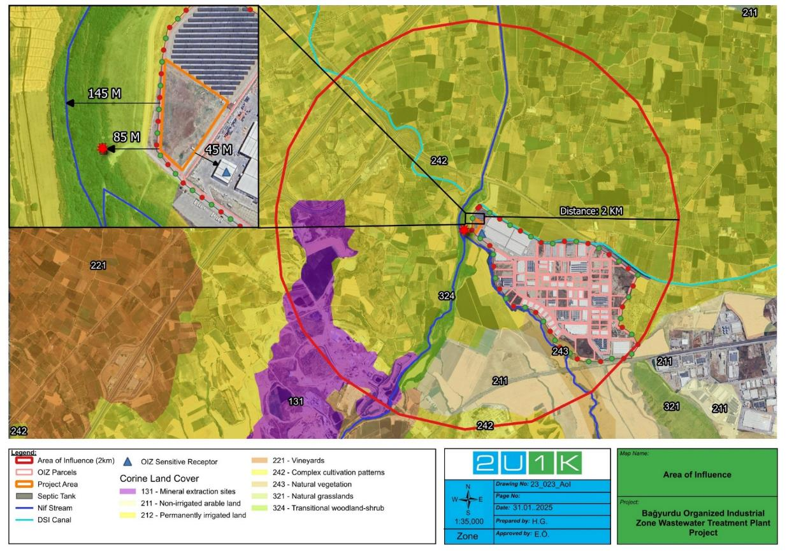
Figure 4-1. Environmental AoI of the Project

Social Area of Influence
The Project’s social area of influence has been defined as a 10 km radius around the Project site, reflecting the potential extent of social impacts and stakeholder interactions. Within this zone, Halilbeyli NeighbourhoodNeighbourhood, located approximately 7 km southeast of the Project area, represents the closest residential settlement. Additionally, Turgutlu District, located about 9.6 km away, is another nearby settlement that may experience indirect effects. While both settlements are expected to be only minimally affected by the Project, short-term impacts such as temporary increases in traffic density and dust during the construction phase may occur. These communities, together with businesses and employees within the Bagyurdu Organized Industrial Zone, form the core social receptors of the Project’s social area of influence.
Figure 4-2 shows the project's social area of influence.
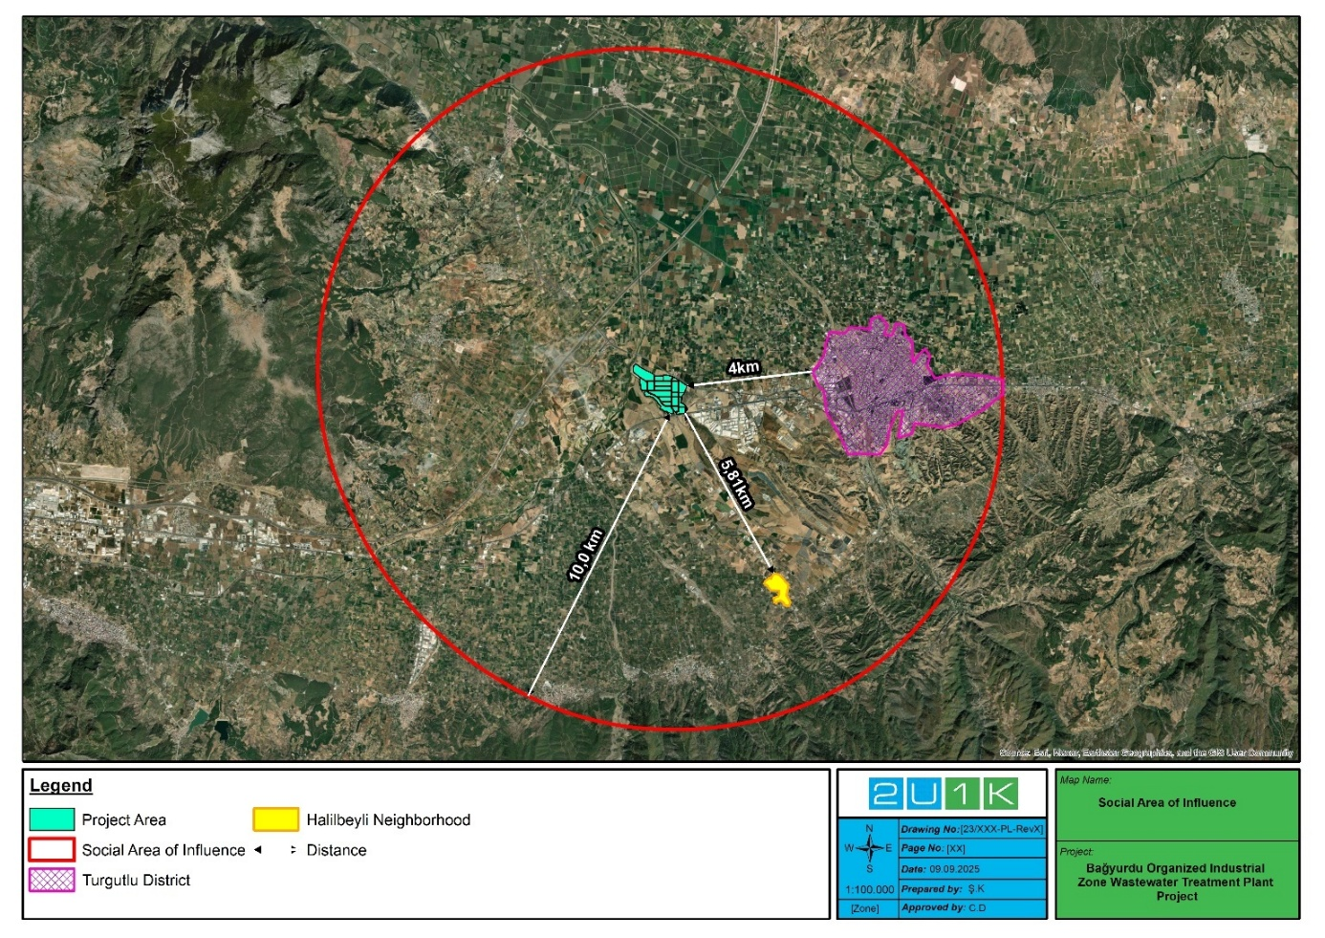
Figure 4-2. Social AoI of the ProjectProject

Impact Assessment Methodology
The impact assessment for the Project has been carried out in line with the principles of the World Bank Environmental and Social Framework (ESF) and the Environmental and Social Management Framework (ESMF) prepared for the Türkiye Organized Industrial Zones Project. The methodology aims to systematically identify, predict, and evaluate potential environmental and social impacts associated with the Project’s pre-construction, construction, and operation phases.
The assessment process followed these main steps:
- Scoping and Identification of Impacts.
Potential environmental and social interactions were first identified through desktop studies, baseline surveys, and stakeholder consultations. The Area of Influence (AoI) was determined considering both direct and indirect impacts, including physical, biological, and social receptors (e.g., Nif Stream, nearby settlements, and access roads).
- Screening and Risk Categorization
In line with the ESMF, the Project was screened against the World Bank Environmental and Social Standards (ESSs). The overall Project was categorized as “Moderate Risk.” Relevant ESSs were then mapped to Project activities to ensure all applicable thematic areas were covered, including ESS1 (Risk and Impact Assessment), ESS2 (Labour and Working Conditions), ESS3 (Resource Efficiency and Pollution Prevention), ESS4 (Community Health and Safety), ESS6 (Biodiversity), ESS8 (Cultural Heritage), and ESS10 (Stakeholder Engagement).
- Assessment Criteria and Significance Rating
Each potential impact was evaluated in terms of magnitude, duration, reversibility, and sensitivity of receptors. A significance matrix was used to rate impacts as negligible, low, medium, or high before and after the application of mitigation measures. The methodology also considered cumulative and residual impacts, ensuring that mitigation actions address both immediate and long-term effects.
- Phase-Based Impact Evaluation
Pre-Construction and Construction Phase: Physical impacts such as noise, dust, soil excavation, waste and wastewater generation, emissions from machinery, and risks related to worker influx were evaluated.
Operation Phase: Key impacts considered include the performance of the wastewater treatment plant in meeting national discharge standards, controlled effluent to Nif Stream, potential habitat modification, and land-use change. Positive impacts include improved wastewater management, reduced transportation-related emissions, and employment opportunities for local communities.
- Mitigation Hierarchy
The assessment followed the mitigation hierarchy by prioritizing avoidance, followed by minimization, mitigation, and offset/compensation measures where necessary. Project-specific management plans (e.g., Waste Management Plan, Traffic Management Plan, OHS Plan, Labour Management Plan) form the basis for implementing these measures.
- Monitoring and Adaptive Management
Residual impacts after mitigation were determined and included in the monitoring framework. Continuous monitoring, reporting, and adaptive management measures will ensure that mitigation actions remain effective and responsive to changing conditions throughout the Project lifecycle.
This structured methodology ensures that the Project’s environmental and social risks are transparently assessed, mitigated, and monitored in accordance with both national legislation and international standards

ENVIRONMENTAL BASELINE OF THE PROJECT
Within the scope of ESMP studies, 2U1K Engineering and Consultancy Inc. made a site visit the Project Area on 22 August 2024. In this context, the baseline findings including the desktop reviews are detailed in the following subsections.
While thet environmental AoI of the Project is designated within a perimeter of 2 km radius from the centre of the Project Area, (see Figure 41 for environmental AoI of the Project, including the closest settlements to the Project Area, Nif Stream, which will be discharge point of the Project), the project's social AoI has been defined as a 10 km radius around the project area, to reflect the potential scope of social impacts and stakeholder interactions (see Figure 42). Table 4-1 also represents summary of the Project’s E&S sensitive receptors.
In the sub-sections of this section, the current environmental situation within the AoI of the Project is analysed.

Project Location and Topography
The BOIZ are located in Kemalpaşa district, 24 km east of Izmir city centre in the Aegean Region of Türkiye, has a front in the south on the D300 Izmir Ankara Highway at the 50th km and a front in the northeast on the D250 Manisa-Turgutlu Highway at the 25th kilometre. The BOIZ Area is located about 20 km north-east of Kemalpaşa district and, the Project Area is on the north-western border of the BOIZ Area (see Figure 5-1).
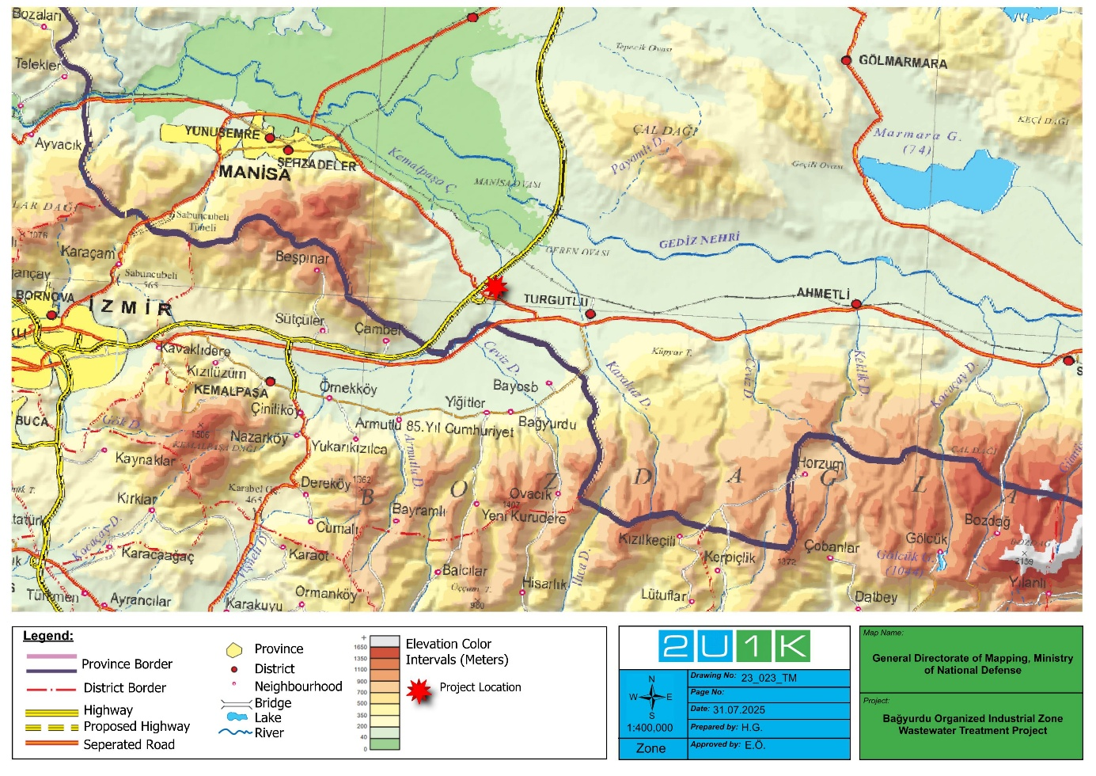
Figure 5-1. Topographic Map of the Project Area

Land Use
The land on which the facility will be established was allocated by the BOIZ. The title deed (Appendix A) dated 22 November 2017 of the Project Area on an area of 29,491.62 m2, including the SPP area registered as Sheet No: K19D-23D-3D, Block No: 110, Lot No: 1, is owned by the BOIZ.
Except for transformer building to be removed and relocated to another area of the BOIZ, the Project Area is vacant and currently has a steppe character. The vegetation on these lands will be removed (see Figure 13-3 to Figure 13-7). There is no evidence and trace of soil contamination at site. Excavation works are planned to be used mostly as backfill. During land preparation works, the transformer building located in the Project Area (see Figure 13-8) will be removed and relocated to another area of the BOIZ.

Geology

General Geology
According to database of the General Directorate of Mineral Research and Exploration Web Site, there are undifferentiated continental clastic rocks (plQ) in the Project Area (see Figure 5-2).
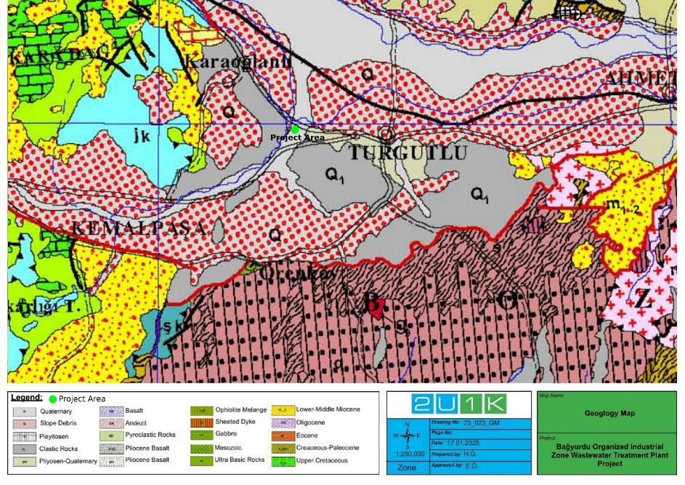
Figure 5-2. Geology Map of the Project Area
Source: (Geosciences Map Viewer of Mineral Research and Exploration, 2025)

Tectonics
Situated between 34.000 - 44.000 N latitudes and 25.000 - 32.000 E meridians, Western Anatolia and its neighbourhood is tectonically very active. Especially Muğla and Izmir Seismotectonic Regions have frequently witnessed severe earthquakes. There has been no major earthquake in Izmir-Kemalpaşa region for years (T.C. Kemalpaşa District Governorship, 2024). Moreover, in the Türkiye Earthquake Hazard Map (see Figure 5-3), the maximum acceleration value of Peak Ground Acceleration (PGA) 475 year in Izmir province, where the Project Area is located, varies between 0.3-0.5g. This shows that the earthquake hazard of the region is relatively high.
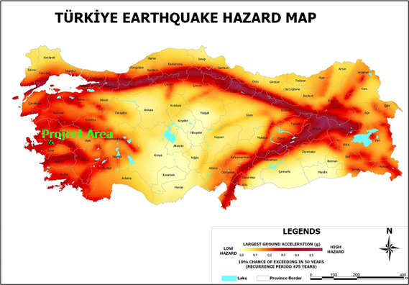
Figure 5-3. Türkiye Earthquake Hazard Map
As the Project Area is evaluated in terms of earthquake hazard, the region's Peak ground acceleration (PGA) 475 maximum acceleration value is 0.485 g, and the earthquake risk for the region is considered as high (see Figure 5-4).
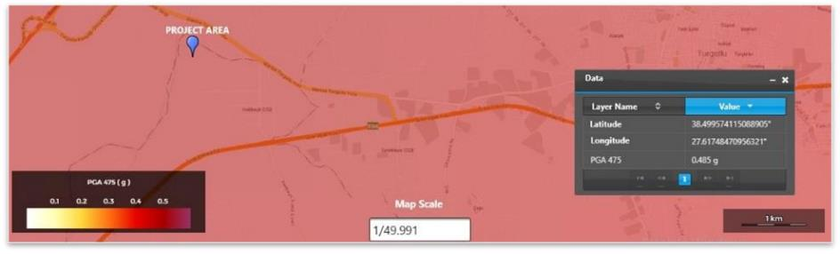
Figure 5-4. Earthquake Risk Map of the Project Area

Soil and Soil Quality
The soils of the Kemalpaşa district show a structure in the form of Cretaceous limestone in the mountainous areas, alluvial deposits in and around the Nif Stream and transported materials in the areas between the foothills and the plain. Most of the soils of the district are classified as calcareous brown soils. The alluvial lands forming the flat parts of the river basins cover a wide area. In this state, the district soils exhibit a structure suitable for all kinds of agricultural activities (T.C. Kemalpaşa District Governorship, 2025).
Between August 24 and 28, 2020, ground survey studies were conducted at a total of six (6) points at depths of 15 to 20 meters (total 95 m) within the Project Area, including drilling works. Following the drilling studies conducted in the Project Area, generally up to the first 6.50-9.50 meters, coffee-coloured sandy low plasticity clay (saCIL), clayey sand (clSa), gravelly silty sand (grsiSa), gravelly clayey sand (grclSa), poorly graded gravel (GrP), sandy clayey gravel (saclGr), sandy silty gravel (sasiGr), silty sand (siSa), and high-very high plasticity clay (CIM-CIV) units were observed, followed by gray-coloured medium-high-very high plasticity clay (CIM-CIH - CIV) and sandy low plasticity clay (saCIL) unit were observed. (Alanyali Geological Drilling Laboratory Inc., 2020)
In this context, no traces of soil contamination were found for the land within the Project Area with bushes and dry grasses during the site visit on August 22, 2024 (see Figure 13-3 to Figure 13-7). Also, no soil quality studies have been conducted in the Project Area.

Hydrogeology
Küçük Menderes, Bakırçay and Gediz Rivers are the most important rivers of the Aegean Region and the Izmir province. The region contains three basins. These are; Küçük Menderes Basin, Gediz Basin and North Aegean Basin. The Project Area is located within the Gediz Basin.
Gediz Basin: Gediz River, Alaşehir Stream, Gürdük Stream, Kum Stream, Kemalpaşa (Nif) Stream, Water bodies such as Kokarazmak Stream, Ahmetli Stream, Karacalı Stream, Sart Stream and Tabakçayı Stream collection areas. Within the boundaries of the Gediz Basin, approximately 16% of Izmir province (SYGM, Gediz Basin Flood Management Plan, 2019) (T.C. Izmir Governorate Directorate of Provincial Disaster and Emergency State, 2021).
According to the study on the hydrogeological characteristics of Kemalpaşa plain near the Project Area in the Science and Engineering Journal published in 2009 by Dokuz Eylül University, drinking and domestic water in the study area is supplied from groundwater. Due to the numerous water wells drilled in the plain, the groundwater level is continuously decreasing. According to the water levels obtained from some of the wells drilled in the plain, the level has been continuously decreasing since 1984 until today. All over the world, groundwater depletion and contamination due to increasing water demand are discussed on scientific platforms. In a similar study, an average annual decrease of 1 meter in groundwater level was determined in Torbalı plain since 1980 (Simsek and Filiz, 2001). In this study, significant declines in groundwater in Kemalpaşa plain were also determined. Namely, while the water depths in the boreholes drilled in the 1970s and 1980s and ranging between 50-120 m in depth were 3-5 m, this level was between 20-40 m during the 1990s and increased more in the 2000s and levels ranging between 140-160 m were recorded. On the other hand, the depth of drilling has increased in response to the increasing water depth and nowadays drilling depths reaching 750 m. The dangerous decline in groundwater levels will bring about significant impacts that will closely affect all living things in the next century (Dokuz Eylül University, 2009).
The Nif Stream then flows into the Gediz River 9.5 km to the northwest of the Project Area within the Gediz Basin. Within the scope of baseline hydrogeology, information on one (1) well with 40 m static level surrounding in the AoI of the Project was obtained from the DSI 2nd.regional Directorate. The usage permit of the well by the BOIZ can be seen in Appendix-D. In this context, the water table contour of the related well in the AoI of the Project is visualised in Figure 5-5. It is observed that the water level dropped to 50 m. Also, in 2021, according to the measurements of the BOIZ, the water level was around 60-70 m. In addition to this, as a result of the ground survey studies conducted in the Project Area in 2020 August, no groundwater was found at depths of 15 and 20 m at 6 drilling points (Alanyali Geological Drilling Laboratory Inc., 2020).
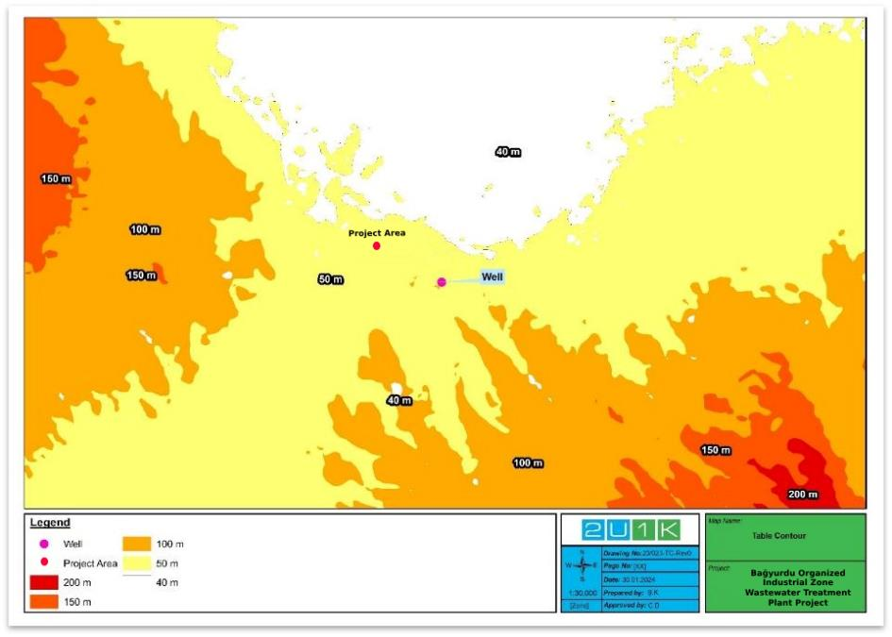
Figure 5-5. The Well and Water Table Contour in the AoI of the Project
As it is evaluated in terms of sensitive water bodies according to the national legislation, the Project Area in Gediz Basin is located in the Nitrate Sensitive Area (see Figure 5-6) and Urban Sensitive Area (see Figure 5-7). Rather than the Project, this baseline assessment was made by considering the sensitivity of the water bodies in the region due to uncontrolled discharges to Nif Stream from non-BOIZ sources. Hence, there is no requirement for this subject for the Project located within the BOIZ areadue to the discharge of treated water with reduced organic load into the receiving environment, it is very clear that the Project will have positive impacts as a WWTP.
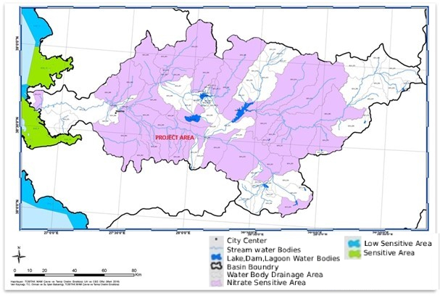
Figure 5-6. Map of Nitrate Sensitive Areas of Gediz Basin and Project Area
Source: Regulation on Identification of Sensitive Water Bodies and the Areas Affecting These Water Bodies, and Remediation of Water Quality (Map #18)
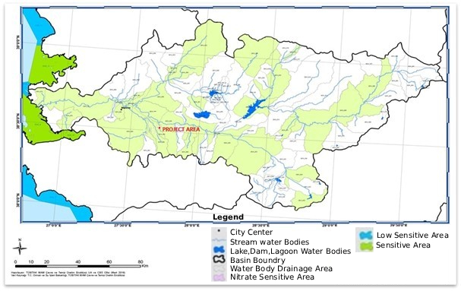
Figure 5-7. Map of Urban Sensitive Water Bodies and Drainage Areas in Gediz Basin and Project Area
Source: The Regulation on Identification of Sensitive Water Bodies and the Areas Affecting These Water Bodies, and Remediation of Water Quality (Map #43)

Noise
The Project Area is located on the north-western border of the BOIZ and is surrounded by Nif Stream to the west and north and the Manisa-Turgutlu highway 400 m to the north. The closest sensitive receptor area, identified within the AoI of the Project Area for the assessment of the environmental impacts is the closest industrial facilities in the BOIZ located at the 45 meters south-east of the Project Area. There is no noise measurement baseline data available for the Project’s AoI. There are no sensitive receptors (e.g., residential areas, schools, health facilities) within the Project’s AoI (see Figure 4-1 and Figure 4-2). Hence, the main sources of environmental baseline noise are the BOIZ facilities to the south-east and the motorway to the north.

Air Quality and Odour
NationalN air quality monitoring station closest to the Project under the supervision of MoEUCC are located in the Turgutlu district of Manisa, approximately 88 km east of thethe Project area (see Figure 5-8).
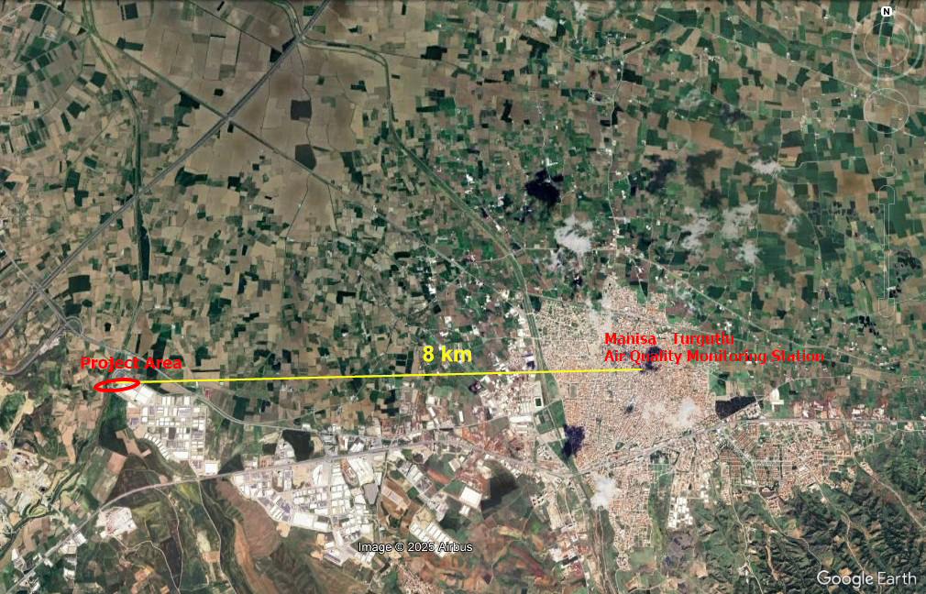
Figure 5-8. The Closest Air Quality Monitoring Station to the Project Area
Source Web Site: (Database of T.C. Ministry of Environment, Urbanization and Climate Change, 2025)(Database of T.C. Ministry of Environment, Urbanization and Climate Change, 2025)
On September 9, 2025, aira quality values for the parameters measured in Turgutlu District of Manisa are presented in Table 5-1.
Table 5-1. Air Quality Values for the Parameters Measured inTurgultu District of ManisaManisa
Unit  (µg/m³)  MeasuredMeasured  datedate | SO₂ | PM₁₀ | PM_{2.5} | CO | NO | NO₂ | NO_{x} | O₃
 | hourly | 24 hours | 24 hours | 8 hours | hourly | hourly | yearly | 8 hours
9.9.2025 | 20.22 | 4444.6 | -* | 653653.1 | -* | 35.88 | -* | 3939.5
National Limit Value | 350 | 50 | - | 10,000 | - | 250 | 30 | 120
IFC Limit Value | 20  (24 hours)  500  (10 minutes) | 50 | 10  (yearly)  25  (24 hours) | - | - | 200 | - | 100
* MoEUCC does not have data for this parameter at this station.
Source Web Site:
In this context, on the website of the MoEUCC, the current air quality index of Turgutlu is described as “good ” in terms of parameters including particulate matter (PM₁₀), SO₂, O₃, CO, NO₂ due to below corresponding national and international (WHO Ambient Air Quality Guidelines (AQG)s global update 2005) specified IFC General EHS Guideline) limit values.
In addition, the WHO Global AQGs offer global guidance on thresholds and limits for key air pollutants that pose health risks. These guidelines are of a high methodological quality and are developed through a transparent, evidence-based decision-making process. In addition to the guideline values, the WHO Global air quality guidelines provide interim targets to promote a gradual shift from high to lower concentrations. In this context, the WHO has updated its Ambient AQGs levels in 2021 as specified in Table 5-2.
Table 5-2. WHO Ambient AQGs Thresholds and Limits for Key Air Pollutants That Pose Health Risks
WHO AQGs value in (µg/m³) | Interim target |  |  |  | Averaging time | AQG level
WHO AQGs value in (µg/m³) | 1 | 2 | 3 | 4 | Averaging time | AQG level
SO₂ | 125 | 50 | - | - | 24-hour | 40
PM₁₀ | 150 | 100 | 75 | 50 | 24-hour | 45
PM_{2.5} | 75 | 50 | 37.5 | 25 | 24-hour | 15
CO | 7,000 | - | - | - | 24-hour | 4,000
O₃ | 160 | 120 | - | - | 8-hour | 100
NO₂ | 120 | 50 | - | - | 24-hour | 25
According to the relevant monitored values, which are assessed to the WHO Ambient AQGs, while SO₂, PM₁₀, CO and O₃ values are below the corresponding recommended AQG level, it is seen that monitored NO₂, value can meet the interim 2 target. Hence, the air quality of the Project Area cannot be characterized as good due to high measured NO₂ value.
In addition, no odour issues were identified in the Project Area during the site visit conducted on 22.08.2024.

Waste Management

Solid Waste
No material that can be characterized as waste was encountered in the Project Area. There is one transformer building in the Project Area (see Figure 13-8) which will be removed and relocated to another area of the BOIZ.
On the other hand, BOIZ has secured Zero Waste Certificate for the BOIZ on 21.12.2020 in line with the Regulation on Zero Waste (see Appendix-D). In this context, a waste collection centre was established within the BOIZ. The participants as facilities can bring their paper, plastic, glass, metal, battery, medical and electronic waste as a packaging waste to the waste collection centre of the BOIZ. The MoEUCC-authorized company “Tuşba Metal Recycling” collects these packaging wastes of the BOIZ on a monthly basis. BOIZ’s waste collection centre consists of an open and closed area, including a closed area tent (see Figure 13-13). This area must be constructed with impermeable flooring and passive ventilation using non-flammable materials. As part of the Project, BOIZ WWTP will construct its own temporary waste storage area in line with the national legislation.
Likewise, domestic wastes generated in BOIZ are placed in containers of the Kemalpaşa Municipality, collected by municipal personnel, and sent to a licensed landfill daily. In this context, BOIZ has a waste management plan.
Besides, 16 facilities in the operation phase within the BOIZ (see Table 5-3), which have environmental permits and environment permit out of scope official letters in accordance with the Regulation on Environmental Permit and License, carry out their waste management in their facility areas.
Table 5-3. The Facilities in the Operation Phase within the BOIZ
No | Block  No | Lot  No | Parcel Area (m²) | Phase | Facility Name
1 | 102 | 11 | 10,000.00 | Operation | Remo Ağir Mak. San. Tic. Ltd.Şti.
2 | 102 | 13 | 10,000.00 | Operation | Borataş Turizm Makina İnş.Taah.San.Tic.Ltd.Şti.
3 | 103 | 2 | 25,000.11 | Operation | Birim Makina San.ve Tic.A.Ş.
4 | 101 | 25 | 5,024.89 | Operation | Recreo Engineering Mühendislik Ekipman ve Tedarik Hizmdetleri Ltd.Şti.
5 | 108 | 3 | 15,000.00 | Operation | Aymas Makina Sanayi ve Tic. Ltd.Şti.
6 | 101 | 29 | 4,999.00 | Operation | Sart Von Rohr Teknik Kontrol Vana A.Ş.
7 | 106 | 13 | 5,001.00 | Operation | Constmach Makina İthalat İhracat Ltd. Şti.
8 | 106 | 21 | 4,999.00 | Operation | Özkan Hidrolik Hortum Ve İş Makinasi Yed. Prç.San.Tic.Ltd.Şti.
9 | 106 | 14 | 4,999.00 | Operation | LYKSOR Yapi Kimyasallari A.Ş.
10 | 107 | 3 | 30,000.00 | Operation | MCP Manisa Seramik Ürünleri San. ve Tic.Aş.
11 | 101 | 28 | 4,999.00 | Operation | Softech Plastik ve Tekstil Ürünleri A.Ş.
12 | 108 | 2 | 20,000.00 | Operation | Dönmez Debriyaj San. ve Tic. A.Ş.
13 | 101 | 21 | 4,999.00 | Operation | Özenir Makina Mühendislik Otomotiv İnş.Tur.Taş.San.ve Tic.Ltd.Şti.
14 | 101 | 27 | 4,999.01 | Operation | Erciyes Demir San.ve Tic.Aş.
15 | 102 | 23 | 5,000.00 | Operation | Çelik Egzost San.ve Tic.Ltd.Şti.
16 | 101 | 26 | 4,999.11 | Operation | Süleyman Yalçin Uludağ İş Mak.Otom.Yed. Parça San.ve Tic. Ltd. Şti.
17 | 102 | 22 | 4,997.00 | Operation | Turan Kağit Ambalaj İnş. San. ve Tic. A.Ş.
18 | 106 | 18 | 5,709.21 | Operation | Simya Metal Demir Çelik İnş.San.Tic.Ltd.Şti
19 | 101 | 20 | 4,999.00 | Operation | Leaf Tobacco Tütün A.Ş.
20 | 114 | 1 | 5,138.62 | Operation | Rifay Geri Dönüşüm Makina İmalat Sanayi İthalat
21 | 114 | 4 | 30,000.39 | Operation | Tekpan Teknik Elektrik Kumanda Pano San. ve Tur. Tic. A.Ş.
22 | 115 | 1 | 15,035.18 | Operation | Cebir Ambalaj San. ve Tic.A.Ş.
23 | 115 | 6 | 5,000.00 | Operation | Mert Çelik Metal Ürünleri San.ve Tic.A.Ş.
24 | 115 | 7 | 10,000.00 | Operation | Borataş Mobil Makine San. ve Tic.A.Ş.
25 | 115 | 8 | 10,000.00 | Operation | Blv Metal San. ve.Tic. A.Ş.
26 | 105 | 10 | 24,081.98 | Operation | Girginer Oto Endüstri San. ve Tic. A.Ş.
27 | 108 | 4 | 10,000.00 | Operation | Dns İnovasyon Sistemleri ve Teknoloji A.Ş.
Source: (E&S Screening Report of the Project, 2024)

Liquid Waste
Wastewater generated in the BOIZ is not connected to a wastewater line ended with a WWTP. In other words, wastewater of the BOIZ is discharged to septic tanks, which are impermeable and enclosed, via the existing sewer line of the BOIZ. Collected wastewater is being vacuumed by trucks from these septic thanks under the supervision of the BOIZ. Then, vacuumed wastewater is being sent to the WWTP of Kemalpaşa OIZ, 20.4 km away by road from the Project Area daily (see Figure 5-9 for the related transport route).
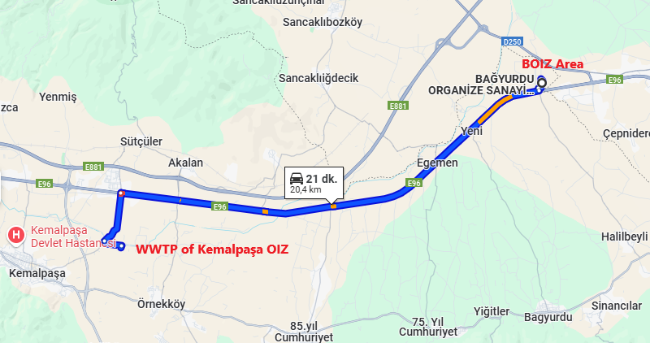
Figure 5-9. WWTP of Kemalpaşa OIZ and BOIZ Area Transport Route
According to the information obtained from the BOIZ, about 50 - 52 trips to the WWTP of Kemalpaşa OIZ are made per month with trucks, the carrying capacity of one truck is 16 m³ and a total of 800 - 832 m³ of domestic wastewater is transported monthly.
The WWTP of Kemalpaşa OIZ performs physical, chemical, and biological treatment with a capacity of 20,000 ton/day wastewater treatment and discharges the effluent to the Nif Stream. (T.C. Izmir Governorship, Provincial Directorate of Environment, Urbanization and Climate Change, 2023)
According to the information on the Environmental Criteria for BOIZ Green OIZ Company-Based Analysis and Road Map Project prepared by the Dokuz Eylül University, Faculty of Engineering, Department of Environmental Engineering in 2021, it is stated that no process water is generated from the existing facilities in the BOIZ, and the wastewater is of domestic nature. There are two (2) facilities that use water in their processes. Wastewater of the concerned companies is either treated or collected in a septic tank and sent to the WWTP of Kemalpaşa OIZ. In order to determine the wastewater flowrate in the BOIZ WWTP planning in 2018, flow measurements were made. When the BOIZ reaches full occupancy (development area also taking into consideration), the amount of domestic wastewater is foreseen as 900 m³/day. The prediction of the BOIZ regarding industrial wastewater is that no industrial wastewater will be generated except for MCP Seramik, Dönmez Debriyaj, and Konfor Mobilya (building license and no construction commenced) facilities. The industrial wastewater flowrate from these three (3) facilities is 350 m³/day and upon reaching full occupancy (considering the need for expansion) is foreseen to increase to the level of 525 m³/day. The BOIZ has a discharge standard for industrial wastewater to the sewer system and companies will be able to discharge their wastewater to the sewer system after bringing it to the specified specifications. In the calculations made for the BOIZ WWTP, the capacity of the treatment plant was taken as 1,500 m³/day considering the facilities in operation, occupancy status and the areas to be opened for new allocation (Dokuz Eylül University, 2021).
In this direction, currently generated wastewater within the BOIZ is being sent to the WWTP of the Kemalpaşa OIZ with the accepted discharge standards given in Table 5-4. The relevant protocol dated 24.06.2015 between Kemalpaşa OIZ and BOIZ is in Appendix-D.
Table 5-4. Discharge Standards to be Provided for the WWTP of the Kemalpaşa OIZ
 | No | Parameters | Unit | Kemalpaşa OIZ Standards
Main Parameters of Discharge  to Kemalpaşa OIZ WW Channel | 1 | Chemical Oxygen Demand (COD) | mg/L | 2,500
Main Parameters of Discharge  to Kemalpaşa OIZ WW Channel | 2 | Suspended Solid (SS) | mg/L | 500
Main Parameters of Discharge  to Kemalpaşa OIZ WW Channel | 3 | Oil and Grease | mg/L | 250
Main Parameters of Discharge  to Kemalpaşa OIZ WW Channel | 4 | Total Kjeldahl Nitrogen (TKN) | mg/L | 20
Main Parameters of Discharge  to Kemalpaşa OIZ WW Channel | 5 | Phosphorus (P) | mg/L | 2
Main Parameters of Discharge  to Kemalpaşa OIZ WW Channel | 6 | Free Chlorine | mg/L | 10
Main Parameters of Discharge  to Kemalpaşa OIZ WW Channel | 7 | Sulphate (SO₄⁻²) | mg/L | 2,000
Main Parameters of Discharge  to Kemalpaşa OIZ WW Channel | 8 | Sulphur (SO₃⁻²) | mg/L | 2
Main Parameters of Discharge  to Kemalpaşa OIZ WW Channel | 9 | Phenol | mg/L | 10
Main Parameters of Discharge  to Kemalpaşa OIZ WW Channel | 10 | Total Chromium | mg/L | 5
Main Parameters of Discharge  to Kemalpaşa OIZ WW Channel | 11 | Arsenic (As) | mg/L | 3
Main Parameters of Discharge  to Kemalpaşa OIZ WW Channel | 12 | Cadmium (Cd) | mg/L | 2
Main Parameters of Discharge  to Kemalpaşa OIZ WW Channel | 13 | Copper (Cu) | mg/L | 2
Main Parameters of Discharge  to Kemalpaşa OIZ WW Channel | 14 | Mercury (Hg) | mg/L | 0.2
Main Parameters of Discharge  to Kemalpaşa OIZ WW Channel | 15 | Nickel (Ni) | mg/L | 5
Main Parameters of Discharge  to Kemalpaşa OIZ WW Channel | 16 | Lead (Pb) | mg/L | 3
Main Parameters of Discharge  to Kemalpaşa OIZ WW Channel | 17 | Tin (Sn) | mg/L | 5
Main Parameters of Discharge  to Kemalpaşa OIZ WW Channel | 18 | Boron (B) | mg/L | 3
Main Parameters of Discharge  to Kemalpaşa OIZ WW Channel | 19 | Iron (Fe) | mg/L | 20
Main Parameters of Discharge  to Kemalpaşa OIZ WW Channel | 20 | Zinc (Zn) | mg/L | 10
Main Parameters of Discharge  to Kemalpaşa OIZ WW Channel | 21 | Total Cyanide | mg/L | 10
Main Parameters of Discharge  to Kemalpaşa OIZ WW Channel | 22 | pH | - | 6.5 - 10
Main Parameters of Discharge  to Kemalpaşa OIZ WW Channel | 23 | Temperature | ˚C | <40
Apart from that, sewage and rainwater are collected separately in the BOIZ. Currently, a 13,663 m long sewerage line made of corrugated pipe has been laid. Rainwater falling on the BOIZ area is collected separately from wastewater and discharged into Nif Stream. Currently, 16,300 m of rain gutters have been installed.
According to their water consumption, the facilities are listed as MCP, LYKSOR, Aymas, Boratas, Birim Makina, Remo and Vergo from large to small. Water consumption is generally for domestic purposes. In general, all facilities have a rainwater collection system. Rainwater falling on the roof and the field is collected. In three (3) companies except for Boratas and Vergo, there is a rainwater tank to collect some of the collected rainwater and reuse it afterwards. The collected rainwater is reused for irrigation and personnel needs in toilet flush tanks, not for drinking purposes. Unused rainwater is discharged into the BOIZ stormwater channel.
Since water use in the process is very low, industrial wastewater generation is very low. Boron oil is mixed with water in the metal cutting process. However, the cutting fluid is collected as it is an economically expensive substance, filtered and reused. Domestic wastewater from cleaning etc. is discharged into the BOIZ sewerage and vacuumed and sent by vacuum trucks to discharge to the Kemalpaşa OIZ WWTP (Dokuz Eylül University, 2021).

Water Resources
The most important water resource of the region as a surface water is the Nif Stream. Wastewater of BOIZ, which is sent by trucks to the WWTP of Kemalpaşa OIZ, is discharged to this stream after treatment. It originates from Bornova Çiçekli Village, crosses the Kemalpaşa Plain and flows into the Gediz River within the borders of Manisa. The effluent currently discharged to Nif Stream is carried by the tributary of Nif Stream 1.65 km west of the Project Area. The discharge point of the Project will be Nif Stream, which flows from south to the north and passes 145 m away.
The map showing the water resources near the Project Area is in Figure 5-10.
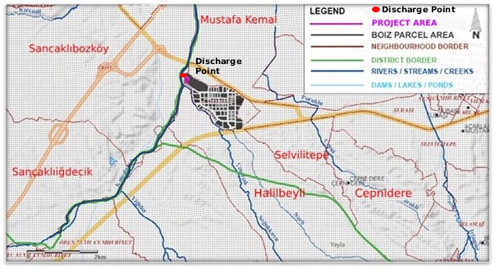
Figure 5-10. Water Resources Near the Project Area
Source: (Ministry of Agriculture and Forestry, National Water Information System, 2025)
As a result of the ground survey studies conducted in the Project Area in 2020 August, no groundwater was found at depths of 15 and 20 m at 6 drilling points (Alanyali Geological Drilling Laboratory Inc., 2020). In addition, the groundwater is used in the BOIZ Area. Groundwater utilization certificate for use as industrial water has been secured from the DSI on 13.02.2014 (see Appendix-D). The well from which the groundwater is supplied has a static water level of 40 m and 50,000 tons/year of water withdrawal is allowed by the concerned authority.
According to the information on the Environmental Criteria for BOIZ Green OIZ Company-Based Analysis and Road Map Project prepared by the Dokuz Eylül University, Faculty of Engineering, Department of Environmental Engineering in 2021, the water supply to the facilities is provided by the BOIZ and the companies are not allowed to drill wells. The water taken from the well is transferred to a storage tank with a capacity of 2,000 m³. The water is delivered to the facilities from the reinforced concrete buried water tank. In the current situation, there is a 7,257 m drinking water transmission line. HDPE (High Density Polyethylene) pipes were used. In addition, 6,776 m long fire water line is now complete.
Facilities with low water consumption are preferred in the BOIZ. Within the BOIZ in 2020, total 100,531 m³ water was used (monthly average 8,377 m³). The most water intensive facilities are MCP and LYKSOR. More than 70% of the water consumed is used by these two (2) facilities. The total water consumption of the five (5) companies in the machinery manufacturing sector, which is the focus of the Green OIZ Project, is 9,333 m³/year (average 762 m³/month), which corresponds to 9-10% of the total water used (Dokuz Eylül University, 2021).
BOIZ provides water supply from water of the permitted well (see Appendix-D for its utilisation certificate) within the BOIZ area (see Figure 5-5 for its location) as industrial water for its facilities. At the same time, groundwater is not used as drinking water but as domestic water (from employees of the BOIZ’s facilities) in the BOIZ. 2U1K ensured that samples were taken to determine the quality of this water. The results of the analysis report of the sample taken from the well water on 12 September 2024 is in compliance with the Regulation on Water Intended for Human Consumption. (see Appendix-H)
In this regard, it was emphasised by the Project representative that all security measures, including cameras, are taken and illegal drilling of wells within the BOIZ is not allowed.

Climate and Vegetation
The climate of the Izmir province generally reflects the Mediterranean climate. Due to the perpendicular position of the mountains to the sea, the sea effect can reach inland through the plains. For this reason, the province experiences mild and rainy winters, dry and hot summers, which are the characteristics of the typical Mediterranean climate. Only the high-altitude areas in the east of the province experience a transitional climate, a mixture of Mediterranean and continental climate. The average annual temperature in Izmir is 17.9°C. The coldest months of the year are January and February, while the hottest months are July and August. The prevailing wind direction in the city is southeast, but in the May-September period, the prevailing wind is west (Imbat Winds) due to the different warming of the land and sea. The highest precipitation is observed in December, January, and February (T.C. Izmir Governorate Directorate of Provincial Disaster and Emergency State, 2021).
According to the metrological data of Izmir province between 1938 and 2022 measured by the Meteorology General Directorate of MoEUCC, the highest temperature measured in the region is 43.0 °C and the lowest temperature is -8.2 °C. Detailed meteorological information of Izmir province between these years is given in Table 5-5.
Table 5-5. According to the Months and Annual Average Precipitation and Temperature Values of Izmir
Izmir | January | February | March | April | May | June | July | August | September | October | November | December
Average Values Over Many Years (1938 – 2022)
Average Temperature (°C) | 8.8 | 9.6 | 11.6 | 15.9 | 20.8 | 25.4 | 27.9 | 27.7 | 23.8 | 18.9 | 14.3 | 10.6
Average Highest Temperature (°C) | 12.4 | 13.6 | 16.3 | 20.9 | 26.1 | 30.7 | 33.2 | 33.0 | 29.2 | 24.0 | 18.6 | 14.1
Average Lowest Temperature (°C) | 5.8 | 6.2 | 7.7 | 11.2 | 15.5 | 19.9 | 22.5 | 22.4 | 18.7 | 14.6 | 10.8 | 7.6
Average Sunshine Duration (hours) | 4.3 | 5.2 | 6.4 | 8.0 | 9.9 | 11.6 | 12.3 | 11.9 | 10.1 | 7.6 | 5.6 | 4.2
Average Number of Rainy Days | 12.66 | 10.69 | 9.27 | 7.88 | 5.31 | 2.33 | 0.45 | 0.54 | 1.93 | 5.36 | 8.75 | 12.74
Average Monthly Total Rainfall (kg/m²) | 134.8 | 103.4 | 75.1 | 45.7 | 31.3 | 12.4 | 4.1 | 5.9 | 15.1 | 44.1 | 91.8 | 146.2
Highest and Lowest Values in Many Years (1938 – 2022)
Highest Temperature (°C) | 22.5 | 27.0 | 30.5 | 32.5 | 37.6 | 41.3 | 42.6 | 43.0 | 40.1 | 36.0 | 30.3 | 25.2
Lowest Temperature (°C) | -8.2 | -5.2 | -3.8 | 0.6 | 4.3 | 9.5 | 15.4 | 11.5 | 10.0 | 3.6 | -2.9 | -4.7
Yearly Average | Average Temperature (°C) |  | Average Highest Temperature (°C) |  | Average Lowest Temperature (°C) |  | Average Sunshine Duration (hours) |  | Average Number of Rainy Days |  | Average Monthly Total Rainfall (kg/m²)
Yearly Average | 17.9 |  | 22.7 |  | 13.6 |  | 8.1 |  | 77.9 |  | 709.9
Daily Total Highest Rainfall | 145.3  29.09.2006 | kg/m² | Daily Fastest Wind |  | 127.08  29.03.1970 |  | km/h |  | Maximum Snow Thickness |  | 32 cm  31.01.1945
Source Web Site: (Meteorology General Directorate of T.C. Ministry of Environment, Urbanization and Climate Change, 2024)
In terms of vegetation, approximately 60% (33.611 ha) of the surface area of Kemalpaşa, where the Project Area is located, is covered with forests. Forest trees are oak, red pine, and larch. There are also maquis and degraded coppice areas, which are typical of the Mediterranean climate.

Natural Disaster Potential
Due to its geological structure, topographical and climatic characteristics, Izmir province is prone to earthquakes, landslides and rock falls, disasters, and emergencies such as floods, inundations, meteorological and climatic disasters, fire, industrial accidents It is among the regions with high disaster risk in terms of situations. A total of 200 disaster events occurred in the province between 2009 and 2020; 131 earthquakes, 23 rock falls, 2 avalanches, 57 landslides, 93 floods/inundations. In these disaster events, a total of 118 citizens lost their lives. A total of 1,546 houses were affected (T.C. Izmir Governorate Directorate of Provincial Disaster and Emergency State, 2021).
In this regard, the landslides, and active faults map of Kemalpaşa district of Izmir, where the Project Area is located, can be seen in Figure 5-11. As can be seen, there is an active fault 1.7 km north of the Project Area. In addition, according to the Disaster and Emergency Management Presidency’s online website, the ground acceleration value (PGA 475) of the Project Area is 0.486 g. This value indicates seismic ground acceleration between zones 2 and 3 for the Project Area.
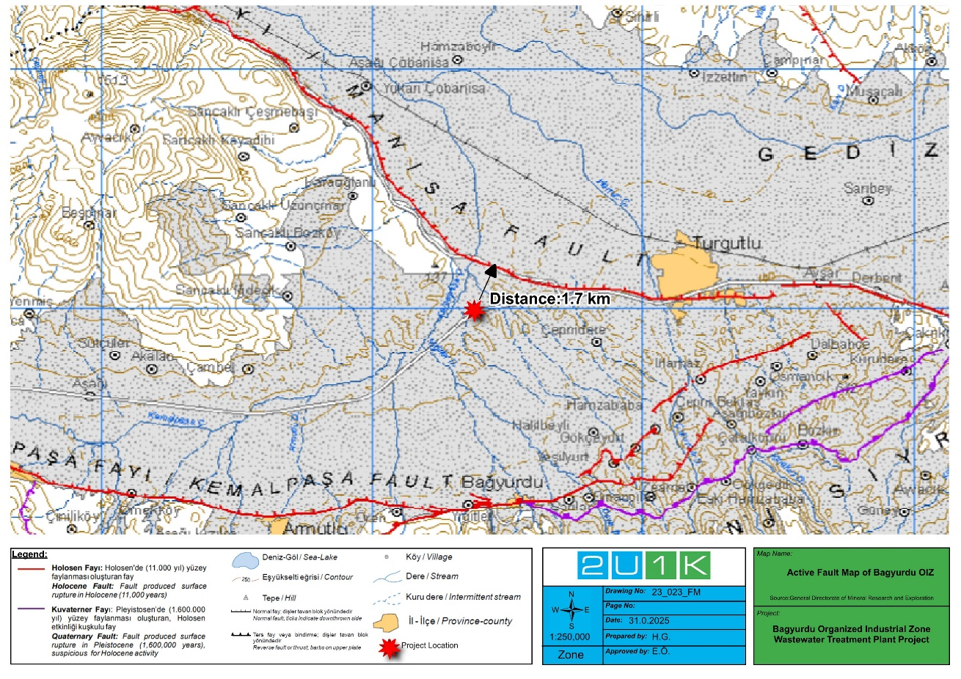
Figure 5-11. Landslides and Faults, and Active Faults Map of Kemalpaşa District of Izmir
Source Web Site: (Geosciences Map Viewer of Mineral Research and Exploration, 2025)

Biodiversity and Protected Areas
The Project Area is identified as “complex cultivation patterns” according to Corine Land Cover Data and is located within the boundaries of the OIZ. In addition, Transitional woodland-shrub are located adjacent to the Project Area. Identified Transitional woodland shrub includes mix of tree species, shrubs and herbaceous plants. Currently, the Project Area has lost its natural habitat status and is under the influence of human impact/activities. Therefore, there are no trees or shrubs in the area where the project will be implemented. Nif Stream passes near the project area. The distance of the Nif Stream passing around the OIZ to the project area is 145 m. There are many fragmite species around Nif Stream, which is an indicator of water pollution. Habitats in the Project Area and surrounding habitats are given in Figure 5-12 and Figure 5-13.
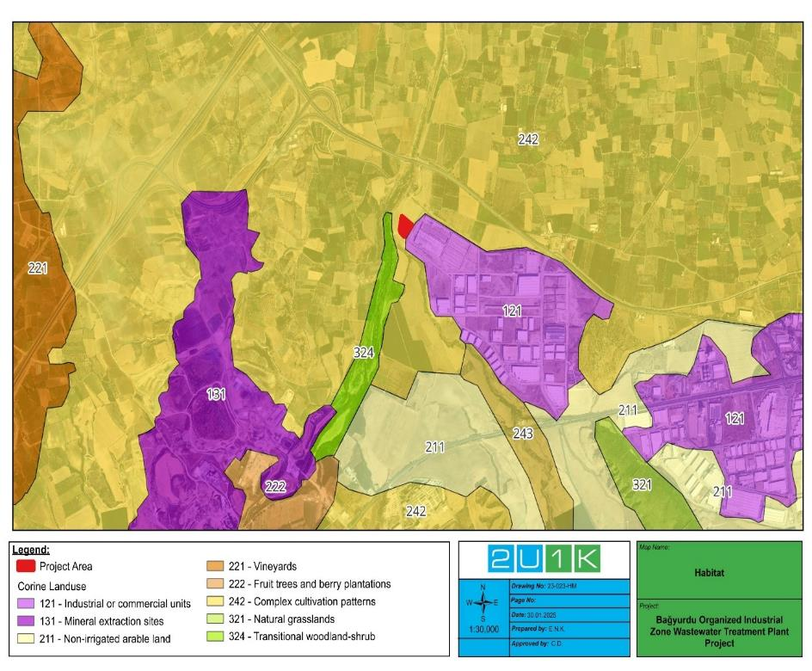
Figure 5-12 Corine Habitat Map
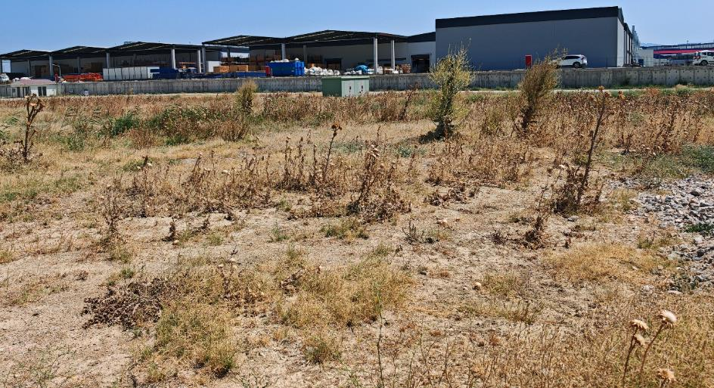
Figure 5-13. Project Area and Surrounding Habitats
Due to the intense anthropogenic impact observed in the project area, the distribution of flora and fauna is highly suppressed. The flora and fauna species that can be observed in the area comprise cosmopolitan species.
In evaluating the threat/protection status of species, Bern Convention (Convention on the Conservation of European Wildlife and Natural Habitats); IUCN (International Union for Conservation of Nature) Red List Database and Convention on International Trade in Endangered Species of Wild Flora and Fauna (CITES) were used.
Bern Convention
The Convention was put into force in 1982 for the conservation of European wildlife and natural habitats. Fauna and flora species protected by Bern Convention are listed in four (4) Annexes (Ann):
  - Annex I: Strictly protected flora species
  - Annex II: Strictly protected fauna species
  - Annex III: Protected fauna species
  - Annex IV: Prohibited means and methods of killing, capture, and other forms of exploitation
Convention on International Trade in Endangered Species of Wild Flora and Fauna (CITES)
Species covered in CITES are listed under three different appendices according to their conservation status. Species protected by Bern Convention are listed in four (4) Appendices (App):
  - Appendix I: covers the species, which are under the threat of extinction. Trade in the specimens of these species is not allowed except in extraordinary circumstances.
  - Appendix II: includes species which are not threatened with extinction, but trade in specimens is restricted in order to prevent utilization incompatible with their survival.
  - Appendix III: includes species for which other parties of CITES is applied for assistance in controlling trade and which are conserved at least in one country.
IUCN Red List of Threatened Species
The International Union for Conservation of Nature (IUCN) Red List is published to draw attention to the species whose population is under risk or threatened. IUCN includes the species to the Red List after researching the reasons causing decrease in its population. IUCN Red List categories are given below:
  - EX: Extinct
  - EW: Extinct in the Wild
  - CR: Critically Endangered
  - EN: Endangered
  - VU: Vulnerable
  - NT: Near Threatened
  - LC: Least Concern
  - DD: Data Deficient
  - NE: Not Evaluated
Red Book of Flora in Türkiye (Ekim et al., 2000), which is prepared as per the 1994 IUCN Red List Categories and Criteria, is used during the determination of risk status of the flora species in the study area. The data prepared in this report was obtained through desktop and field studies.

Flora
Project Area is under intense anthropogenic influence. There is no natural habitat for natural plant species to survive in the construction area. As a result of the field work carried out in the project area on 22.08.2024 and literature research, a total of 33 plant species belonging to 11 families were identified. Plant species in the Project Area are given in Table 5-6 in detail.
Table 5-6. Plant Species Found or Possible to be Found in the Project Area
Species Name | Common Name | Turkish Name | End. | IUCN | BERN | CITES | Source
Apiaceae
Sanicula europaea | Sanicle | Sanikel | - | - | - | - | L
Echinophora tenuifolia ssp. sibthorpiana | Hyssop | Sariçördük | - | - | - | - | L
Eryngium campestre var. virens | Milk Thistle | Boğa Dikeni | - | - | - | - | L
Eryngium creticum | Eye Thorn | Göz Dikeni | - | - | - | - | L
Lagoecia cuminoides | Wild Cumin | Pülüskün | - | - | - | - | L
Torilis leptophylla | Hedgeparsley | Dercikotu | - | - | - | - | L
Asteraceae
Calendula arvensis | Field Marigold | Portakal Nergisi | - | - | - | - | L
Bellis perennis | Common Daisy | Koyungözü | - | - | - | - | L
Centaurea urvillei ssp. urvillei | - | Alakötürüm | - | - | - | - | L
Cichorium intybus | Wild Chicory | Beyaz Hindiba | - | - | - | - | L
Matricaria chamomilla var. chamomilla | Chamomile | Yaban Papatyasi | - | - | - | - | L
Senecio vulgaris | Groundsel | Kanarya Otu | - | - | - | - | L
Boraginaceae
Alkanna tinctoria ssp. tinctoria | Dyer's Alkanet | Havacıva | - | - | - | - | L
Anchusa azurea var. azurea | Bugloss | Sığırdili | - | - | - | - | L
Caryophyllaceae
Agrostemma gracilis | - | - | - | - | - | - | L
Euphorbiaceae
Euphorbia helioscopia | Euphorbia | Sarı Sütleğen | - | - | - | - | O,L
Andrachne telephioides | - | Duvarnohutu | - | - | - | - | L
Fabaceae
Trifolium arvense var. arvense | Alfalfa | Tarla Üçgülü | - | - | - | - | O,L
Trifolium fragiferum var. fragiferum | Clover | Çilek Üçgülü | - | - | - | - | O,L
Genista anatolica | - | Kandaşdikeni | - | - | - | - | L
Lamiaceae
Calamintha nepeta ssp.glandulosa | - | Beyaz Bulut | - | - | - | - | L
Origanum vulgare ssp. hirtum | Black Coral | Kekik | - | - | - | - | L
Origanum onites | Izmir Thyme | Izmir Kekiği | - | - | - | - | L
Salvia verbenaca | Sage | Yabani Ada Çayı | - | - | - | - | L
Lauraceae
Smilax excelsa | Anatolian Sapanara | Kırçan | - | - | - | - | L
Oleaceae
Olea europaea var. europaea | Olive | Zeytin | - | - | - | - | O,L
Poaceae
Brachypodium pinnatum | Tor-Grass | Tüylü Kılcan | - | - | - | - | L
Cynodon dactylon var. dactylon | Couch | Köpek Dişi Ayrığı | - | - | - | - | L
Dactylis glomerata ssp. hispanica | Milkwort | Domuz Ayrığı | - | - | - | - | L
Hordeum bulbosum | Bulbous Barley | Boncuk Arpa | - | - | - | - | O,L
Poa bulbosa | Tussac Grass | Yumrulu Salkım | - | - | - | - | O,L
Violaceae
Viola tricolor | Mountain Violet | Hercai Menekşe | - | - | - | - | L
Viola odorata | Violet | Kokulu Menekşe | - | - | - | - | L
Among the flora species identified in the project area, there is no species included in the IUCN Red List and annexes of the Bern and appendices of CITES conventions. In addition, there is no endemic species among these species.

Fauna
Fauna species in the project area have been suppressed due to the urban structure, human presence, and the presence of domestic fauna species. The species found and likely to be found in the project area are species adapted to these conditions. Fauna species were identified as a result of literature research and field work conducted in the project area on 22.08.2024.
Amphibians
A total of four (4) Amphibian species belonging to four (4) families were identified in the area. Systematic information on these species and conservation status belonging to species are given in Table 5-7.
In terms of IUCN Red List, amphibian species identified in the project area, it is seen that all of the species are in LC (least concern) category. According to Bern Convention, two (2) species are in the list of Annex-II and two (2) species are in the list of Annex-III. However, it is composed of widely spread species. None of the amphibian species are endemic.
Table 5-7. Amphibian Species Found or Possible to be Found in the Project Area
Species | Common Name | Turkish Name | Endemism | IUCN | BERN | CITES | Source
Bufonidae
Pseudepidalea viridis | Green Toad | Gece Kurbağası | - | LC | Ann-II | - | L
Hylidae
Hyla arborea | Tree frog | Ağaç Kurbağası | - | LC | Ann-II | - | L
Pelobatidae
Pelobates syriacus | Earth frog | Toprak Kurbağası | - | LC | Ann-III | - | L
Ranidae
Pelophylax ridibundus | Marsh frog | Ova Kurbağası | - | LC | Ann-III | - | L
L: Literature O: Observation
Reptiles
A total of eleven (12) Reptilian species belonging to eight (8) family species were identified in the area. Systematic information on these species and conservation status belonging to species are given in Table 5-8. Among the reptilian species identified along the project area were one (1) turtle, two (2) gecko, three (3) lizard and six (6) snake species.
According to IUCN criteria, Testudo graeca is included in VU (Vulnerable) category. Rest of the species identified in project area are listed in LC (Least Concern) category. Although this species (Testudo graeca) is in the VU category in the IUCN Red List, its population and distribution are widespread in every region except the Eastern Black Sea region in Türkiye. It is generally found in dry, stony, and sandy terrains.
According to the Bern Convention, eight (8) species are listed in Annex-2 and four (4) species are listed in Annex-3. These reptilian species are widely spread in Türkiye, and they are not endemic.
Table 5-8. Reptile Species Found or Possible to be Found in the Project Area
Species | Common Name | Turkish Name | End | IUCN | BERN | CITES | Source
Testudinidae
Testudo graeca | Common Tortoise | Tosbağa | - | VU | Ann-II | - | L
Gekkonidae
Cyrtopodion kotschyi | Kotschy's Gecko | İnce Parmaklı Keler | - | LC | Ann-II | - | L
Hemidactylus turcicus | Turkish Gecko | Türk Keleri | - | LC | Ann-III | - | L
Scincidae
Ablepharus kitaibeili | Slender Lizard | İnce Kertenkele | - | LC | Ann-II | - | L
Lacertidae
Lacerta trilineata | Balkan Green Lizard | İri Yeşil Kertenkele | - | LC | Ann-II | - | L
Anguidae
Pseudopus apodus | Glass Lizard | Oluklu Kertenkele | - | LC | Ann-II | - | L
Typhlopidae
Xerotyphlops vermicularis | Blind Snake | Kör Yılan | - | LC | Ann-III | - | L
Colubridae
Hemorrhois nummifer | Coin-Marked Snake | Sikkeli Yılan | - | LC | Ann-III | - | L
Eirenis modestus | Ring-Headed Dwarf | Uysal Yılan | - | LC | Ann-II | - | L
Elaphe situla | Zamenis Situla | Ev Yılanı | - | LC | Ann-II | - | L
Natricidae
Natrix natrix | Ringed Water Snake | Yarı Sucul Yılan | - | LC | Ann-III | - | L
Natrix tessellata | Dice Snake | Damalı Su Yılanı | - | LC | Ann-II | - | L
L: Literature O: Observation
Birds
As a result of the studies carried out, a total of twenty-four (24) bird species belonging to sixteen (16) families were identified in the study area. These bird species are widely spread in Türkiye, and they are not endemic.
The conservation status of birds identified in the study area is given in Table 5-9. According to the IUCN Red List, all of the bird species those have been identified in the study area are in the category "LC: Least Concern".
According to the Bern Convention, fourteen (14) species are listed in Annex-2 and four (4) species are listed in Annex-3. The remaining six (6) species are not included in any conservation status of the Bern Convention. There are also two (2) species listed in Annex II and one (1) species is listed in Annex-III of the CITES Convention.
Table 5-9. Bird Species Found or Possible to be Found in the Project Area
Species | Common Name | Turkish Name | IUCN | BERN | CITES | Source
Accipitridae
Buteo buteo | Eurasian Buzzard | Bayağı Şahin | LC | Ann-II | App-II | L
Apodidae
Apus apus | Common swift | Ebabil | LC | Ann-II | - | L
Ciconiidae
Ciconia ciconia | White stork | Leylek | LC | Ann-II | - | L
Columbidae
Streptopelia decaocto | Eurasian Collared-Dove | Gülen Kumru | LC | Ann-III | - | O,L
Columba livia | Rock Dove | Kaya Güvercini | LC | Ann-III | - | O,L
Columba palumbus | Common Wood-Pigeon | Tahtalı Güvercini | LC | - | - | O,L
Corvidae
Pica pica | Magpie | Saksağan | LC | - | - | O,L
Garrulus glandarius | Jay | Alakarga | LC | - | - | O,L
Corvus corone | Carrion Crow | Leş Kargası | LC | - | - | O,L
Falconidae
Falco tinnunculus | Common Kestrel | Bayağı Kerkenez | LC | Ann-II | App-II | O,L
Fringillidae
Carduelis carduelis | Goldfinch | Saka | LC | Ann-II | - | L
Chloris chloris | Greenfinch | Florya | LC | Ann-II | - | L
Fringilla coelebs | Chaffinch | İspinoz | LC | Ann-III | - | L
Hirundinidae
Delichon urbicum | House-Martin | Ev Kırlangıcı | LC | Ann-II | - | L
Hirundo rustica | Barn Swallow | Kır Kırlangıcı | LC | Ann-II | - | L
Meropidae
Merops apiaster | European Bee-eater | Arı Kuşu | LC | Ann-II | - | L
Motacillidae
Cettia cetti | Cetti's Warbler | Kamış Bülbülü | LC | Ann-II | - | L
Muscicapidae
Luscinia megarhynchos | Nightingale | Bülbül | LC | Ann-II | Ann-III | L
Phoenicurus ochruros | Black Redstart | Kara Kızılkuyruk | LC | Ann-II | - | L
Paridae
Parus major | Great Tit | Büyük Baştankara | LC | Ann-II | - | L
Passeridae
Passer domesticus | House Sparrow | Serçe | LC | - | - | O,L
Sturnidae
Sturnus vulgaris | Starling | Sığırcık | LC | - | - | L
Turdidae
Turdus merula | Blackbird | Kara Tavuk | LC | Ann-III | - | O,L
Upupidae
Upupa epops | Eurasian Hoopoe | Ibibik | LC | Ann-II | - | L
L: Literature O: Observation
Mammals
A total of fifteen (15) mammal species belonging to ten (10) families were identified in the project area. These mammal species are widely spread in Türkiye and are not endemic.
The conservation status of mammals identified in the project area is given in Table 5-10.
According to the IUCN Red List, all mammal species identified within the project area are categorized as "LC: Least Concern," with the exception of Nannospalax leucodon, which is classified as "DD: Data Deficient."
According to the Bern Convention, two (2) species are listed in Annex-2 and six (6) species are listed in Annex-3. The remaining seven (7) species are not included in any conservation status of the Bern Convention.

Table 5-10. Mammal Species Found or Possible to be Found in the Project Area
Species | Common Name | Turkish Name | End | IUCN | BERN | CITES | Source
Canidea
Vulpes vulpes | Red Fox | Kızıl Tilki | - | LC | - | - | O
Cricetidaee
Cricetulus migratorius | Migratory Hamster | Cüce Avurtlak | - | LC | - | - | L
Erinaceidae
Erinaceus concolor | Hedgehog | Ak Göğüslü Kirpi | - | LC | - | - | L
Leporidae
Lepus europaeus | Hare | Yabani Tavşan | - | LC | Ann-III | - | L
Muridae
Mus domesticus | House Mouse | Ev Faresi | - | LC | - | - | L
Apodemus sylvaticus | Long-Tailed Field Mouse | Dağ Faresi | - | LC | - | - | L
Rattus rattus | House Rat | Ev Sıçanı | - | LC | - | - | L
Mustelidae
Mustela nivalis | Least Weasel | Bayağı Gelincik | - | LC | Ann-III | - | L
Soricidae
Suncus etruscus | Pygmy White-Toothed Shrew | Cüce Sivri Fare | - | LC | Ann-III | - | L
Crocidura leucodon | Bicolored Shrew | Kır Sivri Faresi | - | LC | Ann-III | - | L
Splacidae
Nannospalax leucodon | Blind Rat | Kör Fare | - | DD | - | - | O,L
Suidae
Sus scrofa | Wild Boar | Yaban Domuzu | - | LC | Ann-III | - | O,L
Vespertilionidae
Pipistrellus pipistrellus | Dwarf Bat | Bayağı Cüce Yarasa | - | LC | Ann-III | - | L
Myotis mystacinus | Whiskered Myotis | Bıyıklı Siyah Yarasa | - |  | Ann-II | - | L
Myotis blythii | Lesser Mouse-Eared Myotis | Küçük Farekulaklı Yarasa | - | LC | Ann-II | - | L
L: Literature O: Observation
Nationally Protected Areas in and around the Project Area
In the scope of the National Parks Law No. 2873, which was published in the Official Gazette dated 11 August 1983 and numbered 18132, there is no area with a protection status (such as National Parks, Wetlands, Nature Reserve Areas, Natural Parks, Wildlife Development Sites) within the Project Area and AoI.
Internationally Recognized Areas in and around the Project Area
The Project AoI does not include Internationally Recognized Areas of high biodiversity value, such as Key Biodiversity Area (KBA), World Heritage Natural Sites, Biosphere Reserves, Ramsar Wetlands of International Importance, Important Bird Areas, and Alliance for Zero Extinction Sites. Neither of these areas is located in the vicinity of the project site.
The location of the Project site and National Protected and Internationally Recognized Areas is given in Figure 5-14.
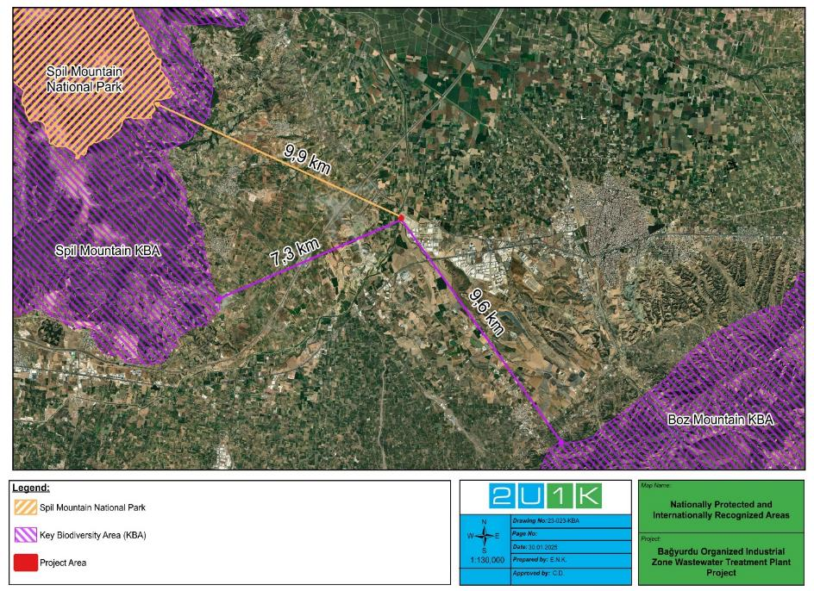
Figure 5-14. Nationally Protected and Internationally Recognized Areas

SOCIAL BASELINE OF THE PROJECT
This section includes social assessments of the Project Impact Area, the social basis for determining the current social situation, risks, impacts, and mitigation measures is presented.
The purpose of the social baseline is to provide background information to be taken into account to determine the impacts of the Project on economic activities, social structure, community health and safety, gender, vulnerable groups and ecosystem services of settlements and household of the project. Based on this social baseline scope and potential Project impacts, the Project's social Area of Impact boundaries have also been determined.
As explained in Chapter 4.6, the social area of influence has a radius of 10 km and includes Halilbeyli Neighbourhood and Turgutlu District.
As a continuation of the general evaluations regarding the socioeconomic status of Project AoI, data on demographics and population are examined in the following section.

Demography and Population

According to 2023 TurkStat data, the population of Izmir is 4,479,525, of which 2,221,180 are male and 2,258,345 are female. Izmir has 30 districts. The population of Kemalpaşa district, where Bagyurdu Town is located, is 117,956. According to 2024 TUİK data, the population of Turgutlu District is 178,386, comprising 88,867 women and 89,519 men. Livelihood and Employment
Izmir is the third largest province in Türkiye and has a strong economic structure based on various sectors such as agriculture, industry, trade and tourism. Fertile agricultural land and favourable climatic conditions have made Izmir an important centre for the production of agricultural products such as olives, grapes, figs and cotton. In addition, Petkim and Tüpraş facilities in Aliağa and the petrochemical sector are among the prominent elements of industrial activities in the province. Izmir Port plays a strategic role in the region's foreign trade, while free zones and organized industrial zones offer attractive opportunities for trade and investment. The tourism sector also plays an important role in Izmir's economy with its historical and cultural heritage and touristic attractions.
Kemalpaşa district is located in the east of Izmir and is characterized by agriculture, industry and logistics activities. The district is the leader in cherry production in Türkiye and is known for its “Kemalpaşa cherry”. Grape and vegetable production also increases the importance of the district in the agricultural sector. Kemalpaşa Organized Industrial Zone is the cornerstone of the district's economic structure and hosts various sectors such as food processing, textiles, chemistry and packaging. Strategically located on the Izmir-Ankara highway, the district also has a developed infrastructure in terms of logistics and trade. Thanks to industrial investments, the region creates employment and attracts migration.

Major Economic Activities in Settlements Located in the Project AoI
During the interview with the headman of Halilbeyli Neighbourhood, it was learned that the most important sources of income of the neighbourhood are animal husbandry and agriculture. Residents of the neighbourhood mostly cultivate cereals and undertake cattle breeding. Apart from this, cattle and sheep slaughtering are carried out through the development cooperative in the neighbourhood. During the interview, it was learned that job opportunities have increased thanks to BOIZ, and the average income of the neighbourhood residents has increased in five years.

Education and Health Services
According to the data of Izmir Provincial Directorate of National Education in 2024, there are 781,353 students and 58,682 teachers in Izmir Province. There are also a total of 2,870 schools and 30,352 classrooms in Izmir Province.
In Izmir Province, public health services are provided by 63 public, university, private and municipal hospitals affiliated to the Ministry of Health, six (6) Oral and Dental Health Centres (ADSM) including one (1) hospital, 123 Emergency Health Services Stations (EHSS), 375 Family Health Centres (FHCs), 1,393 Family Medicine Units (FHDs), 27 District Health Directorates (DHDs), 3 Community Health Centres (CHCs). A total of 38,864 health personnel, including 7,880 physicians, 681 dentists and 30,303 other health workers, work in public hospitals in the province, and services are provided with a bed capacity of 8,860.
According to the data of Kemalpaşa District Directorate of National Education in 2024, there are 17,994 students and 1,103 teachers in Kemalpaşa District. There are also a total of 71 schools and 920 classrooms in Kemalpaşa District.
Kemalpaşa District has two (2) hospitals, one (1) public and one (1) private.
Halilbeyli Neighbourhood, which is within the project impact area, has two (2) schools (13.7 km, one (1) secondary school (13.2 km) and one (1) primary school (13.7 km). There is no high school in the neighbourhood, students receive education in schools in Turgutlu District with transportation education. In addition, there is a health centre (13.3 km) in the neighbourhood.

Vulnerable Groups and Social Equity
In the interview with Halilbeyli Neighbourhood Headman to identify vulnerable groups that may be affected by the project, it was determined that there are seasonal migrant groups, mentally/physically disabled people, female heads of households and refugees in the neighbourhood. Table below shows the number of vulnerable groups.
Table 6-1. Vulnerable Groups in the Settlements
Settlement | Seasonal Migrant | Physically / Mentally Disabled Individuals | Female Heads of Households | Refugees
Halilbeyli Neighbourhood | 100 | 4 | 10 | 50
Source: Interview with the mukhtar

Infrastructure Services
During the interview with the neighbourhood head, it was stated that all infrastructure systems in Halilbeyli neighbourhood are generally adequate. However, during the interview, it was learned that the neighbourhood periodically has problems with agricultural irrigation and that the roads passing through the neighbourhood are damaged due to weather conditions during the winter months. It was also stated that the residents of the neighbourhood wanted a natural gas system to be installed in the neighbourhood.
In Table 6-2, the infrastructure services in the neighbourhood are given in detail.
Table 6-2. Infrastructure Services of Settlements
Settlement | Water Resource | Irrigation Resource | Sewerage System | Waste Management | Mass Transportation Vehicle | Source of heating
Halilbeyli Neighbourhood | Mains Water | Deep water artesian wells | Available | Waste is collected regularly by Kemalpaşa Municipality. | Minibuses are available to the district and the province | Wood and coal
Source: Mukhtar interviews

Traffic and Transportation
According to the feasibility report prepared for the project in 2022, BOIZ is 30 km from Manisa, 45 km from Izmir and 7 km from Turgutlu District. It is also located 0.5 km from the Izmir-Ankara high speed train line and the Izmir-Istanbul highway under construction. Since the wastewater treatment plant is located within the zone, no traffic or transportation problems will be expected.

Cultural Heritage
There are no known cultural heritage sites or resources within or near the Project Area. As a result, the project is not expected to cause any alteration, damage, or removal of existing cultural heritage assets, nor will it restrict community access to cultural sites. In case of any chance finding, the chance find procedure (see Appendix-J) will be applied.

ENVIRONMENTAL AND SOCIAL IMPACTS OF THE PROJECT

Environmental Risks and Impacts of the Project
Construction works of the Project are anticipated to start in October 2025, the total planned period including commissioning is one (1) year. 50 workers/employees are expected to work during the peak period of the Project construction. In the operation phase of the Project, four (4) people are expected to be employed. Currently there is not any site work ongoing on the Project area. There is one transformer building in the Project Area, which will be removed and relocated to another area of the BOIZ.
The environmental AoI of the Project is defined as 2 km perimeter of the Project, taking the Project Area as the centre, including the settlements closest to the Project Area and Nif Stream, which will be the discharge point of the Project and all BOIZ area. In other word, a distance of 2 km has been selected for the AoI of the Project as a buffer so that the entire BOIZ area, including the Nif River where the discharge line is located, remain within the project's AoI. This buffer was selected considering the potential impacts of dust, noise, traffic and wastewater discharge to the receiving environment (Nif Stream). On the other hand, the project's social AoI has been defined as a 10 km radius around the project area, to reflect the potential scope of social impacts and stakeholder interactions.
As for the structures closest to the Project area, there is a factory within the BOIZ, 45 m south-east of the Project Area. Table 4-1, Figure 4-1 and Figure 4-2 represent the summary of the Project’s environmental and social sensitive receptors, and Area of Influence (AoI) of the Project, respectively. In summary, considering the wastewater treatment that will be generated as a result of the activities of the facilities in the BOIZ, the relevant impact area has been determined to cover the entire BOIZ area.
Primarily, since the domestic and industrial wastewater generated within the BOIZ is directed to septic tanks via the wastewater line within the BOIZ area and sent to the WWTP of Kemalpaşa OIZ at certain frequencies, the BOIZ's own WWTP, i.e. the Project, should be implemented for an on-site solution to this situation. Therefore, the two most important positive impacts of the Project will be the reduction of the emission caused by the wastewater transport and the onsite treatment of the wastewater generated within the BOIZ. The designed wastewater treatment capacity of the Project is approximately 1,500 m³/day (see Table 2-3 for Project design flowrate details).
The Project will have impact on its surroundings during construction phase physically due to noise generation, increased dust emission, waste generation, management of excavated soil, and emissions from the construction machinery. In addition, limited potential risks of labour influx may pose for nearby communities.
The main physical impacts of the operation phase for to be established WWTP Units are wastewater discharge, sludge generation and disposal, and odour emissions especially from the WWTP units directly. Socially, employment opportunities will be provided for nearby communities.
Furthermore, due to the objective of effective E&S management for the Project, the preparation of all management plans has been identified as high significance before the implementation of mitigation measures (see Table 8-2).
In conclusion, corresponding impact assessments for the activities of the Project phases have also been included in mitigation measures and monitoring plan tables of the Project in Chapter 8 and Chapter 9, respectively.

Land Use
Impacts related to the soil and groundwater quality and loss of resources will take place during the excavation works needed for the construction of the Project. In general, the soil and groundwater impact during the construction of the Project is considered as minor significance and will be controlled by applying the mitigation measures related to waste management and by maximizing the reuse of the excavated soil and landscaping the stripping topsoil. The Project Area is located within the BOIZ area. There is one transformer building in the Project Area which will be removed and relocated to another area of the BOIZ. Before the land preparation works. Thus, risk significance of the land use subject of the Project is assessed as low for Project’s all phases in line with the WB ESS-1 and 5.

Geology
As the Project area will be in the same geological conditions (see Section 5.3 for baseline conditions) where the existing BOIZ operational activities are continued, the relevant risk significance is assessed as low.

Hydrogeology
The water demand of the Project to be withdrawn from the licensed well during its construction and operation phases will be caused by a limited number of people (see Appendix-I for the estimated water consumption quantities for the Project) and BOIZ will discharge its wastewater to Nif Stream according to the discharge standards of the Project. Therefore the risk of water pollution with soil contamination due to high groundwater level in the AoI of the Project, it is expected that the water demand will be relatively low for the Project, the impact on the discharge to the receiving environment for its operation phase will also be limited and therefore the significance of the hydrogeological impact for the Project will be low throughout its lifetime.

Climate and Vegetation
Considering the size and impact area of the Project, its adverse impact on climate and vegetation is expected to be limited. As the Project Area is in the same climate and vegetation conditions (see Section 5.10 for baseline conditions of the region for climate and vegetation) as compared to the existing BOIZ Area, the relevant risk significance is assessed as low throughout the lifetime of the Project.

Soil Quality
This section assesses soil quality impacts related to chemical and topsoil management expected to result from the Project. The related measures on soil quality to prevent, minimize or mitigate the relevant potential risks and consequential impacts are included in Chapter 8.

Pre-Construction Phase
Potential for chemical usage and excavation works during the land preparation phase of the Project , as well as the risk of water pollution with soil contamination due to high groundwater level in the AoI of the Project, Soil Management Plan and Chemical Spill Emergency Management Plan will be developed by the Contactor and monitored by the PMU in line with the WB ESS-1 prior to construction activities. For chemicals to be used during the Project operation activities. the existing Chemical Spill Emergency Management Plan will also be adapted to the operation phase for prior to the operation phase of the Project.
Since the afore-mentioned management plans will be prepared during the pre-construction phase of the Project, the impact significance value is assessed as high in line with the WB ESS-1 and 3.

Construction Phase
The soil quality impacts that may arise during the construction phase of the Project are as follows.
- The anticipated impact on soil includes loss of loose soil from the site, which is vulnerable to erosion. The potential for runoff will be increased during heavy rains, which can result in loss of significant amount of soil from the site.
- The maintenance of heavy machinery and equipment will involve replacement of machine oil, greasing and other such activities that may lead to soil pollution, if not handled properly. There is potential for contamination of soil due to accidental spills of lubricating oil, fuel oil, paint, thinner etc. during their handling and storage. Besides this storage of discarded containers of paint, varnish, thinner, grease, lubricating oil etc. can lead to contamination.
- The expected solid waste during construction phase will include construction waste/ debris; waste oil and chemicals from construction machinery and domestic solid waste etc. which in the absence of proper disposal can lead to contamination of soil. Runoffs from oil storage area, waste oil collection area, vehicle maintenance area can also lead to contamination of soil.
Although no evidence of soil contamination was found during the site visit, Chemical Spill Emergency Management Plan will be prepared due to the chemical to be used during the construction phase of the Project and high groundwater level (see Section 5.5) that can cause the spread of soil contamination, and the potential for heavy use of machinery and equipment during Project construction activities. Also, Soil Management Plan including the management of topsoil and soil quality specific to the construction phase of the Project and involves the planning and execution of soil testing (will be required if soil contamination occurs) and the removal of contaminated soil from a construction site will be prepared. Both related plans will be implemented by the Contractor and monitored by the PMU during the construction phase of the Project in line with the WB ESS-1.
Consequently, considering the soil quality assessment with the water pollution potential for the construction phase of the Project and also hydrogeological sensitivity of the Project Area (see Section 5.5), the soil quality impact significance in the AoI of the Project is assessed as high in line with the WB ESS-1 and 3.

Operation Phase
During operation phase of the Project, operational activities will be performed with limited physical interaction with soil environment. In the operation phase of the Project, in addition to the waste sludge, which will be disposed with trucks of licenced/authorized company after carrying out its analysis, no significant direct impacts on soil are anticipated under normal operating conditions. In general, impacts of operation phase are related with the risks arise during repair and maintenance works. These risks are spillage/leakage of wastewater, waste sludge, oil, and chemicals to soil and the permanent land use change at the Project Area.
However, considering that chemicals to be used in operational activities including sludge management of the plant, the Project's sensitivity to soil and hydrogeology (see Section 5.5), it would be good industrial practice (GIP) to adapt the Chemical Spill Emergency Management Plan to the operational phase and continue to implement them for this phase by the PMU in line with the WB ESS-1. For all these reasons, the related impact significance for the soil quality within the AoI of the Project is assessed as medium in line with the WB ESS-1 and 3.

Air Quality and Odour
This section assessed the impacts of the calculated (see Appendix-I) or predicted emissions from the Project on air quality and odour. The related measures an air quality and odour to prevent, minimize or mitigate the relevant potential risks and consequential impacts are in Chapter 8.
During all phases of the Project, the vehicles to be used within the Project Area will be regularly maintained, the exhaust emissions will be measured and recorded by authorized institutions, and the provisions of the Regulation on Control of Exhaust Gas Emission will be complied with.

Pre-Construction Phase
Dust Management Plan will be prepared by the Contractor and monitored by the PMU at the pre-construction phase of the Project and implemented throughout the construction phase of the Project. Since the dust management plan will be prepared during the pre-construction phase of the Project, the impact significance value is assessed as high in line with the WB ESS-1 and 3.

Construction Phase
The impact assessment discussed here covers the expected short-term emissions from construction activities. It is expected that particulate matter emissions anticipated to generate during the construction phase will originate from construction activities, including machinery, vehicles, equipment, and ground works used during the construction phase. In addition to the negative impact of resulting particulate matters on human health, this can give rise to potentially harmful build-up on immovable properties and vegetation.
As discussed in the air quality section of the baseline chapter (see Table 5-1 and Table 5-2 ), the air quality of the Project Area cannot be characterized as good due to high PM values especially in the winter. Therefore, it seems essential to prioritise mitigation measures, especially for the construction phase of the Project regarding dust emission.
As a result of the calculation and assessment in Appendix-I, all the calculations were made with the worst-case scenario, with the principle of operating all equipment and vehicles at the same time and considering the emission of the calculated Dust (PM₁₀) and NO₂ values over a period of 60 days, there may be an air quality modelling requirement to calculate these parameters at the sensitive receptor. Nevertheless, since the duration of the construction is limited, and the potential receptors are out of the reach of air quality distribution modelling for dust and NO_{x} emissions will not be required. In addition to this, calculated Total Organic Compounds (TOC)s, Carbon Monoxide (CO) and Sulphur Oxide (SO_{x}), which are among the other pollutant from exhaust emission, their mass flowrate values are below the limit values specified in the related local legislation.
The air quality impact significance of the Project’s construction phase is assessed as medium in line with the WB ESS-1 and 3, especially due to the air quality potential impact of the land preparation period. The Project’s air quality standards, corresponding measured baseline PM₁₀ value and calculated emission value of PM_{2.5} are given in Table 7-1.
Table 7-1. Air Quality Project Standards, and Calculated Emission Values
Parameter | Receptor | Calculated PM_{2.5} Value for the Project Area | Project Standard  (Averaging period)
PM_{2.5} | At sensitive receptor (Industrial Facilities 45 m south-east of the Project Area) | 0.19 µg/m³(**) | 25 µg/m³  (24-hour)
PM₁₀ |  | 1.9 µg/m³ | 50 µg/m³  (24-hour)
NO₂ |  | - (*) | 200 µg/m³  (1-hour)
(*) Air quality modelling is not required due to the duration of the activities and therefore could not be calculated.
(**) This PM_{2.5} value is calculated from the baseline PM₁₀ value, and its calculation is detailed in Appendix-I

Operation Phase
Under the national legislation, the Project will be exempt for air quality subject in the environmental permit and license process. As part of the scope of this process, there will be no air quality measurement requirement, which may include an assessment. Instead of using any fuel that can be a source of emissions, the Project will continue to get its energy needs from its Solar Energy System. The use of generators, which may also be a source of emissions, will therefore continue to be kept to a minimum for emergencies only.
On the other hand, air emissions from wastewater treatment operations may include hydrogen sulphide, methane, gaseous or volatile chemicals used for disinfection processes, and bioaerosols, as it is stated in the WBG EHS Guidelines for Water and Sanitation. Therefore, odour impacts will be observed during the operation phase of the Project due to hydrogen sulphide and methane emissions from the Project. In general, fine, and coarse screens, aeration tanks, settling tanks, sludge thickeners and dewatering units can be odour source depending on operation conditions. This odour emission may cause negative impacts around the treatment plant.
As it is given above, hydrogen sulphide and methane gases are the most significant odorous gas. Due to the sludge treatment performed in the Project, ammonia, sulphur compounds, fatty acids, aromatic compounds, and some hydrocarbons can also cause odour.
Establishing a buffer zone between the treatment plant and residential areas and isolating odour is the main method to prevent odour generated in the treatment plant to be dispersed to settlements.
Odour impact can be minimized with good management and good housekeeping practices at prime level. These practices are.
- To have wastewater influents not greater than treatment plant capacity.
- To increase cleaning frequency of screenings.
- To decrease temporary storage time of stabilized sludge to prevent flies and odour.
- To increase aeration time and rate in aeration if odour observed at aeration tanks.
- To add lime to destabilized sludge temporarily stored at site.
On the other hand, for odour that may arise from Project operation activities, no limit value of the odour is specified for the measurement conducted at ambient in accordance with the Regulation on the Control of Odour-Causing Emissions. As the measurement concentration is 1,000 OU/m³ or less, it is stated in the related regulation that no action will be taken regarding odour removal at the source in the plant. Nevertheless, to avoid any grievances regarding odour, it is recommended that an odour measurement is first carried out within the scope of this regulation after commissioning of the Project and then, if necessary, the following additional measures are taken.
If odour still persist after the proper implementation of prime level management practices, the second level measures will be taken. These are as follows:
- To plant trees at the Project Area boundaries and in the buffer zone around the treatment plant for the prevention of odour distribution.
- To add oxidizing material (such as hydrogen peroxide, sodium hypo chloride) that prevent generation of hydrogen sulphide. For example, addition of sodium hydroxide can dissolve hydrogen sulphur gas in water.
- Preventing excess growth of anaerobic bacteria with control of pH levels.
- Establishment of an operating grievance redress mechanism to manage odour-related grievances.
In conclusion, prior to the operating phase of the Project, Odour Management Plan will be prepared, and developed in line with the WB ESS-1 and monitored by the PMU. The significance of air quality and odour impact during the operation phase of the Project is assessed as medium in line with the WB ESS-1 and 3 considering the potential odour risk of the Project operational activities.

Noise
In this section, noise impacts resulting from the calculated sound volume levels from the Project are assessed. The related measures on noise to prevent, minimize or mitigate the predicting potential noise risks and consequential impacts are in Chapter 8.

Pre-Construction Phase
Noise Management Plan will be prepared by the Contractor and monitored by the PMU at the pre-construction phase of the Project and implemented throughout the construction phase of the Project. The noise management plan will be prepared during the pre-construction phase of the Project; the impact significance value is assessed as high in line with the WB ESS-1.

Construction Phase
The impact assessment discussed here covers the expected short-term noise from construction activities. It is expected that high sound levels anticipated to generate during the construction phase will originate from construction activities, including machinery, vehicles, equipment, and ground works used during the construction phase. In addition to the negative impact of resulting sound levels on human health, this can potentially cause harm to other living organisms.
As discussed in Appendix-I, local regulatory day time limits are slightly exceeded in the worst-case scenario where all equipment and machines are operated simultaneously, the Project will have a limited noise impact only for the construction phase.
In anticipation of limited time noise generation from construction works including ground levelling, the Project construction phase noise impact significance is assessed as medium, especially due to potential noise impact of the land preparation period. In this context, the Project’s noise standards are given in Table 7-2.
Table 7-2. Noise Project Standards
Parameter | Receptor | Unit | Calculated Noise Level Values  (dBA) | Project Standard  (One Hour LAeq (dBA))
Noise | At sensitive receptor (Industrial Facilities 45 m south-east of the Project Area) | dB(A) | 67.16 | Day time (07:00-19:00):  LAeq, 5 min.< 65 dB(A)
Evening time (19:00-23:00):
LAeq, 5 min.< 60 dB(A)
Nighttime (23:00-07:00):
LAeq, 5 min.< 55 dB(A)

Operation Phase
Under the national legislation, the Project will be exempt for noise subject in the environmental permit and license process. Scope of this process, there will be no noise measurement requirement, which may include an assessment.
As a result, the significance of the noise impact during the operation phase of the Project is assessed as low in line with the WB ESS-1 and 3 considering the noise due to isolated and built indoors equipment for WWTP operation activities.

Water Resources and Use
The water resource for the BOIZ and the Project is groundwater, which is and will be withdrawn from the licensed well. This section assesses the water resources and use impacts within the Project’s AoI. The related measures on water resources and use to be taken to prevent, minimise or mitigate the impacts that may arise are in the Chapter 8.

Pre-Construction Phase
Sustainable Water Management Plan will be prepared and monitored by the PMU before the operation phase of the Project and implemented throughout the lifetime of the Project to effectively manage all this water demand in the Project’s AoI. The purpose of this plan will be not only effectively to monitor the amount of water use in the BOIZ area, but also to control its quality for human consumption in line with the RoWIHC and to maintain the sustainability of water. In addition, as the potential for exceeding the permitted quantity of groundwater use is high, new water resources are required with new facilities to be added to BOIZ area. Also, since the water used directly affects WW generation, this plan will be kept up to date to address these issues. Since the sustainable water management plan will be prepared before the operation phase of the Project, the impact significance value is assessed as high in line with the WB ESS-1.

Construction Phase
Topsoil and excavated soil will be temporarily stored during construction phase in the Project Area. Since Nif Stream is 145 m away from the Project Area, no sedimentation risk to the stream is expected. However, when allocating the temporary storage area, an area that will not allow any sedimentation will be determined and the relevant storage will be carried out.
In addition to the calculation made with personnel and dust suppression water usage for the construction phase of the Project and the relevant assessments in Appendix-I, Due to the high potential to exceed the permitted quantity of groundwater use, decline static water level of the well of the BOIZ area and the increase in water demand from facilities of the BOIZ, it is necessary to commence implementing the related plan for the sustainable management of water at this stage. Hence, the Project’s water resources and use impact significance for the construction phase is assessed as high in line with the WB ESS-1 and 3.

Operation Phase
As in the construction phase of the Project, since the amount of excess water demand met from licensed well in the BOIZ Area in terms of cumulative impacts in the groundwater usage in the Project’s AoI, the water resource and use impact significance in the operation phase of the Project is assessed as high. In order to mitigate the relevant risks and impacts, Sustainable Water Management Plan in line with the WB ESS-1 and 3 for the Project will be primarily prepared and monitored by the PMU and implemented throughout lifetime of the Project.

Wastewater Management
This section assesses the wastewater impacts within the Project’s AoI. The related measures on wastewater to prevent, minimise or mitigate the potential risks and consequential impacts that may arise are in the Chapter 8.

Pre-Construction Phase
Effluent Management Plan will be prepared and monitored by the PMU before the operation phase of the Project and implemented throughout the lifetime of the Project to effectively manage potential discharged wastewater risks and consequential impacts within the Project’s AoI. The main purpose of this plan will be to effectively monitor the discharged wastewater quality and quantity in the BOIZ area. Since the effluent management plan will be prepared before the operation phase of the Project, the impact significance value of the pre-construction phase of the Project is assessed as medium in line with the WB ESS-1.

Construction Phase
During the construction phase of the Project, domestic WW will be generated only from human consumption. Therefore, according to the calculation in Appendix-I, 9.1 m³/day domestic water will be generated from workers. The generated WW will be directed to the existing septic tanks of BOIZ Area and sent to the Kemalpaşa OIZ WWTP with licensed/authorized trucks. According to related calculations (see Appendix-I), the quantity of wastewater to be added due to the construction of the Project will be negligible, so wastewater will continue to be sent twice a day with daily wastewater level visual inspection of septic tanks. In this direction, generated wastewater of Project’s construction phase will be sent to the WWTP of the Kemalpaşa OIZ with the accepted WW discharge standards given in Table 5-4 (see Table 3-1 also for Project Standards).
Due to the quantity of wastewater generated from the construction activities of the Project is low, the Project's impact significance in terms of wastewater management is assessed as medium in line with the WB ESS-1 and 3.

Operation Phase
When industrial wastewater management is evaluated in terms of international standards, examples of treatment approaches typically used in the treatment of industrial wastewater are summarized in Annex 1.3.1 of the WBG General EHS Guidelines. One or more treatment technologies may be used to achieve the desired discharge quality and to maintain consistent compliance with regulatory requirements. The design and operation of the selected wastewater treatment technologies should avoid uncontrolled air emissions of volatile chemicals from wastewaters. Residuals from industrial wastewater treatment operations should be disposed in compliance with local regulatory requirements, in the absence of which disposal has to be consistent with protection of public health and safety, and conservation and long-term sustainability of water and land resources. On the other hand, local legislation has set standards in this regard. In this context, Table 7-3 represents the effluent standards for the lifetime of the Project as BOIZ WTTP with the final discharge location as the Nif Stream (see Table 3-1 also for Project Standards).

Table 7-3. Effluent Project Standards
Parameter | Receptor | Unit | Project Standard  (2-Hour Composite Sample)
COD (Chemical Oxygen Demand) | At the discharge location  (Nif Stream, from the closest point to the Project Area) | mg/l | 250
SS (Suspended Solid) |  | mg/l | 200
Oil and Grease |  | mg/l | 20
Total Phosphor |  | mg/l | 2
Total Chromium |  | mg/l | 2
Chromium Cr⁺⁶ |  | mg/l | 0.5
Lead (Pb) |  | mg/l | 2
Total Cyanide (Cn⁻) |  | mg/l | 1
Cadmium (Cd) |  | mg/l | 0.1
Iron (Fe) |  | mg/l | 10
Floride (F⁻) |  | mg/l | 15
Copper (Cu) |  | mg/l | 3
Zinc (Zn) |  | mg/l | 5
Mercury (Hg) |  | mg/l | 0.05
Sulphate (SO₄⁻²) |  | mg/l | 1,500
Total Kjeldahl Nitrogen (TKN) |  | mg/l | 20
Fish Biological Experiment (TDF)  (Toxicity Dilution Factor) |  | - | 10
Colour |  | Pt-Co | 280
pH |  | - | 6-9
During the operation phase of the Project, generated domestic and industrial WW of BOIZ Area will be treated in the WWTP as Project. According to the calculation in Appendix-I, 1 m³/day of domestic water will be generated from WWTP employees. According to the Project design data, which also takes into account the WW generating facilities and other employees in the BOIZ area, WW flowrate design details of the project (see Table 2-3) will have 1,500 m³/day WW treatment capacity. Although wastewater generated from the operation activities of the Project is low, the impact significance of the Project in terms of wastewater management is assessed as high in line with WB ESS-1 and 3 due to the requirement to implement the Effluent Management Plan for the wastewater management of the entire BOIZ Area.

Waste Management
This section assesses the waste management risks and impacts of all phases of the Project. The related measures on waste to prevent, minimise or mitigate the potential risks and consequential impacts that may arise are in the Chapter 8.

Pre-Construction Phase
Waste Management Plan will be prepared by the Contractor and monitored by the PMU to make Project waste management effective at the pre-construction phase of the Project and implemented throughout the lifetime of the Project. Pollution Prevention Plan and Sludge Management Plan will be prepared and monitored by the PMU to make Project waste management effective before the operation phase of the Project and implemented throughout the lifetime of the Project. Since these management plans will be prepared by the Contactor and PMU before the construction and operation phases of the Project, the impact significance value is assessed as high in line with the WB ESS-1. The purposes of these plans for the Project are follows:
- Pollution Prevention Plan is to reduce, eliminate, or prevent pollution at its source before recycling, treatment, or disposal.
- Waste Management Plan covers the management of waste in the hierarchy of waste reduction, reuse, recycling, recovery, and disposal.
Sludge Management Plan includes the management of waste sludge from the process after its generation in the WWTP to its disposal.

Construction Phase
Waste calculations of the construction phase of the Project is in Appendix-I. Potential waste to be generated during the construction activities are domestic solid wastes, packaging waste, hazardous waste, waste batteries and accumulators, medical wastes and waste oils. If waste management is not provided efficiently, there may be a potential risk of soil contamination. In this regard, it should be ensured that all waste types will be managed in accordance with the related national regulations during the construction phase of the Project. In this context, considering the waste management in the Project Area, the significance of waste impact in the AoI of the Project is assessed as high in line with the WB ESS-1 and 3.

Operation Phase
In addition to other wastes that are expected to occur during operation, dried waste sludge, which constitutes large quantity of the total waste to be produced during the operation phase of the Project, is the most important subject in terms of waste management of the Project. The all-waste quantity calculations of the operation phase of the Project can be seen in Appendix-I.
After stabilization and dewatering, the excess dried sludge will be analysed to determine compliance with the local legislation. In line with the analyses of the waste sludge generated, BOIZ plans to transfer the dried waste sludge, which will have more than approximately 70% solid content, to the waste disposal company Süreko Waste Management Inc.
In this direction, Sludge Waste Management Plan will be prepared together with the Waste Management Plan. Sludge Management Plan includes the management of waste sludge from the process after its generation in the WWTP to its disposal. Consequently, considering the waste management in the operation phase of the Project, the waste impact significance in the AoI of the Project is assessed as high in line with the WB ESS-1 and 3.

Natural Disaster Potential
According to Section 5.11, where the natural disaster potential of the region in which the Project Area is located, the relevant risk significance is assessed as low in line with the WB ESS-1.

Biodiversity and Protected Areas
This section assesses the risks on biodiversity and impacts of all phases of the Project. The related measures on biodiversity to prevent, minimise or mitigate the potential risks and consequential impacts that may arise are in the Chapter 8.

Pre-Construction, Construction and Operation Phases
There is a vulnerable species (Testudo graeca) within the project area. Risk and impact for flora species in and around the Project Area can be listed as habitat loss and dust production due to topsoil stripping. Soil stripping activities during the pre-construction phase pose a risk to reptile and amphibian species. Vibration and sound generated by construction activities are expected to affect all fauna, especially bats, birds, and mammals, in and around the Project Area. In addition, the Project Area is surrounded by fields and industrial areas. Therefore, the species is currently under pressure. All of the species including Testudo graeca (whose population and distribution is widespread in every region except the Eastern Black Sea region in Türkiye) in the Project Area have a wide distribution and are not in danger of extinction. Therefore, they are expected to be minimally affected by the Project.
Hence, the significance of the Project’s impact during the pre-construction and construction phase on biodiversity and protected areas is assessed as medium. During the operation phase of the Project, the discharge of treated water to the environment and Nif Stream will have positive impacts on aquatic fauna.

Pesticide Use and Management
The Project Area and AoI of the Project are classified nitrate sensitive area in the national legislation (see Figure 5-6 in Section 5.5). Consequently, considering the pesticide use and management throughout lifetime of the Project, the relevant impact significance in the AoI of the Project is assessed as high.
All the Project activities should avoid the use of pesticides with the potential for surface water, groundwater and soil contamination. In case of pesticide use throughout the lifetime of the Project, to ensure compliance with WB ESS-3 and ESS-4, the following items shall be taken into consideration, which is also specified in the Chapter 8.
    - where practicable, avoiding or minimizing the use of persistent organic pollutants (POPs) in pesticides formulation.
    - Following safety guidelines for the storage, transport, and distribution of pesticides to minimize the potential for misuse, spills, and accidental human exposure.
    - Usage of pesticides containing the chemicals listed in The Rotterdam Convention on the Prior Informed Consent Procedure for Certain Hazardous Chemicals and Pesticides in International Trade, Annex III, will be avoided.

Social Impacts of the Project
It is foreseen that no accommodation facilities will need to be established during the construction activities of the Project. However, containers can be placed on the Project area for those who will work on the Project to rest, eat and for sanitary facilities. These containers will meet standards for worker accommodation prepared by International Finance Corporation (IFC) and European Bank for Reconstruction and Development (EBRD) and approved by the WB.
No negative impact is expected from the Project in terms of population level in settlements expected to be affected during the construction phase of the Project, as stated in the " Bagyurdu Organized Industrial Zone Wastewater Treatment Plant Project". The general evaluation of the project can be summarized as follows.
    - All Project activities will be carried out in the area allocated to the OIZ,
    - The scale of the impacts will be negligible and there will be no distinction between women and men, different ethnic groups, or social classes,
    - National legislation and World Bank ESSs will be implemented on fair employment, equal access, and employment opportunities for women.
- The social impacts of the project have thus been assessed as low and negligible:
    - Project activities will not cause any labour flow that will create security problems or cause demographic effects,
    - Necessary precautions will be taken in case heavy vehicles use the transportation roads near the district due to project activities.
    - No additional land will be acquired within the scope of the project.
- The potential social impacts of the project are assessed in detail under the following sub-headings.

Population/Demography
While WWTP construction works are planned to start in October 2025, the total planned period including commissioning is two (2) years. 50 workers are stipulated to work during the peak period of Sub-Project construction. In the operation phase of the Sub-Project, four (4) people are expected to be employed. The potential impact of the project on population and demography will be low. However, the necessary mitigations, especially regarding ESS 2, ESS 4 and ESS 10, as mentioned under section 8, will be taken and monitored.

Construction Phase
The project is expected to generate local employment opportunities during the construction phase, contributing positively to the local economy.

Operation Phase
Although hiring will decrease during the operation, the project is expected to have a positive economic impact on the local community as it plans to hire locally.

Cultural Heritage
No impact is expected on any tangible or intangible cultural heritage during the construction or operation of the project. However, the Chance Find Procedure to be applied during construction works is given in Appendix-J.

Economy/ Employment
The project will not have a negative impact on the local economy and employment. In addition, the Project will aim to employ workers particularly from settlements within the Area of Impact, prioritizing local employment when business and employment opportunities arise, and it will be ensured that that women will have equal employment opportunities in the Project.

Construction Phase
Although the contractor will be responsible for hiring workers during the construction period, the neighbourhood head will be notified prior to hiring in order to inform neighbourhoodresidents of job opportunities. Priority in hiring for construction work should be given to those with the necessary technical qualifications. When hiring locally, attention will be paid to this matter, and unqualified workers will not be hired. The OIZ, as the project owner, is responsible for ensuring minimum legal labour standards (prohibition of child/forced labour, non-discrimination, working hours, minimum wage) national labour legislation, ILO conventions and the Labour Management Procedures of TOIZsP. Contractors will be required to prepare Labour Management Plan in accordance with the LMP of the OIZ. Precautions and mitigation measures that will regulate the necessary working conditions for these potential risk areas are included in the section "8.2 Mitigation Plan for the Construction Phase of the Project".

Operation Phase
When employment opportunities arise during the operation process, timely information will be provided to Halilbeyli neighbourhood close to the Project area.

Vulnerable/ Disadvantaged Groups
Based on consultations with the Halilbeyli Neighbourhood Headman, vulnerable groups within the Project’s Area of Influence (AoI) include seasonal migrants, persons with physical or mental disabilities, female heads of households, and refugees. The potential impacts of the Project on these groups have been assessed as follows:
1. Seasonal Migrants (approx. 100 individuals)
Potential Impacts: Seasonal migrants, often employed in low-wage, temporary jobs, may face reduced access to water, sanitation, and electricity during the construction phase due to temporary service disruptions. They are also more likely to experience unstable employment and may not benefit equally from project-related job opportunities.
Social Implications: Disruption in basic services or exclusion from employment opportunities could increase their economic vulnerability and strain relations with permanent residents.
2. Physically/Mentally Disabled Individuals (4 persons)
Potential Impacts: Disabled individuals are at greater risk of accidents or injuries due to unmarked construction zones, noise, dust, and limited mobility support. Lack of accessible infrastructure and safety measures during construction could further marginalize them.
Social Implications: Inadequate adaptation of safety practices may lead to social exclusion and reinforce barriers in accessing communal areas and services.
3. Female Heads of Households (10 individuals)
Potential Impacts: Female-headed households often have fewer resources and limited social support. Construction-related disruptions (e.g., increased traffic, reduced access to communal services) may disproportionately affect them by increasing daily caregiving and household management burdens. Additionally, women may have less access to project-related employment opportunities.
Social Implications: Heightened economic vulnerability and limited participation in consultations could deepen gender inequalities within the community.
4. Refugees (50 individuals)
During the meeting with the head of Halilbeyli Neighborhood, it was stated that Syrian refugee families live in the neighborhood.
Potential Impacts: Refugees are particularly vulnerable to social marginalization and discrimination. They may face barriers in accessing project-related benefits (such as employment) due to lack of legal documentation or social acceptance. Increased competition for local resources during construction could exacerbate tensions between refugees and host communities.
Social Implications: If not managed through inclusive engagement, refugees could become further marginalized, leading to community-level tensions and reduced social cohesion.

Land Requirement
The facility will be constructed on Parcel No. 110/1 in Halilbeyli Neighbourhood.. The land was fully expropriated in 2007 from a single owner and is entirely owned by BOIZ. It is designated for wastewater treatment use in the BOIZ spatial plan. No resettlement or additional land acquisition is required.

Working Conditions and Labour Management
BOIZ has a Human Resources Policy. OIZ declares in the HR policy that the OIZ acts will carry out in accordance with the laws and regulations, legislation and instructions regarding Occupational Health and Safety, and in accordance with national legislation in the business opening processes.
However, the HR policy does not include the issues of non-discrimination, prevention of child labour and forced labour, GBV, and ethical rules, and will be expanded and revised by including these issues.
This revision requirement will be realized as regulations that will ensure the conditions of WB ESS 1: Assessment and Management of Environmental and Social Risks and Impacts, ESS 2: Labour and Working Conditions, ESS 4 Community Health, Safety and Security, Turkish Legislation and TOIZsP’s Labour Management Procedure.
With these regulations, BOIZ will develop a policy document that will provide at least the following conditions on Working Conditions and Labour Management.
- Informing and raising awareness of employees by using training tools and communication channels,
- To create and maintain a safe and healthy working environment to prevent work-related injuries and health deterioration in occupational health and safety management processes,
- Ensuring that occupational health and safety management processes include and implement measures appropriate to Project risks,
- Creating sustainable management programs to determine occupational health and safety targets,
- Monitoring and managing all service and activity processes,
- To eliminate hazards and reduce occupational health and safety risks for a safe and healthy working environment,
- Covid -19 etc. To take all necessary precautions within the framework of legal conditions and legislation to prevent the spread of the disease during epidemic disease processes and to inform employees, visitors, and other relevant parties about these measures,
- To ensure continuous improvement in occupational health and safety management system applications,
- To ensure the participation and consultancy support of our employees and employee representatives in our occupational health and safety management processes.
- Developing processes that are sensitive to local employment, women's employment and equality of opportunity, and carrying out appropriate complaint mechanisms and stakeholder participation processes.
- Moreover, Project Owner shall take the following measures:
- Not use or employ children during the construction and operation phases under 18 years of age,
- Not use or employ forced labour and ensure a Human Resources Policy in compliance with the European Convention on Human Rights and the Turkish Constitution,
- Elimination of discrimination based on language, race, sex, political opinion, philosophical belief, and religion in labour relations,
- Ensuring workers' access to the right to collective bargaining (Law No. 6356 on Trade Unions and 4857 Labour Law on Collective Bargaining),
- Ensure access to an effectively functioning Workers’ grievance mechanism.
- Ensure workers are provided with written contracts containing i.e. job description, working hours, information about their rights and duties, code of conduct and information of workers’ GM.
- In order to reduce the possible impacts on the neighbourhoods, facilities such as food, sanitary facilities and resting areas will be provided within the Project Area in accordance with the use of the employees.
- Review and approve Contractor's LMP based on the TOIZsP's Labour Management Procedures.
Contractor's Responsibilities:
- Child and Forced Labour:
- Not use or employ children under 18 years of age during the construction phase.
- Not use or employ forced labour and ensure a Human Resources Policy in compliance with the European Convention on Human Rights and the Turkish Constitution.
- Collective Bargaining:
- Ensure workers' access to the right to collective bargaining, as stipulated by Law No. 6356 on Trade Unions and 4857 Labour Law on Collective Bargaining.
- Employment Contracts:
- Provide all workers with written contracts that include job descriptions, working hours, information about their rights and duties, code of conduct, and information on the workers' grievance mechanism.
- Labour Management Plan (LMP):
- Prepare and implement a comprehensive LMP in line with the Labour Management Procedures of the OIZ project, addressing all aspects of labour management, including but not limited to the prevention of child and forced labour, non-discrimination, and the provision of adequate working conditions, issuing written contracts to workers and providing access to a Workers’ Grievance Mechanism.

Construction Phase
As stated under the 7.2.1 Population/Demography section, number of workers to be employed will be low. It is planned that 50 workers will be work at the peak time of the construction. Therefore, employment process will not cause any adverse impact due to the influx of workers.
During the construction process, OIZ will monitor work and working conditions to prevent the conditions of workers employed by subcontractors from being poor and falling below the international standards of the Project and will include the subcontractors' commitments in this regard in the contracts.

Operation Phase
As stated under the 7.2.1 Population/Demography section, number of workers to be employed will be low. It is expected that 4 workers will be recruited. Therefore, employment process will not cause any adverse impact due to the influx of workers.
During the operation process, Working Conditions and Labour Management impacts will be negligible. However, OIZ will develop HR policy and ensure that the Working Conditions and Labour Management regulations it implements and undertakes are implemented for all employees.

Training
OHS training required by WB ESS conditions will be provided for the personnel who will work on the Project. Within the scope of these trainings, CoC, Gender-Based Violence (GBV), Sexual Exploitation, Abuse and Sexual Harassment (SEA/SH), Workers’ grievance mechanism, public health and safety trainings will be planned, included in the training plan, and provided by the experts in the related issues. On the other hand, training on E&S documents including ESMP and LMP is the responsibility of the Environmental and Social Consultants.
All training records will be kept on file. These records will include a description of the training, the number of hours of training provided, training attendance records, and results of evaluations.

Community Health and Safety

Construction Phase
As highlighted under WB ESF ESS4, project activities, equipment, and infrastructure can increase community exposure to risks and impacts. This standard (ESS4) addresses the health, safety, and security risks and impacts on project-affected communities and the corresponding responsibility of Borrowers to avoid or minimize such risks and impacts, with particular attention to vulnerable people.
During the construction phase, it is expected that limited and temporary impacts will occur in the Project AoI.
Dust and exhaust gases from construction vehicles will remain at a negligible level with the implementation of manageable and mitigating measures.
Low level noise and vibration effects are likely to occur due to construction activities in the Project footprint. None of these impacts resulting from construction activities will spread to residential areas or agricultural activity areas around OIZ. These impacts, which have been described in detail within the scope of environmental impacts (Chapter 7), will occur in the Project footprint and as a temporary impact within the OIZ where the Project Area is located.
During construction, there will be no worker accommodation at the construction site, and
no public health risks of communicable diseases or transmission (e.g. HIV/AIDS, etc.) are anticipated for project workers or communities.
During the pre-construction period, PMU will be trained on stakeholder engagement issues including GBV, SEA/SH and GM. PMU is also responsible for providing trainings to contractor workers in these areas. Awareness raising activities will be organised for workers and security personnel to prevent cultural issues arising from the rude behaviour of workers and/or security personnel towards local communities in relation to gender-based violence (GBV) and sexual exploitation and abuse / sexual harassment.
There have been no reports of spills or environmental pollution since the establishment of BOIZ. The site includes a documented Emergency Plan in accordance with the Regulation on Emergencies in Workplaces. The WWTP construction does not pose risks of communicable diseases or significant safety issues for the community.
The OIZ has its own security personnel and provides security within the ESS4 framework. No new security personnel will be hired for the project. However, the “Community Health, Safety, and Security Management Plan” and the “Transportation and Traffic Management Plan,” which will be prepared in accordance with ESS4, will be developed and implemented by the PMU for the operational phase of the project.
Therefore, Project impacts on Community Health and Safety (CHS) will be negligible.

Operation Phase
No negative impact on CHS is expected during the operation process.

Occupational Health and Safety

Pre-Construction Phase
Occupational Health and Safety Management Plan and Emergency Preparedness and Response Plan (EPRP) will be developed by the Contractor at the pre-construction phase of the Project and implemented throughout the lifetime of the Project to effectively manage all potential OHS issues. These plans will be kept up to date to address these issues.

Construction Phase
The construction phase of the Project requires the use of equipment. Working on construction project brings with it physically demanding conditions for workers. There are main subjects such as working at height, working with chemicals, fire and explosion, noise, and vibration according to WB ESS 2. According to the Environmental, Health, and Safety (EHS) Guidelines, below issues will be applicable to the Project.
- General Facility Design and Operation,
- Communication and Training,
- Physical Hazards,
- Chemical Hazards,
- Personal Protective Equipment (PPE),
- Monitoring.
During the construction works, the contractor will prepare an Emergency Preparedness and Response Plan and Occupational Health and Safety Management Plan in accordance with Turkish legislation specified in Appendix-G and ILO standards, as well as WBG EHS Guidelines.
Measurements, evaluations and measures specified in these laws will be taken, reported and monitored regularly.
In determining the framework for occupational health and safety of the project, the World Bank Environmental and Social Framework (WB ESF) and its applicable Environmental and Social Standards (ESSs), particularly ESS2: Labor and Working Conditions and ESS4: Community Health and Safety, were taken into account.
The control hierarchy given in Figure 7-1 is taken into account when applying control measures for the hazards that may arise as a result of project activities and the risks associated with them. Accordingly, preventing hazards at their source is a priority, and the use of personal protective equipment (PPE) is a control measure that should be applied last.

Figure 7-1. Hierarchy of the Controls
In addition to preparing its own OHS management plan, the Contractor will also ask their environmental and social experts to prepare an OHS management plan in line with the OHS requirements of the Project. These conditions will be added to the tender documents to be prepared for construction tenders. The OHS Plan for the construction phase will include, but is not limited to, the following measures, including sub-sections in this section to prevent accidents and risks:
- All Project personnel will comply with environmental, health and safety policies and guidelines.
- Before the start of the works, an OHS Management Plan will be prepared.
- These plans should include but not limited to followings:
  - Personal hygiene (especially before and after mask usage),
  - Mask usage, how to use it and its standards (TS EN 14683, TS EN 149, or TSE K 599 etc.),
  - Social distancing rule,
  - Placing visual/written banners and posters in visible places to encourage and inform employees, visitors and related persons about respiratory hygiene and cough etiquette regarding potential measures to minimize contamination,
  - Paying special attention to the implementation of cleaning and disinfection measures in common areas (toilets, halls, corridors, elevators, etc.),
  - Disposal of relevant wastes in line with the "COVID-19 Measures in the Management of Personal Hygiene Material Wastes such as Disposable Masks, Gloves",
  - Updating the occupational health and safety training of employees and addressing additional topics in order to ensure a healthy and safe working life and due to the emergence of new risks arising from changing conditions about COVID-19 and/or other pandemic/communicable disease.
- In order to minimize the risks and dangers that may arise in terms of human health and safety (e.g. natural disasters, accidents, equipment failures, etc.), safe working environments will be created at work sites, and physical hazards and risks will be prevented.
- Within the scope of OHS measures and practices, the relevant plans, and procedures of the concerned Turkish legislation and the Project will be complied with.
- Employees will be informed about the hazards that may arise from their work, thus creating a safer working environment.
- Employees will be trained in accordance with the Regulation on the Procedures and Principles of Occupational Health and Safety Training. In this context, a training program will be prepared, training records will be kept, and evaluation activities will be carried out after the trainings.
- All employees will be provided with personal protective equipment (PPE) and necessary training will be provided for their use.
- Work areas will be equipped with warning signs (e.g. "Danger", "Entry Forbidden" etc.) in accordance with the nature and potential risks of the work to be done in that area.
- Project personnel will include first aid trained personnel. In emergencies that require intervention, the personnel will be referred to the nearest health centre by appropriate vehicles. The Contractor will implement the adequacy of the technical requirements of the machinery, equipment, and tools to be used in the activities.
- Moving parts of machinery and equipment shall be equipped with suitable protective systems (e.g. metal shields, etc.) that minimize the risk of injury or damage to the person using the machine or equipment. The machinery used during construction must be regularly inspected.
- Personal factors that can create and control risks during activities (e.g., long hair, use of jewellery and accessories, clothing, etc.) will be removed from the site with the regulations brought by the field management. Project personnel will be informed about the concerned legislation within the scope of the training program.
- Drivers and operators will be trained to comply with traffic rules and to control the vehicles and equipment they use against the risks and dangers arising from vehicle traffic. Required traffic signs will be placed at the Project Area and its surroundings. Machine operators and other workers will be informed and warned about the related signs. Waste that will be generated within the scope of the construction phase of the Project will be managed within the scope of the Regulation on Waste Management and its negative effects on public health will be minimized.
- The areas to be excavated will not be accessible except by authorized personnel. Loading and unloading activities are carried out together with the persons who will supervise the personnel who will carry out the activity.
- Persons and/or organizations with the necessary permits will be assigned to ensure the security of the Project Area. These persons and/or organizations will regularly monitor the facility and its surroundings. The private security practices within the scope of the Project and the authorities of the authorities will comply with the provisions of the Regulation on the Implementation of the Private Security Services Law. The BOIZ will make reasonable inquiries to verify that the direct or contracted workers retained by the BOIZ to provide security are not implicated in past abuses; train them adequately (or determine that they are properly trained) in the use of force and appropriate conduct toward workers and affected communities; and require them to act within the applicable law and any requirements.
- In addition to the security monitoring of the Project Area, a closed-circuit camera system to be installed at appropriate distances (e.g., 30-40 m) at the site boundary will be provided to provide security monitoring, day, and night monitoring at the entire field.
- Since the works will be carried out in areas close to the public, public access to these areas will be restricted in any way. If it is necessary to dig a ditch for the night, the area will be adequately illuminated by the BOIZ, the required signs will be placed, and the area will be surrounded by barriers.
- An adequate OHS organizational structure will be established as defined in local legislation and the required number of OHS officers should be assigned to be on site during working hours.
- Before starting work, a risk assessment will be prepared, implemented, and personnel will be trained on possible risks by OHS Personnel.
- OHS Personnel will inspect the site on a daily basis and if any additional risks are observed, relevant plans and trainings will be renewed.
- The BOIZ will ensure that contractors have ethical codes / Code of Conduct (CoC)s and this CoCs will be signed by employees together with their written contracts at the beginning of the work. Employees should be trained/informed about the rules applicable in the field, especially for interacting with the local community.
- Wastes will not be disposed of at the construction site or disposed of in a way that is harmful to health.
- Sub-Contractors must implement the safety guidelines, such as:
  - All sub-contractors must ensure compliance with health and safety documents and equipment.
  - Prior to commencement of work, subcontractors' employees will be given informative training on the facility's health and safety rules.
The contractor is responsible for the project's OHS management practices or OHS rules in accordance with the OHS rules in the legislation.

Working at Height
Fall prevention and protection measures should be implemented whenever a worker is exposed to the hazard of falling more than 1.2 meters; into operating machinery; into water or other liquid; into hazardous substances; or through an opening in a work surface. Fall prevention / protection measures may also be warranted on a case-specific basis when there are risks of falling from lesser heights. According to the WBG Guidelines, fall prevention that may include are listed below.
- Installation of guardrails with mid-rails and toe boards at the edge of any fall hazard area,
- Proper use of ladders and scaffolds by trained employees,
- Use of fall prevention devices, including safety belt and, lanyard travel limiting devices to prevent access to fall hazard area, or fall protection devices such as full body harnesses used in conjunction with shock absorbing lanyards or self- retracting inertial fall arrest devices attached to fixed anchor point or horizontal lifelines,
- Appropriate training in use, serviceability, and integrity of the necessary PPE,
- Inclusion of rescue and/or recovery plans, and equipment to respond to workers after an arrested fall.
Also, all employees who work at height need relevant training in working on different pieces of personal protective equipment, and such work must be planned appropriately. Safety approaches and precautions should be adopted, such as:
  - Where practical, avoid the need to work at height.
  - Put collective measures in place where working at height can’t be avoided to prevent falls. Such as the use of equipment to provide an extra level of safety to reduce the risk of a fall—for example, a scaffold with a double guard-rail or edge protection. Minimize the consequences of a fall by providing a safety net.
  - Never stand behind large operating plant machinery and never stand under suspended loads.
  - Avoid working close to moving objects and be careful of their surroundings, especially if they do not have lights or beepers.
  - Always ensure you have a banksman to guide plant vehicles.

Working with Chemicals
The following precautions regarding chemicals should be taken during the construction phase of the Project.
- Where a worker may be exposed to any chemical, physical or biological hazard that could adversely affect his or her health, appropriate preventive measures will be taken, including:
  - Replacing dangerous goods with harmless or less dangerous goods, if possible,
  - Taking technical measures to the plant, machinery, equipment, or process,
  - Taking other effective measures, including the use of PPE and protective clothing, when it is not possible to comply with the above measures,
Adequate precautions shall be taken to protect against danger when workers must enter any area where a toxic or harmful substance may be present or where there may be a lack of oxygen or a flammable atmosphere.

Rotating and Moving Equipment
Injury or death can occur from being trapped, entangled, or struck by machinery parts due to unexpected starting of equipment or unobvious movement during operations. The protective measures recommended in the WBG Guidelines are listed below.
- Designing machines to eliminate trap hazards and ensuring that extremities are kept out of harm’s way under normal operating conditions. Examples of proper design considerations include two-hand operated machines to prevent amputations, or the availability of emergency stops dedicated to the machine and placed in strategic locations. Where a machine or equipment has an exposed moving part or exposed pinch point that may endanger the safety of any worker, the machine or equipment should be equipped with, and protected by, a guard or other device that prevents access to the moving part or pinch point. Guards should be designed and installed in conformance with appropriate machine safety standards,
- Turning off, disconnecting, isolating, and de-energizing (Locked Out and Tagged Out) machinery with exposed or guarded moving parts, or in which energy can be stored (e.g. compressed air, electrical components) during servicing or maintenance, in conformance with a standard such as CSA Z460 Lockout or equivalent ISO or ANSI standard,
- Designing and installing equipment, where feasible, to enable routine service, such as lubrication, without removal of the guarding devices or mechanisms.

Electrical
Exposed or faulty electrical devices, such as circuit breakers, panels, cables, cords and hand tools, can pose a serious risk to workers. Overhead wires can be struck by metal devices, such as poles or ladders, and by vehicles with metal booms. Vehicles or grounded metal objects brought into close proximity with overhead wires can result in arcing between the wires and the object, without actual contact. The recommended actions in the WBG Guidelines are listed below.
- Marking all energized electrical devices and lines with warning signs,
- Locking out (de-charging and leaving open with a controlled locking device) and tagging out (warning sign placed on the lock) devices during service or maintenance,
- Checking all electrical cords, cables, and hand power tools for frayed or exposed cords and following manufacturer recommendations for maximum permitted operating voltage f the portable hand tools,
- Double insulating / grounding all electrical equipment used in environments that are, or may become, wet; using equipment with ground fault interrupter (GFI) protected circuits,
- Protecting power cords and extension cords against damage from traffic by shielding or suspending above traffic areas,
- Appropriate labelling of service rooms housing high voltage equipment (electrical hazard’) and where entry is controlled or prohibited,
- Establishing “No Approach” zones around or under high voltage power lines in conformance with WBG EHS Guidelines.
- Rubber tired construction or other vehicles that come into direct contact with, or arcing between, high voltage wires may need to be taken out of service for periods of 48 hours and have the tires replaced to prevent catastrophic tire and wheel assembly failure, potentially causing serious injury or death,
- Conducting detailed identification and marking of all buried electrical wiring prior to any excavation work.

Eye Hazards
Solid particles from a wide variety of industrial operations, and / or a liquid chemical spray may strike a worker in the eye causing an eye injury or permanent blindness. The recommended measures in the WBG Guidelines are listed below.
- Use of machine guards or splash shields and/or face and eye protection devices, such as safety glasses with side shields, goggles, and/or a full-face shield. Specific Safe Operating Procedures (SOPs) may be required for the use of sanding and grinding tools and/or when working around liquid chemicals. Frequent checks of these types of equipment prior to use to ensure mechanical integrity is also good practice. Machine and equipment guarding should conform to standards published by organizations such as CSA, ANSI and ISO.
- Moving areas where the discharge of solid fragments, liquid, or gaseous emissions can reasonably be predicted (e.g. discharge of sparks from a metal cutting station, pressure relief valve discharge) away from places expected to be occupied or transited by workers or visitors. Where machine or work fragments could present a hazard to transient workers or passers-by, extra area guarding or proximity restricting systems should be implemented, or PPE required for transients and visitors.
- Provisions should be made for persons who have to wear prescription glasses either through the use over glasses or prescription hardened glasses.

Industrial Vehicle Driving and Site Traffic
Poorly trained or inexperienced industrial vehicle drivers have increased risk of accidents with other vehicles, pedestrians, and equipment. Industrial vehicles and delivery vehicles, as well as private vehicles on-site, also represent potential collision scenarios. Industrial vehicle driving and site traffic safety practices specified in the WBG Guidelines are listed below.
- Training and licensing industrial vehicle operators in the safe operation of specialized vehicles such as forklifts, including safe loading/unloading, load limits,
- Ensuring drivers undergo medical surveillance,
- Ensuring moving equipment with restricted rear visibility is outfitted with audible back-up alarms,
- Establishing rights-of-way, site speed limits, vehicle inspection requirements, operating rules and procedures (e.g. prohibiting operation of forklifts with forks in down position), and control of traffic patterns or direction,
- Restricting the circulation of delivery and private vehicles to defined routes and areas, giving preference to ‘one-way’ circulation, where appropriate.

Ergonomics, Repetitive Motion, Manual Handling
Injuries due to ergonomic factors, such as repetitive motion, over-exertion, and manual handling, take prolonged and repeated exposures to develop, and typically require periods of weeks to months for recovery. These OHS problems should be minimized or eliminated to maintain a productive workplace. According to the WBG Guidelines, controls that may include are listed below.
- Facility and workstation design with 5th to 95th percentile operational and maintenance workers in mind,
- Use of mechanical assists to eliminate or reduce exertions required to lift materials, hold tools, and work objects, and requiring multi-person lifts if weights exceed thresholds,
- Selecting and designing tools that reduce force requirements and holding times, and improve postures,
- Providing user adjustable workstations,
- Incorporating rest and stretch breaks into work processes, and conducting job rotation,
- Implementing quality control and maintenance programs that reduce unnecessary forces and exertions,
- Taking into consideration additional special conditions such as left-handed persons.

Illumination
Work area light intensity should be adequate for the general purpose of the location and type of activity and should be supplemented with dedicated workstation illumination, as needed. The minimum limits for illumination intensity for a range of locations/activities appear in Table 2.3.3 of the IFC EHS General Guidelines. According to the WBG Guidelines, controls that should include are listed below.
- Use of energy efficient light sources with minimum heat emission,
- Undertaking measures to eliminate glare / reflections and flickering of lights,
- Taking precautions to minimize and control optical radiation including direct sunlight. Exposure to high intensity UV and IR radiation and high intensity visible light should also be controlled,
Controlling laser hazards in accordance with equipment specifications, certifications, and recognized safety standards. The lowest feasible class Laser should be applied to minimize risks.

Fire and Explosion
During the construction phase of the Project, there is a risk of storing chemicals with explosion risk, such as fossil fuels. Fires and or explosions resulting from ignition of flammable materials or gases can lead to loss of property as well as possible injury or fatalities to project workers. According to WBG Guidelines, prevention control strategies that include are listed below.
- Storing flammables away from ignition sources and oxidizing materials. Further, flammables storage area should be:
  - Remote from entry and exit points into buildings,
  - Away from facility ventilation intakes or vents,
  - Have natural or passive floor and ceiling level ventilation and explosion venting,
  - Use spark-proof fixtures,
  - Be equipped with fire extinguishing devices and self-closing doors, and constructed of materials made to withstand flame impingement for a moderate period of time,
- Providing bonding and grounding of, and between, containers and additional mechanical floor level ventilation if materials are being, or could be, dispensed in the storage area,
- Where the flammable material is mainly comprised of dust, providing electrical grounding, spark detection, and, if needed, quenching systems,
- Defining and labelling fire hazards areas to warn of special rules (e.g. prohibition in use of smoking materials, cellular phones, or other potential spark generating equipment),
- Providing specific worker training in handling of flammable materials, and in fire prevention or suppression.
Besides, all necessary precautions will be taken in the Project Area to prevent possible fires caused by construction activities. Uncontrolled fires inside and outside the field will be prevented. Measures to be taken to prevent fires are as follows:
- Smoking is prohibited in areas where there is a fire hazard. All employees should be familiar with what to do in the event of a fire.
- Fire extinguishers shall be prominently and evenly located outdoors, near passageways and in or near fire cabinets in easily accessible locations. Extinguishers should not be located behind doors, in closed cupboards other than fire cupboards, in deep recesses in walls or on or near heating appliances.
- In cases where the safety of the work equipment depends on the installation and assembly conditions, the equipment must be periodically inspected by people authorised to carry out periodic inspections after installation and before first use, after major maintenance and repair work and whenever the location changes.
- Occupational Health and safety instructions and work permit procedures should be prepared.

Noise
Occupational Health and Safety section of the WBG Guidelines recommends the following measures regarding noise in work areas.
- No employee should be exposed to a noise level greater than 85 dB(A) for a duration of more than 8 hours per day without hearing protection. In addition, no unprotected ear should be exposed to a peak sound pressure level (instantaneous) of more than 140 dB(C).
- The use of hearing protection should be enforced actively when the equivalent sound level over 8 hours reaches 85 dB(A), the peak sound levels reach 140 dB(C), or the average maximum sound level reaches 110dB(A). Hearing protective devices provided should be capable of reducing sound levels at the ear to at least 85 dB(A).
- Although hearing protection is preferred for any period of noise exposure in excess of 85 dB(A), an equivalent level of protection can be obtained, but less easily managed, by limiting the duration of noise exposure. For every 3 dB(A) increase in sound levels, the ‘allowed’ exposure period or duration should be reduced by 50 percent. Prior to the issuance of hearing protective devices as the final control mechanism, use of acoustic insulating materials, isolation of the noise source, and other engineering controls should be investigated and implemented, where feasible,
- Periodic medical hearing checks should be performed on workers exposed to high noise levels.
Also, the following measures on noise issue will also be taken into account.
- Select equipment that has low noise emission levels,
- Equipment and vehicles used externally will be regularly maintained.

Vibration
Exposure to hand-arm vibration from equipment such as hand and power tools, or whole-body vibrations from surfaces on which the worker stands or sits, should be controlled through choice of equipment, installation of vibration dampening pads or devices, and limiting the duration of exposure. Limits for vibration and action values, (i.e. the level of exposure at which remediation should be initiated) are provided by the ACGIH. Exposure levels should be checked on the basis of daily exposure time and data provided by equipment manufacturers.
The BOIZ will maintain construction site roads in good condition to reduce noise and vibration from vehicle movements.
As a result, OHS impact significance in the AoI of the Project is assessed as medium throughout the construction phase.

Operation Phase
The operation phase of the Project requires the use of equipment. Working on the project operation phase brings with it physically and chemically demanding conditions for workers. There are main subjects such as physical hazards including working at height, electrical, eye hazards, industrial vehicle driving and site traffic, ergonomics, repetitive motion, manual handling, fire and explosion and noise.
Mitigation measures to be taken during the operation phase are listed below, including subsections in this section:
- The Project Area will be fenced, access to local people and wildlife will be controlled, and encroachment will be prevented. The entrance of employees and third parties to the facility will be made in a controlled manner.
- PPE will be provided to the workers according to the nature of the work to be done. Necessary training will be provided for their use.
- All equipment will be operated in proper working condition.
- In maintenance and repair activities, the procedures approved by the BOIZ and the conditions in the technical specifications of the supplier companies will be followed.
- Required health and safety signs and traffic signs will be placed around the facility. Employees will be informed and warned about subject markings.
- Trainings will be given to employees including operating and maintenance personnel in line with Regulation on the Procedures and Principles of Occupational Health and Safety Trainings by OHS Personnel, and measurement and evaluation activities will be carried out after the training by OHS Personnel.
- Entries of operation and maintenance employees and third parties will be made in a controlled manner.
- Equipment meeting international standards in terms of electrical performance and safety will be used.
- After the construction works of the facility is finalized, necessary electrical tests will be performed to check that the electrical connections and other related equipment are made correctly before the facility is commissioned.
- Automatic cleaning screens should be used instead of manual cleaning screens to prevent cleaners from entering the ducts.
- Vehicles and other equipment used for collection industrial non-hazardous wastes as waste sludge should not be used for collection of municipal solid waste without prior cleaning to remove waste residues. Vehicles and other equipment used for collection industrial non-hazardous wastes should not be used for distribution of goods (e.g., mulch).
- Appropriate ventilation systems should be installed in places where methane accumulation is expected.
- Railings will be placed around all tanks and pits.
- The BOIZ will prepare a Confined Spaces Entry Procedure in line with the WBG EHS Guidelines and applicable national requirements.
- Wear the necessary PPE such as a safety harness.
- Sites should always be planned to manage plant and pedestrian interface where physical barriers and suitable segregation is in place.
To reduce risks, workers should:
- Never stand behind large operating plant machinery and never stand under suspended loads.
- Avoid working close to moving object and be careful of their surroundings, especially if they do not have lights or beepers.
- Always ensure you have a banksman to guide plant vehicles when reversing or maneuvering on a public road.
- Always wear PPE such as a hard hat and high visibility jacket to ensure he/she is seen.
- Managers and Site supervisor on construction sites must effectively manage the site so that workers can move around it safely. Risks should always be reported and sorted to reduce the chances of injury. To reduce harm due to Slips, Trips and Falls:
- Keep work and storage areas tidy and designate specific areas for waste collection.
- Where surfaces are slippery with mud, they should be treated with stone.
- Where surfaces are slippery with ice, they should be treated with grit.
- All slippery areas should be signposted, and footwear with a good grip should be worn.
- Both trainings and incidents (fatalities, lost time incidents, outbreak of pandemic or communicable diseases, social unrest, etc.) will be recorded.
- BOIZ will advise people with asthma, diabetes, or immunosuppression not to work in treatment plants and auxiliary facilities due to the higher risk of infection.
- An adequate OHS organizational structure will be defined in accordance with local legislation and the required number of OHS officers should be assigned to be on site during working hours.
- A risk assessment will be prepared, and employees will be trained on risks before the operational activities of the Project begins.
- OHS Personnel will inspect the site on a daily basis and if any additional risks are observed, related plans and trainings will be renewed.
- Before the operational activities of the Project, an OHS Management Plan will be prepared, which will also include measures for COVID-19 and/or other pandemic/communicable disease risks.
- The BOIZ will ensure that all activities comply with national standards and WBG EHS Guidelines.

Working at Height
Fall prevention and protection measures should be implemented whenever a worker is exposed to the hazard of falling more than 1.2 meters; into operating machinery; into water or other liquid; into hazardous substances; or through an opening in a work surface. Fall prevention / protection measures may also be warranted on a case-specific basis when there are risks of falling from lesser heights. According to the WBG Guidelines, fall prevention that may include are listed below.
- Installation of guardrails with mid-rails and toe boards at the edge of any fall hazard area,
- Proper use of ladders and scaffolds by trained employees,
- Use of fall prevention devices, including safety belt and, lanyard travel limiting devices to prevent access to fall hazard area, or fall protection devices such as full body harnesses used in conjunction with shock absorbing lanyards or self- retracting inertial fall arrest devices attached to fixed anchor point or horizontal lifelines,
- Appropriate training in use, serviceability, and integrity of the necessary PPE,
- Inclusion of rescue and/or recovery plans, and equipment to respond to workers after an arrested fall.
Also, all employees who work at height need relevant training in working on different pieces of personal protective equipment, and such work must be planned appropriately. Safety approaches and precautions should be adopted, such as:
- Where practical, avoid the need to work at height.
- Put collective measures in place where working at height can’t be avoided to prevent falls. Such as the use of equipment to provide an extra level of safety to reduce the risk of a fall—for example, a scaffold with a double guard-rail or edge protection. Minimize the consequences of a fall by providing a safety net.
- Never stand behind large operating plant machinery and never stand under suspended loads.
- Avoid working close to moving object and be careful of their surroundings, especially if they do not have lights or beepers.
- Always ensure you have a banksman to guide plant vehicles.

Working with Chemicals
In terms of hazardous substance management, various chemicals including Aluminium Sulphate, Sodium Hypochlorite, Adipic Acid, Calcium Oxide, Calcium Hydroxide, and laboratory kits (Ammonium, Phosphorus, Nitrogen and COD cell test kits) are and will be stored temporarily in the allocated areas including laboratory room, handled, and disposed according to their safety data sheets within the scope of the Project operation activities. Therefore, the following precautions regarding chemicals should be taken during the operation phase of the Project.
- BOIZ will train operators working with disinfectants on safe handling practices and emergency response procedures,
- Provide appropriate PPE (including, for example, self-contained breathing apparatus) and training on its proper use and maintenance,
- Install safety showers and eye wash stations near the chlorine and ammonia equipment and other areas where hazardous chemicals are stored or used,
- Rotate personnel among the various treatment plant operations to reduce inhalation of air-stripped chemicals, aerosols, and other potentially hazardous materials.

Rotating and Moving Equipment
Injury or death can occur from being trapped, entangled, or struck by machinery parts due to unexpected starting of equipment or unobvious movement during operations. The protective measures recommended in the WBG Guidelines are listed below.
- Designing machines to eliminate trap hazards and ensuring that extremities are kept out of harm’s way under normal operating conditions. Examples of proper design considerations include two-hand operated machines to prevent amputations or the availability of emergency stops dedicated to the machine and placed in strategic locations. Where a machine or equipment has an exposed moving part or exposed pinch point that may endanger the safety of any worker, the machine or equipment should be equipped with, and protected by, a guard or other device that prevents access to the moving part or pinch point. Guards should be designed and installed in conformance with appropriate machine safety standards,
- Turning off, disconnecting, isolating, and de-energizing (Locked Out and Tagged Out) machinery with exposed or guarded moving parts, or in which energy can be stored (e.g. compressed air, electrical components) during servicing or maintenance, in conformance with a standard such as CSA Z460 Lockout or equivalent ISO or ANSI standard,
- Designing and installing equipment, where feasible, to enable routine service, such as lubrication, without removal of the guarding devices or mechanisms.

Electrical
Exposed or faulty electrical devices, such as circuit breakers, panels, cables, cords and hand tools, can pose a serious risk to workers. Overhead wires can be struck by metal devices, such as poles or ladders, and by vehicles with metal booms. Vehicles or grounded metal objects brought into close proximity with overhead wires can result in arcing between the wires and the object, without actual contact. The recommended actions specified in the WBG Guidelines are listed below.
- Marking all energized electrical devices and lines with warning signs,
- Locking out (de-charging and leaving open with a controlled locking device) and tagging out (warning sign placed on the lock) devices during service or maintenance,
- Checking all electrical cords, cables, and hand power tools for frayed or exposed cords and following manufacturer recommendations for maximum permitted operating voltage f the portable hand tools,
- Double insulating / grounding all electrical equipment used in environments that are, or may become, wet; using equipment with ground fault interrupter (GFI) protected circuits,
- Protecting power cords and extension cords against damage from traffic by shielding or suspending above traffic areas,
- Appropriate labelling of service rooms housing high voltage equipment (electrical hazard’) and where entry is controlled or prohibited,
- Establishing “No Approach” zones around or under high voltage power lines in conformance with Table 2.3.2 of the IFC EHS General Guidelines,
- Rubber tired construction or other vehicles that come into direct contact with, or arcing between, high voltage wires may need to be taken out of service for periods of 48 hours and have the tires replaced to prevent catastrophic tire and wheel assembly failure, potentially causing serious injury or death,
- Conducting detailed identification and marking of all buried electrical wiring prior to any excavation work.

Eye Hazards
Solid particles from a wide variety of industrial operations, and / or a liquid chemical spray may strike a worker in the eye causing an eye injury or permanent blindness. The recommended measures in the WBG Guidelines are listed below.
- Use of machine guards or splash shields and/or face and eye protection devices, such as safety glasses with side shields, goggles, and/or a full-face shield. Specific Safe Operating Procedures (SOPs) may be required for use of sanding and grinding tools and/or when working around liquid chemicals. Frequent checks of these types of equipment prior to use to ensure mechanical integrity is also good practice. Machine and equipment guarding should conform to standards published by organizations such as CSA, ANSI and ISO.
- Moving areas where the discharge of solid fragments, liquid, or gaseous emissions can reasonably be predicted (e.g. discharge of sparks from a metal cutting station, pressure relief valve discharge) away from places expected to be occupied or transited by workers or visitors. Where machine or work fragments could present a hazard to transient workers or passers-by, extra area guarding or proximity restricting systems should be implemented, or PPE required for transients and visitors.
- Provisions should be made for persons who have to wear prescription glasses either through the use over glasses or prescription hardened glasses.

Industrial Vehicle Driving and Site Traffic
Poorly trained or inexperienced industrial vehicle drivers will increase risk of accident with other vehicles, pedestrians, and equipment. Industrial vehicles and delivery vehicles, as well as private vehicles on-site, also represent potential collision scenarios. Industrial vehicle driving and site traffic safety practices specified in the WBG Guidelines are listed below.
- Training and licensing industrial vehicle operators in the safe operation of specialized vehicles such as forklifts, including safe loading/unloading, load limits,
- Ensuring drivers undergo medical surveillance,
- Ensuring moving equipment with restricted rear visibility is outfitted with audible back-up alarms,
- Establishing rights-of-way, site speed limits, vehicle inspection requirements, operating rules, and procedures (e.g. prohibiting operation of forklifts with forks in down position), and control of traffic patterns or direction,
- Restricting the circulation of delivery and private vehicles to defined routes and areas, giving preference to ‘one-way’ circulation, where appropriate.

Ergonomics, Repetitive Motion, Manual Handling
Injuries due to ergonomic factors, such as repetitive motion, over-exertion, and manual handling, take prolonged and repeated exposures to develop, and typically require periods of weeks to months for recovery. These OHS problems should be minimized or eliminated to maintain a productive workplace. According to the WBG Guidelines, controls that may include are listed below.
- Facility and workstation design with 5th to 95th percentile operational and maintenance workers in mind,
- Use of mechanical assists to eliminate or reduce exertions required to lift materials, hold tools, and work objects, and requiring multi-person lifts if weights exceed thresholds,
- Selecting and designing tools that reduce force requirements and holding times, and improve postures,
- Providing user adjustable workstations,
- Incorporating rest and stretch breaks into work processes, and conducting job rotation,
- Implementing quality control and maintenance programs that reduce unnecessary forces and exertions,
- Taking into consideration additional special conditions such as left-handed persons.

Air Quality
Wastewater may contain potentially hazardous chemicals depending on the source water quality. Workers may be exposed to hydrogen sulphide, methane, carbon monoxide, chloroform, and other chemicals generated during wastewater treatment. Oxygen may be displaced or consumed by microorganisms, thus resulting in an oxygen deficient environment in areas where wastewater or wastewater residues are processed. The following procedures that specified in the WBG EHS Guidelines for Water and Sanitation are recommended to prevent, minimize, and control chemical exposure at water and sanitation facilities include:
- Implement a training program for operators who work with chlorine and ammonia regarding safe handling practices and emergency response procedures,
- Provide appropriate personal protective equipment (including, for example, self-contained breathing apparatus) and training on its proper use and maintenance,
- Prepare escape plans from areas where there might be a chlorine or ammonia emission,
- Install safety showers and eye wash stations near the chlorine and ammonia equipment and other areas where hazardous chemicals are stored or used,
- If source water contains radioactive substances, locate water treatment units and water treatment sludge areas as far as possible from common areas (e.g., offices),
- Conduct radiation surveys at least annually, especially in areas where radionuclides are removed,
- Limit wastes entering the sewer system to those that can be effectively treated in the wastewater treatment facility and reduce the amount of air-strippable hazardous compounds entering the system by controlling industrial discharges (e.g., by permit or similar system). Analyse incoming raw wastewater to identify hazardous constituents,
- Ventilate enclosed processing areas and ventilate equipment, such as pump stations, prior to maintenance,
- Use personal gas detection equipment while working in a wastewater facility,
- Continuously monitor air quality in work areas for hazardous conditions (e.g. explosive atmosphere, oxygen deficiency),
- Periodically sample air quality in work areas for hazardous chemicals. If needed to meet applicable occupational health national requirements or internationally accepted standards, install engineering controls to limit worker exposure, for example collection and treatment of off-gases from air stripping,
- Prohibit eating, smoking, and drinking except in designated areas,
- Rotate personnel among the various treatment plant operations to reduce inhalation of air-stripped chemicals, aerosols, and other potentially hazardous materials.

Fire and Explosion
Methane generated from anaerobic biodegradation of sewage can lead to fires and explosions during the operation phase of the Project. The following procedures are recommended to prevent, minimize, and control accidents and injuries at sewerage system and the plant:
- Smoking will be prohibited in places where the risk of fire is high. In case of fire, all employees will be informed about the action plan,
- Appropriate ventilation systems should be installed in places where methane accumulation is expected,
- BOIZ will distribute sufficient personal gas detection equipment to its employees,
- Install railing around all process tanks and pits. Require use of a lifeline and Personal Flotation Device (PFD) when workers are inside the railing, and ensure rescue buoys and throw bags are readily available,
- Use PFDs when working near waterways,
- BOIZ will prepare a Confined Spaces Entry Procedure in line with the WBG EHS Guidelines and applicable national requirements. Valves to process tanks should be locked to prevent accidental flooding during maintenance,
  - Use fall protection equipment when working at heights,
  - Maintain work areas to minimize slipping and tripping hazards,
  - Use proper techniques for trenching and shoring,
  - Implement fire and explosion prevention measures in accordance with internationally accepted standards,
  - When installing or repairing mains adjacent to roadways, implement procedures and traffic controls, such as,
    - Establishment of work zones so as to separate workers from traffic and from equipment,
    - Reduction of allowed vehicle speeds in work zones,
    - Use of high-visibility safety apparel for workers in the vicinity of traffic,
    - For night work, provision of proper illumination for the workspace, while controlling glare so as not to blind workers and passing motorists,
  - Locate all underground utilities before digging.
During the operation phase of the Project, there is a risk of storing chemicals with explosion risk, such as fossil fuels. Fires and or explosions resulting from ignition of flammable materials or gases can lead to loss of property as well as possible injury or fatalities to project workers. According to the WBG Guidelines, prevention control strategies that include are listed below.
- Storing flammables away from ignition sources and oxidizing materials. Further, flammables storage area should be:
  - Remote from entry and exit points into buildings,
  - Away from facility ventilation intakes or vents,
  - Have natural or passive floor and ceiling level ventilation and explosion venting,
  - Use spark-proof fixtures,
  - Be equipped with fire extinguishing devices and self-closing doors, and constructed of materials made to withstand flame impingement for a moderate period of time,
- Providing bonding and grounding of, and between, containers and additional mechanical floor level ventilation if materials are being, or could be, dispensed in the storage area,
- Where the flammable material is mainly comprised of dust, providing electrical grounding, spark detection, and, if needed, quenching systems,
- Defining and labelling fire hazards areas to warn of special rules (e.g. prohibition in use of smoking materials, cellular phones, or other potential spark generating equipment),
- Providing specific worker training in handling of flammable materials, and in fire prevention or suppression.
Besides, all necessary precautions will be taken in the Project Area to prevent possible fires caused by operational activities. Measures to be taken to prevent fires are as follows:
- Smoking is prohibited in areas where there is a fire hazard. All employees should be familiar with what to do in the event of a fire.
- Fire extinguishers shall be prominently and evenly located outdoors, near passageways and in or near fire cabinets in easily accessible locations. Extinguishers should not be located behind doors, in closed cupboards other than fire cupboards, in deep recesses in walls or on or near heating appliances.
- In cases where the safety of the work equipment depends on the installation and assembly conditions, the equipment must be periodically inspected by people authorized to carry out periodic inspections after installation and before first use, after major maintenance and repair work and whenever the location changes.
- Occupational Health and safety instructions and work permit procedures should be prepared.

Noise
Occupational Health and Safety section of the WBG Guidelines recommends the following measures regarding noise in work areas.
- No employee should be exposed to a noise level greater than 85 dB(A) for a duration of more than 8 hours per day without hearing protection. In addition, no unprotected ear should be exposed to a peak sound pressure level (instantaneous) of more than 140 dB(C).
- The use of hearing protection should be enforced actively when the equivalent sound level over 8 hours reaches 85 dB(A), the peak sound levels reach 140 dB(C), or the average maximum sound level reaches 110dB(A). Hearing protective devices provided should be capable of reducing sound levels at the ear to at least 85 dB(A).
- Although hearing protection is preferred for any period of noise exposure in excess of 85 dB(A), an equivalent level of protection can be obtained, but less easily managed, by limiting the duration of noise exposure. For every 3 dB(A) increase in sound levels, the ‘allowed’ exposure period or duration should be reduced by 50 percent.
Prior to the issuance of hearing protective devices as the final control mechanism, use of acoustic insulating materials, isolation of the noise source, and other engineering controls should be investigated and implemented, where feasible,
- Periodic medical hearing checks should be performed on workers exposed to high noise levels.
Also, the following measures on noise issue will also be taken into account.
- Select equipment that has low noise emission levels.
- Fit silencing equipment to plant, e.g. baffles/mufflers.
- Use buildings to contain inherently noisy fixed plant equipment and consider use of sound-insulating materials in construction.

Vibration
Exposure to hand-arm vibration from equipment such as hand and power tools, or whole-body vibrations from surfaces on which the worker stands or sits, should be controlled through choice of equipment, installation of vibration dampening pads or devices, and limiting the duration of exposure. Limits for vibration and action values, (i.e. the level of exposure at which remediation should be initiated) are provided by the ACGIH . Exposure levels should be checked on the basis of daily exposure time and data provided by equipment manufacturers.
Besides, BOIZ will maintain site roads in good condition to reduce noise and vibration from vehicle movements.

Corrosive, Oxidizing and Reactive Chemicals
Corrosive, oxidizing, and reactive chemicals present similar hazards and require similar control measures as flammable materials. However, the added hazard of these chemicals is that inadvertent mixing or intermixing may cause serious adverse reactions. This can lead to the release of flammable or toxic materials and gases and may lead directly to fires and explosions. These types of substances have the additional hazard of causing significant personal injury upon direct contact, regardless of any intermixing issues.
In terms of hazardous substance management, various chemicals including Aluminum Sulphate, Sodium Hypochlorite, Adipic Acid, Calcium Oxide, Calcium Hydroxide, and laboratory kits (Ammonium, Phosphorus, Nitrogen and COD cell test kits) are and will be stored temporarily in the allocated areas including laboratory room, handled, and disposed according to their safety data sheets within the scope of the Project operation activities.
Hence, the following controls specified in the WBG Guidelines should be observed in the work environment when handling such chemicals:
- Corrosive, oxidizing and reactive chemicals should be segregated from flammable materials and from other chemicals of incompatible class (acids vs. bases, oxidizers vs. reducers, water sensitive vs. water based, etc.), stored in ventilated areas and in containers with appropriate secondary containment to minimize intermixing during spills,
- Workers who are required to handle corrosive, oxidizing, or reactive chemicals should be provided with specialized training and provided with, and wear, appropriate PPE (gloves, apron, splash suits, face shield or goggles, etc).
- Where corrosive, oxidizing, or reactive chemicals are used, handled, or stored, qualified first aid should be ensured at all times. Appropriately equipped first-aid stations should be easily accessible throughout the place of work, and eye-wash stations and/or emergency showers should be provided close to all workstations where the recommended first-aid response is immediate flushing with water.
As a result, it was assessed that overall OHS impact significance in the AoI of the Project is assessed as medium for the operation phase, considering the number of employees, low density of physical activities during operation phase, static facilities, and low chemical/hazardous material to be used.

Traffic and Transportation
Traffic and Transportation issues and assessment are explained in detail under the 6.6 Traffic and Transportation section. Mitigation measures related to traffic and transportation are also defined in the 8.2 Mitigation Plan for the Construction Phase of the Project. In the light of these explanations and information, the following issues come to the fore regarding impact assessment.

Construction Phase
The traffic risk that may arise during the construction process of the project will be low.
In this area, mitigation measures will be implemented to reduce the risk of traffic accidents caused by heavy vehicles passing, to ensure the safety of local people and to eliminate the negativities caused by dust formation. In this context,
- Drain irrigation will be done to prevent dust formation,
- Heavy vehicle traffic during construction is expected to be limited and managed. Local people and mukhtars will be informed in advance for days with heavy shipments.
- Intensive shipping and transportation activities will be avoided as much as possible during periods when school buses and public transportation vehicles are used intensively,
- Necessary road markings and warning signs will be placed,
Drivers will be provided with training on speed limits and rules to be followed within the scope of the Project.

Operation Phase
No impact on traffic is expected during the operation of the Project.

ENVIRONMENTAL AND SOCIAL ASPECTS, AND BEST PRACTICE MITIGATION MEASURES
The activities to be performed in the scope of the Project are presented in Table 8 1 and considered for the assessment of the best practice mitigation measures defined for the Project.
The activities to be carried out within the scope of the Project will be in compliance with the most up-to-date national legislation and WB standards. Where Turkish legislation differs from WB Policies, the stricter one will be applied for the implementation of the Project.
The mitigation plans prepared for the pre-construction, construction and operation phases are presented in Section 8.1, Section 8.2 and Section 8.3, respectively. Activities to be performed in the scope of the Project are presented in Table 8-1.
Table 8-1. Activities to be performed in the Scope of the Project
ENVIRONMENTAL/SOCIAL REVIEW
Activities to be carried out as part of on-site works | Activity | Status
Activities to be carried out as part of on-site works | - Building improvement | [X] Yes | [ ] No
Activities to be carried out as part of on-site works | - New minor construction works | [X] Yes | [ ] No
Activities to be carried out as part of on-site works | - Individual wastewater treatment system | [X] Yes | [] No
Activities to be carried out as part of on-site works | - Historical building(s) and sites | [ ] Yes | [X] No
Activities to be carried out as part of on-site works | - Land acquisition | [ ] Yes | [X] No
Activities to be carried out as part of on-site works | - Hazardous or toxic materials | [X] Yes | [ ] No
Activities to be carried out as part of on-site works | - Impacts on forestlands and/or protected areas | [ ] Yes | [X] No
Activities to be carried out as part of on-site works | - Medical waste collection / management | [ ] Yes | [X] No
Activities to be carried out as part of on-site works | - Traffic and Pedestrian Safety | [X] Yes | [ ] No

Mitigation Plan for the Pre-Construction Phase of the Project
Table 8-2. Mitigations for the Pre-Construction Phase of the Project
Issue | Potential Impact | Impact Significance Before Mitigation  (Negligible, Low, Medium, High) | Mitigation Measure | Impact Significance After Mitigation  (Negligible, Low, Medium, High) | Cost of  Mitigation  (if substantial) | Responsible Party/Parties
Documentation of Contractor | Missing documentation | High | - Project specific management plans will be prepared by the Contactor and monitored by the PMU before the construction phase.  - Dust Management Plan,  - Noise Management Plan,  - Waste Management Plan,  - Soil Management Plan,  - Transport and Traffic Management Plan,  - Chemical Spill Emergency Management Plan,  - Occupational Health and Safety Management Plan,  - Emergency Preparedness and Response Plan,  - Community Health, Safety, and Security Management Plan,  - Labour Management Plan. | Low | No additional costs | - Contractor (preparation and implementation)  - BOIZ/PMU (performance control and management)
Documentation of BOIZ | Missing documentation | High | - Project specific management plans will be prepared by the BOIZ and monitored by the PMU prior to the operation phase.  - Effluent Management Plan,  - Waste management Plan,  - Sludge Management Plan,  - Pollution Prevention Plan,  - Odour Management Plan,  - Chemical Spill Emergency Management Plan,  - Sustainable Water Management Plan,  - Occupational Health and Safety Management Plan,  - Emergency Preparedness and Response Plan,  - Community Health, Safety, and Security Management Plan,  - Labour Management Plan. & Workers’ GM | Low | No additional costs | - BOIZ/PMU (performance control and management)
Trainings | Risk to community health and safety | High | - Training topics to be given to workers before construction:  - Implementation of Grievance mechanism procedures,  - Implementation of E&S documents,  - Code of Conduct,  - OHS,  - GBV, SEA/SH.  - Chance Find Procedure | Low | No additional costs | - Contractor(implementation)  - BOIZ/PMU (performance control and management for contractor)
Disclosure | Insufficient information | Medium | - Before the start of construction works, the local people and all relevant stakeholders will be informed of the works to be performed and the measures to be taken.  - The information on the start and finish dates of construction and working periods and the permits obtained from the government agencies will be shown by the BOIZ in a signboard that is easily visible to all personnel at the construction site.  - ESMP, and GM will be finalised and disclosed at the Project web site.  - ESMP will be disclosed to consult to all stakeholders review and opinions | Negligible | No additional costs | - BOIZ/PMU (coordination)  - Contractor (implementation)  - E&S Consultant (implementation)
Working Conditions and Labour Management | Improper Working Conditions,  Child labour, forced labour and unregistered employment | Medium | - All workers will be issued written contract containing job description, work hours, salary, rights and duties, code of conduct, and information about GM for workers during the pre-construction phase and the construction phase (for employees who will start work after construction).  - Prohibition and control of child labour and forced labour.  - The contractor will prepare their own LMP in accordance with Labour Management Procedures of TOIZsP and Workers' GM. | Low | No additional costs | - Contractor (preparation and implementation)  - BOIZ/PMU (coordination and performance control)
Biodiversity | Habitat Loss  Loss or damage of flora and fauna species during topsoil stripping  Disturbance and displacement of resident fauna due to noise, visual nuisance and vibration  Impacts on flora due to dust emission | Medium | - Pre-construction biodiversity survey will be conducted to identify biodiversity sensitivities before starting construction activities. Particular attention should be given to the vulnerable Testudo graeca to prevent loss of individuals due to Project activities. This species will be screened before the commencement of the construction activities in the Project site. If this species is identified in the area, they will be carefully relocated/transported to another safe location. During the construction activities, relocation works for species will continue. | Low | No additional costs | - Contractor (preparation and implementation)  - BOIZ/PMU (coordination and performance control)

Mitigation Plan for the Construction Phase of the Project
Table 8-3. Mitigations for the Construction Phase of the Project
Issue | Potential Impact | Impact Significance Before Mitigation  (Negligible, Low, Medium, High) | Mitigation Measure | Impact Significance After Mitigation  (Negligible, Low, Medium, High) | Cost of  Mitigation  (if substantial) | Responsible Party/Parties
Wastewater | Wastewater management failure, pollution from wastewater | Medium | - The number of employees at peak time during the construction phase of the Project is expected to be 50. Thus, the limited amount of domestic WW generated at site. WW collected in septic tanks will continue to be sent to Kemalpaşa OIZ WWTP.  - Surface runoff or WW generations due to dust suppression activities will be prevented.  - Construction activities may pose the potential for accidental release/leakages of petroleum-based products, such as lubricants, hydraulic fluids, or fuels during their storage, transfer, or use in equipment. All chemical storage containers, including diesel fuel, and hazardous liquid waste drums/containers should be placed in secondary containment so as to minimize the risk of soil, surface water and groundwater contamination during construction phase. | Low | No additional costs | - BOIZ/PMU (coordination and performance control)
Water Resources and Use | Groundwater decline and depletion | High | - Topsoil and excavated soil will be temporarily stored during construction phase in the Project Area. Since Nif Stream is 145 m away from the Project Area, no sedimentation risk to the stream is expected. However, when allocating the temporary storage area, an area that will not allow any sedimentation will be determined and the relevant storage will be carried out.  - The environmental impacts will be high due to the demand for excess water use from groundwater. With regard to well which is currently used and to be used later by BOIZ Management for water network, considering the water that will be needed due to capacity increase, Sustainable Water Management Plan in accordance with ESS 3 for the Project should be developed and implemented and monitored by the PMU. | Low | No additional costs | - Contractor (preparation and implementation)  - BOIZ/PMU (coordination and performance control)
Waste Management | Wastes of Construction Works | High | - Waste Management Plan will be prepared for the construction phase of the Project by the Contractor and monitored by the PMU.  - It should be ensured the waste management primarily in the area where the gas station that was previously operating. In this context, Waste Management Plan to be prepared will include special measures for the removal of the inert wastes from the buildings used as gas station previously.  - During the construction period, any waste will be collected separately at source and stored in the temporary waste storage area in compliance with the relevant national regulations.  - Topsoil will be separated from general trash and organic, liquid, and chemical wastes on site, and stored in appropriate containers.  - Construction wastes will be regularly collected by licensed collectors at the permitted excavation waste storage site of the Municipality.  - Waste disposal records will be kept regularly. To keep these records, a Waste Registry Information Form will be prepared, which will contain information on the waste code, amount, and transfer and disposal method as presented in the Annex 4 of the Regulation on Waste Management.  - Where appropriate, waste can be reused or recycled.  - Mitigation measures during the land preparation and construction phase of the Project are follows.  - Identify waste collection and disposal pathways for all major waste types expected from demolition and construction activities,  - Separate mineral construction and demolition wastes from general refuse, organic, liquid, and chemical wastes by on-site sorting and stored in appropriate containers,  - Collect construction waste and dispose properly to the designated locations,  - Whenever feasible, reuse and recycle appropriate and viable materials (except asbestos).  - Temporarily store all hazardous or toxic substances on site in safe containers labelled with details of composition, properties, and handling information,  - Place containers of hazardous substances in leak-proof containers to prevent spillage and leaching,  - Transport waste to official landfills and dispose excess excavated material at sites agreed with the local authorities,  - Do not use paints with toxic ingredients or solvents, or lead-based paints.  - The presence of contaminated lands or asbestos containing material was not established. If any asbestos is identified, asbestos management of the Project in accordance with Regulation on Health and Safety Precautions in Work Involving Asbestos is follows.  - If asbestos is located on Project Area, mark it clearly as hazardous material,  - When possible, appropriately contain and seal asbestos to minimize exposure,  - Treat asbestos prior to removal (if removal is necessary) with a wetting agent to minimize asbestos dust,  - Handle and disposed asbestos using skilled & experienced professionals,  - If asbestos material is being stored temporarily, securely enclosed it inside closed containments and mark appropriately. Take security measures against unauthorized removal from the area,  - Do not reuse the removed asbestos | Low | No additional costs | - Contractor (preparation and implementation)  - BOIZ/PMU (coordination and performance control)
Excavation Soil, Construction and Demolition Wastes | Waste management failure, pollution from waste, loss of topsoil | High | - Soil Management Plan will be prepared by the Contactor and monitored by the PMU for the construction phase of the Project.  - Before starting excavation works elsewhere where there is topsoil, concerned topsoil will be stripped to a sufficient depth (minimum 20 cm) prior to the start of the construction activities. To avoid soil compaction, stripping operation will not be done when soil is wet. Average height of topsoil stacks will be 1.5 meters. Side slope of these stacks will not exceed 3:1 (h:v). Stripped topsoil should be temporarily stored in the Project Area to be used for landscaping.  - Consideration will be given to recycling excavation soil and construction wastes and especially to their reuse as infrastructure material.  - For a robust recycling and disposal system, waste will be sorted at source.  - Removal of the excavated material, which will not be used for backfilling, from the site will be performed at regular intervals without waiting. BOIZ plans to backfill some portion of excavation soil in a region within the boundaries of the Project Area. Excavation material that will not be backfilled will be transferred to permitted excavation waste storage area by licensed transportation companies. | Low | No additional costs | - Contractor (preparation and implementation)  - BOIZ/PMU(coordination and performance control)
Waste Oils | Waste management failure, pollution from waste | High | - If different categories of oils are generated from the works at the construction site, these oils will be stored separately.  - Containers where waste oils are stored will be kept closed and protected from stormwater, and they will be kept impermeable ground.  - Waste oils will only be transported by licensed transportation companies and will only be delivered to licensed recycling or disposal facilities. | Low | No additional costs | - Contractor (preparation and implementation)  - BOIZ/PMU (coordination and performance control)
Waste Batteries and Accumulators | Waste management failure, pollution from waste | Medium | - Waste batteries will be collected separately from other wastes, delivered to authorized organizations and recycled.  - Waste batteries and accumulators will be delivered to waste battery and accumulator disposal facilities within the Municipal borders through authorized transportation companies. | Low | No additional costs | - Contractor (preparation and implementation)  - BOIZ/PMU (coordination and performance control)
Domestic Waste | Waste management failure, pollution from waste | Medium | - Any domestic waste generated will be sorted at source (plastic, glass, paper, etc.), and reusable waste will be recycled.  - Unrecyclable waste will be collected in closed sanitary trash bins and will be disposed of by the solid waste collection system of Izmir/Kemalpaşa Municipalities periodically. | Low | No additional costs | - Contractor (preparation and implementation)  - BOIZ/PMU (coordination and performance control)
End-of-life Tires | Waste management failure, pollution from waste | Medium | - In cases when tires of the vehicles to be changed during construction activities; end-of-life tires will be delivered to the companies that distributes and sells tires via the authorized transportation companies. | Low | No additional costs | - Contractor (preparation and implementation)  - BOIZ/PMU (coordination and performance control)
Hazardous Materials | Pollution from hazardous materials | High | - Chemical Spill Emergency Management Plan will be prepared by the Contactor and monitored by the PMU for the construction phase of the Project.  - If hazardous wastes are stored in the project area, those wastes will be stored in containers that are strong, leak-proof, safe and in accordance with internationally recognized standards. The containers will bear "hazardous waste" label, with the amount, content, properties, storage conditions and storage date of the stored material indicated on the containers.  - Containers containing hazardous materials will be placed in sealed vessels to prevent spills and leaks.  - Hazardous wastes will be transported by licensed waste transportation companies and will be disposed of at licensed facilities.  - Toxic paints, solvents or lead-based paints will not be used.  - Hazardous chemicals and wastes likely to be generated at the construction site will be stored not to pose a threat to community health.  - The disposal of hazardous chemicals and wastes that may be generated at the construction site will be carried out at licensed facilities under the supervision of authorized companies and experts. | Low | No additional costs | - Contractor (preparation and implementation)  - BOIZ/PMU (coordination and performance control)
Pesticide Use and Management | Soil and Groundwater Contamination | High | - Where practicable, avoiding or minimizing the use of persistent organic pollutants (POPs) in pesticides formulation.  - Following safety guidelines for the storage, transport, and distribution of pesticides to minimize the potential for misuse, spills, and accidental human exposure.  - Training and awareness raising are required for personnel handling and applying pesticides to avoid harm to personnel and avoid environmental issues like surface and groundwater pollution, wind drift beyond the targeted area, and other adverse side effects.  - The list of pesticides proposed for procurement under the project must be checked against the criteria of carcinogenicity, mutagenicity, or reproductive toxicity outlined in the pesticides Material Safety Data Sheet and as set forth by relevant international agencies and outlined in the Globally Harmonized System of Classification and Labelling of Chemicals (GHS).  - Usage of pesticides containing the chemicals listed in The Rotterdam Convention on the Prior Informed Consent Procedure for Certain Hazardous Chemicals and Pesticides in International Trade, Annex III, will be avoided. | Low | No additional costs | - Contractor (preparation and implementation)  - BOIZ/PMU (coordination and performance control)
Soil Quality | Soil degradation | High | - The following plans will be developed and implemented by the Contactor and monitored by the PMU for the construction phase of the Project considering soil quality.  - Soil Management Plan,  - Chemical Spill Emergency Management Plan,  - Waste Management Plan.  - If soil contamination is detected at the area, construction works within the Project Area will only be started by the contractor after the rehabilitation of the area in line with the national legislation.  - Materials will be stored in closed and sheltered areas.  - If it is required to provide an additional space for closed and sheltered areas, the contractor will fulfil temporary rental formalities or obtain relevant permits. | Low | No additional costs | - Contractor (preparation and implementation)  - BOIZ/PMU (coordination and performance control)
Air Quality | Air pollution from Construction Works | Medium | - Dust Management Plan will be included in the Contractor Contact, prepared by the Contactor, and monitored by the PMU for the construction phase of the Project.  - Dust from outdoor sources will be minimized by employing control measures such as covering the piles and increasing the moisture content.  - Dust suppression techniques such as the application of water or non-toxic chemicals will be used to minimize dust from vehicle movements.  - Truck loading and unloading operations will be carried out with due care, and materials will be prevented from scattering around.  - Modern equipment and vehicles that can meet the applicable emission standards will be selected for construction works.  - All vehicles will have exhaust emission permits, and all vehicles will be regularly maintained.  - Exhaust systems and emission levels of machinery and vehicles will be checked by the contractor.  - Project Grievance mechanism will be implemented.  - In case of any complaints, air quality measurement will be carried out at the nearest sensitive receptors in accordance with international standards, and the results will be recorded.  - Speed limits will be set for construction equipment, and actions will be taken to ensure that such limits are complied with.  - During transportation, excavated materials will be covered with nylon canvas or materials with grain size larger than 10 mm.  - Any damage caused by inadequate dust suppression measures (i.e. pollution of the surrounding area, transport to a residential area by wind, dust deposits by the wind, etc.) failure to perform routine maintenance of vehicles and equipment in line with manufacturers' specifications will be compensated by the contractor. | Low | No additional costs | - Contractor (preparation and implementation)  - BOIZ/PMU (coordination and performance control)
Noise | Noise from Construction Works | Medium | - Noise Management Plan will be prepared by the Contactor and monitored by the PMU for the construction phase of the Project.  - Residents living near the project area will be informed during the construction phase.  - Construction works will be planned in consultation with local communities, and operations with the highest noise generation potential will be scheduled during the time of the day that will cause minimum disturbance.  - Noise control devices, such as temporary noise barriers and deflectors, will be used for operations causing impact as well as exhaust silencers for combustion engines.  - Use of roads close to the settlements in transportation activities for the project will be avoided or minimized.  - Equipment and vehicles used externally will be regularly maintained.  - "Low noise" equipment will be used as much as possible during the construction phase. Where construction equipment is provided with impermeable acoustic covers or enclosures, covers will be kept closed while equipment is in operation.  - When equipment is not working, they will be turned off or reduced to the minimum level.  - Vibration levels will be monitored in case of complaints, and measures will be taken to reduce vibration if standards are exceeded.  - Noise measurement will be carried out at the complaint area in accordance with the international standard, in case of any complaints. | Low | No additional costs | - Contractor (preparation and implementation)  - BOIZ/PMU (coordination and performance control)
Occupational Health and Safety (OHS) (1) | Inadequate workers health and safety conditions | Medium | - Occupational Health and Safety Management Plan, Risk Assessment and Emergency Preparedness and Response Plan (EPRP) will be prepared by the Contactor, approved, and monitored by the PMU for the construction phase of the Project.  - All Project personnel will comply with environmental, health and safety policies and guidelines.  - To control the cases (fire, earthquake, etc.) which may occur during the construction activities under the project, and which require urgent action, an EPRP will be prepared and shared with all employees. Measures to be taken to prevent fires are as follows:  - Fire extinguishers shall be prominently and evenly located outdoors, near passageways and in or near fire cabinets in easily accessible locations. Extinguishers should not be located behind doors, in closed cupboards other than fire cupboards, in deep recesses in walls or on or near heating appliances.  - In cases where the safety of the work equipment depends on the installation and assembly conditions, the equipment must be periodically inspected by persons authorized to carry out periodic inspections after installation and before first use, after major maintenance and repair work and whenever the location changes.  - Occupational Health and safety instructions and work permit procedures should be prepared.  - Workers will be provided with all necessary personal protective equipment (PPE) (hard hats, safety harnesses, protective coveralls, glasses, gloves, armour-clad shoes, etc.) by contractors.  - Smoking is prohibited in areas where there is a fire hazard. All employees should be familiar with what to do in the event of a fire. Smoking is prohibited in areas where there is a fire hazard. All employees should be familiar with what to do in the event of a fire. For this reason, EPRP trainings will be organized by contractors.  - Non-smoking areas will be allocated at the construction site.  - Appropriate hand and face washing facilities will be provided to the employees and also shower facilities for dusty works.  - Technical and OHS training, including the code of conduct indicating the possible risks regarding the work site and work to be carried will be given to workers by the contractor. These will include regular trainings to workers on COVID-19 symptoms, how to be protected and what to do when symptoms appear. Training will also be given at risks that may arise due to changes in workplace or job, change of work equipment, application of new technology. Information and training activities will be carried out not only for the employees, but also for the measures to be taken for public health and safety.  - All employees will be informed about working conditions, job definitions, responsibilities, relations with the local community and potential work risks.  - Workers will be required to comply with all OHS regulations given in Appendix-G and necessary inspections will be made.  - The contractor formally agrees that all work will be carried out in a safe and disciplined manner and is designed to minimize risks on neighbouring residents and environment.  - All activities will be implemented in line with both the Law on Occupational Health and Safety and its relevant regulations which presented in Appendix-G, and also the WBG Guidelines.  - Emergency teams including extinguishing team, rescue team, protection team and first aid team will be formed in accordance with the Regulation on Emergency Responses at Workplaces, and drills and training programs will be carried out in line with emergency scenarios.  - Employees will have a good command of emergency plans, and the grievance will be reported to the authorized teams and resolved, if they require urgent action.  - Appropriate signposting of the sites will be provided and then workers will be informed of key rules and regulations to follow.  - OHS trainings and toolbox talks will be provided to the employees by contractors including the code of conduct indicating the possible risks regarding the work site and works to be carried out. These will include regular trainings to workers on COVID-19 symptoms, how to be protected and what to do when symptoms appear.  - First aid kit will be kept available at the construction site, taking into account that first aid response may be required before the casualty is referred to the nearest healthcare provider.  - Both trainings and incidents (fatalities, lost time incidents, accident investigation and root cause analysis, any significant events including spills, fire, outbreak of pandemic or communicable diseases, social unrest, etc.) will be recorded.  - Project personnel will include first aid trained personnel. In emergencies that require intervention, the personnel will be referred to the nearest health centre by appropriate vehicles. The Contractor will implement the adequacy of the technical requirements of the machinery, equipment, and tools to be used in the activities,  - Personal factors that can create and control risks during activities (e.g., long hair, use of jewellery and accessories, clothing, etc.) will be removed from the site with the regulations brought by the field management. Project personnel will be informed about the concerned legislation within the scope of the training program.  - Persons and/or organizations with the necessary permits will be assigned to ensure the security of the Project Area. These persons and/or organizations will regularly monitor the facility and its surroundings. The private security practices within the scope of the Project and the authorities of the authorities will comply with the provisions of the Regulation on the Implementation of the Private Security Services Law.  - In addition to the security monitoring of the Project Area, a closed-circuit camera system to be installed at appropriate distances (e.g., 30-40 m) at the site boundary will be provided to provide security monitoring, day, and night monitoring at the entire field.  - An adequate OHS organizational structure will be established as defined in local legislation and the required number of OHS officers should be assigned to be on site during working hours.  - In the event of any significant incident and Accidents or near miss shall be reported immediately, and the PIU shall promptly inform the World Bank. A report shall be submitted to the PIU within 5 days, and the PIU shall submit the final version to the World Bank within 10 days.  - Areas where excavation work is to be carried out will not be accessible other than the authorized personnel. The loading and unloading activities shall be carried out together with the persons to oversee the personnel to carry out the activity.  - Since the works will be performed at areas close to the public, the public access to these areas shall be restricted by any means. If a trench needed to be left open for night, the sufficient illumination of the area shall be ensured by the Contractor and necessary signs shall be placed, and the area shall be enclosed with barriers.  - Adequate and appropriate training in confined space hazard control, atmospheric testing, use of required PPE as well as the serviceability and integrity of PPE shall be verified before workers are required to enter a permitting confined space. In addition, adequate and appropriate rescue and/or rescue plans and equipment shall be in place before the worker enters the confined space. In the event of an accident, coordination will be established with the emergency response teams to ensure that the most accurate first aid is given. The EPRP will be revised in accordance with the construction period and necessary training will be given to all personnel.  - The areas to be excavated will not be accessible except by authorized personnel. Loading and unloading activities will be carried out together with the persons who will supervise the personnel who will carry out the activity.  - The construction areas will be surrounded, and necessary security measures will be taken, no one will be allowed to enter except for the staff.  - The WBG General Environment, Health and Safety Guidelines will apply.  - Equipment that meets international standards in terms of performance and safety will be used.  - All equipment used during the construction phase will be kept in good working condition.  - The contractor will assign a full-time staff responsible for OHS with relevant certification and experience and monitor field practices.  - Sub-Contractors must implement the safety guidelines, such as:  - All sub-contractors must ensure compliance with health and safety documents and equipment.  - Prior to commencement of work, subcontractors' employees will be given informative training on the facility's health and safety rules.  - The contractor is responsible for the project's OHS management practices or OHS rules in accordance with the OHS rules in the legislation. | Low | No additional costs | - Contractor (preparation and implementation)
Occupational Health and Safety (OHS) (2) | Hygiene Deficiency and COVID-19 | Medium | - Project and site-specific OHS Management Plan, which developed and implemented by the Contactor and monitored by the PMU, based on construction site OHS risk assessment and that will also cover measures to address COVID-19 and/or any other pandemic/communicable disease risk, which will be in line with the WBG EHS Guidelines (both general and sector specific) should be developed before the commencement of works and implemented on site.  - Guidance, directives, and recommendations of Ministry of Health, Ministry of Family and Social Services, WHO and the WB shall be followed, and all relevant necessary measures shall be taken, both for occupational health and safety of employees and for workplaces, in case of an outbreak of any other pandemic/communicable disease including COVID-19.  - The contractor will ensure a safe working environment for the workers in line with international best practice and Turkish Legislation including the health and safety measures related to COVID-19 provided by the Ministry of Health and Ministry of Family and Social Services.  - Before the construction works start, a Risk Assessment study will be implemented for all works to be carried out. Emergency Preparedness and Response Plan (EPRP) will be prepared and put into practice. Both the Risk assessment and EPRP will take into consider the COVID-19 risks and other communicable disease risks, as relevant.  - These plans should include but not limited to followings:  - Personal hygiene (especially before and after mask usage),  - Mask usage, how to use it and its standards (TS EN 14683, TS EN 149, or TSE K 599 etc.),  - Social distancing rule,  - Placing visual/written banners and posters in visible places to encourage and inform employees, visitors and related persons about respiratory hygiene and cough etiquette regarding potential measures to minimize contamination,  - Paying special attention to the implementation of cleaning and disinfection measures in common areas (toilets, halls, corridors, elevators, etc.),  - Disposal of relevant wastes in line with the "COVID-19 Measures in the Management of Personal Hygiene Material Wastes such as Disposable Masks, Gloves",  - Updating the occupational health and safety training of employees and addressing additional topics in order to ensure a healthy and safe working life and due to the emergence of new risks arising from changing conditions about COVID-19 and/or other pandemic/communicable disease. | Low | No additional costs | - Contractor (preparation and implementation)
Occupational Health and Safety (OHS) (3) | Inadequate workers health and safety conditions during work at height | Medium | - Only personnel holding the height work permit will work at height, and safeguarding measures (guardrails, fall arrest) will be in place.  - Installation of concrete moulds, concreting, installation of water tank etc. may require working at height, working in confined space etc. Therefore, relevant procedures such as Confined Space Entry Procedure, Working at Height Procedure, etc. will be prepared in accordance with applicable national requirements and internationally accepted standards.  - All employees who work at height need relevant training in working on different pieces of personal protective equipment, and such work must be planned appropriately. Safety approaches and precautions should be adopted, such as:  - Where practical, avoid the need to work at height.  - Put collective measures in place where working at height can’t be avoided to prevent falls. Such as the use of equipment to provide an extra level of safety to reduce the risk of a fall—for example, a scaffold with a double guard-rail or edge protection. Minimize the consequences of a fall by providing a safety net.  - According to the WBG Guidelines, fall prevention that may include are listed below.  - Installation of guardrails with mid-rails and toe boards at the edge of any fall hazard area,  - Proper use of ladders and scaffolds by trained employees,  - Use of fall prevention devices, including safety belt and, lanyard travel limiting devices to prevent access to fall hazard area, or fall protection devices such as full body harnesses used in conjunction with shock absorbing lanyards or self- retracting inertial fall arrest devices attached to fixed anchor point or horizontal life-lines,  - Appropriate training in use, serviceability, and integrity of the necessary PPE,  - Inclusion of rescue and/or recovery plans, and equipment to respond to workers after an arrested fall. | Low | No additional costs | - Contractor (preparation and implementation)
Occupational Health and Safety (OHS) (4) | Inadequate workers health and safety conditions during use of rotating and moving equipment | Medium | - Moving parts of machinery and equipment shall be equipped with suitable protective systems (e.g. metal shields, etc.) that minimize the risk of injury or damage to the person using the machine or equipment. The machinery used during construction must be regularly inspected.  - Avoid working close to moving object and be careful of their surroundings, especially if they do not have lights or beepers.  - Never stand behind large operating plant machinery and never stand under suspended loads.  - The protective measures on rotating and moving equipment recommended in the WBG Guidelines are listed below.  - Designing machines to eliminate trap hazards and ensuring that extremities are kept out of harm’s way under normal operating conditions. Examples of proper design considerations include two-hand operated machines to prevent amputations, or the availability of emergency stops dedicated to the machine and placed in strategic locations. Where a machine or equipment has an exposed moving part or exposed pinch point that may endanger the safety of any worker, the machine or equipment should be equipped with, and protected by, a guard or other device that prevents access to the moving part or pinch point. Guards should be designed and installed in conformance with appropriate machine safety standards,  - Turning off, disconnecting, isolating, and de-energizing (Locked Out and Tagged Out) machinery with exposed or guarded moving parts, or in which energy can be stored (e.g. compressed air, electrical components) during servicing or maintenance, in conformance with a standard such as CSA Z460 Lockout or equivalent ISO or ANSI standard,  - Designing and installing equipment, where feasible, to enable routine service, such as lubrication, without removal of the guarding devices or mechanisms. | Low | No additional costs | - Contractor (preparation and implementation)
Occupational Health and Safety (OHS) (5) | Inadequate workers health and safety conditions during use of electrical devices | Medium | - The recommended actions on electrical in the WBG Guidelines are listed below.  - Marking all energized electrical devices and lines with warning signs,  - Locking out (de-charging and leaving open with a controlled locking device) and tagging out (warning sign placed on the lock) devices during service or maintenance,  - Checking all electrical cords, cables, and hand power tools for frayed or exposed cords and following manufacturer recommendations for maximum permitted operating voltage f the portable hand tools,  - Double insulating / grounding all electrical equipment used in environments that are, or may become, wet; using equipment with ground fault interrupter (GFI) protected circuits,  - Protecting power cords and extension cords against damage from traffic by shielding or suspending above traffic areas,  - Appropriate labelling of service rooms housing high voltage equipment (‘electrical hazard’) and where entry is controlled or prohibited,  - Establishing “No Approach” zones around or under high voltage power lines in conformance with Table 2.3.2 of the WBG Guidelines,  - Rubber tired construction or other vehicles that come into direct contact with, or arcing between, high voltage wires may need to be taken out of service for periods of 48 hours and have the tires replaced to prevent catastrophic tire and wheel assembly failure, potentially causing serious injury or death,  - Conducting detailed identification and marking of all buried electrical wiring prior to any excavation work. | Low | No additional costs | - Contractor (preparation and implementation)
Occupational Health and Safety (OHS) (6) | Inadequate workers health and safety conditions against eye hazards | Medium | - The recommended measures against eye hazards in the WBG Guidelines are listed below.  - Use of machine guards or splash shields and/or face and eye protection devices, such as safety glasses with side shields, goggles, and/or a full-face shield. Specific Safe Operating Procedures (SOPs) may be required for use of sanding and grinding tools and/or when working around liquid chemicals. Frequent checks of these types of equipment prior to use to ensure mechanical integrity is also good practice. Machine and equipment guarding should conform to standards published by organizations such as CSA, ANSI and ISO.  - Moving areas where the discharge of solid fragments, liquid, or gaseous emissions can reasonably be predicted (e.g. discharge of sparks from a metal cutting station, pressure relief valve discharge) away from places expected to be occupied or transited by workers or visitors. Where machine or work fragments could present a hazard to transient workers or passers-by, extra area guarding or proximity restricting systems should be implemented, or PPE required for transients and visitors.  - Provisions should be made for persons who have to wear prescription glasses either through the use over glasses or prescription hardened glasses. | Low | No additional costs | - Contractor (preparation and implementation)
Occupational Health and Safety (OHS) (7) | Inadequate workers health and safety conditions during driving and site traffic | Medium | - Drivers and operators will be trained to comply with traffic rules and to control the vehicles and equipment they use against the risks and dangers arising from vehicle traffic. Required traffic signs will be placed at the Project Area and its surroundings. Machine operators and other workers will be informed and warned about the related signs. Waste that will be generated within the scope of the construction phase of the Project will be managed within the scope of the Regulation on Waste Management and its negative effects on public health will be minimized.  - Always ensure you have a banksman to guide plant vehicles.  - Industrial vehicle driving and site traffic safety practices specified in the WBG Guidelines are listed below.  - Training and licensing industrial vehicle operators in the safe operation of specialized vehicles such as forklifts, including safe loading/unloading, load limits,  - Ensuring drivers undergo medical surveillance,  - Ensuring moving equipment with restricted rear visibility is outfitted with audible back-up alarms,  - Establishing rights-of-way, site speed limits, vehicle inspection requirements, operating rules and procedures (e.g. prohibiting operation of forklifts with forks in down position), and control of traffic patterns or direction,  - Restricting the circulation of delivery and private vehicles to defined routes and areas, giving preference to ‘one-way’ circulation, where appropriate. | Low | No additional costs | - Contractor (preparation and implementation)
Occupational Health and Safety (OHS) (8) | Inadequate workers health and safety conditions for controls on ergonomics, repetitive motion, manual handling | Medium | - According to the WBG Guidelines, controls on ergonomics, repetitive motion, manual handling that may include are listed below.  - Facility and workstation design with 5th to 95th percentile operational and maintenance workers in mind,  - Use of mechanical assists to eliminate or reduce exertions required to lift materials, hold tools and work objects, and requiring multi-person lifts if weights exceed thresholds,  - Selecting and designing tools that reduce force requirements and holding times, and improve postures,  - Providing user adjustable work stations,  - Incorporating rest and stretch breaks into work processes, and conducting job rotation,  - Implementing quality control and maintenance programs that reduce unnecessary forces and exertions,  - Taking into consideration additional special conditions such as left-handed persons. | Low | No additional costs | - Contractor (preparation and implementation)
Occupational Health and Safety (OHS) (9) | Inadequate workers health and safety conditions on illumination | Medium | - According to the WBG Guidelines, controls on illumination that should include are listed below.  - Use of energy efficient light sources with minimum heat emission,  - Undertaking measures to eliminate glare / reflections and flickering of lights,  - Taking precautions to minimize and control optical radiation including direct sunlight. Exposure to high intensity UV and IR radiation and high intensity visible light should also be controlled,  - Controlling laser hazards in accordance with equipment specifications, certifications, and recognized safety standards. The lowest feasible class Laser should be applied to minimize risks. | Low | No additional costs | - Contractor (preparation and implementation)
Occupational Health and Safety (OHS) (10) | Inadequate workers health and safety conditions on prevention control strategies | Medium | - According to the WBG Guidelines, prevention control strategies that include are listed below.  - Storing flammables away from ignition sources and oxidizing materials. Further, flammables storage area should be:  - Remote from entry and exit points into buildings,  - Away from facility ventilation intakes or vents,  - Have natural or passive floor and ceiling level ventilation and explosion venting,  - Use spark-proof fixtures,  - Be equipped with fire extinguishing devices and self-closing doors, and constructed of materials made to withstand flame impingement for a moderate period of time,  - Providing bonding and grounding of, and between, containers and additional mechanical floor level ventilation if materials are being, or could be, dispensed in the storage area,  - Where the flammable material is mainly comprised of dust, providing electrical grounding, spark detection, and, if needed, quenching systems,  - Defining and labelling fire hazards areas to warn of special rules (e.g. prohibition in use of smoking materials, cellular phones, or other potential spark generating equipment),  - Providing specific worker training in handling of flammable materials, and in fire prevention or suppression. | Low | No additional costs | - Contractor (preparation and implementation)
Occupational Health and Safety (OHS) (11) | Inadequate workers health and safety conditions on noise | Medium | - Occupational Health and Safety section of the WBG Guidelines recommends the following measures regarding noise in work areas.  - No employee should be exposed to a noise level greater than 85 dB(A) for a duration of more than 8 hours per day without hearing protection. In addition, no unprotected ear should be exposed to a peak sound pressure level (instantaneous) of more than 140 dB(C).  - The use of hearing protection should be enforced actively when the equivalent sound level over 8 hours reaches 85 dB(A), the peak sound levels reach 140 dB(C), or the average maximum sound level reaches 110dB(A). Hearing protective devices provided should be capable of reducing sound levels at the ear to at least 85 dB(A).  - Although hearing protection is preferred for any period of noise exposure in excess of 85 dB(A), an equivalent level of protection can be obtained, but less easily managed, by limiting the duration of noise exposure. For every 3 dB(A) increase in sound levels, the ‘allowed’ exposure period or duration should be reduced by 50 percent . Prior to the issuance of hearing protective devices as the final control mechanism, use of acoustic insulating materials, isolation of the noise source, and other engineering controls should be investigated and implemented, where feasible,  - Periodic medical hearing checks should be performed on workers exposed to high noise levels. | Low | No additional costs | - Contractor (preparation and implementation)
Occupational Health and Safety (OHS) (12) | Inadequate workers health and safety conditions | Medium | - The PMU to be formed by the BOIZ will include staff(s) (at least one environmental and social expert and OHS expert with a Class A specialization certificate) who will take part in full-time and effectively control the implementation of the Project. She/he shall monitor the site implementations.  - BOIZ will make sure that the measures provided below are taken by the contractor and enforce necessary actions/sanctions in case lack of these measures on site. In accordance with the Occupational Health and Safety Regulation in Construction Works, the required person, information, plan, and organization will be provided.  - The BOIZ will require all employees and contractors to adhere to local and international health and safety legislation and guidelines.  - BOIZ will train workers to use Workers’ Grievance Mechanism declaration of the inadequate working conditions. | Low | No additional costs | - BOIZ/PMU (coordination and performance control)
Documentation | Missing documentation | Medium | - All specified management plan including Contractor Management Plan for the construction phase of the Project will be developed and implemented.  - All activities, information meetings, opinions/suggestions, grievances, etc. provided during the construction period will be documented continuously. | Low | No additional costs | - Contractor (preparation and implementation)  - BOIZ/PMU (performance control and management)
Working Conditions and Labour Management | Improper Working Conditions,  Child labour, forced labour and unregistered employment | Medium | - LM Plan based on TOIZsP’s Labour Management Procedures will be implemented throughout the construction phase.  - Starting from pre-construction and throughout the construction period, all workers will be issued written contract containing job description, work hours, salary, rights and duties, code of conduct, and information about GM for workers.  - Workers will have access to the Grievance mechanism and will be required to be aware about this Mechanism.  - All workers will be given training on discrimination and codes of conduct. The trainings given to the employees will be explanatory about the concepts of GBV and SEA/SH. At the same time, through the trainings, it will be ensured that workers learn the Grievance mechanism of the Project and the steps to be followed in exercising their legal rights. Access to the Grievance mechanism will be easy and effective. The grievance mechanism officer designated for the Project will be announced to all employees during the trainings to be given before starting work. There will be brochures and posters containing the grievance mechanism and the contact information of the authorized person in places such as the cafeteria, canteen and service areas used by the employees.  - Minimum legal labour standards will be met (prohibition of child/forced labour, anti-discrimination, working hours, minimum wages) as per International Labour Organization (ILO) regulations.  - The work permits of the employees will be controlled within the scope of the Project, prohibiting, forced labour, and child labour under the age of 18.  - Transportation to the project area will be provided by the services provided by the Contractor.  - Full compliance with all Turkish Laws and International Labour Organization Conventions regarding child labour, forced labour, discrimination, freedom of association, collective bargaining, working hours and minimum wage will be ensured, and the requirements of this compliance will be included in contractor, employee and supplier contracts and within the scope of the code of conduct.  - Employees will be trained to prevent discrimination in the workplace.  - Necessary measures will be taken by contractor to make sure that workers coming from outside the city will be given a training program on dialogue and communication with local communities, and that there are no social or cultural issues between host communities and external workers.  - At the same time, the Operational Policies of the World Bank given in Chapter 3 and the national legislation given in Appendix-G will be complied with in terms of the working conditions.  - Workers will be provided hygienic and adequate facilities.  - Workers will have access to primary healthcare on site, enabling the provision of prescriptions.  - Discrimination based on language, race, gender, political thought, philosophical belief, and religion will be avoided in business relations.  - Rest Breaks, Leaves, Overtime Work, Labour disputes, Freedom of association, and Collective dismissal will be handled according to ESS2, Turkish Labour Law-4857 and LMP to be implemented.  - It is important that the above-mentioned measures are included in bidding documents with contractors. | Low | No additional costs | - Contractor (preparation and implementation)  - BOIZ/PMU (coordination and performance control)
Economy / Employment | Child labour, forced labour and unregistered employment | Medium | - Care will be taken to contributing to the local economy through the use of local materials and to procuring various goods and services from local resources.  - Priority should be given to the local labour where possible and practical.  - Efforts will be exercised to allocate employment opportunities to the local parties and the settlements within the AoI.  - The work permits of the employees will be controlled within the scope of the Project, prohibiting, forced labour, and child labour under the age of 18.  - Employees will be trained to prevent discrimination in the workplace.  - Necessary measures will be taken by contractor to make sure that workers coming from outside the city will be given a training program on dialogue and communication with local communities, and that there are no social or cultural issues between host communities and external workers.  - It is important that the above-mentioned measures are included in bidding documents with contractors. | Negligible | No additional costs | - Contractor (preparation and implementation)  - BOIZ/PMU (coordination and performance control)
Economy / Employment | Failure to Achieve Targeted Local Development/  Local Employment | Medium | - Throughout the life of the Project, workers will be recruited from the region as much as possible.  - Throughout the life of the Project, priority will be given to working with local suppliers and procuring services from the local employees in the service industry, as much as possible (fuel supply, vehicle maintenance/food, beverage, and spare parts supply, etc.).  - During the recruitment process, local collaborations will be made to deliver job postings to women, disabled people, female heads of households, young unemployed people and disadvantaged vulnerable groups, and announcements will be made in a comprehensive manner.  - Vulnerable groups will be given priority in recruitment and local procurement to the extent feasible.  - It is important that the above-mentioned measures are included in bidding documents with contractors. | Negligible | No additional costs | - Contractor (preparation and implementation)  - BOIZ/PMU (coordination and performance control)
Vulnerable groups | Inadequate / weak inclusion of vulnerable groups in Project processes and stakeholder consultations | Medium | - During the Project consultation, information and grievance mechanism introduction processes, communication strategies, communication tools and activities will be developed to ensure the meaningful participation of vulnerable and disadvantaged groups in the Project process. These improvements and measures will be implemented to ensure that the opinions, suggestions, and complaints of vulnerable groups are conveyed to the Project smoothly and in a timely manner.  - In order to mitigate the potential negative impacts of the project activities mentioned under the section 7.2.4, the following measures will be taken:  - E&S teams of the Contractor will monitor&visit the AoI regularly  - Translation support will be provided, if it is necessary  - To mitigate tensions especially with local community, awareness raising trainings and informative meetings will be conducted  - It is important that the above-mentioned measures are included in bidding documents with contractors. | Negligible | No additional costs | - Contractor (preparation and implementation)  - BOIZ/PMU (coordination and performance control)
Stakeholder Engagement & disclosure | Insufficient stakeholder engagement activities and public consultation | Medium | - An adequate timing will be planned for interaction / communication with communities and for engagement.  - Regular consultations will be carried out with the authorities and communities regarding the project management.  - Additional public consultation meeting can be held if requested by the stakeholders, or if deemed necessary.  - It is important that the above-mentioned measures are included in bidding documents with contractors. | Low | No additional costs | - Contractor (implementation)  - BOIZ/PMU (implementation and performance control)
Biodiversity | Habitat loss,  Fauna injury, death or disturbance, Trapped/caught fauna in infrastructure, such as fences and excavations,  The disturbance and displacement of resident fauna species,  Noise, light and vibration disturbance,  Dust generation,  Habitat pollution due to waste from construction works,  Introduction of alien invasive species | Medium | - If reptile and bird species are encountered in the project area, they will not be disturbed especially during breeding, feeding, and wintering periods, the eggs of these species will not be damaged, and these eggs must not be collected even if they are empty.  - If individuals belonging to amphibians, reptiles and mammals are detected, they will be carefully moved to another safe place. Special attention will be paid to threatened and endemic species.  - After the ground has been cleared and the amphibians, reptiles, and mammals to be encountered at the site have been transported, the surface soil will be carefully stripped. During the stripping, some amphibians, reptiles, and mammals can be seen again in the stripped soil. All these animals will be collected and moved to a suitable habitat nearby.  - Waste from construction works and activities will be stored in designated areas and then disposed of. Solid waste will not be allowed to be left in natural habitats.  - Solid and liquid waste will never be poured into the stream, they will be collected in a designated area and disposed of by licensed companies or municipalities.  - Paint, solvent, etc., which may pose a threat to the freshwater ecosystem. Chemicals will be collected separately and disposed of by licensed companies.  - If any active burrows are encountered during the construction phase of the Project, marking tape will be placed on the section/area where the burrow was encountered, and necessary signage will be placed. The construction activities on this section/area will be suspended, while construction activities in other sections of the Project site are continued. If an individual is found in the burrow, it will be released to a suitable habitat.  - Prohibit hunting, trapping and intentional killing of wild animals by the project workers and drivers.  - As mentioned in the “Air” and “Noise” section, measures to reduce dust and noise will be taken.  - Environmental Awareness training will be provided to all staff to raise awareness about the impacts of disturbance, waste and spills on habitats, diversity of animals present, risks associated with wildlife and how to react when confronted by different species of large wildlife, and requirements to actively prevent the loss of any animals including snakes and species commonly considered to be vermin.  - Rapid replanting (i.e. planting native herbaceous species and/or planting native shrubs/trees) in bare soil with native or semi-natural vegetation will reduce the spread of alien species.  - Any invasive flora species will be prevented from entering the project area and its surroundings. For this purpose, especially the tools used for plant cleaning and/or plant transfer will be washed/cleaned before use.  - In order to avoid the risk of pest/invasive species in the project area, project workers will not be allowed to bring live animals or plants to the construction site.  - Planting of alien species will be prohibited in the Project Area or project-related areas, including the landscaping of re-vegetated areas.  - Invasive species will not be used in the replanting/seeding activities to be carried out due to the Project. The topsoil will be stripped and stored prior to construction and the stripped vegetation will be used to make the surrounding natural. The topsoil will not be used in any other area.  - Lighting for construction and security purposes will be inward and downward to minimize light pollution in remote areas and to minimize disturbance to nocturnal wildlife, birds, and invertebrates. | Low | No additional costs | - Contractor (preparation and implementation)  BOIZ/PMU (coordination and performance control)
Community Health and Safety | Community health and safety risks  - Increased traffic  - Noise pollution.  - Uncontrolled access to construction site  - Exposure to hazardous materials and dust from construction activities.  Risk of fires due to construction activities. | Low | - Develop and implement a Community Health, Safety, and Security Management Plan to be monitored by the PMU during the construction phase.  - Prepare and implement an Emergency Response and Preparedness Plan (ERPP) to manage public health and safety measures. Inform project employees, local residents, and response teams about this plan.  - Implement Relevant management plans regarding, noise, traffic, dust and emergency issues.  - Fence the project area to prevent public access to construction area as well as hazardous zones.  - Equip construction sites with adequate firefighting equipment at all times.  - Inform the local community about potential dangers and precautions through brochures, signs, and notice boards in common areas.  - Provide detailed information about the grievance mechanism, including contact details, via the project website, information brochures at Mukhtar offices, and posters in schools, health centres, hospitals, and mosques.  - It is important that the above-mentioned measures are included in bidding documents with contractors. | Negligible | No additional costs | - Contractor (preparation and implementation)  - BOIZ/PMU (coordination and performance control)
Community Health and Safety | Increased risk of gender-based violence (GBV) and sexual exploitation and abuse/sexual harassment (SEA/SH) due to the influx of construction workers. | Low | - Provide training to project staff on risks such as GBV and SEA/SH,  - Provide detailed information about the grievance mechanism, including contact details, via the project website, information brochures at Mukhtar offices, and posters in schools, health centres, hospitals, and mosques,  - Implement the grievance mechanism.  - It is important that the above-mentioned measures are included in bidding documents with contractors. | Negligible | No additional costs | - Contractor (preparation and implementation)  - BOIZ/PMU (coordination and performance control)
Traffic and Pedestrian Safety | Direct and indirect threats posed by construction activities against traffic and pedestrians | Low | - Transport and Traffic Management Plan will be prepared by the Contactor and monitored by the PMU for the construction phase of the Project.  - EPRP will be developed by the Contactor and monitored by the PMU to include Traffic and Pedestrian Safety.  - Adjust working hours to avoid peak transportation times, minimizing traffic congestion and reducing the risk of accidents.  - For earthmoving trucks, times of low traffic density should be preferred, and necessary warning signs should be placed on special access roads.  - Personnel operating vehicles and construction equipment will be specially assigned and provided with traffic and road safety training.  - Construction machinery and equipment will be regularly maintained and regulatory speed limits for construction vehicles will be adhered to, and this should be included in the site transport and traffic management plan to be prepared by the Contractor.  - Actions will be taken to ensure that any vehicles operating during the construction period obey the set speed limit (30 km/hr).  - Traffic and warning signs will be placed around and near the project area.  - The project area will be made visible.  - Local people will be informed about potential hazards and risks through brochures and posters left in common areas frequently used by local people such as mukhtar’s offices, hospital, health centre, mosque, coffee house and marketplace.  - The activities affecting the local traffic will be planned considering the rush hours of the traffic as much as possible.  - All drivers involved in the project will be informed about road safety, speed limits, and traffic rules to be followed during the project, and requirements to be observed.  - The weight of all vehicles will not exceed the legal limits according To Highway Traffic Regulation which is given in Appendix-G.  - In case of hazardous chemical or waste storage on site, the transfer of these wastes will be performed out by licensed carriers not to pose a threat to community health.  - The routes developed in agreement with the competent authorities will be used for special cargos. The designated routes will be programmed to prevent traffic congestion on the roads and will be published in advance to prevent possible disturbance.  - The arrangements in traffic will be discussed with the Municipality and planned jointly.  - To prevent unauthorized access to the construction site, the construction site will be surrounded by fence/curtain/protection tape, and uncontrolled entrances will be prevented.  - It is important that the above-mentioned measures are included in bidding documents with contractors. | Negligible | No additional costs | - Contractor (preparation and implementation)  - BOIZ/PMU (coordination and performance control)
Grievance mechanism | Weak management of grievance mechanism | Low | - BOIZ Grievance mechanism will be revised in accordance with the SEP of the TOIZP and the WB ESS10 to all stakeholders’ individuals to voice their concerns on the Project.  - GM will be disclosed to all stakeholders’ individuals to voice their concerns on the Project in accordance with the WB ESS10.  - Grievances will be logged, resolved, and closed within a short period of time to the satisfaction of the complainants. | Negligible | No additional costs | - Contractor (implementation)  - BOIZ/PMU (implementation and performance control)
Cultural Heritage | Loss of cultural heritage | Negligible | - Any artifacts found during the construction works will be indicated and recorded as “chance finds”. A “Chance Find Procedure”, annexed to this ESMP (Appendix-J), has been prepared for the steps to be followed and implemented after the chance finding.  - The Cultural and Natural Assets Conservation Boards will be informed about the chance finds and the approval of the Conservation Board, who is responsible for the area where the construction site is located, will be required. No demolition/construction work will be carried out when awaiting the said approval.  - All relevant actions for demolition, postponing or rescheduling of construction activities regarding the chance finds will be put into effect.  - Any correspondence on this subject will be updated in accordance with all decisions taken, and all documents will be submitted as annexed to ESMP.  - It is important that the above-mentioned measures are included in bidding documents with contractors. | Negligible | No additional costs | - Contractor (preparation and implementation)  - BOIZ/PMU (coordination and performance control)

Mitigation Plan for the Operation Phase of the Project
Table 8-4. Mitigations for the Operation Phase of the Project
Issue | Potential Impact | Impact Significance Before Mitigation  (Negligible, Low, Medium, High) | Mitigation Measure | Impact Significance After Mitigation  (Negligible, Low, Medium, High) | Cost of  Mitigation  (if substantial) | Responsible Party/Parties
Wastewater | Sewage Overflows  Discharge of treated effluent | High | - The number of employees within the Project’s operation phase is expected to be four (4). Treated wastewater of the Project will be discharged into the Nif Stream as a receiving environment.  - Recommended measures to prevent, minimize, and control industrial discharges to the sewerage system of the BOIZ include:  - BOIZ will continuously improve its source control program within the BOIZ area.  - Treatment or pre-treatment to neutralize or remove toxic chemicals should ideally take place at the industrial facility itself within the BOIZ, prior to discharge of the effluent to the sewerage of the BOIZ with help of the implementation of a BOIZ’s source control program for industrial and commercial users to ensure that any wastewater discharged to the sewer system can be effectively treated. Examples of problematic discharges include flammable, reactive, explosive, corrosive, or radioactive substances; noxious or malodorous materials; medical or infectious wastes; solid or viscous materials that could cause obstruction to the flow or operation of the treatment plants; toxic substances; non-biodegradable oils; and pollutants that could result in the emission of hazardous gases.  - BOIZ will continue to monitor with the regular inspection of industrial user facilities and collect samples of wastewater discharges to the sewerage system to ensure compliance with the source control program.  - BOIZ will continue to conduct surveillance monitoring at sewer maintenance and of the influent to the wastewater treatment facilities.  - BOIZ will continue to investigate upstream sources of pollutants causing treatment plant upsets or interference.  - Recommended measures to prevent, minimize, and control leaks and overflows include:  - Equip pumping stations with a backup power supply, such as a diesel generator, to ensure uninterrupted operation during power outages, and conduct regular maintenance to minimize service interruptions. Consider redundant pump capacity in critical areas.  - Conduct repairs prioritized based on the nature and severity of the problem. Immediate clearing of blockage or repair is warranted where an overflow is currently occurring or for urgent problems that may cause an imminent overflow (e.g. pump station failures, sewer line ruptures, or sewer line blockages);  - Review previous sewer maintenance records to help identify “hot spots” or areas with frequent maintenance problems and locations of potential system failure, and conduct preventative maintenance, rehabilitation, or replacement of lines as needed.  - When a spill, leak, and/or overflow occurs, keep sewage from entering the storm drain system by covering or blocking storm drain inlets or by containing and diverting the sewage away from open channels and other storm drain facilities (using sandbags, inflatable dams, etc.). Remove the sewage using vacuum equipment or use other measures to divert it back to the sanitary sewer system.  - Establish routine maintenance program, including:  - Development of an inventory of system components, with information including age, construction materials, drainage areas served, elevations, etc.  - Regular cleaning of grit chambers and sewer lines to remove grease, grit, and other debris that may lead to sewer backups. Cleaning should be conducted more frequently for problem areas. Cleaning activities may require removal of tree roots and other identified obstructions.  - Inspection of the condition of sanitary sewer structures and identifying areas that need repair or maintenance. Items to note may include cracked/deteriorating pipes; leaking joints or seals at manhole; frequent line blockages; lines that generally flow at or near capacity; and suspected infiltration or exfiltration.  - Monitoring of sewer flow to identify potential inflows and outflows.  - Effluent Management Plan will be developed, and implemented, by the PMU that includes measures and procedures for operational activities.  - Broken pipes and other repairs to be undertaken without delay,  - Pumps and pumping stations to be adequately maintained,  - All storage tanks and drums will be placed on concrete areas with proper secondary containments. When necessary; spill kits, absorbent pads or materials and adsorbent sands will be provided near the chemical storage areas at all times.  - System overflows will be prevented as much as possible by using level meters,  - Bypass of the treatment system will be avoided, if not possible, will be minimized,  - Effluent water quality of the Project will comply with the limit values stipulated in National Legislation and WBG’s Guidelines, the more comprehensive and strict ones will be considered.  - An EPRP will be developed and implemented by the PMU. | Low | No additional costs | - BOIZ/PMU (coordination and performance control)
Water Resources and Use | Groundwater decline and depletion | High | - The environmental impacts will be high due to the demand for excess water use from groundwater. With regard to well which is currently used and to be used later by BOIZ Management for water network, considering the water that will be needed due to capacity increase of the BOIZ, Sustainable Water Management Plan for the Project should be developed and implemented by the PMU. The purpose of this plan will be not only effectively to monitor the amount of water use in the BOIZ area, but also to control its quality for human consumption in line with the RoWIHC and to maintain the sustainability of water. | Low | No additional costs | - BOIZ/PMU (coordination and performance control)
Waste and Chemical Management | Waste generation | High | - Waste Management Plan will be prepared by the PMU for the operation phase of the Project.  - Waste will be characterized based on their composition, source, types, generation rates or local legal requirements.  - In addition to the adoption of waste prevention strategies, putting recycling plans into practice will considerably reduce the total amount of waste.  - If waste materials are still generated after appropriate waste prevention, reduction, reuse, and recycling measures are put into action, all necessary measures will be taken to avoid potential effects of waste material treatment and disposal on human health and the environment.  - The following measures will be taken, including the oils, greases to be used during maintenance activities and chemicals used during the operation of the Project. All storage tanks and drums will be placed on concrete areas with proper secondary containments. When necessary; spill kits, absorbent pads or materials and adsorbent sands will be provided near the chemical storage areas at all times. | Low | No additional costs | - BOIZ/PMU (coordination and performance control)
Sludge Disposal | Waste Sludge generation | High | - After stabilization and dewatering, the excess dried sludge will be analysed to determine compliance with the Annex-2 of the Regulation on Landfilling of Wastes.  - In line with the analyses of the waste sludge generated, BOIZ plans to transfer the dried waste sludge, which will have more than approximately 70% solid content, to the waste disposal company Süreko Waste Management Inc. In this context, Sludge Management Plan will be adapted to the Project, implemented by the PMU. | Low | No additional costs | - BOIZ/PMU (preparation and implementation)
Waste Batteries and Accumulators | Waste generation | Medium | - Waste batteries will be collected separately from other wastes, delivered to authorized organizations and recycled.  - Waste batteries and accumulators will be delivered to waste battery and accumulator disposal facilities within the Municipal boundaries through authorized transportation companies. | Low | No additional costs | - BOIZ/PMU (coordination and performance control)
Medical Waste | Waste generation | Medium | - If infirmary is planned within the Project, red plastic bags of the following qualities will be used: Bearing the 'International Biohazard' emblem, Resistant to tearing, puncture, explosion, transportation, made of medium density polyethylene, equipped with seal, with double bottom seam and without bellows, with a 100-micron thick double layer, having a minimum lifting capacity of 10 kilograms, and Bearing 'Caution Medical Waste' warning on both sides. Medical waste will be collected by being filled in coloured plastic bags or boxes made of laminated cardboard or containers of the same qualities at a maximum rate of 3/4. Medical waste bags / containers will be delivered to the nearest healthcare provider or the nearest municipality without being compressed with the help of transportation companies authorized for the transportation of such wastes. | Low | No additional costs | - BOIZ/PMU (coordination and performance control)
Pesticide Use and Management | Soil and Groundwater Contamination | High | - Where practicable, avoiding or minimizing the use of persistent organic pollutants (POPs) in pesticides formulation.  - Following safety guidelines for the storage, transport, and distribution of pesticides to minimize the potential for misuse, spills, and accidental human exposure.  - Training and awareness raising are required for personnel handling and applying pesticides to avoid harm to personnel and avoid environmental issues like surface and groundwater pollution, wind drift beyond the targeted area, and other adverse side effects.  - The list of pesticides proposed for procurement under the project must be checked against the criteria of carcinogenicity, mutagenicity, or reproductive toxicity outlined in the pesticides Material Safety Data Sheet and as set forth by relevant international agencies and outlined in the Globally Harmonized System of Classification and Labelling of Chemicals (GHS).  - Usage of pesticides containing the chemicals listed in The Rotterdam Convention on the Prior Informed Consent Procedure for Certain Hazardous Chemicals and Pesticides in International Trade, Annex III, will be avoided. | Low | No additional costs | - BOIZ/PMU (coordination and performance control)
Soil Quality | Soil degradation | Medium | - The following plans will be developed and implemented by the PMU for the operation phase of the Project considering soil quality.  - Chemical Spill Emergency Management Plan,  - Effluent Management Plan,  - Pollution Prevention Plan,  - Waste Management Plan,  - Sludge Management Plan.  - If soil contamination is detected at the area, operational works within the Project Area will only be started after the rehabilitation of the related area in line with the national legislation. | Low | No additional costs | - BOIZ/PMU (coordination and performance control)
Air Quality and Odour | Odour nuisance | Medium | - An Odour Management Plan will be prepared and implemented by the PMU that offers strategies to ensure the following especially at the WWTP area: The first level measures:  - Prevention of wastewater influents which exceed treatment plant capacity.  - Reduction of solid waste and activated sludge amounts.  - Increasing disposal frequency of screenings.  - Proper and timely disposal of sludge to prevent flies and odour.  - Increasing aeration rate in biological treatment process.  - Addition of chlorinated water to sludge thickeners if activated sludge is in open area.  - Addition of lime to activated sludge.  - Keeping water level under control in order to prevent turbulence as a result of instant decrease of water.  - If odour nuisance prevails after the proper implementation of first level measures, the second level measures shall be taken. These are:  - Addition of oxidizing material (such as hydrogen peroxide, sodium hypochlorite) (oxidizing materials, prevent generation of especially hydrogen sulphide). Addition of sodium hydroxide can also be considered. Sodium hydroxide will dissolve hydrogen sulphur gas in water.  - Preventing anaerobic bacteria with control of pH levels or disinfection.  - Oxidizing odorous compound by the help of chemicals.  - Planting trees in the WWTP area and the buffer zone around the treatment plant for the prevention of odour distribution.  - If nuisance still prevails after implementation of first and second measures, the final measure shall be determined as:  - Enclosing of preliminary treatment units, aeration tanks and bio-P tanks  - Apart from that, following mitigation measures will be implemented throughout the Project.  - Establishment of an operating grievance redress mechanism to manage odour related grievances.  - Maintaining pipelines and ensuring effective management and operation of the sewerage system including effective maintenance of all elements of the sewerage system and rapid response to emergencies.  - Regular maintenance and cleaning works shall be conducted on the machinery and equipment in order to prevent occurrence of odour.  - Regular and sufficient ventilation at the pumping stations will be provided.  - Trees will be planted around the pumping station areas | Low | No additional costs | - BOIZ/PMU (coordination and performance control)
Air Quality and Energy Saving | Low air quality | Medium | - Vehicles and equipment to be used during the operation phase will be regularly maintained, and maintenance records will be kept.  - Where possible, electric powered vehicles and equipment will be used instead of fossil fuel ones.  - During the operation phase, emissions that may cause air pollution due to the treatment process will be minimized by providing good operating conditions. | Low | No additional costs | - BOIZ/PMU (coordination and performance control)
Occupational Health and Safety | Inadequate workers health and safety conditions | Medium | - Occupational Health and Safety Management Plan will be developed and implemented by the PMU for the operation phase of the Project.  - Before starting work, employees will be knowledgeable about job descriptions, responsibilities, relationships with the local people, and risks that may threaten occupational health and safety.  - Workers will be provided with appropriate induction, health and safety training and information.  - All equipment used during the operation phase will be kept in good working condition.  - EPRP will be prepared for a potential accident and emergency. Emergency teams will be formed, and drills and training programs will be carried out in line with emergency scenarios.  - Employees will have a good command of emergency plans, and the grievance will be reported to the authorized teams and resolved, if they require urgent action.  - In case of any potential accident involving injury during the operation phase, the equipment for the first aid will be kept available at the rehabilitation centre, taking into account that first aid response may be required before the casualty is referred to the nearest healthcare provider.  - The BOIZ formally agrees that all work will be carried out in a safe and disciplined manner and is designed to minimize risks on neighbouring residents and environment.  - All activities will be implemented in line with both the Law on Occupational Health and Safety and its relevant regulations, and also the WBG’s Guidelines.  - The following precautions regarding chemicals should be taken during the operation phase of the Project.  - The BOIZ will train operators working with disinfectants on safe handling practices and emergency response procedures.  - Provide appropriate PPE (including, for example, self-contained breathing apparatus) and training on its proper use and maintenance.  - Install safety showers and eye wash stations near the chlorine and ammonia equipment and other areas where hazardous chemicals are stored or used,  - Rotate personnel among the various treatment plant operations to reduce inhalation of air-stripped chemicals, aerosols, and other potentially hazardous materials.  - The protective measures of rotating and moving equipment recommended in the WBG Guidelines are listed below.  - Designing machines to eliminate trap hazards and ensuring that extremities are kept out of harm’s way under normal operating conditions. Examples of proper design considerations include two-hand operated machines to prevent amputations, or the availability of emergency stops dedicated to the machine and placed in strategic locations. Where a machine or equipment has an exposed moving part or exposed pinch point that may endanger the safety of any worker, the machine or equipment should be equipped with, and protected by, a guard or other device that prevents access to the moving part or pinch point. Guards should be designed and installed in conformance with appropriate machine safety standards,  - Turning off, disconnecting, isolating, and de-energizing (Locked Out and Tagged Out) machinery with exposed or guarded moving parts, or in which energy can be stored (e.g. compressed air, electrical components) during servicing or maintenance, in conformance with a standard such as CSA Z460 Lockout or equivalent ISO or ANSI standard,  - Designing and installing equipment, where feasible, to enable routine service, such as lubrication, without removal of the guarding devices or mechanisms.  - The recommended actions on electrical specified in the WBG Guidelines are listed below.  - Marking all energized electrical devices and lines with warning signs,  - Locking out (de-charging and leaving open with a controlled locking device) and tagging out (warning sign placed on the lock) devices during service or maintenance,  - Checking all electrical cords, cables, and hand power tools for frayed or exposed cords and following manufacturer recommendations for maximum permitted operating voltage f the portable hand tools,  - Double insulating / grounding all electrical equipment used in environments that are, or may become, wet; using equipment with ground fault interrupter (GFI) protected circuits,  - Protecting power cords and extension cords against damage from traffic by shielding or suspending above traffic areas,  - Appropriate labelling of service rooms housing high voltage equipment (‘electrical hazard’) and where entry is controlled or prohibited,  - Establishing “No Approach” zones around or under high voltage power lines in conformance with Table 2.3.2 of the IFC EHS General Guidelines,  - Rubber tired construction or other vehicles that come into direct contact with, or arcing between, high voltage wires may need to be taken out of service for periods of 48 hours and have the tires replaced to prevent catastrophic tire and wheel assembly failure, potentially causing serious injury or death,  - Conducting detailed identification and marking of all buried electrical wiring prior to any excavation work.  - The recommended measures against eye hazards specified in the WBG Guidelines are listed below.  - Use of machine guards or splash shields and/or face and eye protection devices, such as safety glasses with side shields, goggles, and/or a full-face shield. Specific Safe Operating Procedures (SOPs) may be required for use of sanding and grinding tools and/or when working around liquid chemicals. Frequent checks of these types of equipment prior to use to ensure mechanical integrity is also good practice. Machine and equipment guarding should conform to standards published by organizations such as CSA, ANSI and ISO.  - Moving areas where the discharge of solid fragments, liquid, or gaseous emissions can reasonably be predicted (e.g. discharge of sparks from a metal cutting station, pressure relief valve discharge) away from places expected to be occupied or transited by workers or visitors. Where machine or work fragments could present a hazard to transient workers or passers-by, extra area guarding or proximity restricting systems should be implemented, or PPE required for transients and visitors.  - Provisions should be made for persons who have to wear prescription glasses either through the use over glasses or prescription hardened glasses.  - Industrial vehicle driving and site traffic safety practices specified in the WBG Guidelines are listed below.  - Training and licensing industrial vehicle operators in the safe operation of specialized vehicles such as forklifts, including safe loading/unloading, load limits,  - Ensuring drivers undergo medical surveillance,  - Ensuring moving equipment with restricted rear visibility is outfitted with audible back-up alarms,  - Establishing rights-of-way, site speed limits, vehicle inspection requirements, operating rules, and procedures (e.g. prohibiting operation of forklifts with forks in down position), and control of traffic patterns or direction,  - Restricting the circulation of delivery and private vehicles to defined routes and areas, giving preference to ‘one-way’ circulation, where appropriate.  - According to the WBG Guidelines, controls on ergonomics, repetitive motion, manual handling that may include are listed below.  - Facility and workstation design with 5th to 95th percentile operational and maintenance workers in mind,  - Use of mechanical assists to eliminate or reduce exertions required to lift materials, hold tools, and work objects, and requiring multi-person lifts if weights exceed thresholds,  - Selecting and designing tools that reduce force requirements and holding times, and improve postures,  - Providing user adjustable work stations,  - Incorporating rest and stretch breaks into work processes, and conducting job rotation,  - Implementing quality control and maintenance programs that reduce unnecessary forces and exertions,  - Taking into consideration additional special conditions such as left-handed persons.  - The following procedures that specified in the WBG EHS Guidelines for Water and Sanitation are recommended to prevent, minimize, and control chemical exposure at water and sanitation facilities include:  - Implement a training program for operators who work with chlorine and ammonia regarding safe handling practices and emergency response procedures,  - Provide appropriate personal protective equipment (including, for example, self-contained breathing apparatus) and training on its proper use and maintenance,  - Prepare escape plans from areas where there might be a chlorine or ammonia emission,  - Install safety showers and eye wash stations near the chlorine and ammonia equipment and other areas where hazardous chemicals are stored or used,  - If source water contains radioactive substances, locate water treatment units and water treatment sludge areas as far as possible from common areas (e.g., offices),  - Conduct radiation surveys at least annually, especially in areas where radionuclides are removed,  - Limit wastes entering the sewer system to those that can be effectively treated in the wastewater treatment facility and reduce the amount of air-strippable hazardous compounds entering the system by controlling industrial discharges (e.g., by permit or similar system). Analyse incoming raw wastewater to identify hazardous constituents,  - Ventilate enclosed processing areas and ventilate equipment, such as pump stations, prior to maintenance,  - Use personal gas detection equipment while working in a wastewater facility,  - Continuously monitor air quality in work areas for hazardous conditions (e.g. explosive atmosphere, oxygen deficiency),  - Periodically sample air quality in work areas for hazardous chemicals. If needed to meet applicable occupational health national requirements or internationally accepted standards, install engineering controls to limit worker exposure, for example collection and treatment of off-gases from air stripping,  - Prohibit eating, smoking, and drinking except in designated areas,  - Rotate personnel among the various treatment plant operations to reduce inhalation of air-stripped chemicals, aerosols, and other potentially hazardous materials.  - The following procedures are recommended to prevent, minimize, and control accidents and injuries at sewerage system and the plant:  - Smoking will be prohibited in places where the risk of fire is high. In case of fire, all employees will be informed about the action plan,  - Appropriate ventilation systems should be installed in places where methane accumulation is expected,  - BOIZ will distribute sufficient personal gas detection equipment to its employees,  - Install railing around all process tanks and pits. Require use of a lifeline and Personal Flotation Device (PFD) when workers are inside the railing, and ensure rescue buoys and throw bags are readily available,  - Use PFDs when working near waterways,  - BOIZ will prepare a Confined Spaces Entry Procedure in line with the WBG EHS Guidelines and applicable national requirements. Valves to process tanks should be locked to prevent accidental flooding during maintenance,  - Use fall protection equipment when working at heights,  - Maintain work areas to minimize slipping and tripping hazards,  - Use proper techniques for trenching and shoring,  - Implement fire and explosion prevention measures in accordance with internationally accepted standards,  - When installing or repairing mains adjacent to roadways, implement procedures and traffic controls, such as,  - Establishment of work zones so as to separate workers from traffic and from equipment,  - Reduction of allowed vehicle speeds in work zones,  - Use of high-visibility safety apparel for workers in the vicinity of traffic,  - For night work, provision of proper illumination for the workspace, while controlling glare so as not to blind workers and passing motorists,  - Locate all underground utilities before digging.  - The BOIZ will distribute sufficient personal gas detection equipment to its employees.  - Occupational Health and Safety section of the WBG Guidelines recommends the following measures regarding noise in work areas.  - No employee should be exposed to a noise level greater than 85 dB(A) for a duration of more than 8 hours per day without hearing protection. In addition, no unprotected ear should be exposed to a peak sound pressure level (instantaneous) of more than 140 dB(C),  - The use of hearing protection should be enforced actively when the equivalent sound level over 8 hours reaches 85 dB(A), the peak sound levels reach 140 dB(C), or the average maximum sound level reaches 110dB(A). Hearing protective devices provided should be capable of reducing sound levels at the ear to at least 85 dB(A),  - Although hearing protection is preferred for any period of noise exposure in excess of 85 dB(A), an equivalent level of protection can be obtained, but less easily managed, by limiting the duration of noise exposure. For every 3 dB(A) increase in sound levels, the ‘allowed’ exposure period or duration should be reduced by 50 percent,  - Prior to the issuance of hearing protective devices as the final control mechanism, use of acoustic insulating materials, isolation of the noise source, and other engineering controls should be investigated and implemented, where feasible,  - Periodic medical hearing checks should be performed on workers exposed to high noise levels.  - The following controls specified in the WBG Guidelines should be observed in the work environment when handling corrosive, oxidizing and reactive chemicals:  - Corrosive, oxidizing and reactive chemicals should be segregated from flammable materials and from other chemicals of incompatible class (acids vs. bases, oxidizers vs. reducers, water sensitive vs. water based, etc.), stored in ventilated areas and in containers with appropriate secondary containment to minimize intermixing during spills,  - Workers who are required to handle corrosive, oxidizing, or reactive chemicals should be provided with specialized training and provided with, and wear, appropriate PPE (gloves, apron, splash suits, face shield or goggles, etc).  - Where corrosive, oxidizing, or reactive chemicals are used, handled, or stored, qualified first-aid should be ensured at all times. Appropriately equipped first-aid stations should be easily accessible throughout the place of work, and eye-wash stations and/or emergency showers should be provided close to all workstations where the recommended first-aid response is immediate flushing with water.  - Exposure levels should be checked on the basis of daily exposure time and data provided by equipment manufacturers.  - Both trainings and incidents (fatalities, lost time incidents, outbreak of pandemic or communicable diseases, social unrest, etc.) will be recorded.  - In the event of any significant incident, accident, or near miss, a report must be submitted immediately, and the Project Implementation Unit (PIU) shall promptly inform the World Bank. Form B shall be reported to the PIU within 1 business day, and the PIU shall forward it to the World Bank within 24 hours. The incident report, including root cause analysis, precautions, and compensation measures taken, shall be submitted to the PIU within 5 days after the incident, and the PIU shall submit the final version to the World Bank within 10 days.  - IEquipment that meets international standards in terms of performance and safety will be used in the Project. | Low | No additional costs | - BOIZ/PMU (coordination and performance control)
Working Conditions and Labour Management | Improper Working Conditions  Child Labour, forced Labour and unregistered employment | Medium | - Labour Management Plan incl. access to Workers’ GM will be developed and implemented by the PMU for the operation phase of the Project.  - Workers will be familiar with the social specialist and will be enabled to have access to and be aware of the Grievance mechanism.  - All workers are receiving written contract with job description, wages, work hours etc.  - Minimum legal labour standards will be met (prohibition of child/forced labour, anti-discrimination, working hours, minimum wages) as per ILO regulations.  - At the same time, WB ESSs given in Chapter 3 and the national legislation given in Appendix-G will be complied with in terms of the working conditions.  - In addition, according to the Labour Management Procedures of TOIZsP, Rest Breaks, Leaves, Overtime Work, Labour disputes, Freedom of association, Collective dismissal will be handled according to ESS2, Turkish Labour Law-4857 and Project’s LMP.  - It is important that the above-mentioned measures are included in bidding documents with contractors. | Negligible | No additional costs | - BOIZ/PMU (coordination and performance control)
Economy / Employment | Child labour, forced labour and unregistered employment  Contribution to economy | Low | - Care will be taken to contributing to the local economy through the use of local materials and to procuring various goods and services from local resources.  - Priority should be given to the local labour where possible and practical.  - Efforts will be exercised to allocate employment opportunities to the local parties and the settlements within the AoI.  - The work permits of the employees will be controlled within the scope of the Project, prohibiting use of forced labour, and child labour under the age of 18.  - Employees will be trained to prevent discrimination in the workplace.  - Necessary measures will be taken by contractor to make sure that workers coming from outside the city will be given a training program on dialogue and communication with local communities, and that there are no social or cultural issues between host communities and external workers.  - It is important that the above-mentioned measures are included in bidding documents with contractors. | Negligible | No additional costs | - BOIZ/PMU (coordination and performance control)
Vulnerable groups | Inadequate / weak inclusion of vulnerable groups in Project processes and stakeholder consultations | Low | - During the Project consultation, information, and grievance mechanism introduction processes, tailored communication strategies and tools will be developed for identified vulnerable groups within the AoI and BOIZ. These include:  - Seasonal migrants (approx. 100): Provide information in accessible formats and at times aligned with their work schedules to ensure participation.  - Physically/mentally disabled individuals (4): Ensure consultation venues are physically accessible and communication is adapted for persons with disabilities.  - Female heads of households (10): Schedule consultation activities at times convenient for women with caregiving responsibilities and actively encourage their participation.  - Refugees (50): Provide culturally sensitive engagement, with translation/interpretation support if necessary, and ensure non-discrimination in access to information and grievance mechanisms.  - It is important that the above-mentioned measures are included in bidding documents with contractors. | Negligible | No additional costs | - BOIZ/PMU (implementation and performance control)
Stakeholder Engagement & disclosure | Lack of communication with stakeholders  ( misunderstandings may cause lack of cooperation, and possible conflicts that could delay the project implementation and affect the overall success of the project) | Medium | - Interaction and communication will be established with communities, with adequate timing planned for engagement activities. Additionally, regular consultations will be carried out with authorities and communities regarding project management.  - It is important that the above-mentioned measures are included in bidding documents with contractors. | Low | No additional costs | - BOIZ/PMU (coordination and performance control)
Grievance mechanism | Weak management of grievance mechanism | Low | - BOIZ Grievance mechanism will be revised in accordance with SEP of TOIZP and with the WB ESS10 to all stakeholders’ individuals to voice their concerns on the Project.  - Revised GM will be disclosed to all stakeholders’ individuals to voice their concerns on the Project in accordance with the WB ESS10.  - Special measures should be taken to address GBV/SEA/SH related complaints.  - It is important that the above-mentioned measures are included in bidding documents with contractors. | Negligible | No additional costs | - BOIZ/PMU (implementation and performance control)
Biodiversity | Disturbance of fauna species due to project,  Loss of fauna species due to hunting,  Accidental or deliberate damage to habitat or species by the working staff,  Spread of invasive species | Low | - Species are encountered in the project area, they must not be disturbed especially during breeding, feeding, and wintering periods, the eggs of these species will not be damaged, and these eggs must not be collected even if they are empty,  - Necessary measures will be taken to prevent hunting activities in the project area and its immediate surroundings.  - Lighting for security purposes will be inward and downward facing to minimise light pollution in remote areas, and to minimize the disturbance to nocturnal wildlife, birds.  - Only non-invasive species are to be used for rehabilitation. These species will be native species. | Negligible | No additional costs | - BOIZ/PMU (implementation and performance control)
Community Health and Safety | Community health and safety risks | Low | - Community Health, Safety, and Security Management Plan and Transport and Traffic Management Plan will be developed and implemented by the PMU for the operation phase of the Project. (Detailed information regarding the security of the project is provided in Section 7.2.7.)  - The public, and nearby institutions and organizations, and hospitals and schools will be informed at least two days before starting repair / maintenance works that may cause disturbance temporarily.  - The grievance mechanism officer will be introduced to the local people and updated information about the grievance mechanism will continue to be provided. In case of an update in the documents, the updated information will be announced to the local people through the relevant mukhtar’s office.  - Trainings will be provided to Project staff on risks such as GBV/SEA/SH.  - It is important that the above-mentioned measures are included in bidding documents with contractors. | Negligible | No additional costs | - BOIZ/PMU (coordination and performance control)

ENVIRONMENTAL AND SOCIAL MONITORING PLAN
The monitoring, review and audit program detailed in Section 9.1, Section 9.2, and Section 9.3 will be implemented during pre-construction, construction and operation phases to monitor the implementation of the environmental and social commitments of this ESMP requirements. According to ESMF, MoIT PIU environmental and social experts shall monitor the sites on quarterly/biannually basis during construction/operation phases, depending on the sub-project scope. More frequent monitoring may be conducted if needed to ensure compliance with the mitigation measures and resolution of any issues that are noted. Monthly monitoring activities will be carried out by BOIZ PMU, and E&S compliance will be reported regularly to MoIT. MoIT will carry out its supervision monitoring as required and report to WB semi-annually on the progress and updates.
Key performance indicators (KPIs) of this procedure will be monitored, verified, and evaluated within the scope of the project monitoring phase.

Monitoring Plan for the Pre-Construction Phase
Table 9-1. Monitoring Plan for the Pre-Construction Phase of the Project
Issue | Parameters to be monitored | KPI  (Target/Threshold Value) | Monitoring location | Monitoring Method | Timing/Frequency of Monitoring | Cost of Monitoring | Responsible Party/Parties | OIZ Monitoring observation and comments  (to be filled out during supervision with reference to adequate measuring reports)
Documentation of Contractor | - Following the ESMP Project specific plans will be developed and be in place.  - Dust Management Plan,  - Noise Management Plan,  - Waste Management Plan,  - Soil Management Plan,  - Transport and Traffic Management Plan,  - Chemical Spill Emergency Management Plan,  - Occupational Health and Safety Management Plan,  - Emergency Preparedness and Response Plan,  - Community Health, Safety, and Security Management Plan,  - Labour Management Plan, | 100% of required plans submitted and approved before construction starts | Project area | - Document control | At the beginning of the Project before the construction period for the preparation of the plans  Monthly document controls the related plans | No additional costs | - Contractor (preparation and implementation)  - BOIZ/PMU (performance control and management)
Biodiversity | - Encounters with threatened and endemic species | Zero encounters recordedrecorded | Project area | - On-site inspection | Pre-construction,  Daily | No additional costs | - Contractor (preparation and implementation)  - BOIZ/PMU (performance control and management)
Trainings | - Training records | - 100% of workers (including subcontractors) trained before site mobilizationmobilization | Project area | - Training records. | At the beginning of the Project before the construction period | No additional costs | - Contractor  - BOIZ/PMU (performance control and management  - Consultants (2U1K) (preparation and implementation)  - MoIT PIU (ccordination)

Monitoring Plan for the Construction Phase
Table 9-2. Monitoring Plan for the Construction Phase of the Project
Issue | Parameters to be monitored | KPI  (Target/Threshold Value) | Monitoring location | Monitoring Method | Timing/Frequency of Monitoring | Cost of Monitoring | Responsible Party/Parties | OIZ Monitoring observation and comments  (to be filled out during supervision with reference to adequate measuring reports)
Disclosure | - Grievance Records  - Disclosure meeting participant records  - ESMP, GM will be disclosed at Project web site in two languages (English and Turkish) | ESMP and GM disclosed in Turkish and English; ≥2 consultation meetings with community per yearyear | Settlements near the Project Area | - On-site inspections  - Minutes of meetings  - Grievance mechanism records | Monthly | No additional cost | - Contractor (preparation and implementation)  - BOIZ/PMU (performance control and management)
Occupational Health and Safety | - Safe conditions on the construction site  - Risk analysis and procedures  - Disease  - Incidents  - Grievances  - Toolbox talks and trainings  - HSE Inspection  - Legal Requirements  - EPRP | - Zero fatalities; LTIR < 1; 100% workers trained; 100% PPE usage | Project area  Settlements((Halilbeyli Neighborhood and Turgutlu District) near the project area | - On-site inspections  - Interviews with employees  - Complaint records  - Training and toolbox records  - Contract examples  - Internal and external audits  - Accident and near miss records  - Drill records | Daily | No additional costs | - Contractor (preparation and implementation)  - BOIZ/PMU (performance control and management)
Population/ Demography (social life) | - Incidents  - Grievances  - Toolbox talks and trainings | - All grievances closed out within the target timeframe  - At least 1 representative from each identified group attends consultation activities | Project area  Settlements near the project area | - Internal and external audits  - Grievance records  - Accident records  - Training records | Monthly | No additional costs | - Contractor (preparation and implementation)  - BOIZ/PMU (performance control and management)
Vulnerable groups (Seasonal migrant groups, mentally/physically disabled people, female heads of households and refugees.) | - Incidents  - Grievances  - Toolbox talks and trainings  - Information/ disclosure | - ≥1 representative of each group attends meetings; 100% grievances resolved within 30 daysdays | Project area  Settlements near the project area | - Internal and external audits  - Grievance records | Monthly | No additional costs | - Contractor (preparation and implementation)  - BOIZ/PMU (performance control and management)
Working Conditions and Labour Management | - Grievance records, disaggregated by type (e.g., wage-related, contract-related, working hours, OHS, discrimination, GBV/SEA/SH)  - Number and frequency of grievances raised per category  - Resolution times for grievancesgrievances | - 100% legal contracts in place for all workers  - 100% of workers covered by the Grievance Mechanism (GM)  - At least 90% of grievances resolved within 30 days  - Zero unresolved GBV/SEA/SH grievances  - Quarterly reporting on the nature and frequency of grievances, with corrective measures documenteddocumented | Project area | - Internal and external audits  - Grievance records  - Accident records  - Training records  - Sample contracts  - Human Resource Policy  - Number of the local employees  - Legal work permit  - GBV and SEA/SH related trainings  - GBV and SEA/SH related complaints in GM | Monthly  Quarterly analysis and reporting of grievance trends (nature, frequency, resolution performance) | No additional costs | - Contractor (preparation and implementation)  - BOIZ/PMU (performance control and management)
Community Health & Safety | - Safety conditions at the site  - Fencing of construction site  - Warning signs and flashlights  - Grievances  - Incidents  - Accident | - Zero unauthorized entries; Zero community accidents; All traffic safety measures in placeplace | Project area  Residential areas around project area | - Records of comments/ suggestions/ grievances  - Site Audits  - Training records  - GBV and SEA/SH related trainings  - GBV and SEA/SH related complaints in GM | Daily | No additional costs | - Contractor (preparation and implementation)  - BOIZ/PMU (performance control and management)
Grievance mechanism | - Grievance Records  - GM disclosure | - 100% grievances acknowledged within 7 days and resolved within 30 days; GM disclosed at project website and settlementssettlements | Project area  Settlements near the project area | - View/suggestion/ grievance records  - On-site inspection  - Disclosure meeting records  - Informed stakeholder numbers/records | Monthly | No additional costs | - Contractor (preparation and implementation)  - BOIZ/PMU (performance control and management)
Air Quality | - PM₁₀  - NO₂  - Grievance Records | - Minimization and continued improvement in the number of the reported air quality related incidents.  - Zero complaints per year  - Minimization and continued improvement in the number of air quality related community complaints. | Project area  Settlements and the facility near the project area | - On-site inspections  - PM₁₀ Measurements to be performed in case of grievance | In case of grievance  Monthly | No additional costs | - Contractor (preparation and implementation)  - BOIZ/PMU (performance control and management)
Noise | - Sound Power Level (dB) LAeq for daytime  - Grievance Records | - Minimize and continued improvement in number of reported noise and vibration related incidents.  - Zero NCRs per year  - Zero grievances per year | Project area  Settlements and facility near the project area | - Monitoring conducted at the nearest sensitive receptors using noise measuring devices.  - On-site inspections  - Measurements to be performed in case of grievance | In case of grievance  Monthly | No additional costs | - Contractor (preparation and implementation)  - BOIZ/PMU (performance control and management)
Waste Management | - Temporary waste storage area conditions  - Waste amount  - Recovery / reuse / recycle ratio | - Minimization of total waste generated.  - Minimize the ratio of hazardous waste generated to total waste (by contamination + by generation)  - Increasing the ratio of recovered/reused/recycled waste to total waste generated | Project area | - Waste records  - On-site inspection | Daily | No additional costs | - Contractor (preparation and implementation)  - BOIZ/PMU (performance control and management)
Domestic Waste | - Waste amount  - Recovery /reuse /recycle ratio | - Minimization of total waste generated.  - Increasing the ratio of recovered/reused/recycled waste to total waste generated | Project area | - Waste records  - On-site inspection | Daily | No additional costs | - Contractor (preparation and implementation)  - BOIZ/PMU (performance control and management
Waste Oils | - Waste amount  - Waste storage conditions  - Recovery /reuse/ recycle ratio | - Minimization of total waste generated.  - Increasing the ratio of recycled waste to total waste generated. | Project area | - Visual observations  - Waste records | Weekly | No additional costs | - Contractor (preparation and implementation)  - BOIZ/PMU (performance control and management)
Waste Batteries and Accumulators | - Waste amount  - Recovery /reuse/ recycle ratio | - Minimization of total waste generated.  - Increasing the ratio of recycled waste to total waste generated. | Project area | - Waste records | Monthly | No additional costs | - Contractor (preparation and implementation)  - BOIZ/PMU (performance control and management)
Excavation Soil, Construction and Debris Demolition Wastes | - Waste amount and storage conditions  - Transfer records | - Minimization of total waste generated.  - Minimization of ratio of excavation waste to total waste. | Project area | - On-site inspection | Daily | No additional costs | - Contractor (preparation and implementation)  - BOIZ/PMU (performance control and management)
Water Management | - Water Flowrate of the Well  - Water Depth of the Well  - Well water quality parameters | - Permitted well usage quantity  - Well water quality | BOIZ area | - Well water level records  - Water quality | At the beginning of the Project.  Monthly | No additional costs | - BOIZ/PMU (performance control and management)
Wastewater Management | - Wastewater delivery records  - Wastewater level of septic tanks  - Effluent discharge quality analysis parameters  - Chemical Oxygen Demand (COD)  - Suspended Solid (SS)  - Oil and Grease  - Total Kjeldahl Nitrogen (TKN)  - Phosphorus (P)  - Free Chlorine  - Sulphate (SO₄⁻²)  - Sulphur (SO₃⁻²)  - Phenol  - Total Chromium  - Arsenic (As)  - Cadmium (Cd)  - Copper (Cu)  - Mercury (Hg)  - Nickel (Ni)  - Lead (Pb)  - Tin (Sn)  - Boron (B)  - Iron (Fe)  - Zinc (Zn)  - Total Cyanide  - pH  - Temperature (˚C) | - WW acceptance standards of Kemalpaşa OIZ WWTP | BOIZ area | - Wastewater delivery quantity by records  - Visual inspection for wastewater level of septic tanks | Daily from the beginning of the Project.  Daily for wastewater level of septic tanks monitoring | No additional costs | - Contractor (preparation and implementation)  - BOIZ/PMU (performance control and management)
Hazardous Waste Management | - Waste amount and storage conditions | - Minimization of total waste generated.  - Minimize the ratio of hazardous waste generated to total hazardous waste (by contamination + by generation)  - Increasing the ratio of recovered/recycled hazardous waste to total waste generated | Project area | - Waste records  - On-site inspection | Daily | No additional costs | - Contractor (preparation and implementation)  - BOIZ/PMU (performance control and management)
Cultural Heritage | - Existence of a Chance Find | - Zero chance finds unreported; 100% finds handled per Chance Find ProcedureProcedure | Project area  Settlements near the project area | - On-site inspection  - Existence of a Chance Find Procedure | Monthly | No additional costs | - Contractor (preparation and implementation)  - BOIZ/PMU (performance control and management)
Traffic and Pedestrian Safety | - Grievance  - Information gathered through Public Consultation  - Information on available pedestrian ways  - Existence and number of warning signs properly installed at designed location  - Training records for drivers  - Availability of Emergency Preparedness and Response Plan (EPRP). | - Zero traffic-related fatalities; 100% drivers trained annuallyannually | Project area | - On-site inspection | Daily | No additional costs | - Contractor (preparation and implementation)  - BOIZ/PMU (performance control and management)
Soil Quality | - Soil quality related accident and incidents | - Minimization and continued improvement in the number of the reported soil quality related incidents and accidents.  - Zero NCRs per year  - Zero grievances per year | Project area | - On-site inspection  - Incident/accident records | Daily | No additional costs | - Contractor (preparation and implementation)  - BOIZ/PMU (performance control and management)
Pesticide Use and Management | - Pesticides containing chemicals listed in “The Rotterdam Convention on the Prior Informed Consent Procedure for Certain Hazardous Chemicals and Pesticides in International Trade” will not be used | - Zero usage of pesticides or avoiding the specified chemicals listed in “the Rotterdam Convention on the Prior Informed Consent Procedure for Certain Hazardous Chemicals and Pesticides in International Trade, Annex III” | Project area | - To avoid usage of pesticides containing the chemicals listed in “The Rotterdam Convention on the Prior Informed Consent Procedure for Certain Hazardous Chemicals and Pesticides in International Trade, Annex III” | If there is a need to use pesticide | No additional costs | - Contractor (preparation and implementation)  - BOIZ/PMU (performance control and management)
Biodiversity | - Encounters with threatened and endemic species  - Incidents  - Natural habitat losses,  - Injuries and deaths of threatened and endemic species | - Zero damage to natural habitats, wetlands  - Zero loss of threatened and endemic species | Project area | - On-site inspection  - Accident records | Daily | No additional costs | - Contractor (preparation and implementation)  - BOIZ/PMU (performance control and management)

Monitoring Plan for the Operation Phase
Table 9-3. Monitoring Plan for the Operation Phase of the Project
Issue | Parameters to be monitored | KPI  (Target/Threshold Value) | Monitoring location | Monitoring Method | Timing/Frequency of Monitoring | Cost of Monitoring | Responsible Party/Parties
Documentation of BOIZ | - Following the ESMP Project specific plans will be developed and be in place.  - Effluent Management Plan,  - Waste Management Plan,  - Sludge Management Plan,  - Pollution Prevention Plan,  - Odour Management Plan,  - Chemical Spill Emergency Management Plan,  - Sustainable Water Management Plan,  - Occupational Health and Safety Management Plan,  - Emergency Preparedness and Response Plan,  - Community Health, Safety, and Security Management Plan,  - Labour Management Plan, | - 100% of plans approved before commissioningcommissioning | Project area and BOIZ area | - Document control | Prior to the operation period of the Project for the preparation of the plans  Monthly document controls the related plans | No additional costs | - BOIZ/PMU
Working Conditions and Labour Management | - Grievance Records  - Toolboxes  - Trainings | - 100% legal contracts; ≥90% grievances closed within 30 days; At least 10% of workforce recruited locallylocally  - 100% workers trained; Zero unresolved GBV/SEA/SH grievances | Project area | - Internal and external audits  - Grievance records  - Accident records  - Training records  - Sample contracts  - Human Resource Policy  - Number of the local employees  - Legal work permit | Monthly | No additional costs | - BOIZ/PMU
Occupational Health and Safety | - Disease  - Incidents  - Grievances  - Toolbox talks and trainings  - HSE Inspection  - Legal Requirements | - The targets are expressed numerically in Section 7.2.8.3. | Project area  Settlements near the project area | - On-site inspections  - Interviews with employees  - Complaint records  - Training and toolbox records  - Contract examples  - Internal and external audits  - Accident and near miss records | Weekly | No additional costs | - BOIZ/PMU
Community Health & Safety | - Grievances  - Incidents  - Accidents | - Zero community accidents; Decreasing complaints trendtrend | Project area  Residential areas around project area | - Records of comments/ suggestions/ grievances  - Site Audits  - Training records | Monthly | No additional costs | - BOIZ/PMU
Grievance mechanism | - Grievance Records | - 100% grievances acknowledged within 7 days and resolved within 30 days; At least 1 GM outreach activity targeting vulnerable groups annuallyannually | Project area  Settlements near the project area | - View/suggestion/grievance records  - On-site inspection | Monthly | No additional costs | - BOIZ/PMU
Stakeholder Engagement & disclosure | - Grievance Records  - Disclosure meeting participant records  - ESMP and GM will be disclosed at the Project web site in two languages (English and Turkish) | ≥2 disclosure/consultation events per year; ≥1 targeted to vulnerable groupsgroups | Settlements near the Project Area | - On-site inspections  - Minutes of meetings  - Grievance mechanism records | Monthly | No additional cost | - BOIZ/PMU
Vulnerable groups(Seasonal migrant groups, mentally/physically disabled people, female heads of households and refugees.) | As a part of community health and safety:  - Incidents  - Grievances  - Toolbox talks and trainings  - Information/ disclosure | - 100% grievances resolved within 30 daysdays | Project area  Settlements near the project area | - Internal and external audits  - Grievance records | Monthly | No additional costs | - BOIZ/PMU
Waste Management | - Waste amount  - Recovery / reuse / recycle ratio | - Minimization of total waste generated.  - Minimize the ratio of hazardous waste generated to total waste (by contamination + by generation)  - Increasing the ratio of recovered/reused/ recycled waste to total waste generated | Project area | - Waste records  - On-site inspection | During the lifetime of the project.  In case of grievance  Daily | No additional costs | - BOIZ/PMU
Dried Waste Sludge | - Waste amount  - Waste analysis | - Minimization of total waste generated.  - Compliance with the waste acceptance standards of the disposal facility | Project area | - Waste records  - On-site inspection  - Waste Analysis | During the lifetime of the project.  In case of grievance  Daily  In accordance with the request of the disposal company | No additional costs | - BOIZ/PMU
Treated Wastewater | - Effluent discharge quality analysis parameters  - Chemical Oxygen Demand (COD)  - Suspended Solids (SS),  - Oil and Grease,  - Total Phosphorus,  - Total Chromium,  - Chromium Cr⁺⁶  - Lead (Pb),  - Total Cyanide (Cn-),  - Cadmium (Cd),  - Iron (Fe),  - Fluoride (F-),  - Copper (Cu),  - Zinc (Zn),  - Mercury (Hg),  - Sulphate (SO₄⁻²),  - Total Kjeldahl-Nitrogen (TKN),  - Fish Biological Experiment (TDF)  - (Toxicity Dilution Factor),  - pH and Colour | - Minimization and continued improvement in the number of the reported water quality related incidents.  - Compliance with the national regulation limit values for corresponding parameters  - Zero NCRs per year  - Zero grievances per year  - No infrastructure damage and damage to loads/humans | Discharge point and Nif Stream | Sampling Analysis results | During the lifetime of the project.  In case of grievance  Daily | No additional costs | - BOIZ/PMU
Water resource and water use | - Water Flowrate of the Well  - Water Depth of the Well  - Well water quality parameters | - Permit in place.  - Sustainable Water Management  - Permitted well usage quantity  - No significant adverse impact  - Well water quality  - Permitted reclaimed water quality limit values | Project are and BOIZ area | - Permit for Well  - Well water level records with well counter or water meter reading  - Water quality | During the lifetime of the project.  Monthly | No additional costs | - BOIZ/PMU
Odour | - Odour concentration (Odour Unit/m³) | - Minimization and continued improvement in the number of the reported odour related incidents  - Zero NCRs per year  - Zero grievances per year  - Odour Management Plan | WWTP Area, Discharge point and Nif Stream | Sampling Analysis results | During the lifetime of the project.  In case of grievance  Daily | No additional costs | - BOIZ/PMU
Pesticide Use and Management | - Pesticides containing chemicals listed in “The Rotterdam Convention on the Prior Informed Consent Procedure for Certain Hazardous Chemicals and Pesticides in International Trade” will not be used | - Zero usage of pesticides or avoiding the specified chemicals listed in “the Rotterdam Convention on the Prior Informed Consent Procedure for Certain Hazardous Chemicals and Pesticides in International Trade, Annex III” | Project area | To avoid usage of pesticides containing the chemicals listed in “The Rotterdam Convention on the Prior Informed Consent Procedure for Certain Hazardous Chemicals and Pesticides in International Trade, Annex III” | If there is a need to use pesticide | No additional costs | - BOIZ/PMU

INSTITUTIONAL ARRANGEMENT AND TRAINING
The Project is executed by the Zone Manager, Deputy Zone Manager (B.Sc. Civil Engineer, technical operations), Project Coordinator, Social Coordinator under the coordination and direction of the Chairwoman of the Board of the BOIZ. The organizational chart of the Project is presented in Figure 10-1.
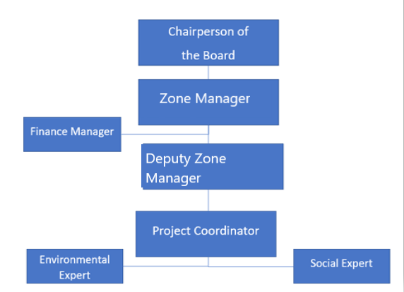
Figure 10-1. Organizational Chart of the Project for Both Construction and Operation Phases
The BOIZ, in collaboration with relevant third parties, will establish, maintain and promote, as required, a Project-specific organizational structure that defines roles, responsibilities and authority for the implementation of ESMP as provided as a model in Figure 10-2.
Specific personnel with clear boundaries of responsibility and authority will be appointed, including management representatives. The Project-specific organizational structure to be developed will include executives, who will coordinate and manage the Project, the Technical and Financial Experts who will be in charge of construction and operational phases of the Project, and at least one Social Expert, one Environmental Expert and one OHS Expert. Core environmental and social responsibilities should be well defined and communicated to the relevant personnel and the rest of the Project Management Unit. Additionally, personnel should have adequate knowledge, skills and experience to competently and efficiently take specific measures and actions required under ESMP.

Roles and Responsibilities
Regarding implementation of the ESMP, a team (Project Management Unit – PMU) to be established by the BOIZ management will be specified to include team members detailed as follows and indicated in the below chart.
Project Coordinator
- Overall responsibility for the ESMP implementation,
Project Manager
- Ensure that ESMP provisions are implemented to mitigate environmental (including OHS) and social impacts, and approve contractor’s LMP is in accordance with the Labour Management Procedures of TOIZsP
- Ensure that all workers, participate in training sessions on ESMP. Maintain a record of training and conduct of awareness sessions for staff to ensure compliance with environmental and safety commitments stated in ESMP,
- Prepare monthly environmental and social monitoring reports for submission to MoIT PIU.
Environmental Expert
- Ensure that the environmental management systems of the project comply with the ESMP,
- Monitor the environmental impacts and risks of the construction activities on site,
- Ensure that ESMP provisions are implemented to mitigate environmental and social impacts,
- Undertake monitoring of the implementation of the ESMP.
Social Expert
- Establish an easily accessible public grievance mechanism,
- Manage and ensure effective operationalization of the GM,
- Record grievances,
- Disclosure to complainant,
- Monitor the social impacts and risks of the construction activities on site,
- Ensure that ESMP provisions are implemented to mitigate social impacts,
- Undertake monitoring of the implementation of the ESMP.
OHS Expert
- Ensure that implementation and supervision of Occupational Health and Safety Management Plan,
- Preparedness and response to emergency situation according to Emergency Response Plan
- Notify MoIT PIU immediately if any contingencies such as labour issues, accidents, and incidents. The incident report including root cause analysis, precautions and compensation measures taken, will be shared with MoIT PIU in 5 days.
Technical Expert
- Responsible for the project design,
- Coordinating the actions and evaluations in case of a change due to engineering/design changes.
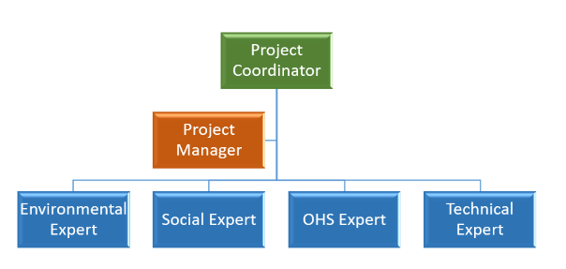
Figure 10-2. Organizational Chart of Project Management Unit
The implementing organisation of the project is the Ministry of Industry and Technology of the Republic of Türkiye (MoIT). MoIT will provide loans to the borrowing OIZs as a sub-borrower. The General Directorate of Industrial Zones of MoIT is the responsible Project Implementation Unit (PIU) coordinating overall project activities on a day-to-day basis. The PIU includes environmental and social experts with sufficient qualifications and experience to manage the implementation of the ESMP and related requirements.
The BOIZ will be responsible for detecting nonconformities, notifying MoIT and monitoring corrective actions within the scope of the Project.
Non-conformities identified during audits will be managed through a process tailored to the severity of the situation. Non-conformities are divided into 4 categories: minor non-conformities, Level 1, 2, 3 non-conformities.
Minor nonconformities can be overcome with minor measures. Level 1 non-conformities are non-conformities that do not pose a major immediate risk to health, environment, society, or safety. Level 2 nonconformities apply to all nonconformities that represent a risk with significant consequences for health and/or the environment, society or safety. Level 3 non-conformities apply to all non-conformities that cause harm to health or the environment or represent a high safety hazard or high social risk.
Organizational chart of BOIZ and organizational chart of Project coordination unit are presented in Figure 10-1 and Figure 10-2. Project's organizational management is presented in Table 10-1.
Table 10-1. Project’s Organizational Management
Institution | Responsibilities
MoIT Project Implementation Unit (PIU) | - Providing guidance to OIZ that is responsible for preparation of this ESMP considering WB’s requirements (standards, guidelines and procedures),  - Reviewing the documents related to the environmental and social assessment of the project, provide comments/revisions to the OIZ in order to develop (performing overall quality assurance) the E&S documents,  - Guiding OIZ on stakeholder consultation and announcement requirements within the scope of this ESMP,  - Following of monitoring activities such as the implementation of this ESMP, other environmental and social mitigation measures, grievance process and Main Project’s Labour Management Procedures,  - Auditing the OIZ's ESMP practices and giving feedback on its performance, and further actions to be taken within the overall project audit,  - Being open and responsive to concerns raised by affected groups and local environmental authorities regarding environmental aspects of sub-project implementation. Meet with these groups during site visits, as necessary,  - In case of necessity, providing coordination and communication regarding the field visits  - To provide CoC, OHS, GM, GBV, SEA/SH training to the contractor, and OIZ PMU specialists before the construction activities
OIZ Project Management Unit (PMU) | - Assigning/hiring one environmental, one social expert and one OHS specialist with sufficient qualifications and skills  - Identification and management of risks and impacts related to environmental, social and OHS issues during construction activities on site  - Implementation of this ESMP and related management plans and achieving of all commitments under these plans. Checking both the technical and administrative progress of contract packages and  - Providing support to implementation of the mitigation measures and commitments given in the ESMP on site  - The E&S Team will also be responsible for taking actions required to eliminate/minimize environmental and social impacts and risks in line with this ESMP and for putting monitoring plans into practice,  - Sharing the ESMP with the Contractor,  - Guiding the Contractor in preparing and approving the sub-management plans, and Contractor’s LMP,  - Coordinating the actions and evaluations in case of a change due to engineering/design changes, route/location changes, legislative changes related to environmental and social issues, authorization provision changes, new environmental/social data, construction/operation strategy changes,  - Updating the ESMP when necessary and sharing additional commitments with the Contractor,  - Informing MoIT PIU via monthly ES Monitoring Reports which will be prepared in line with ESMF and submitted by the contractor,  - Monitoring and evaluating the performance of the contractor activities in line with ESMP requirements,  - Ensuring compliance with project standards, taking urgent action in case of non-compliance within the knowledge and approval of MoIT PIU,  - Any non-conformities found during the inspections will be managed by a process adapted to the severity of the case to provide training to the project personnel of the Contractor and their own personnel on ESMP implementations, CoC, OHS, GM, GBV, SEA/SH trainings and commitments, which covers project related environmental and social impacts and risks, and corresponding measures applied to avoid, reduce, and mitigate the risks and potential adverse impacts, roles and responsibilities assigned to the relevant party, monitoring plan and reporting process prior to the construction activities are commenced  - Preparing the bidding documents during the implementation, conducting bidding processes. The requirements of the WB and the Construction Contract including this ESMP and LMP will be chased and cooperating with the MoIT PIU for the supervision of construction activities  - Supervision of construction and/or rehabilitation works and installation of equipment,  - Suspending work in any situation that threatens environment and community and occupational health and safety and informing MoIT PIU,  - Analysing and following up the environmental (including OHS) and social accidents/incidents. Specifically, for any significant environmental or social incidents (e.g. fatalities, lost time incidents, environmental spills etc.), the OIZs will inform MoIT PIU within 48 hours immediately ,  - In the event of any significant incident, accident, or near miss, a report must be submitted immediately, and the Project Implementation Unit (PIU) shall promptly inform the World Bank. Form B shall be reported to the PIU within 13 business day, and the PIU shall forward it to the World Bank within 24 hours. The incident reportdays, including aa root cause analysis, precautionscorrective actions taken, and any compensation measures taken, shall be submitted. MoIT will forward this report to the PIU within 5 days afterWB upon receipt, in accordance with the incident,Environmental and Social Commitment Plan (ESCP) and ESMF of the PIU shall submit the final version to the World Bank within 10 days.Project.  - Follow up the penalties arising from the contract, checking the suitability of the work done by the Contractor, giving warnings and directions and notifying the MoIT PIU in a timely manner if necessary,  - Receiving and processing public workers’ grievances.
Consultant  (E&S) | - Preparation and finalizing this ESMP as per the concerns/opinions of the stakeholders of the Project for the approval of MoIT PIU and WB,  - Supporting the PIU to organize and carry out the stakeholder consultation meeting for the draft version of this ESMP,  - Organizing and delivering a training to the respective OIZ on ESMP implementations, GM, GBV, SEA/SH trainings and commitments, which covers project related environmental and social impacts and risks, and corresponding measures applied to avoid, reduce, and mitigate the risks and potential adverse impacts, roles and responsibilities assigned to the relevant party, monitoring plan and reporting process prior to the construction activities are commenced.
Contractor | - Fulfilment of all requirements of ESMP and the relevant management plans,  - Implementation of additional commitments to be included in the Construction Contract,  - Preparation of its site-specific sub-management plans (mentioned above in the relevant sections and the mitigation measures Tables) in line with this ESMP, including OHS plans before construction, as part of their method statement and submit to the OIZ and MoIT PIU for reviewing and approval,  - Ensuring compliance with project standards, obtaining all relevant permits and licenses,  - Implementing of the mitigation measures provided in this ESMP and monitoring of construction activities (including subcontractor activities) in compliance with the national legislation and WB standards,  - Development of monitoring plans/procedures in accordance with the ESMP structure, implementation after the approval of OIZ and MoIT PIU,  - Employment of competent Environmental, Social and OHS Experts (at least one Environmental and Social Expert and one full-time OHS Expert) within the scope of the project,  - Training its own and subcontractor’s staff on environmental, social and OHS issues,  - Carrying out the environmental and social audits to monitor the ESMP practices on site and report on this to the OIZ PMU,  - Submission of Environmental and Social Progress Reports (ESPRs) on environmental and social issues, mitigation, results and findings throughout the construction period to the OIZ PMU,  - In the event of any significant incident, accident, or near miss, a report must be submitted immediately, and the Project Implementation Unit (PIU) shall promptly inform the World Bank. Form B shall be reported to the PIU within 1 business day, and the PIU shall forward it to the World Bank within 24 hours. The incident report, including root cause analysis, precautions, and compensation measures taken, shall be submitted to the PIU within 5 days after the incident, and the PIU shall submit the final version to the World Bank within 10 days.  - On the basis of the project’s Labour Management Procedures, the Labour Management Plan (LMP) which will be prepared by the contractor will also comply with the Labour Legislation (4857 Labour Law), Occupational Health and Safety Plan and Procedures (6331 Occupational Health and Safety Law) and 5510 Social Insurance Law,  - Implementing LMP (based on TOIZsP’s Labour Management Procedures) including working conditions, fair treatment, non-discrimination, equal opportunity, vulnerable/disadvantaged workers, GBV, SEA/SH, prevention of child labour and forced labour issues under the project’s Labour and Employment Policy for construction phase,  - To provide CoC, GM, GBV, SEA/SH, OHS training to the project personnel before construction activities and repeat annually. Training records will be kept,  - Establishment and implementation of project specific grievance mechanism for the Project construction activities in coordination with OIZ PMU.

Reporting
The Contractor presents the monthly Environmental and Social Progress Report (ESPR), to OIZ PMU. The PMU evaluates and revises if required and submits it to the Project Implementation Unit (PIU) of MoIT.
Subsequently, the MoIT will perform its own supervision and monitoring along with the information obtained from the BOIZ. After that the MoIT will prepare Environmental and Social Report (ESR) to cover summary of these ESMRs and submit it to the World Bank (WB) quarterly. During the operation phase, the social and environmental impacts, if any, will be evaluated and presented to the WB and MoIT biannually.
Reporting processes that should be put into action during the implementation phase of the project and the requirements of such processes are presented in Table 10-2.
Table 10-2. Reporting Process Requirements and Distribution of Roles
Responsible Party | Roles & Responsibility
MoIT Project Implementation Unit (PIU) | - Quarterly inform the WB with ESRs to include summary of monthly Environmental and Social Monitoring Reports (ESMRs) on the progress and updates. Quarterly ESRs will highlight any issues arising from non-compliance with ES requirements and how it has been/is being addressed from the ES safeguards point of view.  - Submitting the quarterly Grievance Mechanism Report (GMR) to WB.  - Site visits will be carried out periodically and environmental and social issues will be examined on site. Findings after site visit will be included in the quarterly ESRs.  - Before the construction starts GM, OHS, CoC, GBV, SEA/SH training will be given to OIZ PMU, and Contractor’s Environmental and Social Specialists, OHS Specialists and training records will be kept.
BOIZ Project Management Unit (PMU) | - Review, revise if required, and submit monthly ESMRs to MoIT PIU  - Follow up construction activities  - This ESMP implementation, CoC, OHS, GM, GBV, SEA/SH training will be given to employees of Contractor, and their own employees and training records will be kept.
Contractor | - Prepare and submit monthly ESPRs covering the progress of the construction and environmental and social, OHS issues to the OIZ PMU  - CoC, OHS, GM, GBV, SEA/SH training will be given to their own employees and training records will be kept.

Training
The BOIZ will implement a training and awareness program covering ESMP commitments, which covers project related environmental and social impacts and risks, and corresponding measures applied to avoid, reduce, and mitigate the risks and potential adverse impacts. 2U1K will organize and conduct, together with the BOIZ, a workshop for this training in accordance with the scope of work in its current contract. At a minimum, this program will provide training to employees and contractors responsible for implementing the ESMP. Training will be provided to employees and the BOIZ before construction begins. Once the contract with the construction contractor is signed, the BOIZ will deliver these trainings, as specified in Table 10 3 to the construction contractor prior to the start of construction activities. The training sessions will last a maximum of two days and will be conducted twice a year.
If the Environmental and Social Monitoring Reports (ESMRs) reveal that the ESMP mitigation measures are not effectively implemented, additional training programs may be required to meet the desired standards. Training will be provided to personnel soon after they are hired, with grading and evaluation conducted at the end of each session. The BOIZ will review the relevance of the training program and the results of the evaluation. Based on these results, the training program may be modified, trainers replaced, or training sessions repeated if necessary to ensure effectiveness and enhance personnel competency.
The training program/modules will address a range of issues, including but not limited to:
- Purpose of ESMP regarding the project activities,
- Requirements in management plans, mitigation measures to be applied and monitoring activities to be performed within the scope of this plan,
- Understanding of the sensitive environmental and social receptors within the project area and its vicinity,
- Awareness raising about the potential risk and impacts from the project activities,
- Grievance mechanism developed within the scope of the project, process, procedures and service standards, grievance mechanism contact channels and employee rights,
- Occupational health and safety, first aid, emergency preparedness,
- GBV and SEA/SH trainings,
- Communication with the local community,
- Code of conduct training, including dress code, gender-based violence, sexual harassment, sexual exploitation, and abuse,
- Traffic and road safety principles, and
- Training aims at the sorting, storage, and environmental planning of waste,
- In case any cultural heritage/asset is encountered in the project site, the project staff will be trained on the chance find procedure to implement.
The BOIZ will ensure that all personnel responsible for the implementation of this ESMP are competent in terms of education, training, and experience. All personnel will be provided with environmental and social, OHS training appropriate to their scope of activity and level of responsibility.
The institutional capacity of BOIZ will be strengthened through the trainings to be delivered by the environmental, social, stakeholder engagement and OHS specialists of the MoIT PIU in case needed, MoIT PIU can hire external consultants, who have knowledge and experience about ESSs, to support the trainings for BOIZ officials/staff in order to increase their awareness of risks and mitigate the impacts of the Project. Information regarding proposed training program is provided in Table 10-3.
Table 10-3. Training Program
Item No | Heading of the Training | Target Group | Responsible Party | Timing and Duration | Cost
1 | Environmental and Social Framework:  - Training on ESF, and the ESSs relevant for the Project including preparation of ESMP  - Implementation of the project specific ESMP, LMP and GM | - Personnel of BOIZ | - E&S Consultant | Pre-construction phase (at least 0.5 day)  Immediately after approval of this ESMP by the WB | No additional costs
2 | Pre-construction E&S documents trainings:  - Code of Conduct, GBV, SEA/SH,  - GM,  - OHS,  - Chance Find Procedures. | - BOIZ PMU  - Specialists of the Contractor | - MoIT PIU  - BOIZ PMU (for personnel of Contractor and their own personnel if any personnel changes) | Pre-construction phase (at least 0.5 day)  Immediately after award of the contract  (0.5 days) | No additional costs
3 | Occupational Health and Safety:  - Workplace risk management  - Prevention of accidents at work sites  - Use of Personal Protection Equipment’s (PPEs)  - Health and safety standards  - Hazardous waste management  - Solid and liquid waste management  - Preparedness and response to emergency situation  - Awareness on communicable diseases (i.e. Covid-19, HIV/AIDS etc.) | - Personnel of BOIZ | - OIZ PMU | Immediately after award of the contract  (2 days) | No additional costs
4 | Labour and Working Conditions:  - Implementation of LMP  - Terms and conditions of employment according to national working laws and regulations  - Contractor and sub-contractor codes of conduct incl. prevention of GBV, SH/SEA  - Worker’s organizations  - Child labour and forced labour issues  - Workers Grievance Mechanism | - Personnel of BOIZ | - OIZ PMU | Immediately after award of the contract  (1 day) | No additional costs
5 | Public Grievance Mechanisms:  - Implementation of GM  - Registration and processing procedure  - Grievance procedure  - Documenting and processing grievances | - Personnel of the Contractor | - OIZ PMU | Immediately after award of the contract  (0.5 day) | No additional costs
6 | Worker Grievance Mechanism  - Implementation of GM  - Registration and processing procedure  - Grievance procedure  - Documenting and processing grievances | - Personnel of the Contractor | - OIZ PMU | Immediately after award of the contract  (0.5 day) | No additional costs

STAKEHOLDER MANAGEMENT UNDER ESMP
This chapter contains a brief description of stakeholder engagement. As mentioned above, the TOIZsP Stakeholder Engagement Plan (SEP), will be used for this sub-project and all project parties (including contractor, Organized Industrial Zone (OIZ) and Ministry of Industry and Technology (MoIT) PIU) will be responsible for ensuring compliance with the TOIZsP SEP.
A stakeholder is defined as any individual, organization or group who is potentially affected by the Project or who has an interest in the Project and its impacts. The objective of stakeholder identification is to establish which stakeholders may be directly or indirectly affected – either positively or negatively - (“affected parties”) or have an interest in the Project (“other interested parties”).
The term “project affected parties” includes those likely to be affected by the project because of actual impacts or potential risks to their physical environment, health, security, cultural practices, well-being, or livelihoods. These stakeholders may include individuals or groups, including local communities.
The term “other interested parties” refers to individuals, groups, or organizations with an interest in the project, which may be because of the project location, its characteristics, its impacts, or matters related to public interest.
Vulnerable groups refer to people who may be more affected by the potential negative impacts of the project or are less able to access information or get their voices heard and concerns raised.
Table 11-1 presents the stakeholder groups and their relevance to this Project.
Table 11-1. Stakeholder Groups and Their Relevance to This Project
Stakeholder Groups |  | Methods for engagement | Relevance to the Project
Project Affected Parties | Settlements  - Halilbeyli Neighbourhood (population 1,413)  - Local businesses  - Local institutions | Consultation meeting and interviews  Other requested measures (phone, letter etc) | Potential noise and dust emission during the construction phase
Project Affected Parties | Businesses  - Businesses operated within the OIZ | Face to Face Meeting  e-mail  phone  official letter  announcements | Potential noise and dust emission during the construction phase,  User/ beneficiary after commissioning
Other Interested Parties | Government / Authorities  - Governorship of Izmir  - Izmir City Health Authority | Face to Face Meeting  e-mail  phone  official letter  announcements | Representing the state side of the project to be realized on behalf of the public
Other Interested Parties | Municipality  - Metropolitan Municipality of Izmir  - Municipality of Kemalpaşa | Face to Face Meeting,  Consultation meetings,  Other requested measures (e-mail, phone, official letter, etc) | Management unit  Responsible for infrastructure, public healthcare, environmental and social services
Other Interested Parties | NGO  - NGOs with themes such as environmental protection, public health, and citizenship: | Face to Face Meeting  Other requested measures (e-mail, phone, official letter, etc) | Creating public opinion on the environmental and social impacts of the project
Other Interested Parties | Media  - International, national, and local media | Face to Face Meeting | Informing the public about the project
Vulnerable/Disadvantaged groups | - seasonal migrants  - Physically / Mentally disabled individuals  - Female heads of households  - Refugees | Face to Face Meeting  Other requested measures (phone, translator, letter etc)  Hold informal sessions at shelters, drop-in centres, and day facilities they already visit.  Ensure wheelchair access, ramps, and accessible toilets for in-person sessions. | Individuals with the potential to be more affected by the project activities (especially construction works)
Contractor | - Contractor’s workforce | Face to Face Meeting  e-mail  phone  official letter  announcements | Contractor employees will be affected by the Project as they will work within the scope of the Project.

Previous Stakeholder Engagement Activities
During the preparation of this ESMP under the Project, a site visit to BOIZ was conducted by E&S Consultants on August 22, 2024. After the consultants and the project manager had a meeting about the progress of the project, the lands where WWTP will be established were visited. In addition, Halilbeyli Neighbourhood Headman was interviewed.
During a meeting with the headman of Halilbeyli Neighbourhood, it was learned that the residents of the neighbourhood had no complaints about BOIZ in general. However, it was learned that the neighbourhood experiences seasonal problems related to agricultural irrigation and that the roads passing through the neighbourhood are damaged due to weather conditions in the winter months. In addition, it was stated that the residents of the neighbourhood wanted a natural gas system to be installed in the neighbourhood.

Disclosure and Consultation of the ESMP
E&S documents will be consulted before final approval by WB, to ensure that any concern raised can be addressed in final version, which will then be approved and disclosed. After that a consultation meeting will be organized to the participation of all stakeholders. Stakeholders will be sent an invitation call/information about the meeting place, time, and content at least seven (7) days in advance.

Grievance Mechanism
The main aim of the grievance mechanism is to assist in resolving complaints and grievances in a timely, effective, and efficient manner that satisfies all parties involved. The GM (and also workers’ GM) will be effective during the lifespan of the project. It is intended to serve as a mechanism to:
    - Allow identification and impartial, timely and effective resolution of issues affecting the project,
    - Strengthen accountability vis-a-vis the beneficiaries, including project-affected stakeholders, and
    - Provide channels for the stakeholders to provide feedback and raise concerns.
    - Offer a consultation process that is clear, transparent, culturally sensitive, and easily accessible.
    - Provide the option for anonymous complaints and feedback, particularly in cases related to Gender Based Violence (GBV), Sexual Exploitation and Abuse (SEA) and Sexual Harassment (SH).
    - Recognize that grievances concerning community health, safety, and environmental risks may be urgent, especially in cases of accidents, communicable diseases, and pollution. Immediate actions must be taken to address and prevent further harm.
The Project-based GM is detailed in Chapter 7 of the TOIZsP Stakeholder Engagement Plan. The steps that complete the grievance mechanism and the description of this process. There are steps that complete the grievance mechanism. This process has been detailed in Table 11-2.
Table 11-2. Procedural Steps of Grievance Mechanism
Step | Description of Process | Time Frame | Responsibility
GM implementation structure | There exist three Grievance Mechanism at the National Level:  - Presidency’s Communication Centre,  - Foreigners Communication Centre,  - MoIT level GM.  Additionally, there is also a Project Level GM | - | Presidency’s Communication Centre, and Foreigners Communication Centre and related authorities  MoIT PIU  OIZ PMU
Grievance uptake | Grievances can be submitted via the following channels:  - Stakeholder visits,  - Telephone call (+90 530 782 69 08),  - Mail (info@bayosb.org),  - Via Web site,  - Online meeting or meeting,  - Wish-complaint boxes.  Anonymous Grievances can be submitted via the following channels:  - Telephone,  - Letter to Grievance focal points at local facilities,  - Suggestion box. | - | Presidency’s Communication Centre, and Foreigners Communication Centre and related authorities  MoIT PIU  OIZ PMU
Sorting, processing | Any complaint received is forwarded to social expert of the Project Owner Logged in GM record log and categorized according to the complaint types:  If the complaint is assessed to be out of the scope of the Grievance Mechanism, the grievant will be notified through the desired communication method and an alternative mode of solution will be suggested. | Upon receipt of complaint | OIZ PMU
Acknowledgement and follow-up | Receipt of the grievance is acknowledged to the complainant by Social Expert of the Project Owner | Within 2 working days of receipt | OIZ PMU/Social Expert
Verification, investigation, action | Investigation of the complaint is led by Social Expert.  A proposed resolution is formulated by the relevant unit and communicated to the complainant by the preferred tool. | Within 10 working days | OIZ PMU / Social Expert  Relevant unit(s) (if necessary)  Worker representative (if the compliant is logged under workers’ GM)
Provision of feedback | Feedback from complainants regarding their satisfaction with complaint resolution is collected in the log | 15 working days after the implementation of the resolution | OIZ PMU
In addition to the project’s GM for its internal and external stakeholders, ESS 2 requires the establishment of a Workers’ Grievance Mechanism (WGM) for the project workers. Worker GRM is defined as complaints from project employees (including both direct and indirect employees). This mechanism, defined in the Labour Management Procedures of TOIZsP and required to be adhered to in the contractor’s LMP, to be an effective approach for early identification, assessment, and resolution of grievances throughout the project’s lifespan.
The scope of the Worker GRM can be summarized as follows, but not limited to: occupational health and safety, labour conditions, wages, problems with the local community or co-workers, hygiene problems in common areas, insufficient food and/or worker safety, etc. Grievance related to OHS would be addressed and managed immediately, where feasible. Procedural steps of Worker GRM are same as described in Table 11-2.
The WB and the Borrower do not tolerate reprisals and retaliation against project stakeholders who share their views about Bank-financed projects.

Grievances Related GBV/SH/SEA
To properly address SEA/SH risks, a Grievance Mechanism (GM) will be established and operational before contractor mobilization. Recognizing the risks of stigmatization, rejection, and reprisals against complainants, the GM will include multiple safe and confidential channels for registering complaints to ensure survivors can access support without fear.
Key Features of the GM:
    - Safe Access: Survivors of GBV, SH, or SEA will be provided with multiple, clearly communicated, and secure channels to report grievances. The channels will be designed to minimize barriers such as language, literacy, or fear of exposure. The ESMP, which includes GM, will be explained in detail to the public.
    - Confidentiality and Empathy: GM operators will undergo specialized training to collect and manage SEA/SH cases confidentially and empathetically. Survivor anonymity will be strictly maintained, and no identifiable information will be recorded or stored.
    - Limited Data Collection: Only essential information related to the complaint will be recorded, including:
    - The nature of the complaint (verbatim, as shared by the survivor, without direct questioning);
    - Whether the alleged perpetrator is linked to the project;
    - If possible, the age and sex of the survivor;
    - Whether the survivor was referred to appropriate services.
Addressing Case Handling and Survivor Support:
While the GM will ensure confidentiality and provide reporting mechanisms, clear protocols for case resolution are lacking and must be developed. This includes outlining how complaints will be assessed, addressed, and resolved, ensuring survivors receive justice and support without undue delays or bias.
Collaboration with Local NGOs and Services:
To strengthen the GM’s effectiveness, existing provincial and district-level NGOs that provide support to GBV, SH, and SEA survivors must be engaged . The Social Assistance And Solidarity Foundation, affiliated with the Kemalpaşa District of İzmir Province, is one of these NGOs. These organizations also can:
    - Offer expertise in survivor-centred care, including counselling and medical assistance.
    - Provide support for reintegration and advocacy on behalf of survivors.
    - Assist in raising community awareness to reduce stigma and promote reporting.
A directory of relevant NGOs and service providers should be maintained and integrated into the GM framework to ensure seamless referrals for survivors.

REFERENCES
Alanyali Geological Drilling Laboratory Inc. (2020). Ground Survey Report of the Project Area. Izmir.
BOIZ, Process Report of the Project. (2021). BOIZ Domestic and Industrial WWTP Process Report. Izmir: BOIZ.
Database of T.C. Ministry of Environment, Urbanization and Climate Change. (2025, 7 31). Retrieved from National Air Quality Monitoring Network: www.havaizleme.gov.tr
Dokuz Eylül University. (2009). Three Dimensional Interactive Hydrogeological Model of the Kemalpaşa Plain. Science and Engineering Journal, 14-15.
Dokuz Eylül University. (2021). Environmental Criteria for the BOIZ Green OIZ Company-Based Analysis and Road Map Project. Izmir: Dokuz Eylül University, Faculty of Engineering, Department of Environmental Engineering.
E&S Screening Report of the Project. (2024). E&S Screening Report of the Project. Ankara.
Geosciences Map Viewer of Mineral Research and Exploration. (2025, 1 28). Retrieved from General Directorate of Mineral Research and Exploration Web Site: http://yerbilimleri.mta.gov.tr/
Geosciences Map Viewer of Mineral Research and Exploration. (2025, 1 29). Retrieved from General Directorate of Mineral Research and Exploration Web Site: http://yerbilimleri.mta.gov.tr/
Meteorology General Directorate of T.C. Ministry of Environment, Urbanization and Climate Change. (2024, 1 26). Retrieved from Turkish State Meteorological Service: www.mgm.gov.tr
Ministry of Agriculture and Forestry, National Water Information System. (2025, 1 29). National Water Information System. Retrieved from National Water Information System: https://usbs.tarimorman.gov.tr/usbs/VatandasGirisi/Index
T.C. Izmir Governorate Directorate of Provincial Disaster and Emergency State. (2021). Provincial Disaster Risk Mitigation Plan 2021. Izmir.
T.C. Izmir Governorship, Provincial Directorate of Environment, Urbanization and Climate Change. (2023). Izmir Province Environmental Status Report for 2022. Izmir.
T.C. Kemalpaşa District Governorship. (2025, 1 28). Kemalpaşa Historical and Geographical Structure. Retrieved from T.C. Kemalpasa District Governorship Official Web Site: http://www.kemalpasa.gov.tr/kemalpasa-tarihi-ve-cografi-yapi

APPENDICES
Appendix-A Land Title Deed Records
Appendix-B Layout Plan, Spatial Plan, 1/25,000 and 1/100,000 Environmental Plans
Appendix-C EIA Out-of-Scope Official Letter for the Project
Appendix-D Other Permits, Licenses, Certificates and Agreements
Appendix-E Official Environmental Fine Minute
Appendix-F Photographs of the Project Area and BOIZ
Appendix-G National Environmental and Social Legal and Policy Framework Table
Appendix-H Analysis Reports
Appendix-I Calculations of Environmental Impact of the Project
Appendix-J Chance Find Procedure
Appendix-K Gap Analysis of the World Bank ESSs and the National Legislation

Appendix-A Land Title Deed Records

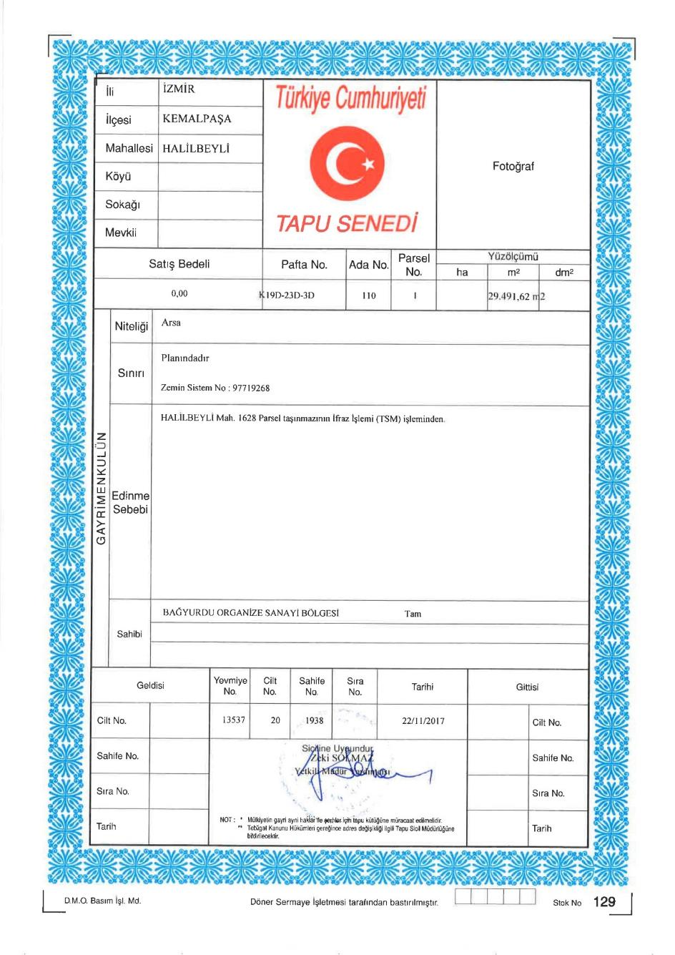

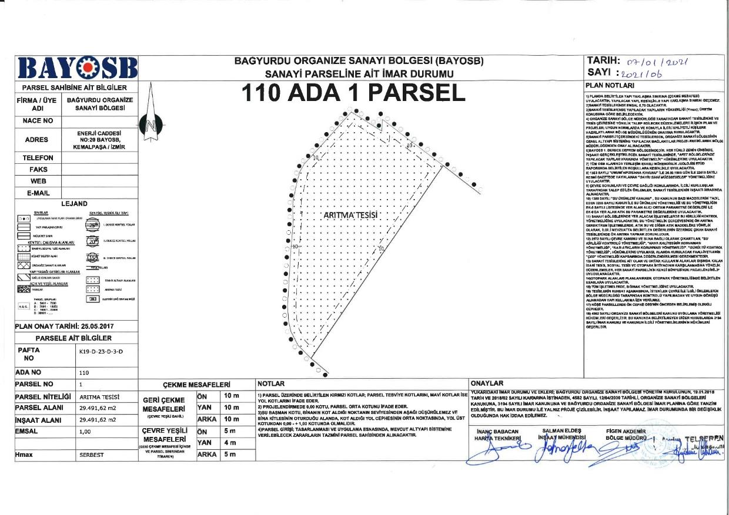

Appendix-B Layout Plan, Spatial Plan, 1/25,000 and 1/100,000 Environmental Plans

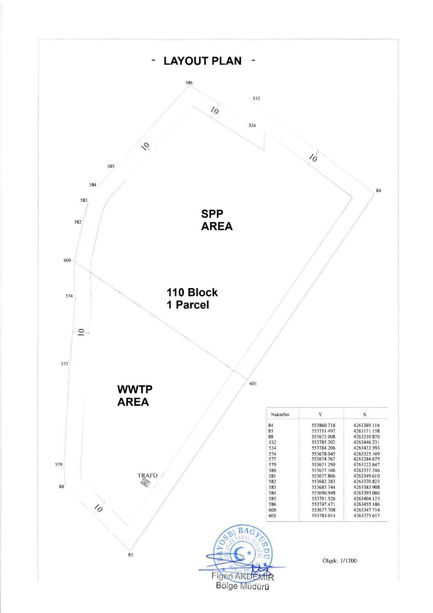
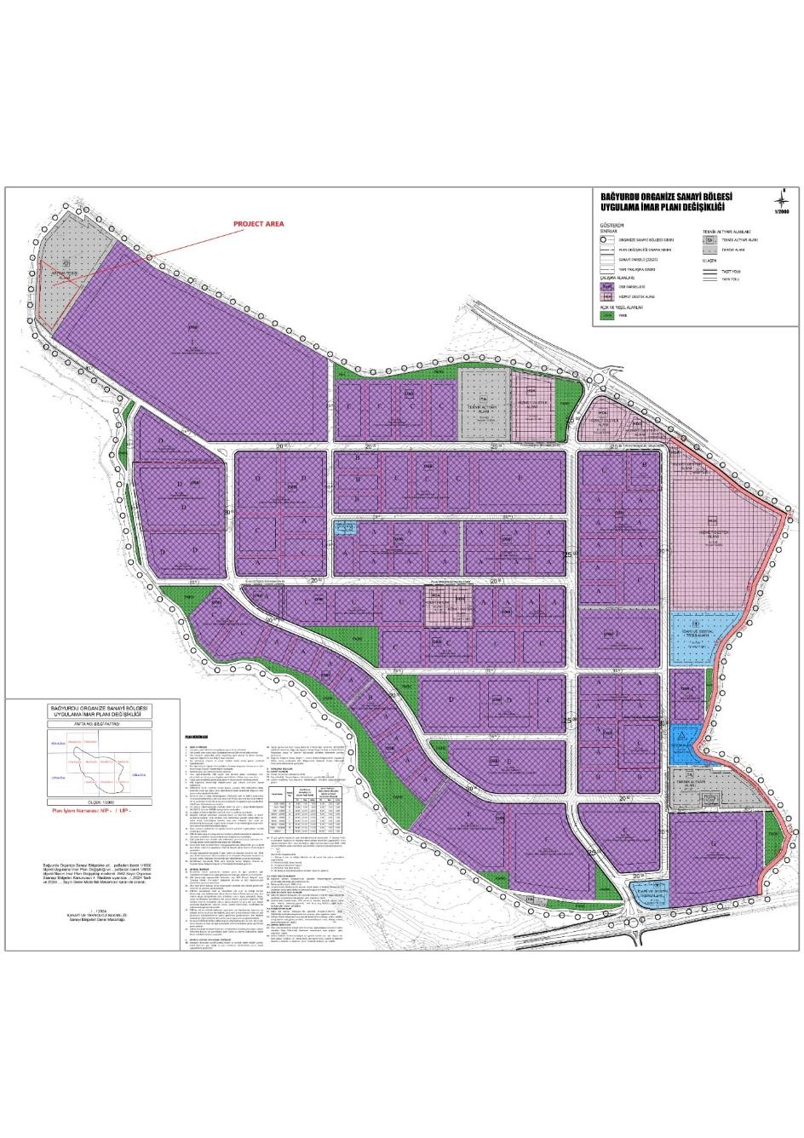

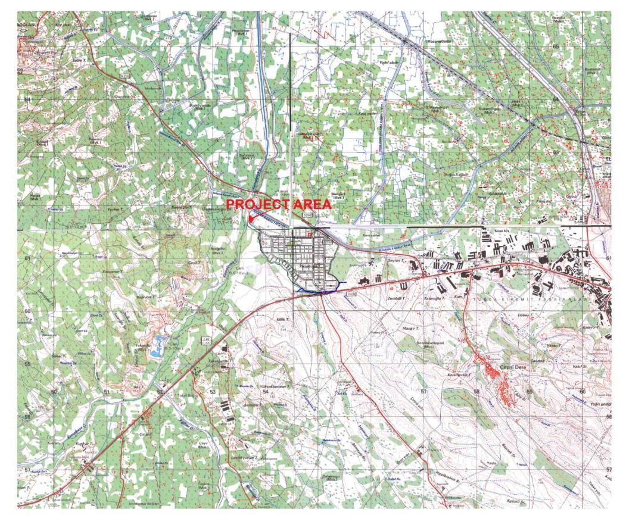
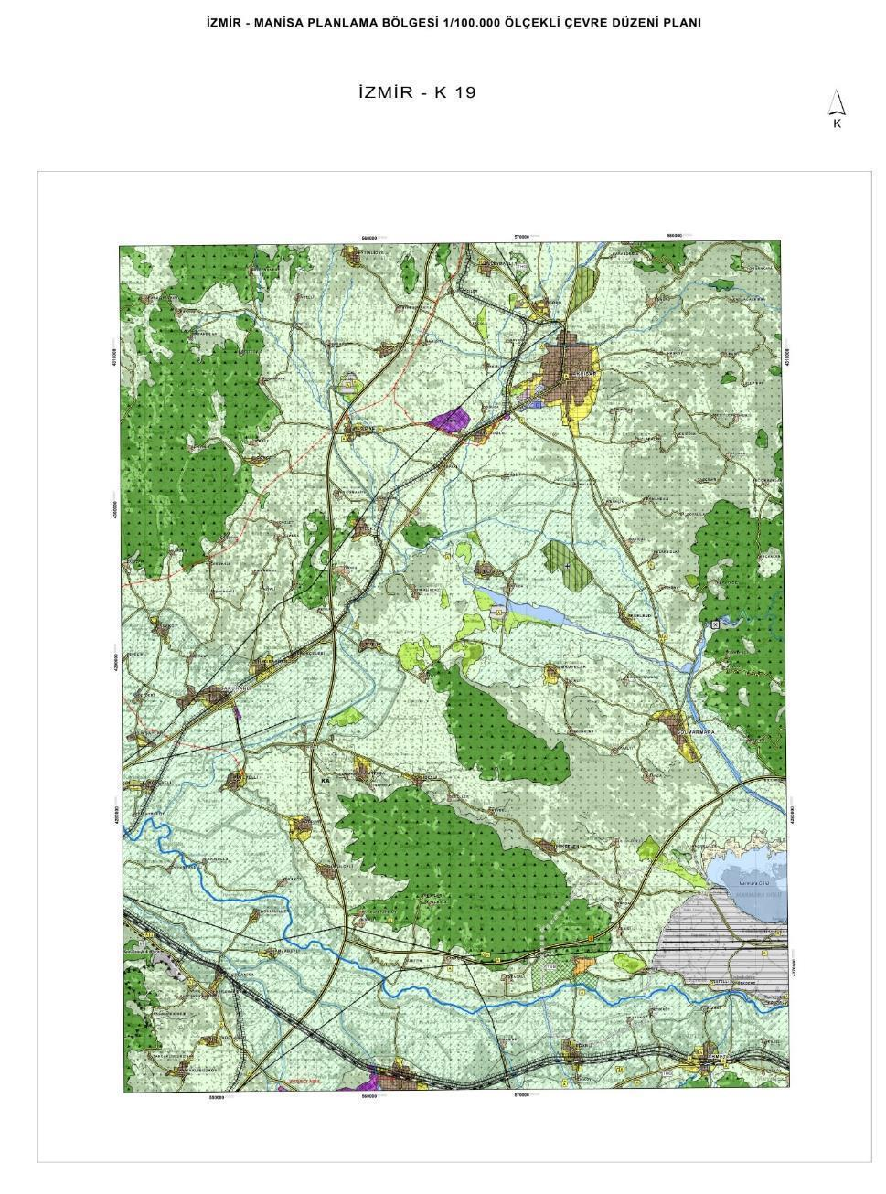

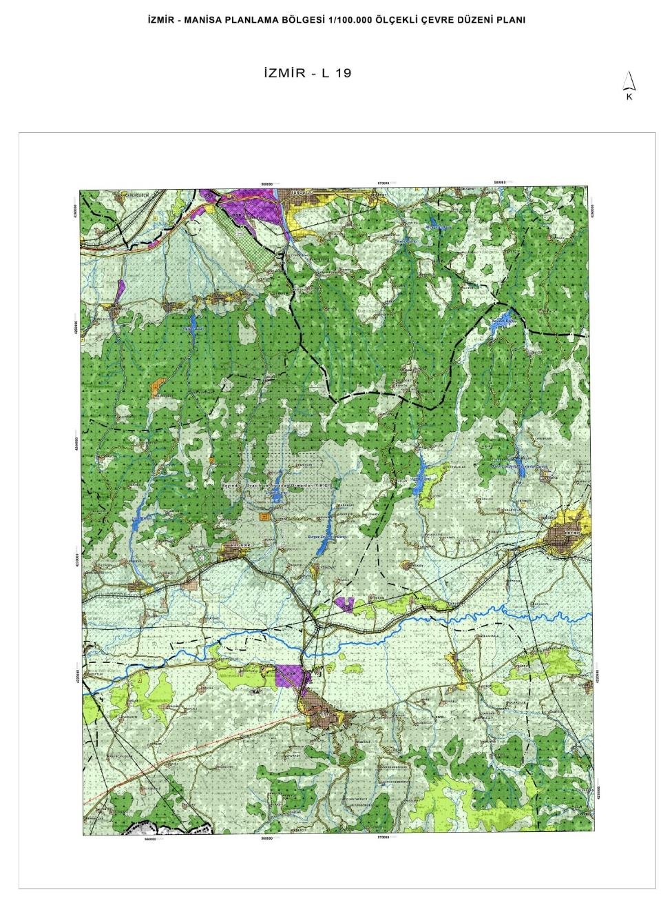

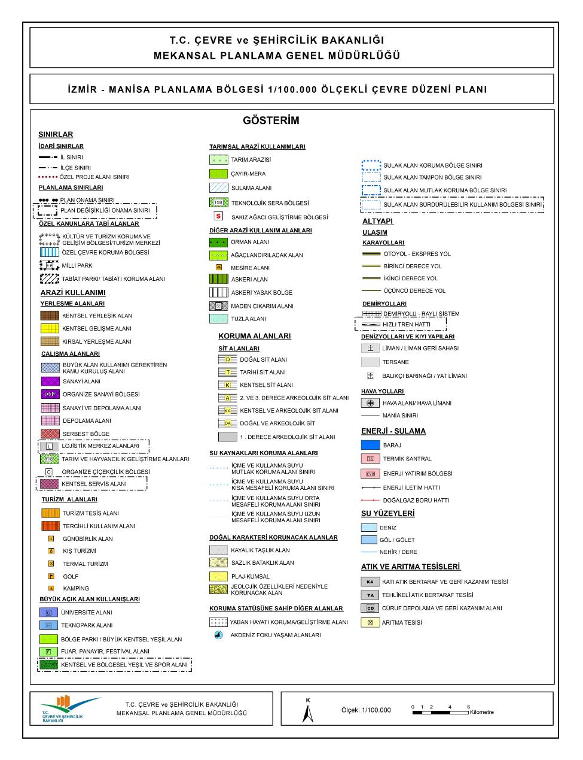

Appendix-C EIA Out-of-Scope Official Letter for the Project

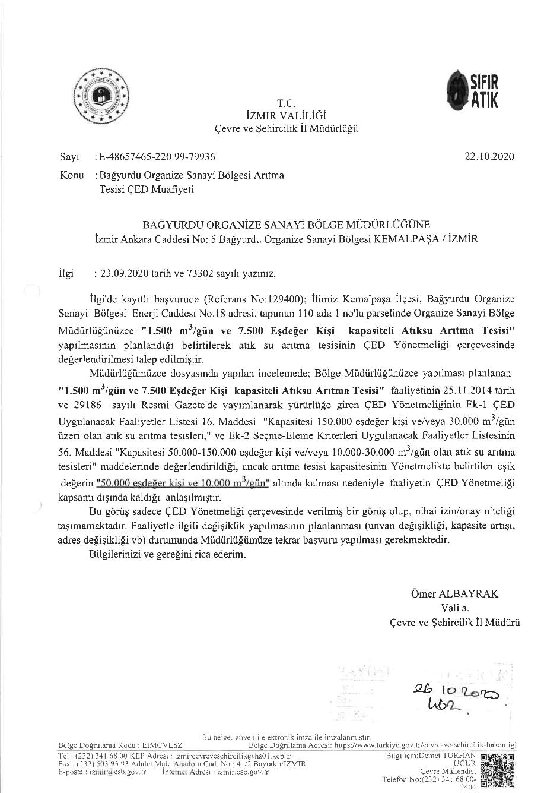

Appendix-D Other Permits, Licenses, Certificates and Agreements

Project Approval Official Letter from MoEUCC
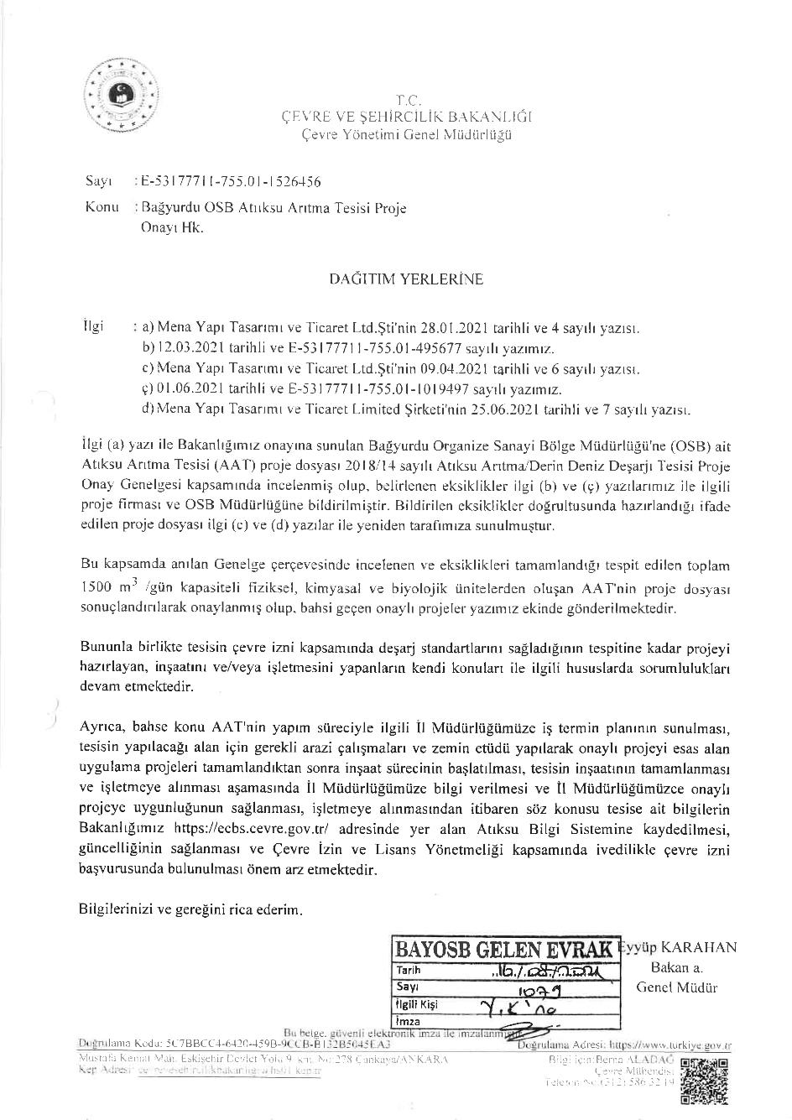
Project Approval Official Letter from MoIT
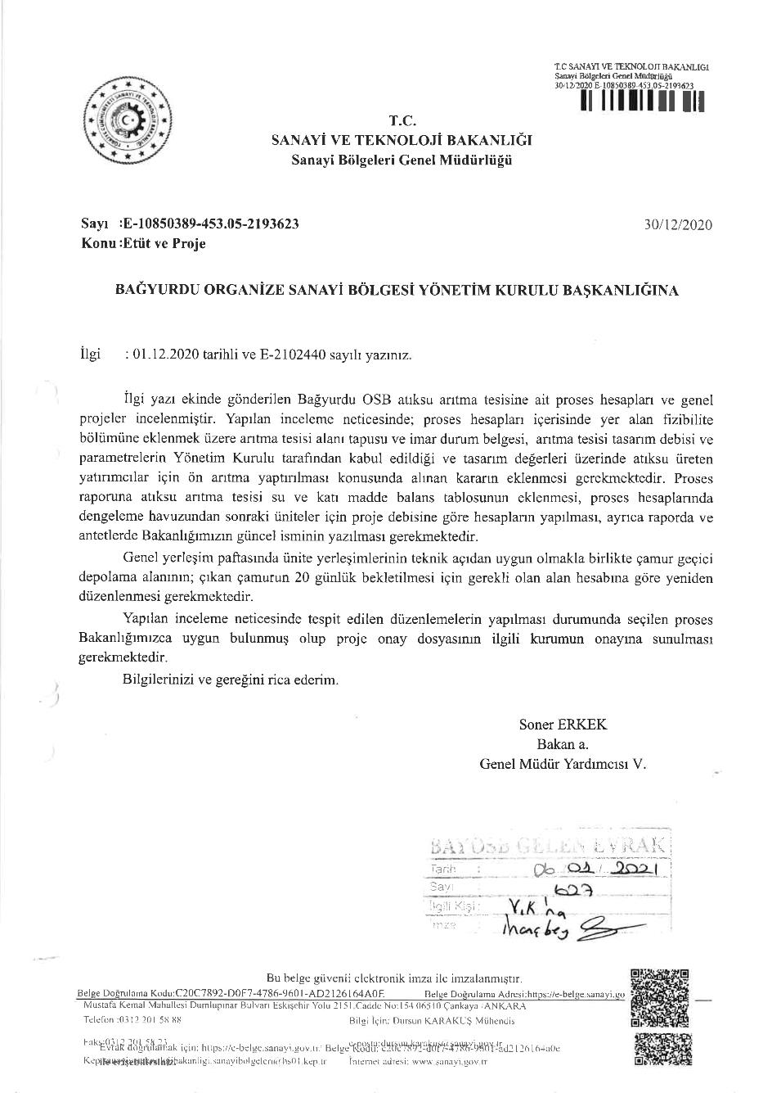
Zero-Waste Certificate of the BOIZ
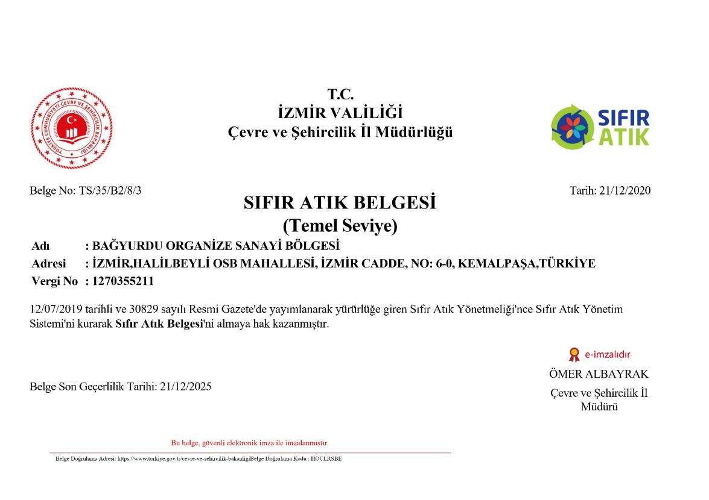

OIZ Distribution License from Energy Market Regulatory Authority
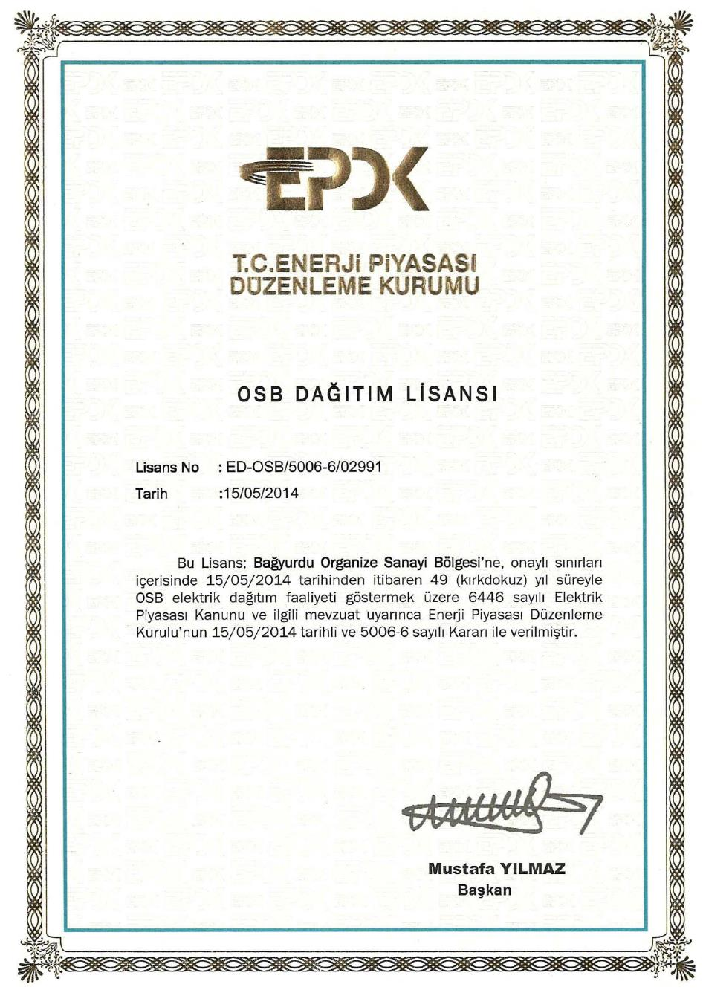
ISO 9001:2015 (Quality Management System) Certificate
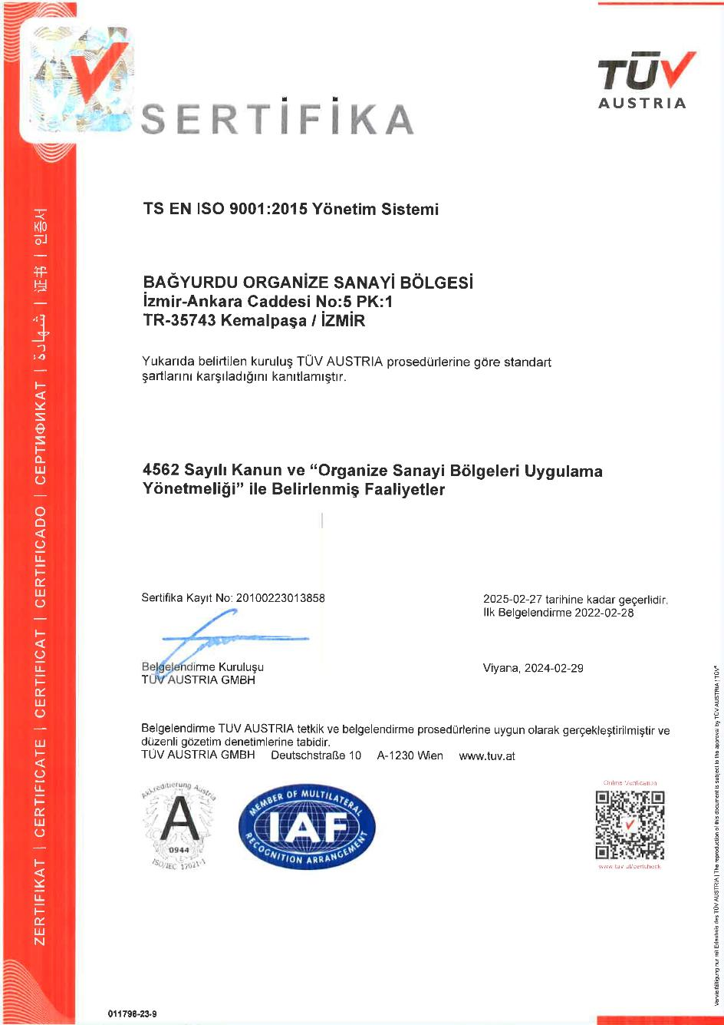
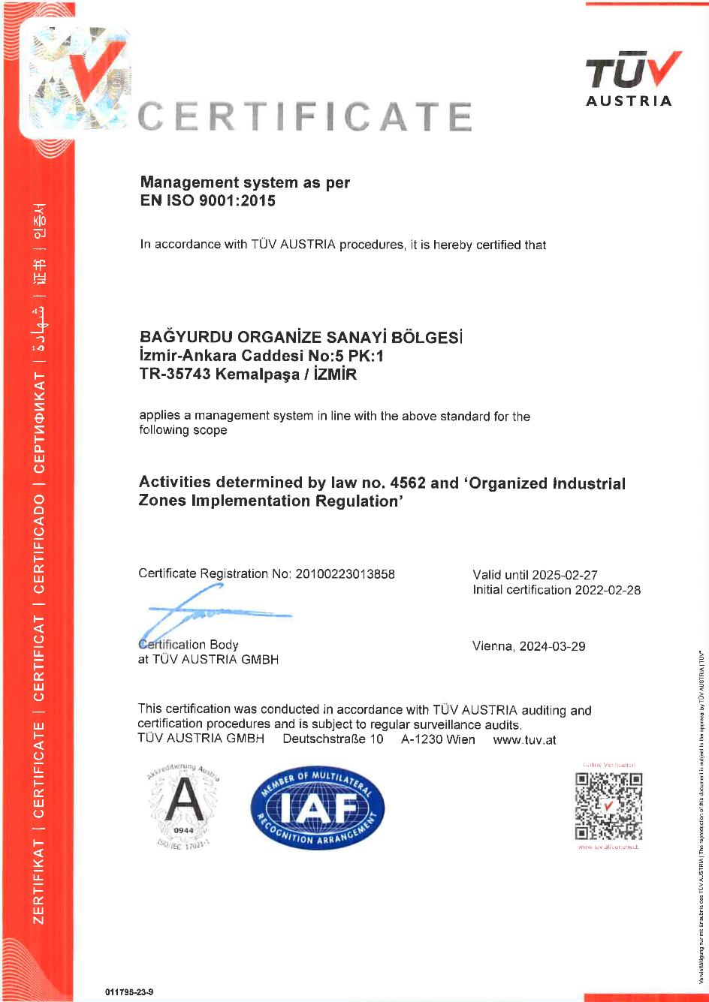
Groundwater Utilisation Certificate
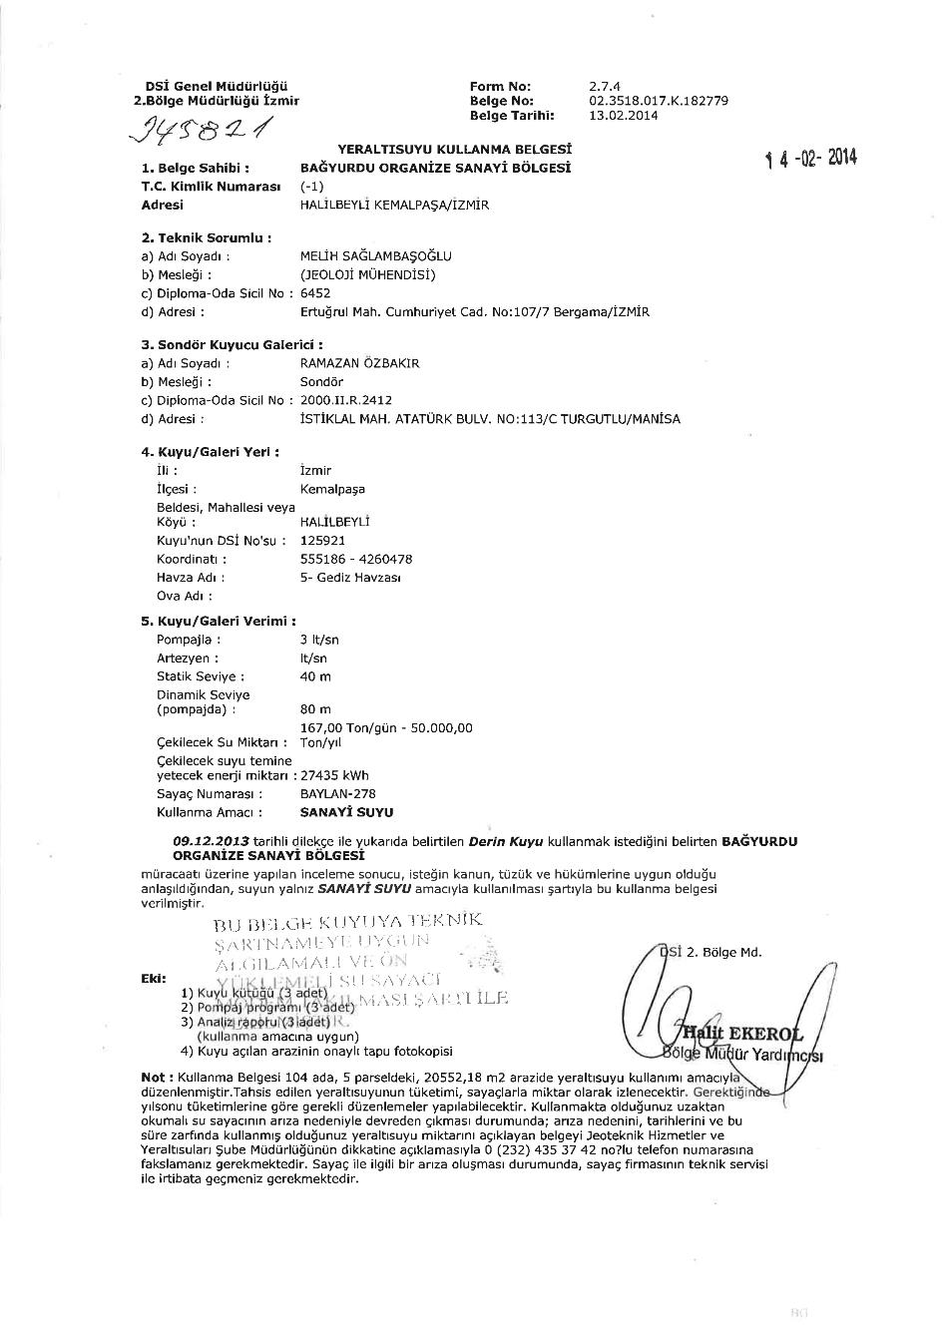
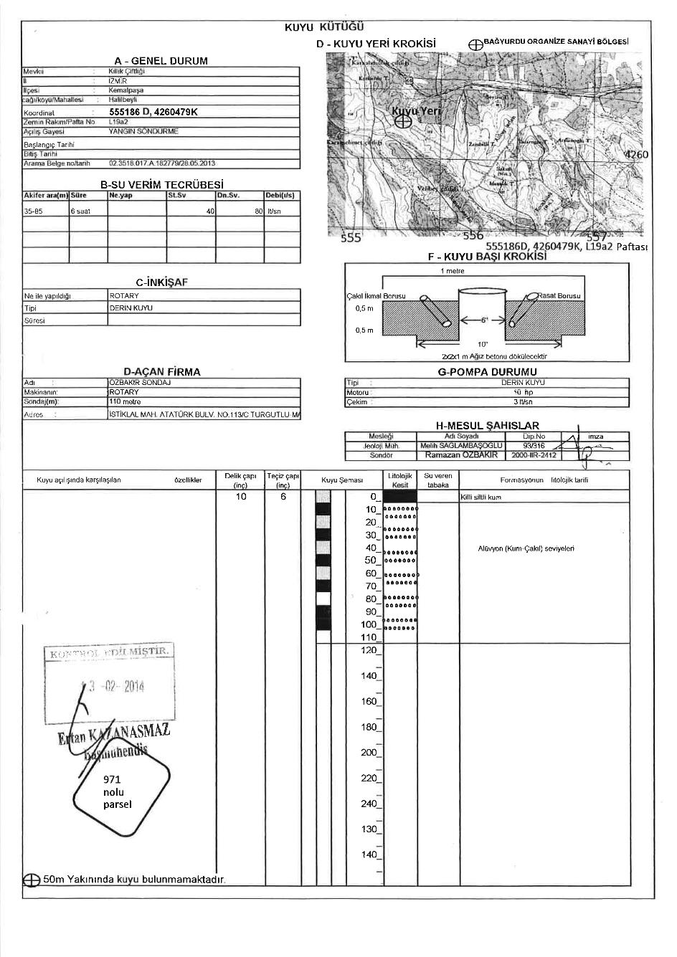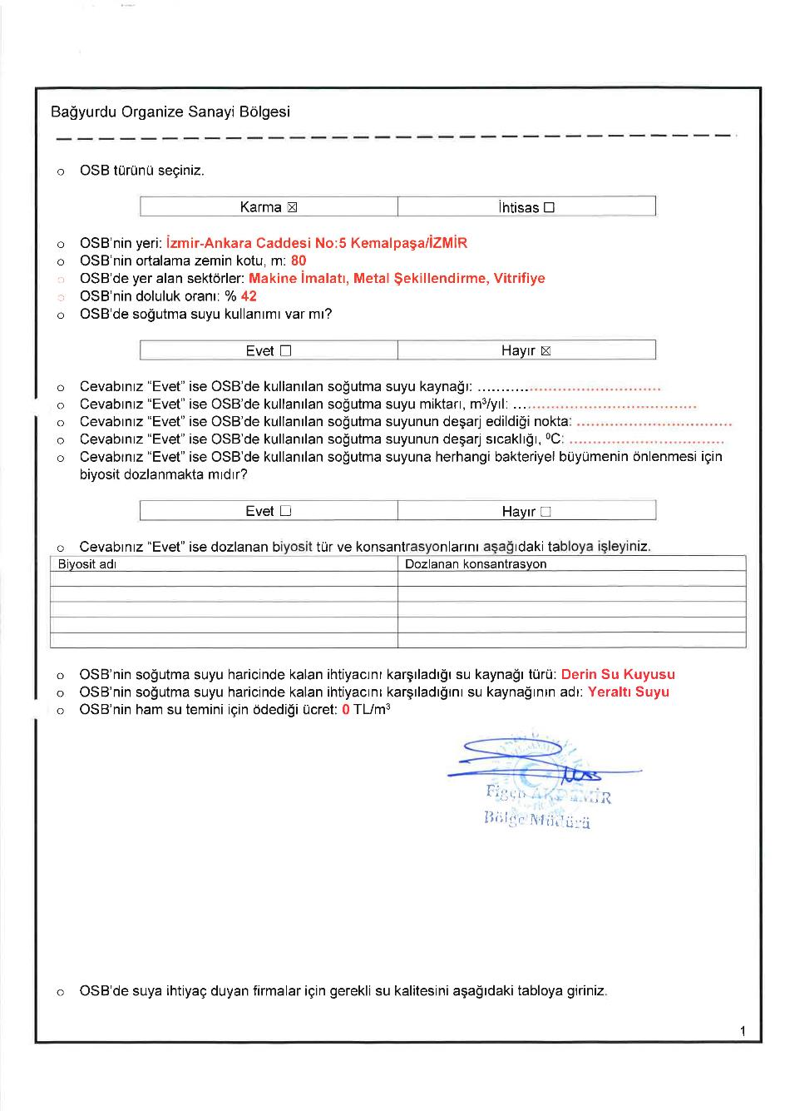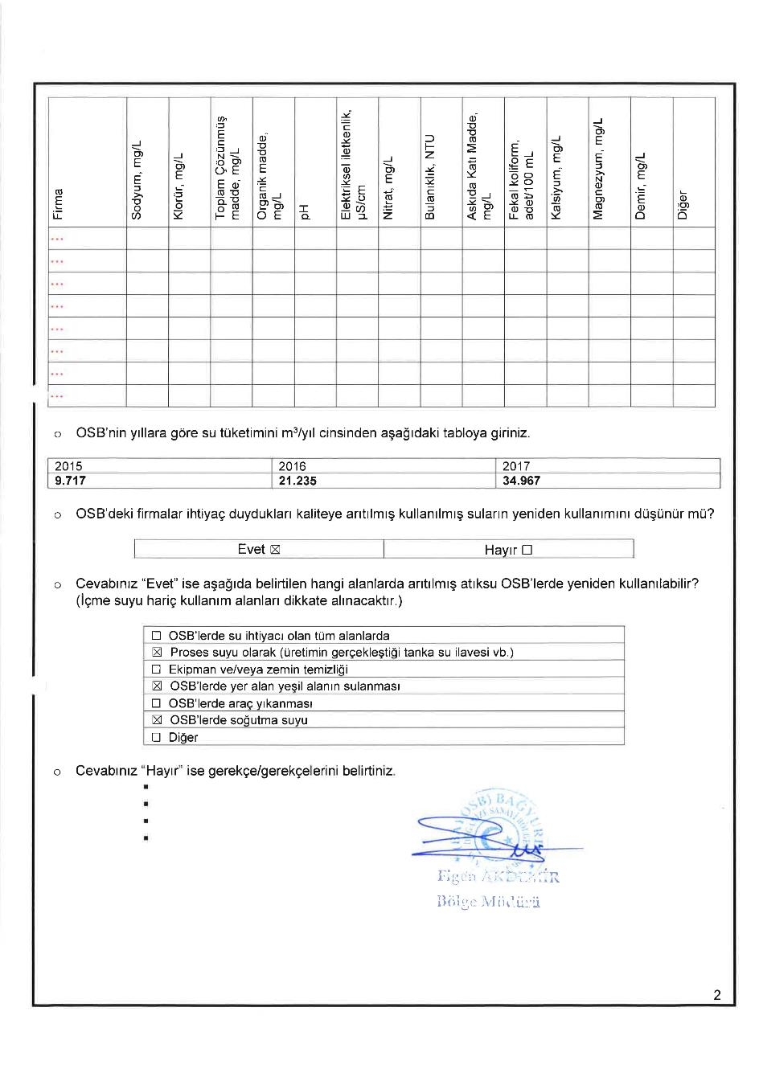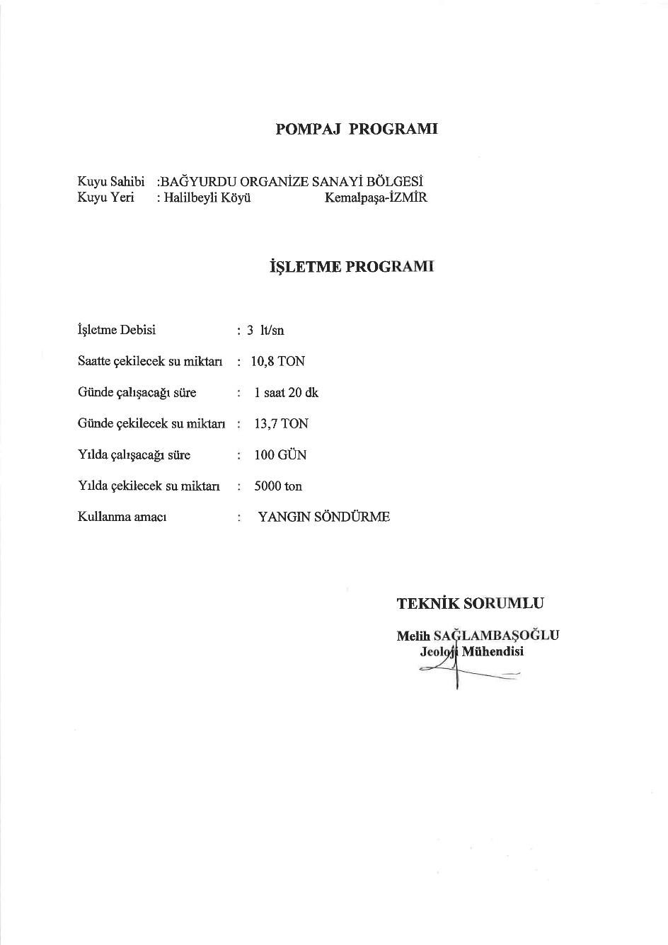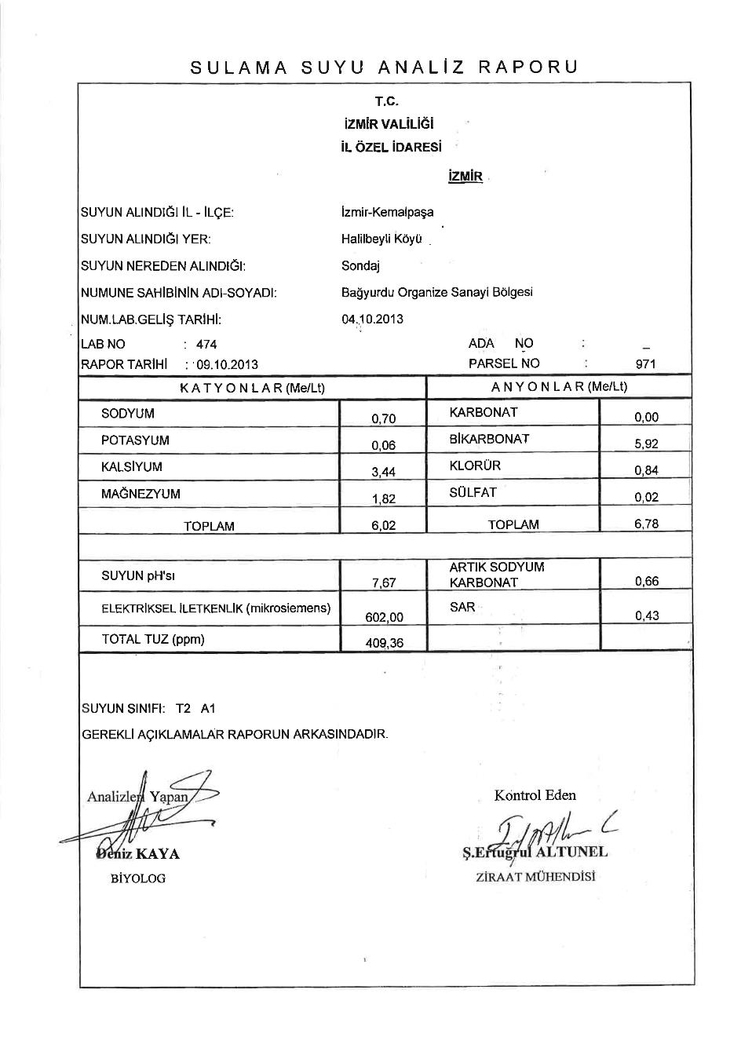

Wastewater Intake Protocol between Kemalpaşa OIZ and BOIZ
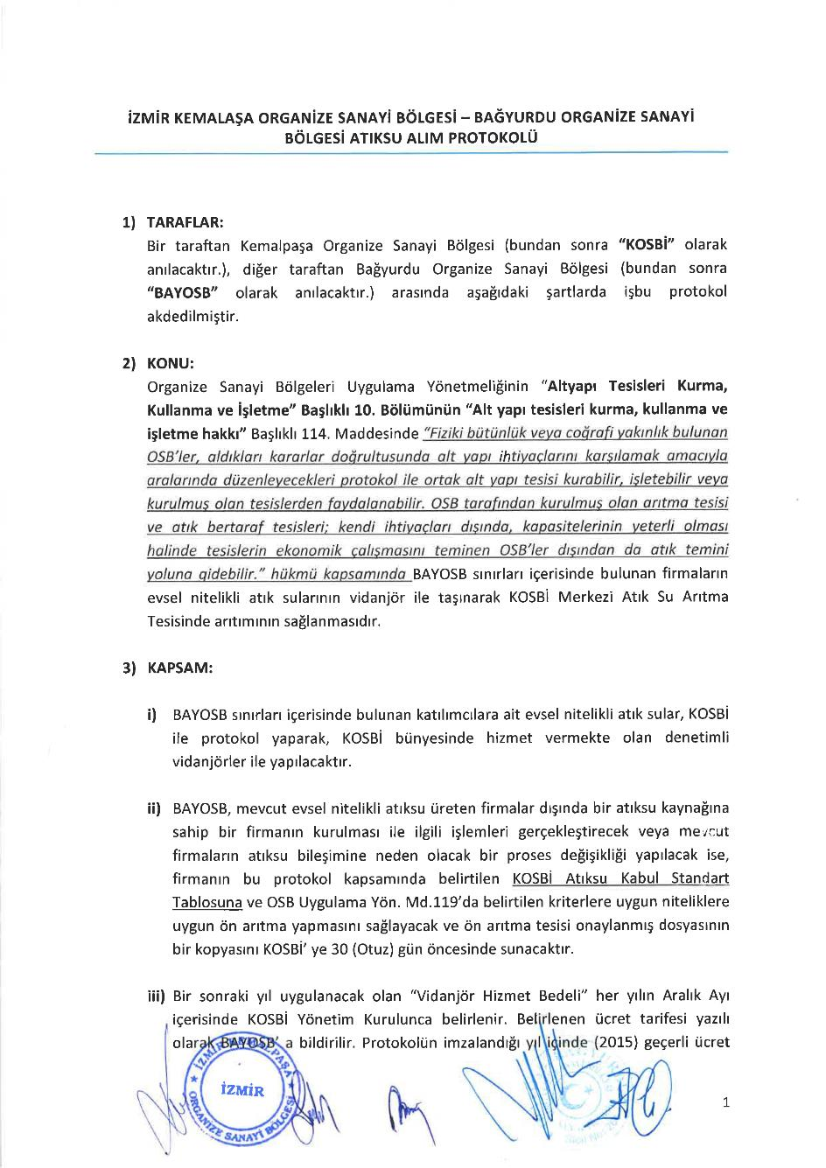
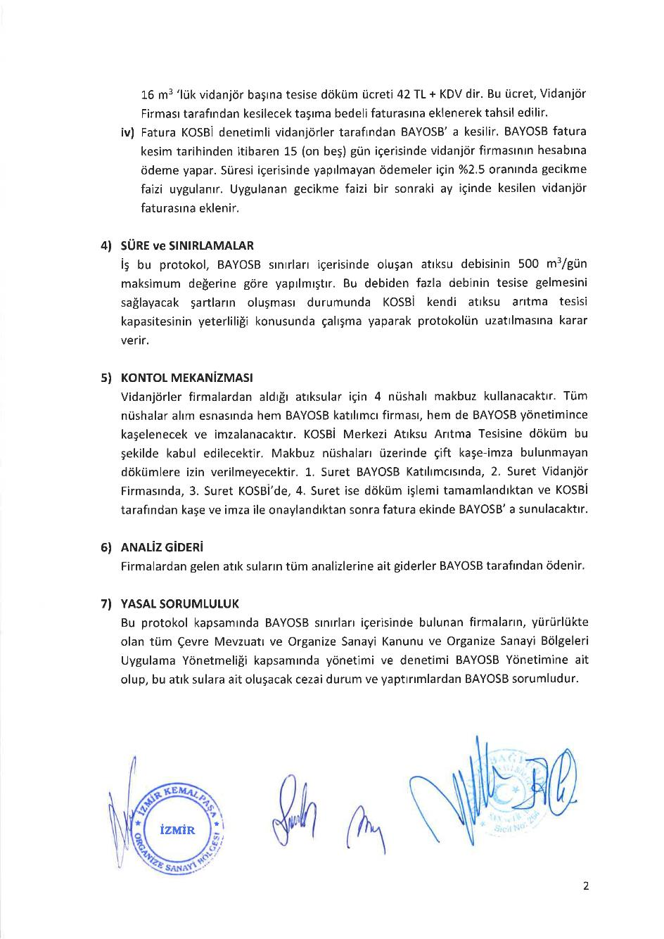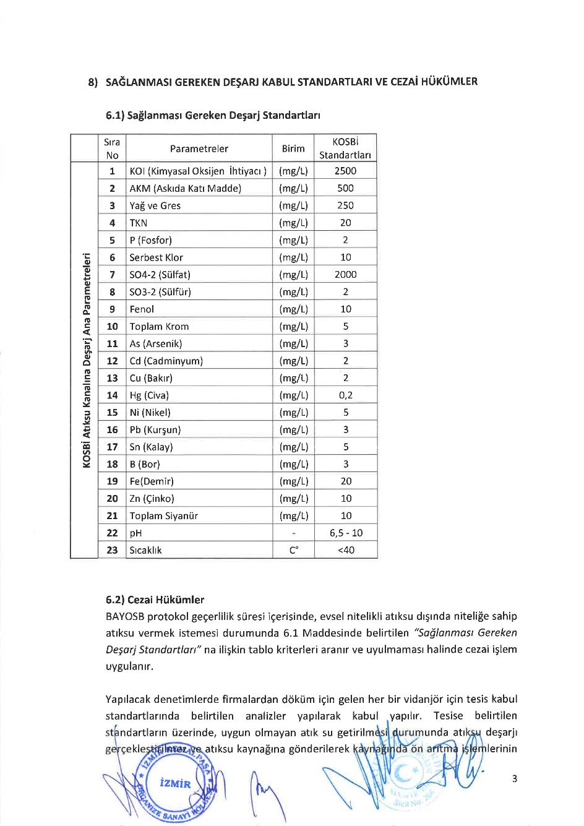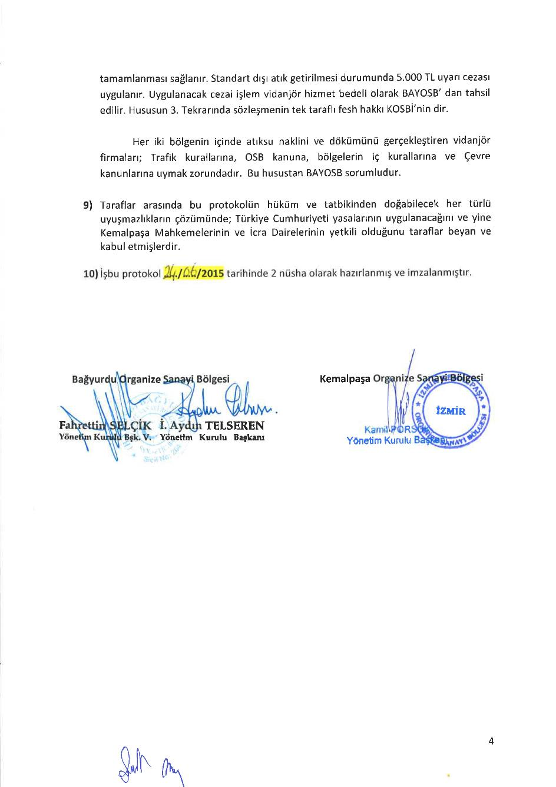

Waste Agreement between Süreko Waste Management Inc. and BOIZ 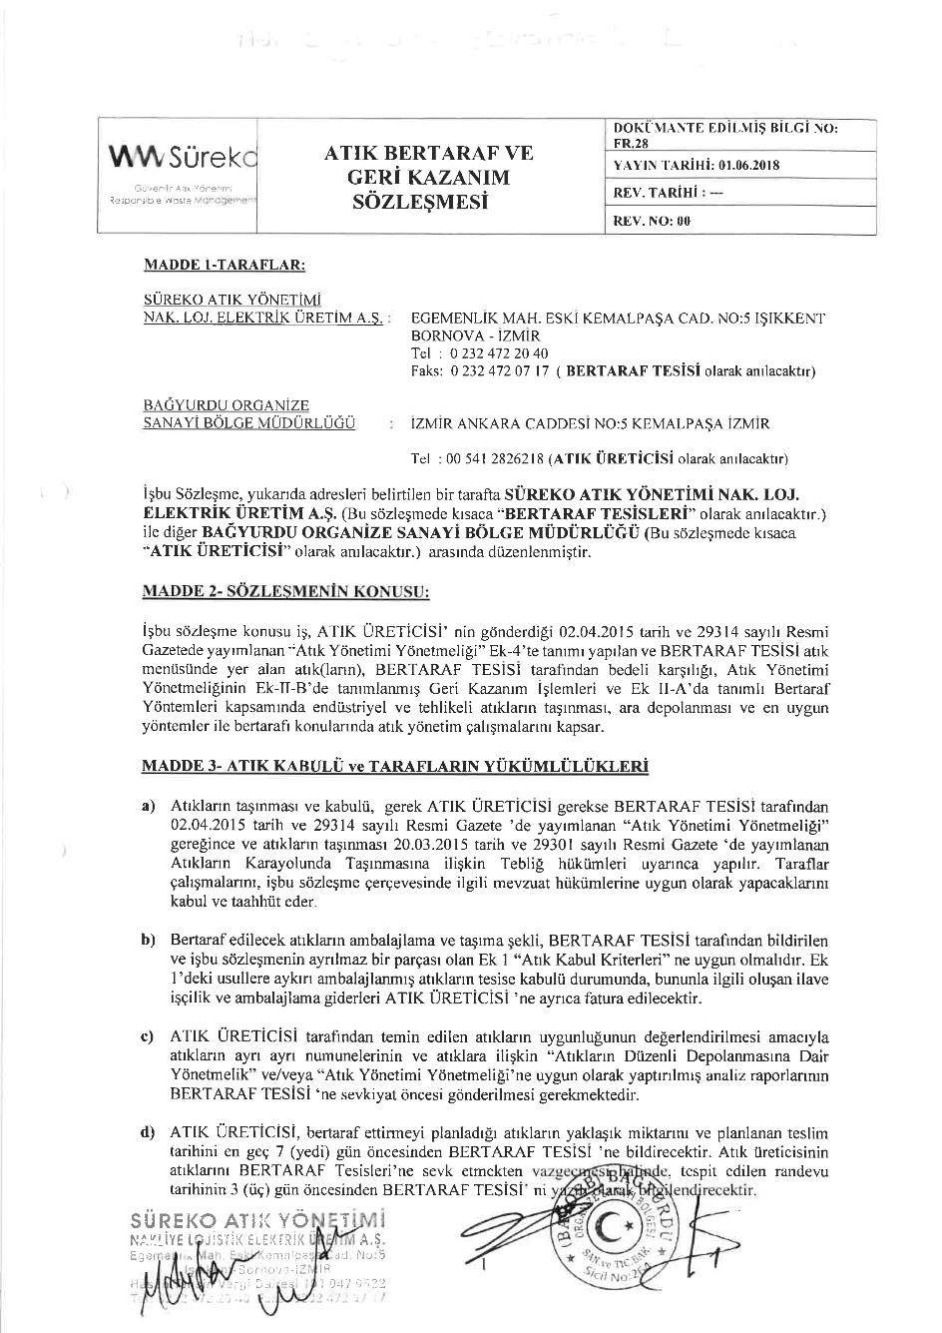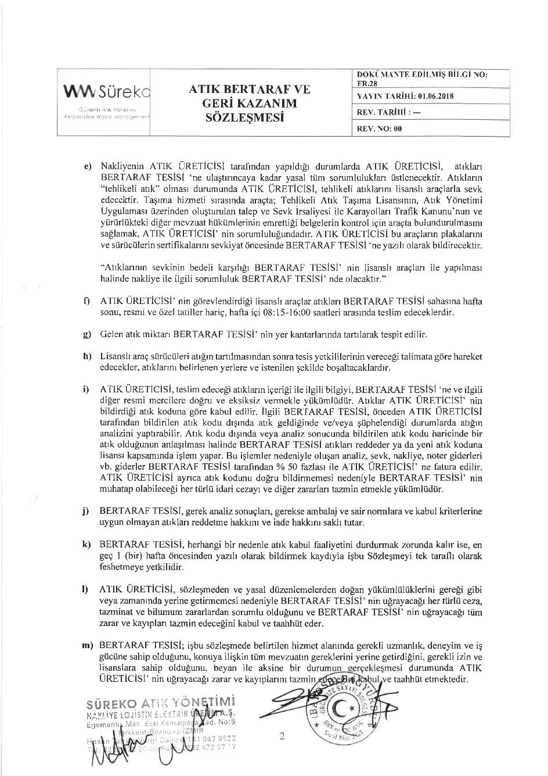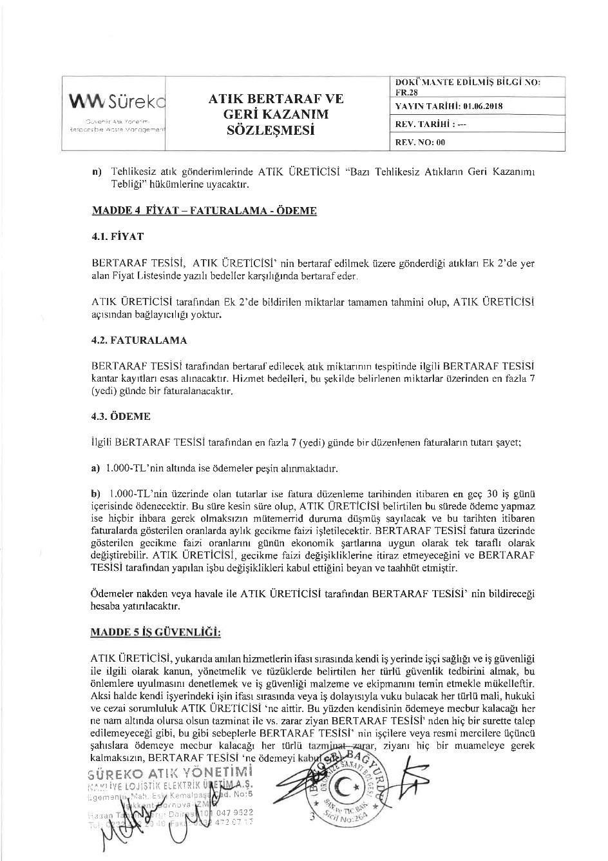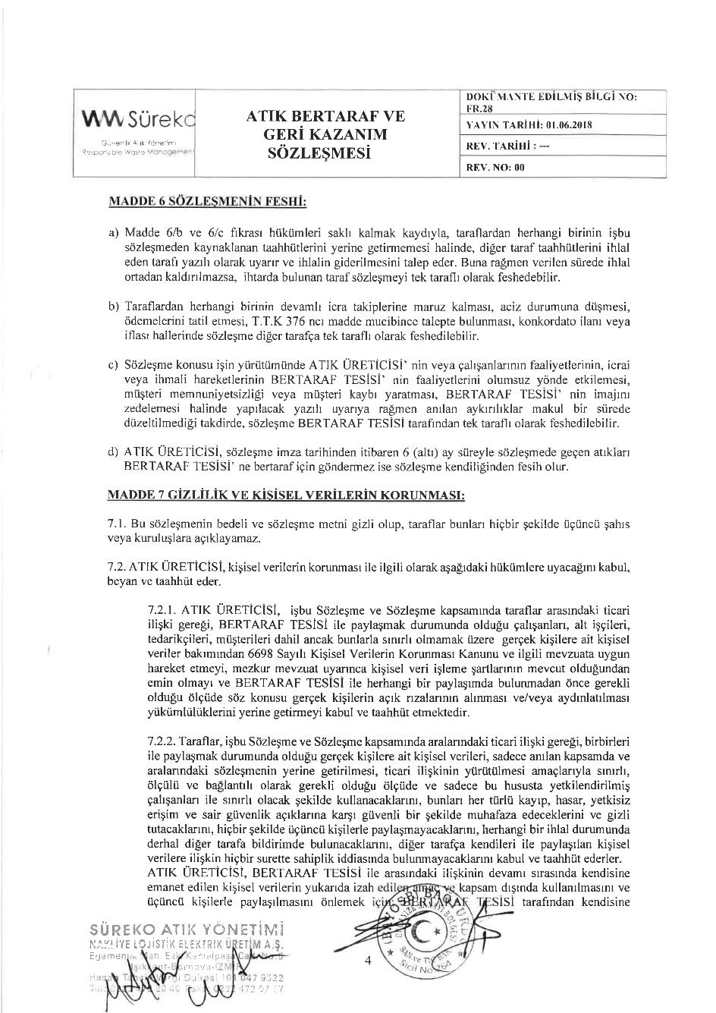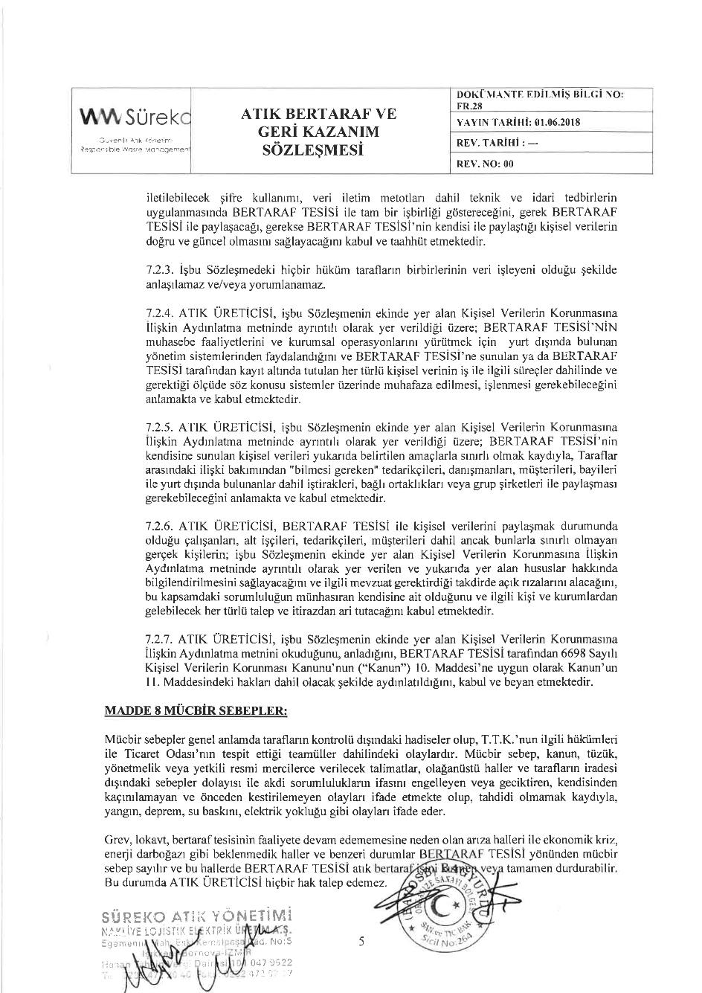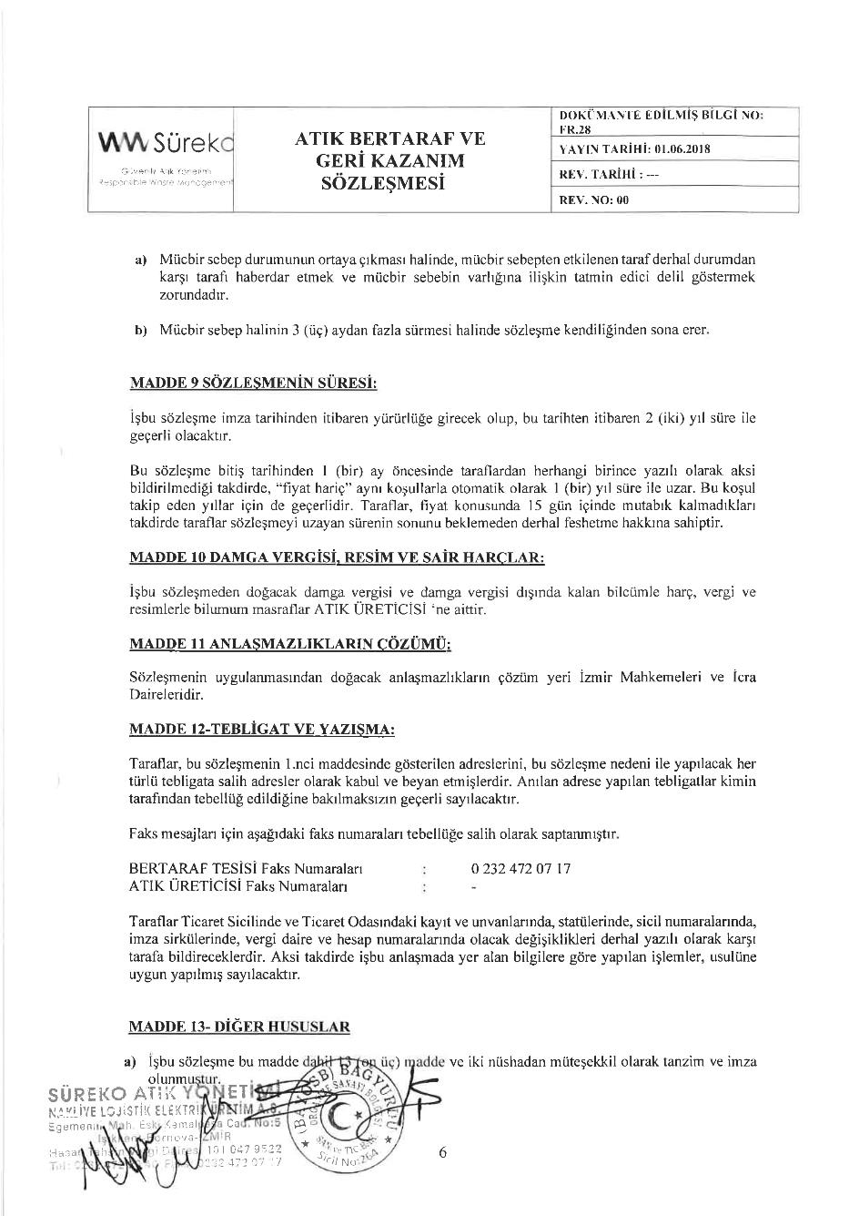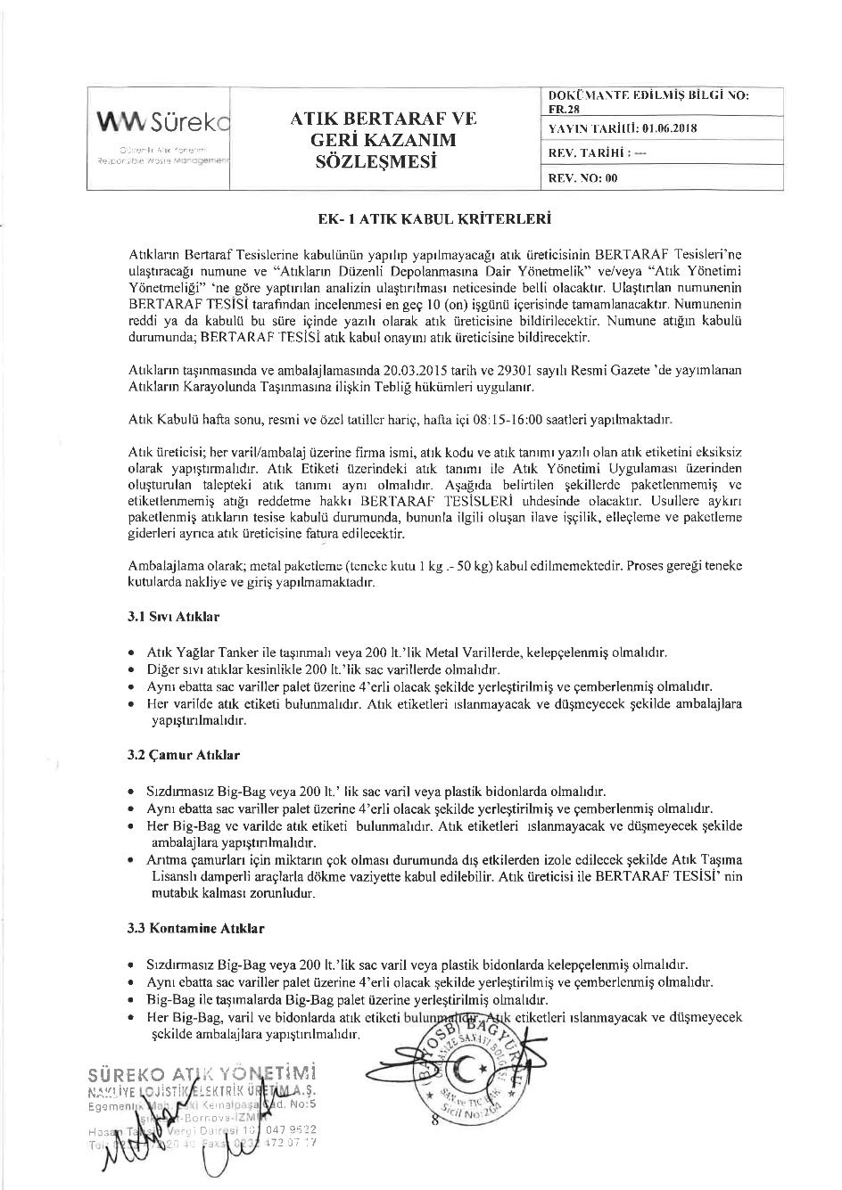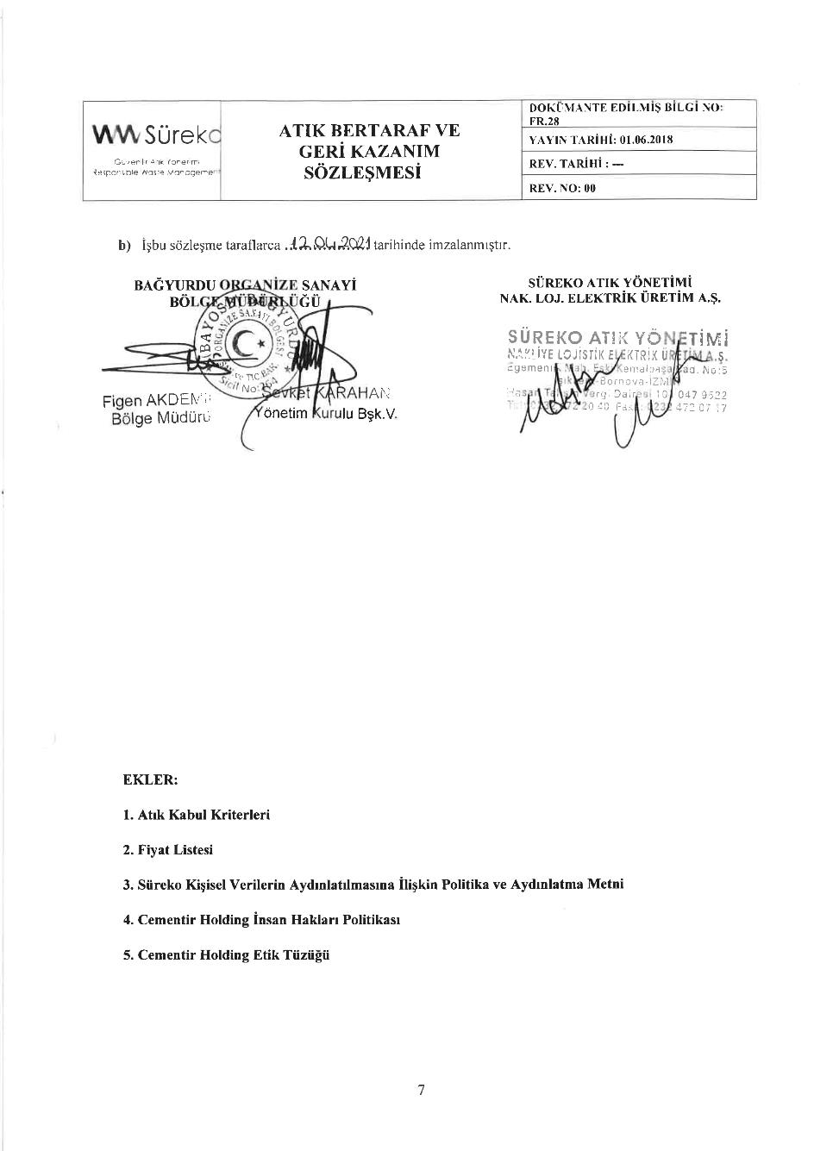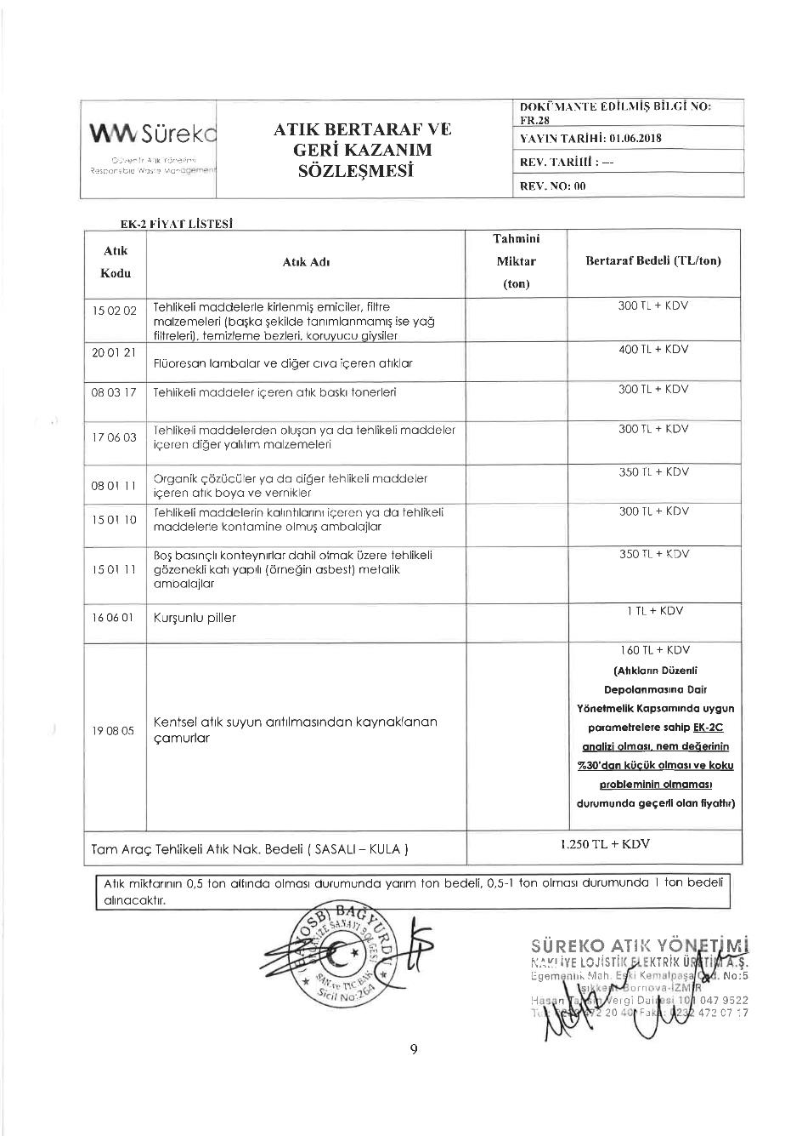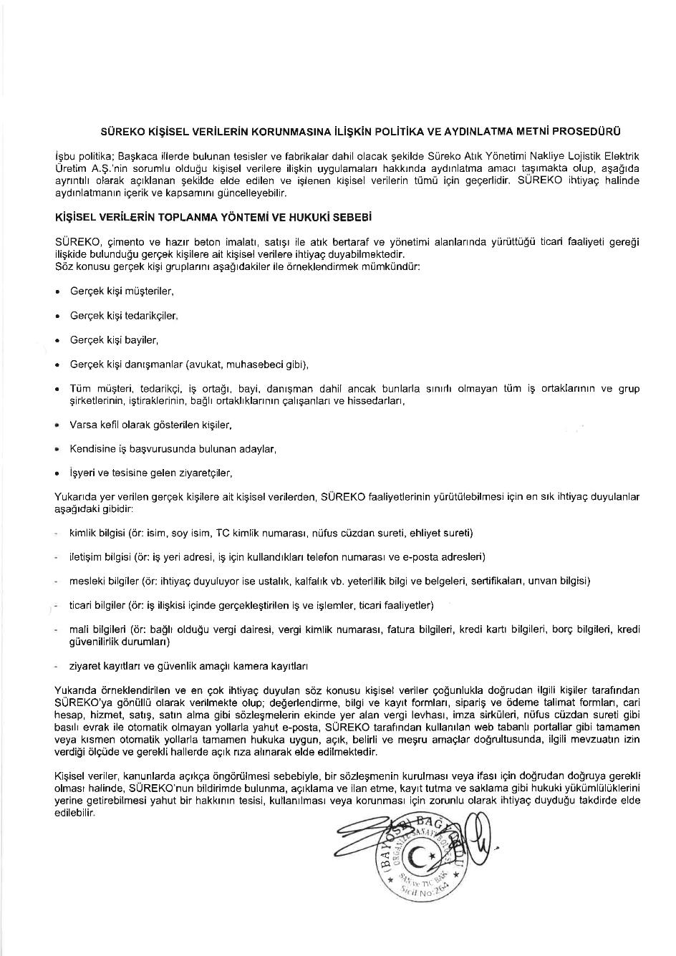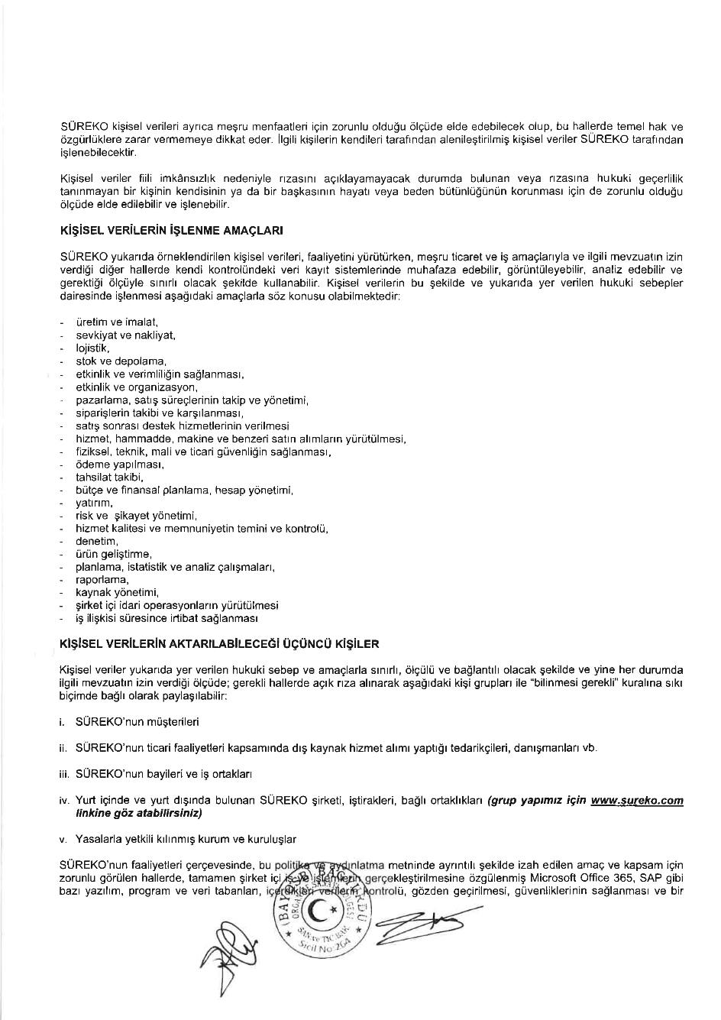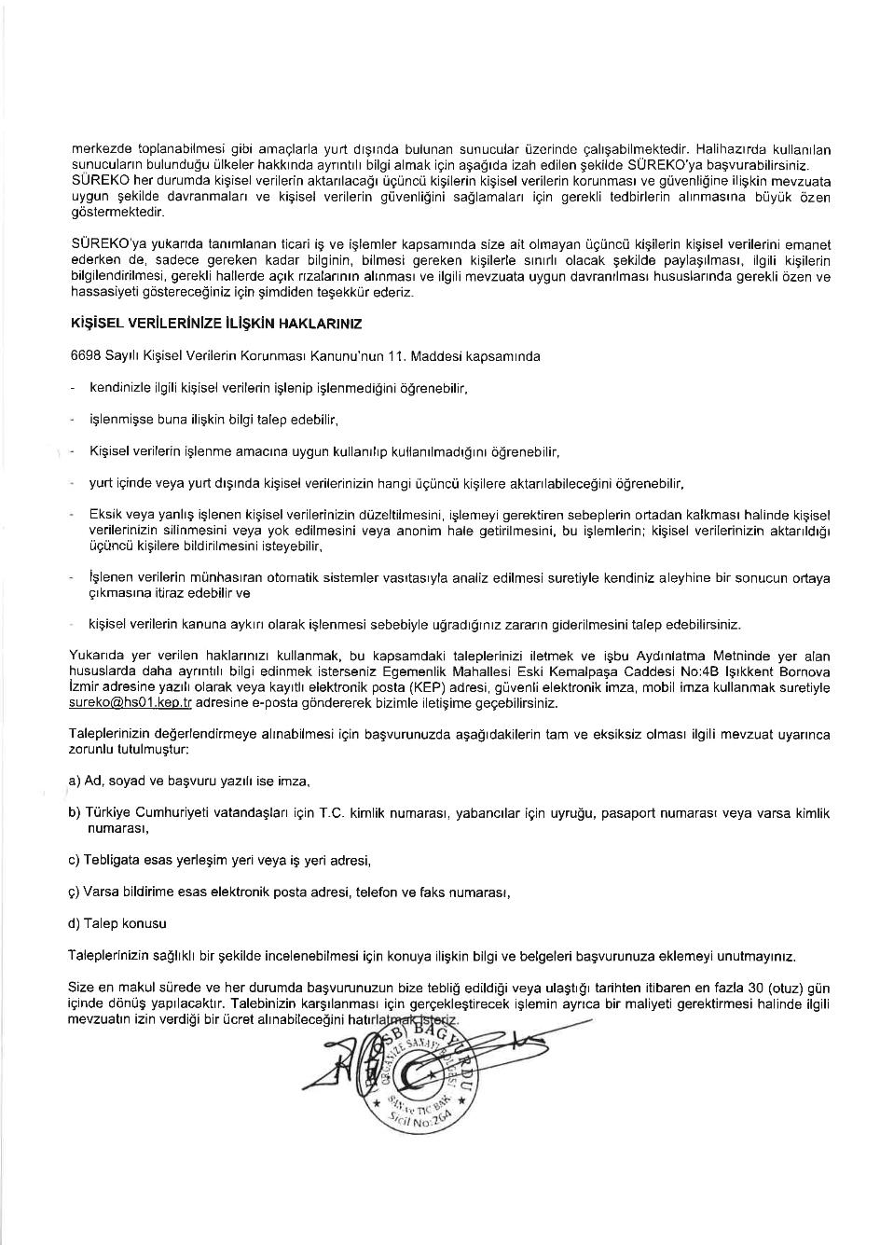

Appendix-E Official Environmental Fine Minute

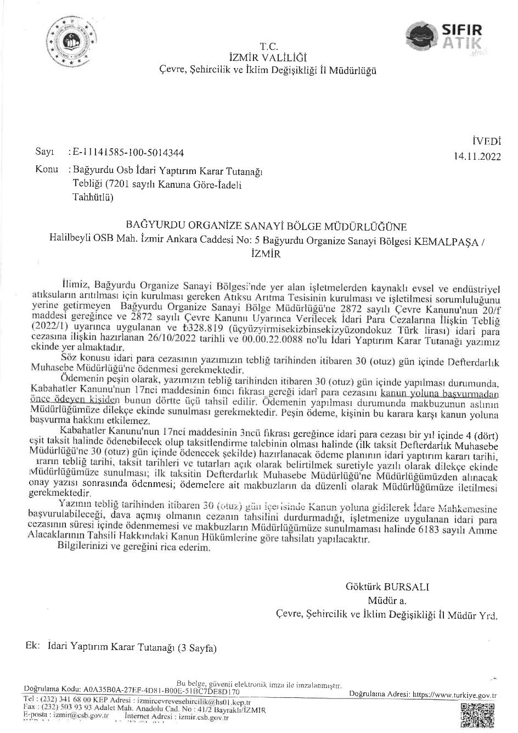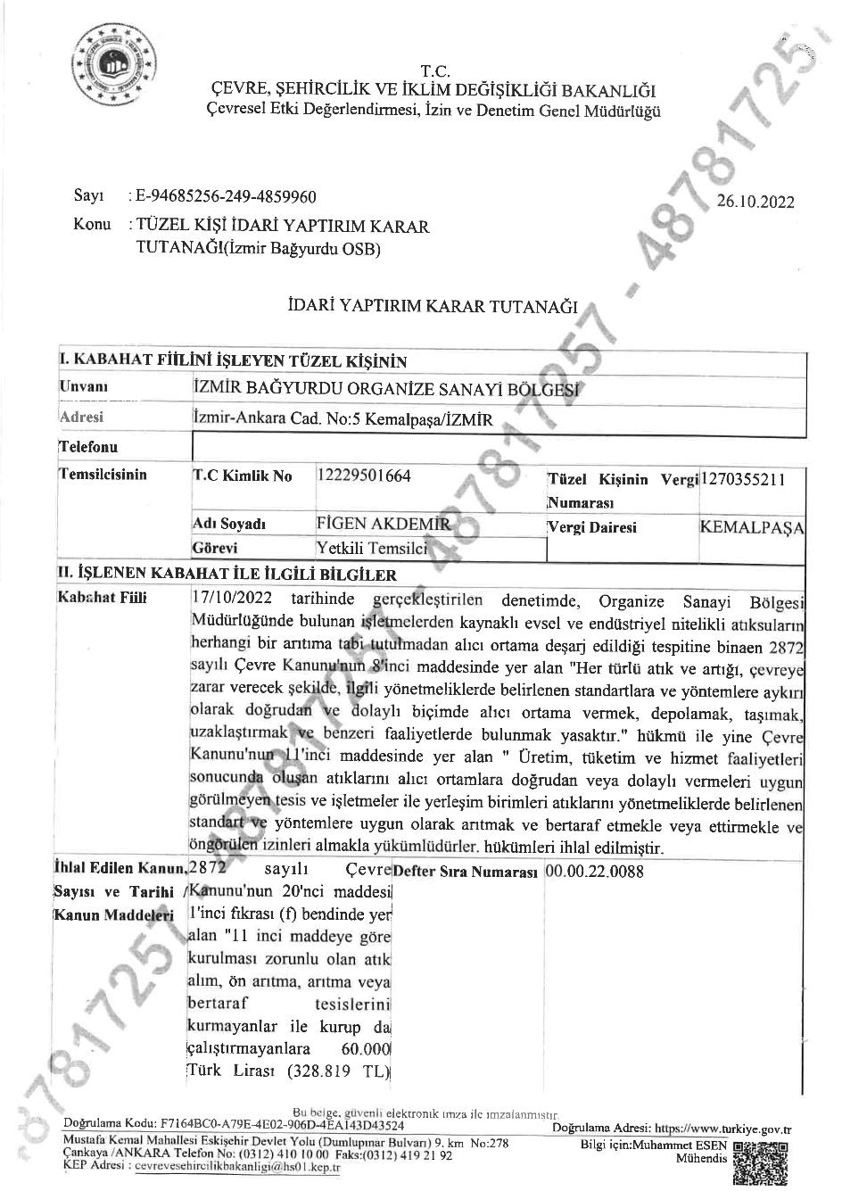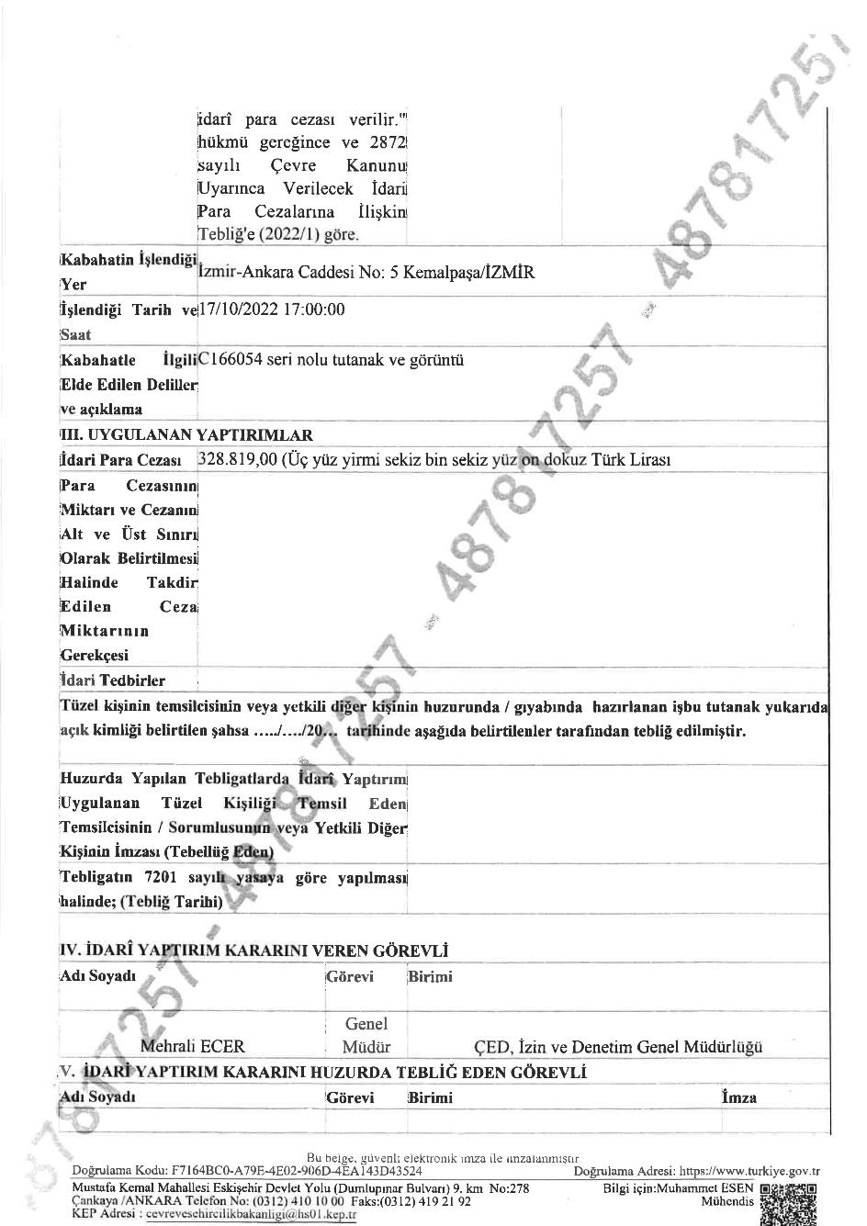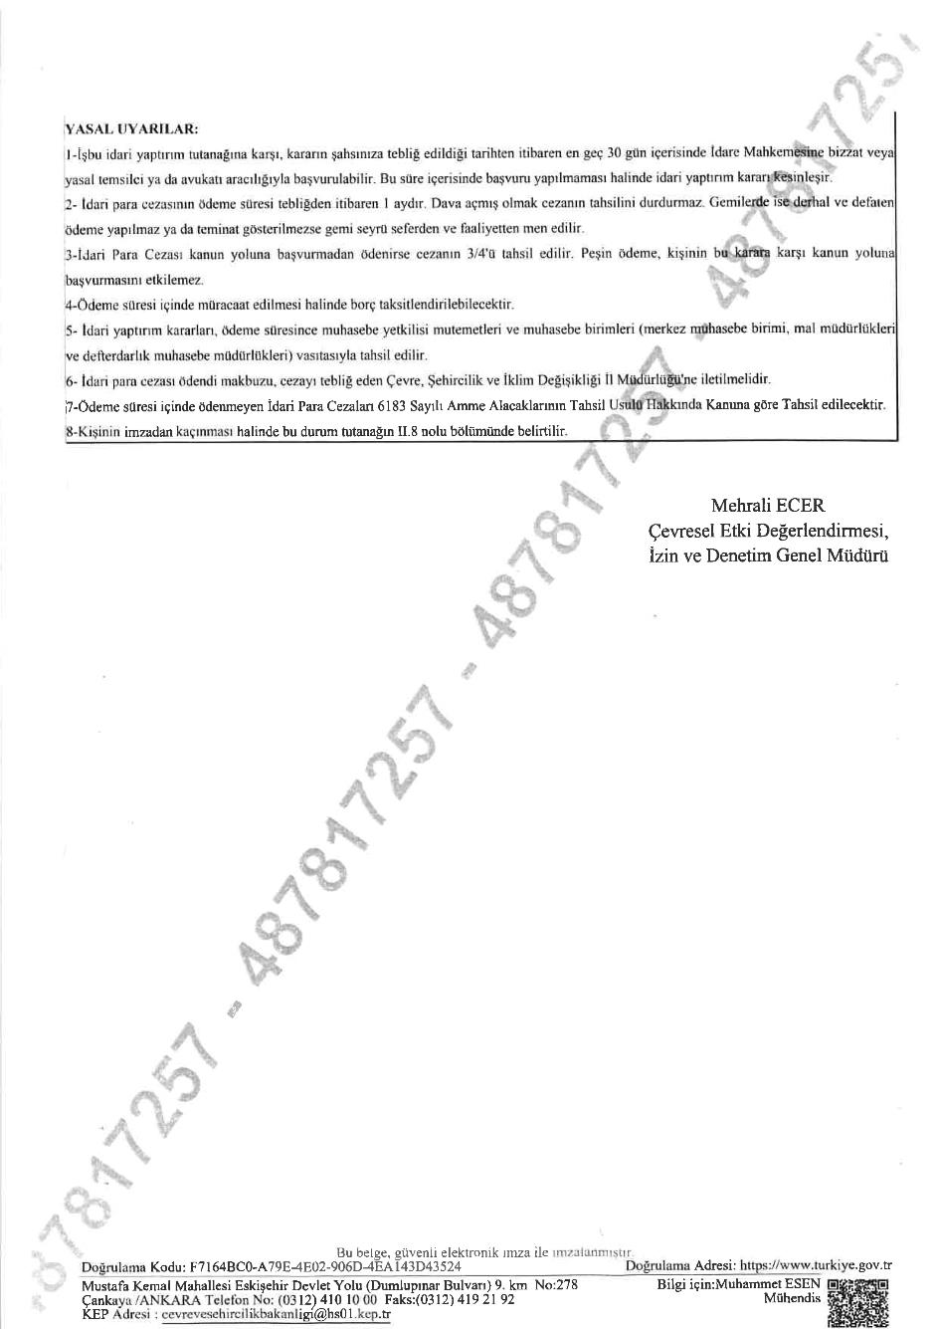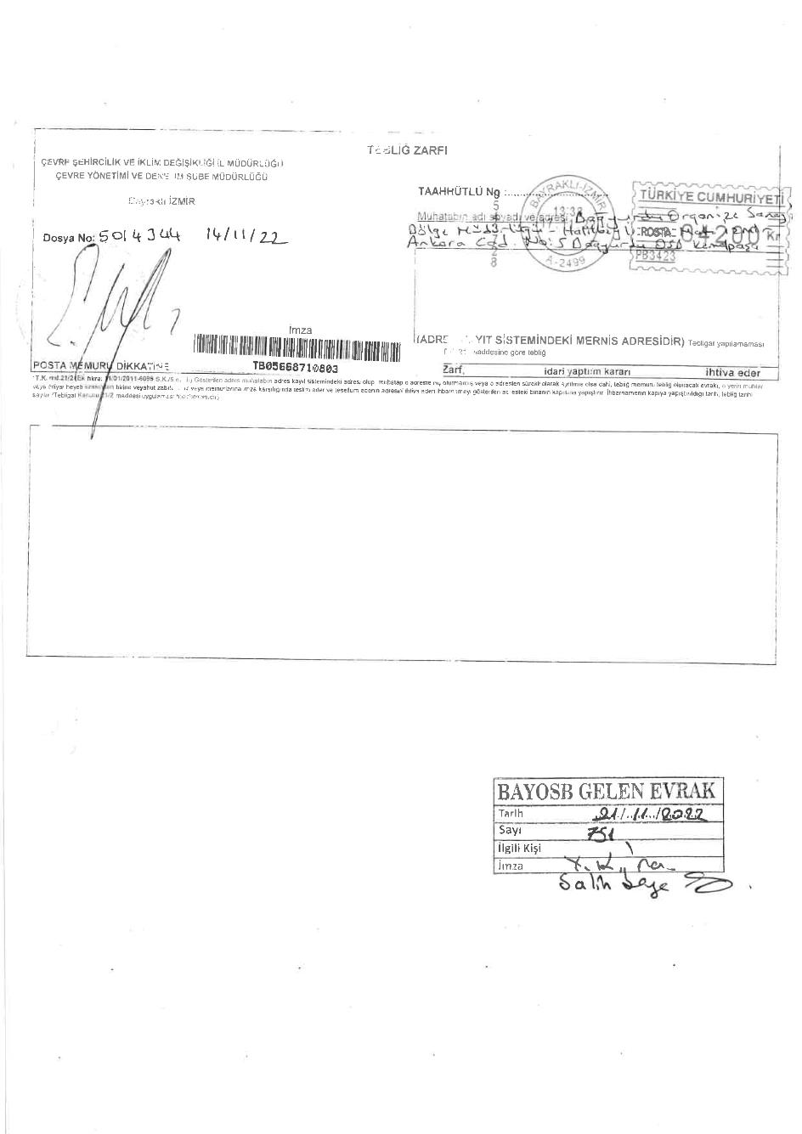

Appendix-F Photographs of the Project Area and BOIZ

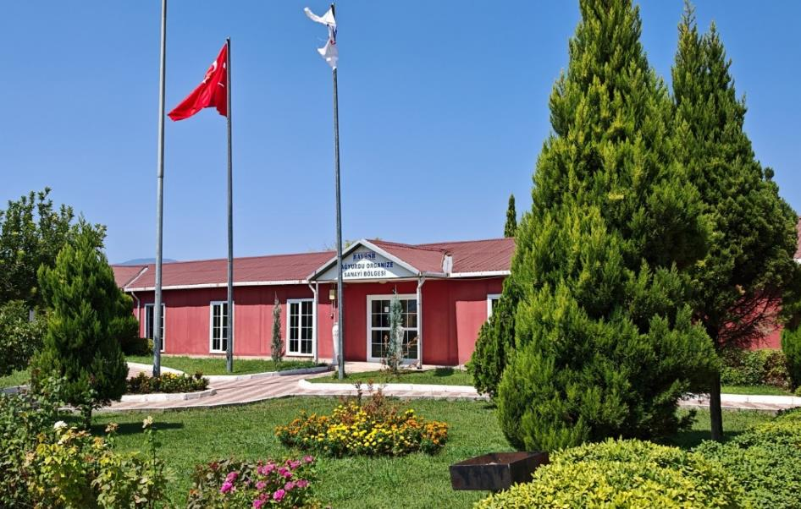
Figure 13-1. The BOIZ Administrative Building
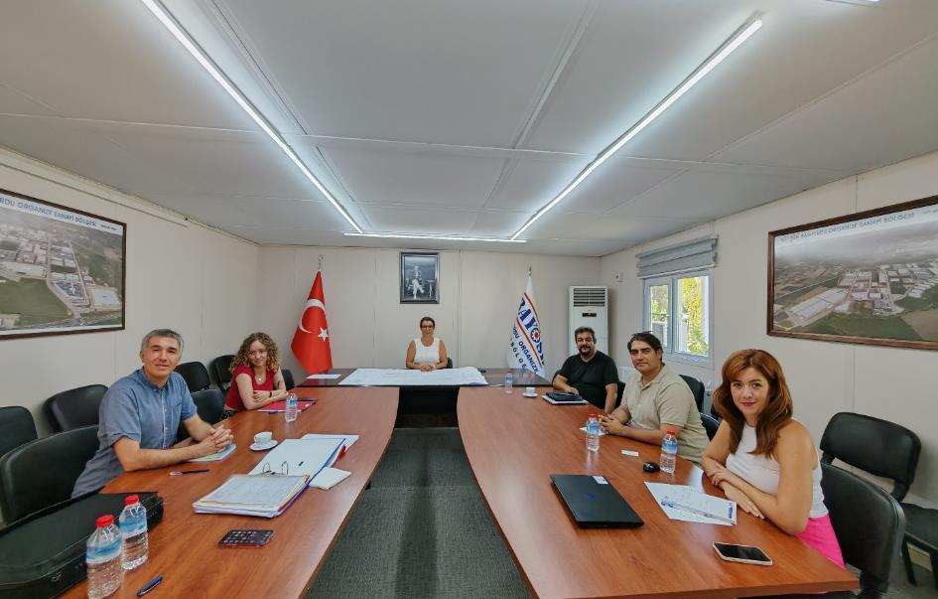
Figure 13-2. The Kick-off Meeting at the BOIZ Administration Building
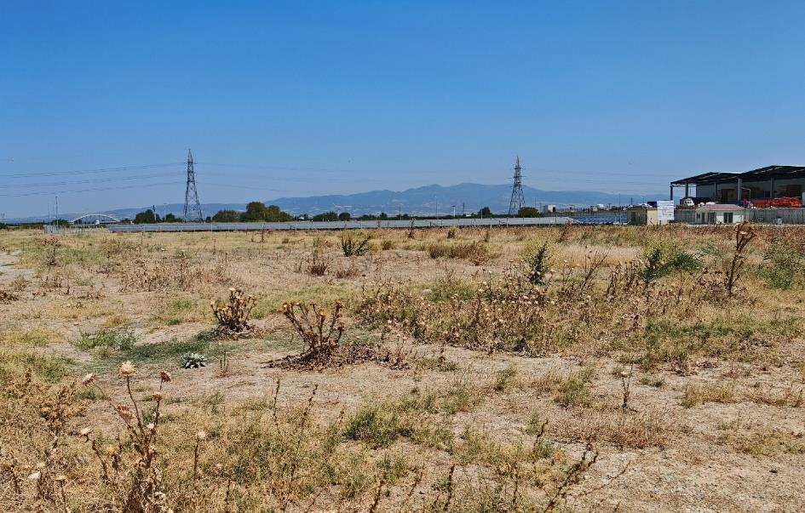
Figure 13-3. The Project Area (North)
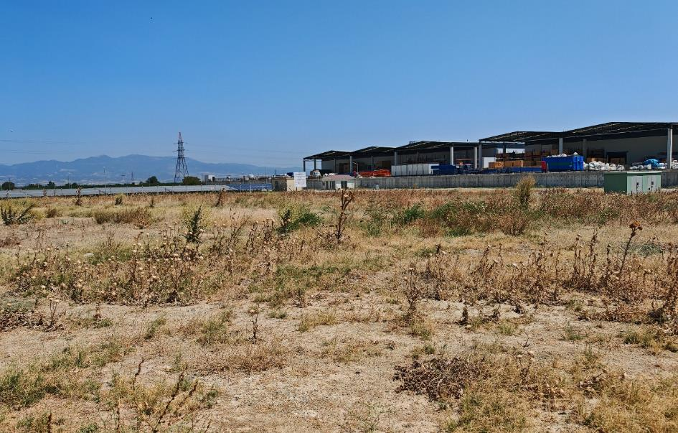
Figure 13-4. The Project Area (North-East)
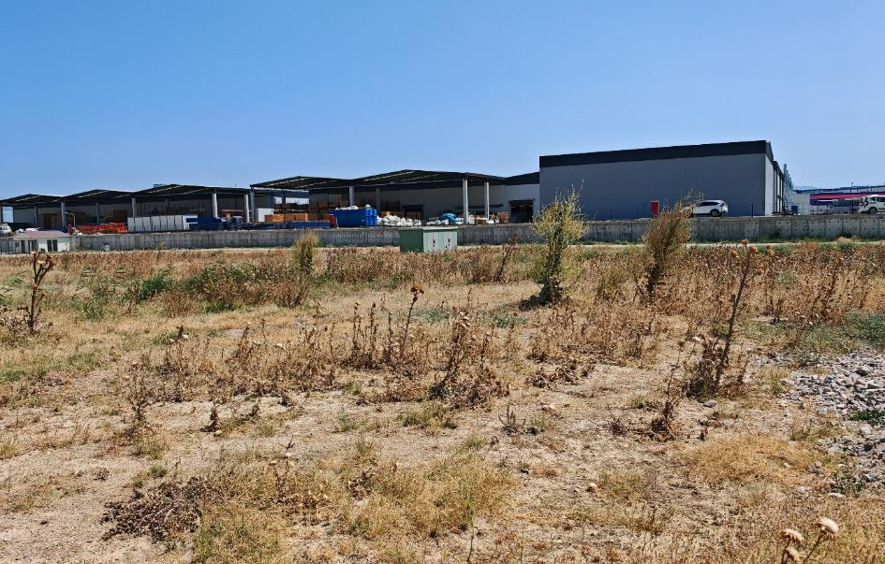
Figure 13-5. The Project Area (East)
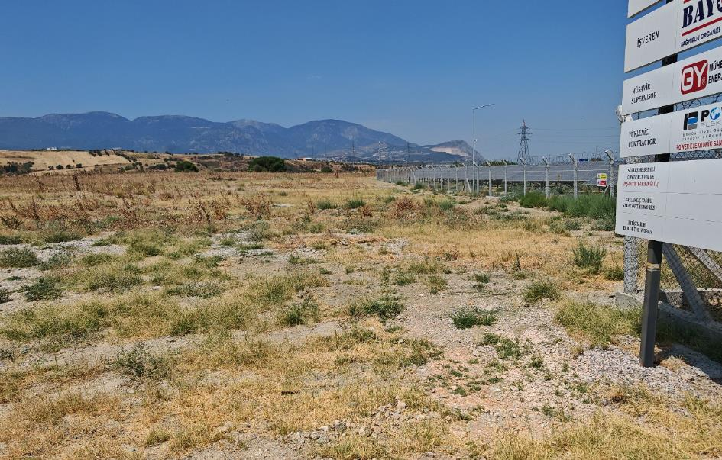
Figure 13-6. The Project Area (West)
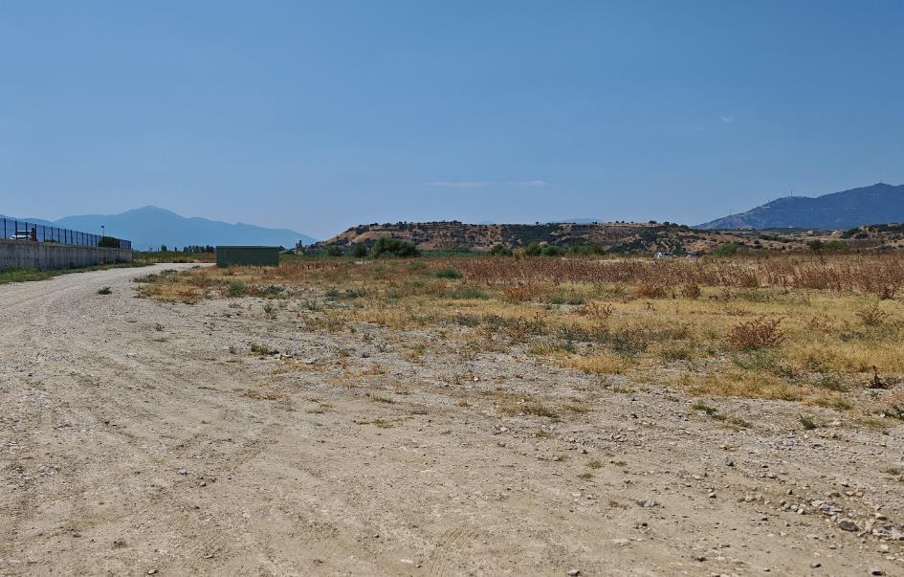
Figure 13-7. The Project Area (South-West)
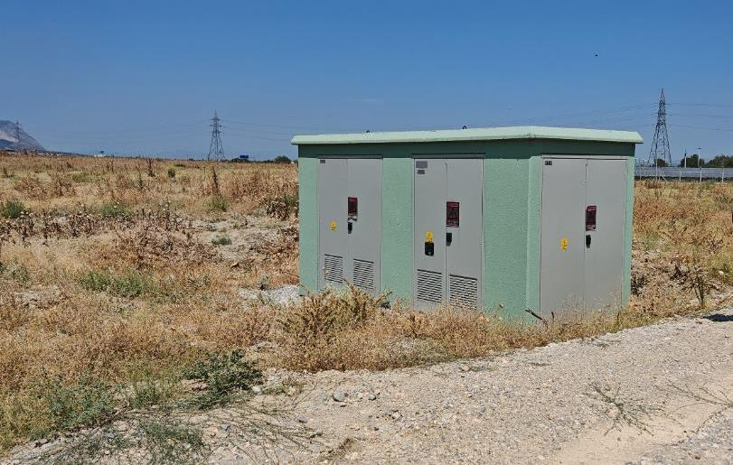
Figure 13-8. The Project Area (Transformer Building)
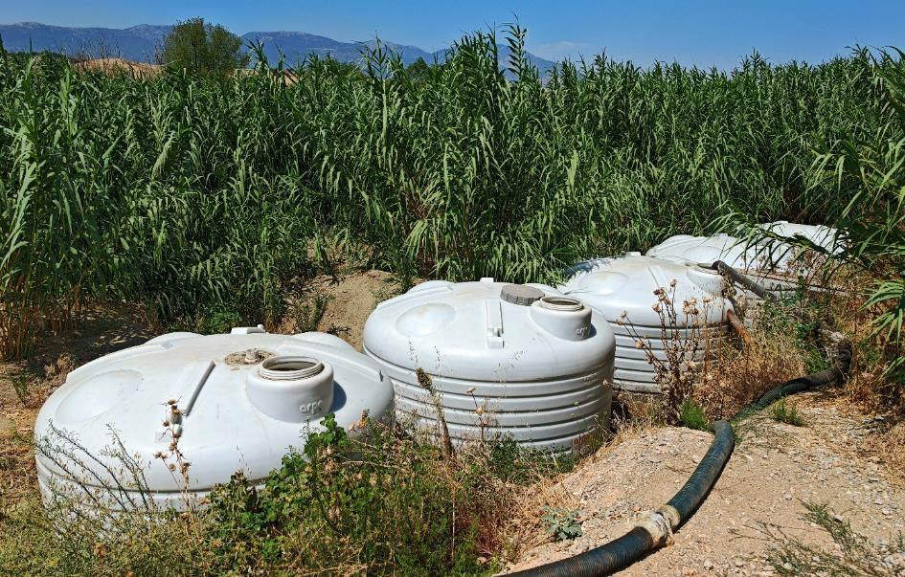
Figure 13-9. The Septic Tanks in the BOIZ Area
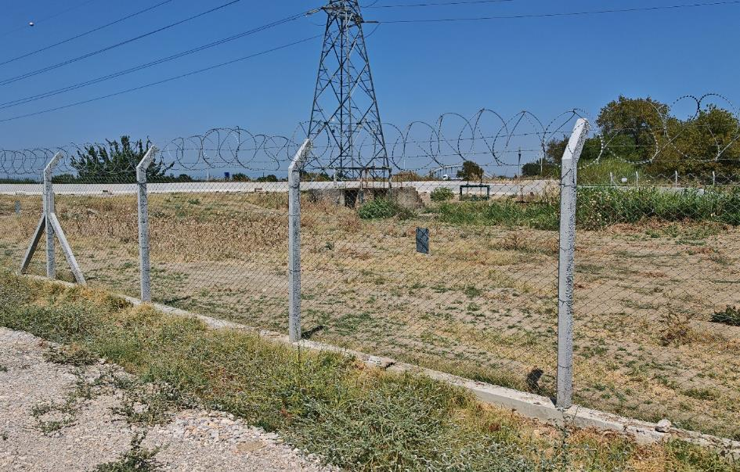
Figure 13-10. The DSI Canal Near the BOIZ Area
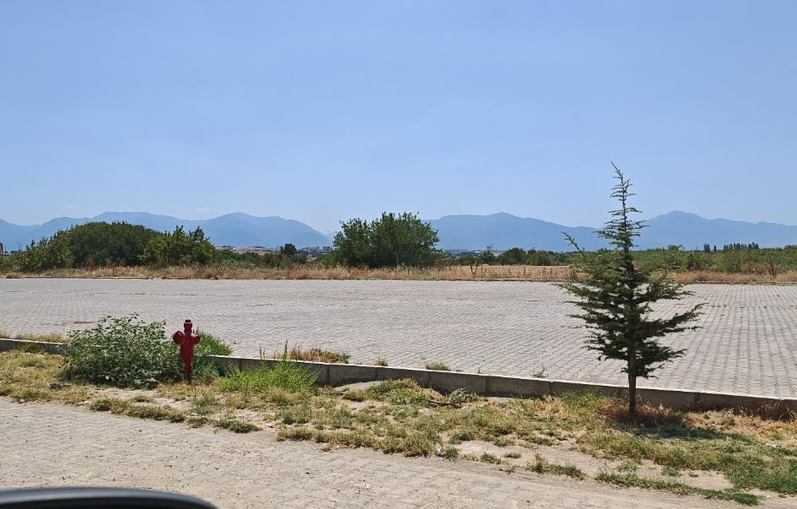
Figure 13-11. The Parking Area of the BOIZ
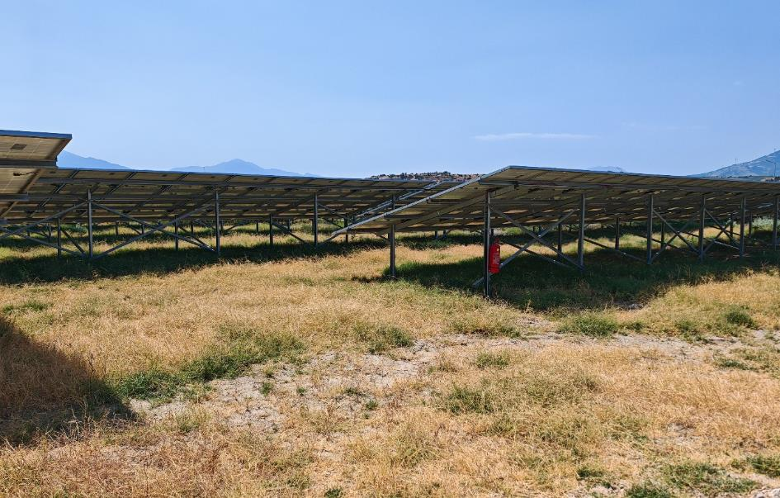
Figure 13-12. The SPP Area of the BOIZ
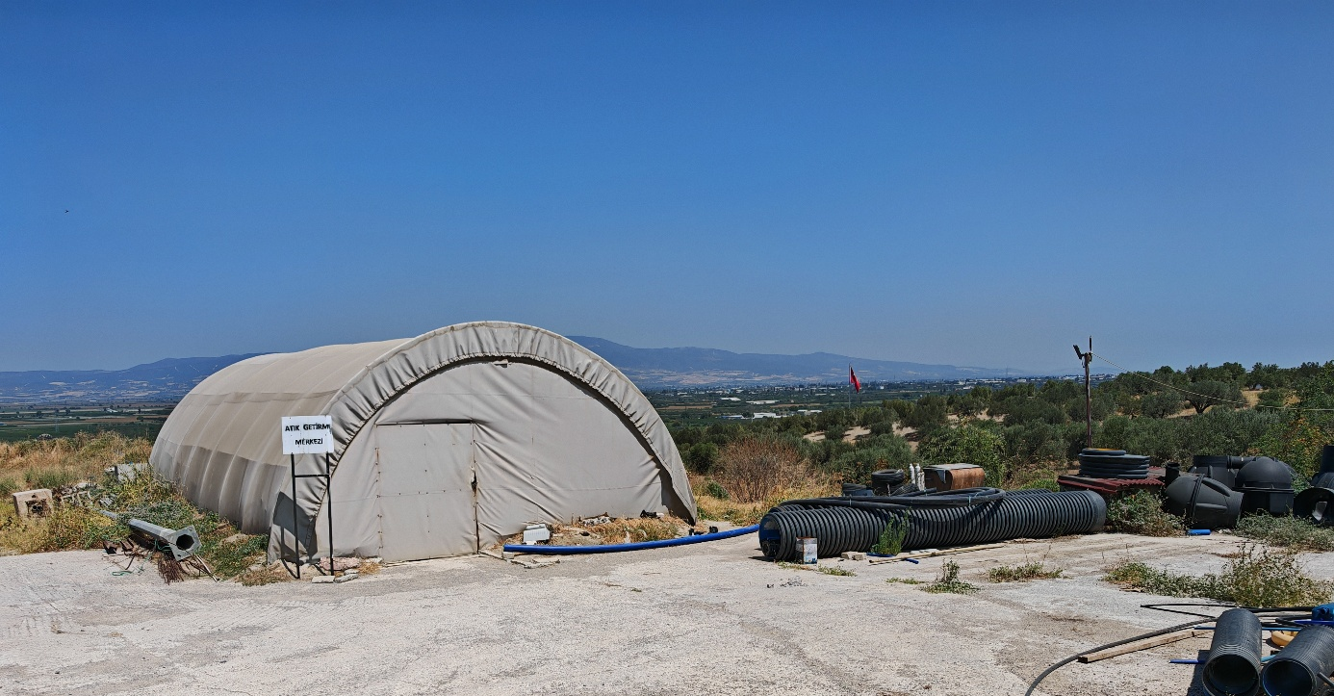
Figure 13-13. Waste Collection Centre of the BOIZ

Appendix-G National Environmental and Social Legal and Policy Framework Table

National Environmental, Legal and Political Framework
General |  | Relevancy/Implications for the Project
Law on Organized Industrial Zones | Law No. 4562; OG. No. 24021 dated 15.04.2000 | As the Project is the OIZ area, the provisions of this general law for the OIZ should be followed.
Environmental Impact Assessment |  | Relevancy/Implications for the Project
Environmental Law | Law No: 2872; Date of Ratification: 1983 | It is the general law that regulates the main environmental rules for all activities to be carried out during the lifetime of the Project.
Regulation on Environmental Impact Assessment | OG. No. 31907 dated 29 July, 2022 | It is the regulation that regulates the national environmental impact assessment processes in Türkiye. In this context, it has been secured the EIA out-of-scope official letter. (see Appendix-C)
Regulation on Environmental Permit and License | OG. No. 29115 dated 10 September 2014 | It is the regulation that regulates the national environmental permit and license processes of the Project’s operation phase.
Water |  | Relevancy/Implications for the Project
Groundwater Law | Law No: 167; Date of Ratification: 1960 | It is the general law on the use of groundwater. Thus, compliance with this law should be ensured due to the well used within the Project’s AoI.
Regulation on Control of Water Pollution | OG. No. 25687 dated 31 December 2004  (Last amendment on 12 May 2023 with OG. No. 32188) | The Project is subject to the regulation due to activities that may cause water pollution within the Project’s AoI during the lifetime of the Project.
Communiqué on Wastewater Treatment Plants Technical Processes | OG. No. 27527 dated 20 March 2010  (Last amendment on 25 October 2022 with OG. No. 31994) | This communiqué sets out the standards for the reclamation of water to be treated for irrigation purposes within the scope of the Project.
Regulation on the Monitoring of Surface Waters and Groundwater | OG. No. 28910 dated 11 February 2014 | Compliance with this regulation should be ensured due to the well used (or planned to be used) within the scope of the Project.
Regulation on Identification of Sensitive Water Bodies and the Areas Affecting These Water Bodies, and Remediation of Water Quality | OG. No. 29927 dated 23 December 2016 | According to this regulation, the Project Area falls within the Nitrate Sensitive Area and Urban Sensitive Area of the Gediz Basin.
Regulation on Water Intended for Human Consumption | OG. No. 25730 dated 17 February 2005 | Compliance with this regulation should be ensured due to the monitoring of the suitability for human consumption of the wells used and packaging water within the scope of the Project.
Regulation on Surface Water Quality | OG. No. 28483 dated 30 November 2012  (Last amendment on 1 February 2023 with OG. No. 32091) | Due to the effluent sourced from the Project within the Project’s AoI, it should comply the provision of the regulation.
Regulation on the Quality and Treatment of Water intended for Potable Water Supply | OG. No. 30823 dated 06 July 2019 | Compliance with this regulation should be ensured due to the controlling of the suitability as potable water supply from the wells used and packaging water within the scope of the Project.
Regulation on Protection of Drinking-Potable Water Basins | OG. No. 30224 dated 28 October 2017 | Due to the existence of the wells used and the potential impacts of the Project’s effluent within the Project’s AoI, the provisions of the regulation should be complied with.
Regulation on Control of Water Losses in Water Supply and Distribution Systems | OG. No. 28994 dated 08 May 2014 | Due to the potential impacts of the well used on groundwater within the Project’s AoI, the provisions of the regulation should be complied with.
Regulation on the Protection of Water Against Agricultural Nitrate Pollution | OG. No. 29779 dated 23 July 2016 | Due to the potential impacts of the Project within the Project’s AoI, the provisions of the regulation should be complied with.
Regulation on the Control of Pollution caused by Hazardous Materials in and around Water Sources | OG. No. 26005 dated 26 November 2005 | The Project is subject to the regulation due to the impacts on the water and its surroundings that may occur during the Project lifetime activities within the Project’s AoI.
Regulation on Protection of Groundwater Against Pollution and Deterioration | OG. No. 28257 dated 07 April 2012  (Last amendment on 12 May 2023 with OG. No. 32188) | Due to the potential impacts of the Project’s effluent to the groundwater within the Project’s AoI, the provisions of the regulation should be complied with.
Regulation on the Procedures and Principles to be Followed in Setting the Tariffs for Wastewater Infrastructure and Municipal Solid Waste Disposal Facilities | OG. No. 27742 dated 27 October 2010 | Since the Project is a WWTP Project, the provisions of the regulation should be complied with.
Regulation on Wastewater Collection and Disposal Systems | OG. No. 29940 dated 06 January 2017 | Since the Project is a WWTP Project, the provisions of the regulation should be complied with.
Air |  | Relevancy/Implications for the Project
Regulation on Air Quality Assessment and Management | OG. No. 26898 dated 06 June 2008 | The Project is subject to this regulation due to activities that may cause the deterioration of the air quality during the lifetime of the Project, especially the construction phase of the Project within the Project’s AoI.
Regulation on Control of Exhaust Gas Emission | OG. No. 30004 dated 11 March 2017 | The Project is subject to the regulation due to activities sourced from vehicles that may cause gas emissions during the lifetime of the Project within the Project’s AoI.
Regulation on Control of Industrial Air Pollution | OG. No. 27277 dated 03 July 2009 | The Project is subject to the regulation due to activities that may cause air pollution during the lifetime of the Project, especially the construction phase of the Project within the Project’s AoI.
Odour |  | Relevancy/Implications for the Project
Regulation on the Control of Odour-Creating Emissions | OG. No. 28712 dated 19 July 2013 | The Project is subject to the regulation due to activities to be sourced from WWTP that may cause odour nuisance within the Project’s AoI during the lifetime of the Project.
Soil |  | Relevancy/Implications for the Project
Soil Conservation and Land Use Law and Applicable Regulation | Law No: 5403; OG. No. 25880 dated 03 July 2005  (Last amendment on 5 April 2023 with Amended Law No. 7442) | Due to land use within the scope of the Project, the law and applicable regulation should be complied with.
Regulation on Control of Soil Pollution and Point Source Contaminated Lands | OG. No. 27605 dated 08 June 2010  (Last amendment on 11 July 2013 with OG. No. 28704) | The Project is subject to the regulation due to the suspicion of soil pollution, especially the area for which land preparation has not yet been made in the Project Area.
Noise |  | Relevancy/Implications for the Project
Regulation on the Ambient Noise Emission Caused by Equipment Used Outdoors | OG. No. 26392 dated 30 December 2006 | The Project is subject to the regulation due to the noise that may occur during the use of equipment, especially throughout the construction phase within the Project’s AoI.
Regulation on Control of Ambient Noise | OG. No. 32029 dated 30 November 2022 | The Project is subject to the regulation due to the noise that may occur during especially throughout the construction phase within the Project’s AoI.
Energy Efficiency |  | Relevancy/Implications for the Project
Energy Efficiency Law | Law No: 5627, OG. No. 26510 dated 2 May 2007 | It is the regulation that is subject to all activities that will directly or indirectly require energy throughout the lifetime of the Project.
Waste |  | Relevancy/Implications for the Project
Regulation on Waste Management | OG. No. 29314 dated 02 April 2015 | It is the main regulation regarding the wastes that will occur as a result of all activities to be carried out throughout the lifetime of the Project.
Regulation on Management of Waste Electrical and Electronic Equipment | OG. No. 32055 dated 26 December 2022 | It is the regulation on electrical and electronic equipment waste as a result of activities to be carried out throughout the lifetime of the Project.
Regulation on the Control of Excavation Soil, Construction and Demolition Wastes | OG. No. 25406 dated 18 March 2004 | It is the regulation that is subject to activities that will cause generation of excavation soil, construction and demolition wastes during especially the construction phase of the Project.
Regulation on Control of Packaging Waste | OG. No. 31523 dated 26 June 2021 | It is the regulation on packaging waste that will occur as a result of activities that can be carried out throughout the lifetime of the Project.
Medical Waste Control Regulation | OG. No. 29959 dated 25 January 2017 | It is the regulation on the generation of medical waste as a result of first aid treatment throughout the lifetime of the Project.
Regulation on the Control of Waste Batteries and Accumulators | OG. No. 25569 dated 31 August 2004 | It is the regulation on battery and accumulator wastes that may occur as a result of office or vehicle use throughout the lifetime of the Project.
Regulation on the Management of Waste Oils | OG. No. 30985 dated 21 December 2019  (Last amendment on 12 January 2023 with OG. No. 32071) | It is the regulation on waste oils that may occur as a result of vehicle/equipment maintenance throughout the lifetime of the Project.
Regulation on Control of Waste Vegetable Oil | OG. No. 29378 dated 06 June 2015 | It is the regulation on waste vegetable oils that may occur as a result of cooking in the cafeteria during especially the operation phase of the Project.
Regulation on the Control of End-of-life Tires | OG. No. 26357 dated 25 November 2006 | Regulation on the provisions covering the transport, storage and waste management of all other end-of-life tyres, excluding bicycle and embankment tyres, which may occur especially during the construction phase of the Project.
Communiqué on the Transport of Wastes by Road | OG. No. 29301 dated 20 March 2015 | It is a communiqué including the provisions regarding the transportation of wastes that will be generated as a result of all activities to be carried out throughout the lifetime of the Project.
Zero Waste Regulation | OG. No. 30829 dated 12 July 2019 | It is the regulation on the zero-waste management system that aims to protect the environment and human health and all resources regarding the wastes that will be generated as a result of all activities to be carried out throughout the lifetime of the Project.
Nature Conservation |  | Relevancy/Implications for the Project
Forestry Law | Law No: 6831; OG. No:9402 dated 08 September 1956  (Last amendment on 5 October 2023 with Amended Law No. 7442) | It is the general law that regulates the main forestry rules for all activities in the Project’s AoI to be carried out during the lifetime of the Project.
National Social Legal and Policy Framework
Community Health and Safety |  | Relevancy/Implications for the Project
Public Health Law | Law No: 1593; OG. No:1489 dated 6 May 1930 | It is the law that expresses the whole of the measures required for a healthy life. It is related to the protection of public health in the project cycle process.
Law on Disabled People | Law No: 5378; OG. No:25868 dated 7 July 2005 | It is the law that will ensure that the necessary arrangements are made to promote and ensure the enjoyment of fundamental rights and freedoms by persons with disabilities, to ensure their full and effective participation in equal conditions and to take measures to prevent disability.
Regulation on Special Educational Services | OG. No: 30471 dated 7 July 2018 | It is a regulation to ensure that individuals with special educational needs benefit from their educational rights.
Regulation on Health and Safety Signs | OG. No. 28762 dated 11 September 2013 | Regulation specifying the minimum requirements for the application of health and safety signs to be used at workplaces.
Highway Traffic Regulations | OG. No 23053 dated 18 July 1997 | It is the regulation that ensures traffic order and safety on motorways.
Labour and Working Conditions |  | Relevancy/Implications for the Project
Occupational Health and Safety Law | Law No: 6331; OG. No:28339 dated 30 June 2012 | It is the main law that regulates the duties, authorities, responsibilities, rights and obligations of employers and employees to ensure occupational health and safety at workplaces and to improve existing health and safety conditions throughout the lifetime of the Project.
Occupational Health and Safety Regulation in Construction Works | OG. No. 28786 dated 5 October 2013 | It is the regulation that regulates the minimum occupational health and safety conditions to be taken in construction works during the construction phase of the Project.
Regulation on Emergency Responses at Workplaces | OG. No. 28681 dated 18 June 2013 | For the lifetime of the Project, it is the regulation that regulates the procedures and principles regarding the preparation of emergency responses plans, prevention, protection, evacuation, firefighting, first aid and similar, as well as the safe management of these situations and the determination of the employees to be assigned in these subjects.
Regulation on Fire Protection of Buildings | OG. No. 26735 dated 19 December 2007 | Throughout the lifetime of the Project, it is the regulation that regulates the procedures and principles of organization, training and supervision, the measures to be taken before and during the fire in order to minimize the fires that may occur during the design, construction, operation, maintenance and use phases of all kinds of structures, buildings, facilities and businesses used, and to extinguish any fire that may occur in any way by minimizing the loss of life and property.
Regulation on Health and Safety Signs | OG. No. 28762 dated 11 September 2013 | It is the regulation that regulates the minimum requirements for the application of health and safety signs to be used at the Project Area throughout the lifetime of the Project.
Regulation on Occupational Health and Safety Risk Assessment | OG. No. 28512 dated 29 December 2012 | It is the regulation that regulates the procedures and principles of the risk assessment to be made in terms of occupational health and safety at the Project Area throughout the lifetime of the Project.
Regulation on Occupational Hygiene Measurement, Test, and Analysis Laboratories | OG. No. 32086 dated 27 January 2023 | Throughout the lifetime of the Project at the Project Area, it is the regulation that regulates the obligations regarding occupational hygiene measurements, tests and analyses related to physical, chemical, and biological factors for personal exposure and working environment, and the procedures and principles regarding authorization, certification and inspection of laboratories that will carry out these operations.
Regulation on the Health and Safety Measures to be Taken in the Workplace Buildings and built on | OG. No. 28710 dated 17 July 2013 | It is the regulation that regulates the minimum health and safety conditions that should be present in the workplace buildings and built on during the operation phase of the Project.
Regulation on Contractors and Sub-contractors | OG. No. 27010 dated 27 September 2008 | It is the regulation that regulates the conditions for the establishment of the main contractor-subcontractor relationship, the notification and registration of the workplace belonging to the subcontractor, and the issues that should be included in the subcontractor agreement during the lifetime of the Project.
Labour Law | Law No. 4857; OG. No. 25134 dated 10 June 2003  (Last amendment on 28 December 2022 with Amended Law No. 7429) | It is the main law that regulates the rights and responsibilities of the workers employed based on the labour contract with the employers, regarding the working conditions and working environment during the lifetime of the Project.
Law on Trade Unions and Collective Bargaining Agreements | Law No. 6356; OG. No. 28460 dated 7 November 2012 | For the lifetime of the Project, it is the law that regulates the procedures and principles related to the establishment, management, functioning, supervision, working and organization of workers’ and employers’ unions and confederations, making collective bargaining agreements to determine mutual economic and social situations and working conditions of workers and employers, to settle disputes by peaceful means, to resort to strikes and lockouts.
Law on Right to Information | Law No. 4982; OG. No. 25269 dated 24 October 2003 | For the lifetime of the Project, it is the law that regulates the principles and procedures for individuals to exercise their right to information in accordance with the principles of equality, impartiality, and openness, which are a requirement of democratic and transparent administration.
Regulation on First Aid | OG. No. 29429 dated 29 July 2015 | For the lifetime of the Project; it is the regulation that regulates the procedures and principles regarding increasing the basic health information of individuals and the society, teaching first aid knowledge and skills to the public, having first aiders according to the number of personnel in all public and private institutions/organizations and reducing the risk of death and disability due to accidents, in this respect, the training of first aid trainers, first aid trainers and first aiders, and the opening, operation and inspection of the centres that will organize these trainings.
Regulation on Health and Safety Requirements for the Use of Work Equipment | OG. No. 28628 dated 25 April 2013 | It is the regulation that regulates the minimum conditions to be complied with in terms of health and safety regarding the use of work equipment in the Project Area throughout the lifetime of the Project.
Regulation on Procedures and Principles of Occupational Health and Safety Training of Employees | OG. No. 28648 dated 15 May 2013 | It is the regulation that regulates the procedures and principles of occupational health and safety training to be given to employees throughout the lifetime of the Project.
Regulation on Protection of Employees from Noise-Related Risks | OG. No. 28721 dated 28 July 2013 | During the lifetime of the Project, it is the regulation that regulates the minimum requirements for the protection of the employees from the health and safety risks that may occur as a result of exposure to noise, especially the risks related to hearing.
Regulation on the Protection of Workers from Risks Related to Vibration | OG. No. 28743 dated 22 August 2013 | This regulation sets out the minimum requirements to ensure that Project workers are protected from health and safety risks arising from exposure to mechanical vibration.
Regulation on the Protection of Workers from the Hazards of Explosive Atmospheres | OG. No. 28633 dated 30 April 2013 | This Regulation is to regulate the procedures and principles regarding the measures to be taken to protect the Project employees from the dangers of explosive atmospheres that may occur in the workplaces in terms of health and safety.
Regulation on Health and Safety Measures at Work with Chemical Substances | OG. No. 28733 dated 12 August 2013 | The purpose of this Regulation is to determine the minimum requirements to protect the health of workers from existing or potential risks arising from the effects of chemical substances contained, used, or processed in any way within the scope of the Project and to provide a safe working environment.
Regulation on Dust Control | OG. No. 28812 dated 5 November 2013 | The purpose of this Regulation is to determine the procedures and principles regarding the necessary measures to be taken to combat dust in terms of occupational health and safety in order to prevent the risks that may arise from dust in workplaces and to ensure that workers in these works are protected from the effects of dust.
Regulation on the Use of Personal Protective Equipment at Workplaces | OG. No. 28695 dated 2 July 2013 | The purpose of this Regulation is to determine the procedures and principles regarding the characteristics, supply, use and other issues of personal protective equipment to be used in cases where the prevention or adequate reduction of risks in the workplace cannot be achieved by collective protection based on technical measures or work organization or working methods.
Regulation on Occupational Health and Safety Committees | OG. No. 28532 dated 18 January 2013 | The purpose of this Regulation is to determine in which workplaces occupational health and safety committees will be established to carry out activities related to occupational health and safety, the formation, duties, and powers, working procedures and principles of these committees, and the methods of coordination and cooperation between the committees in case there is more than one committee.
Stakeholder Engagement |  | Relevancy/Implications for the Project
Laws on Right to Information | Law No. 4982; OG. No. 25269 dated 24 October 2003 | It is the law the exercise of the right to information by individuals as a requirement of democratic and transparent governance.
Social and Economic Rights and Responsibilities |  | Relevancy/Implications for the Project
Expropriation Law | Law No. 2942; OG. No. 18215 dated 8 November 1983  (Last amendment on 26 November 2022 with Amended Law No.7421) | The purpose of laws on land acquisition/expropriation is to provide the framework for the State's right to exercise eminent domain and acquire property for public use.
Municipal Law | Law No. 5393; OG. No. 25874 dated 13 July 2005  (Last amendment on 5 April 2023 with Amended Law No.7446)
Zoning Law | Law No. 3194; OG. No. 18749 dated 9 May 1985  (Last amendment on 26 November 2022 with Amended Law No.7421)

Appendix-H Analysis Reports

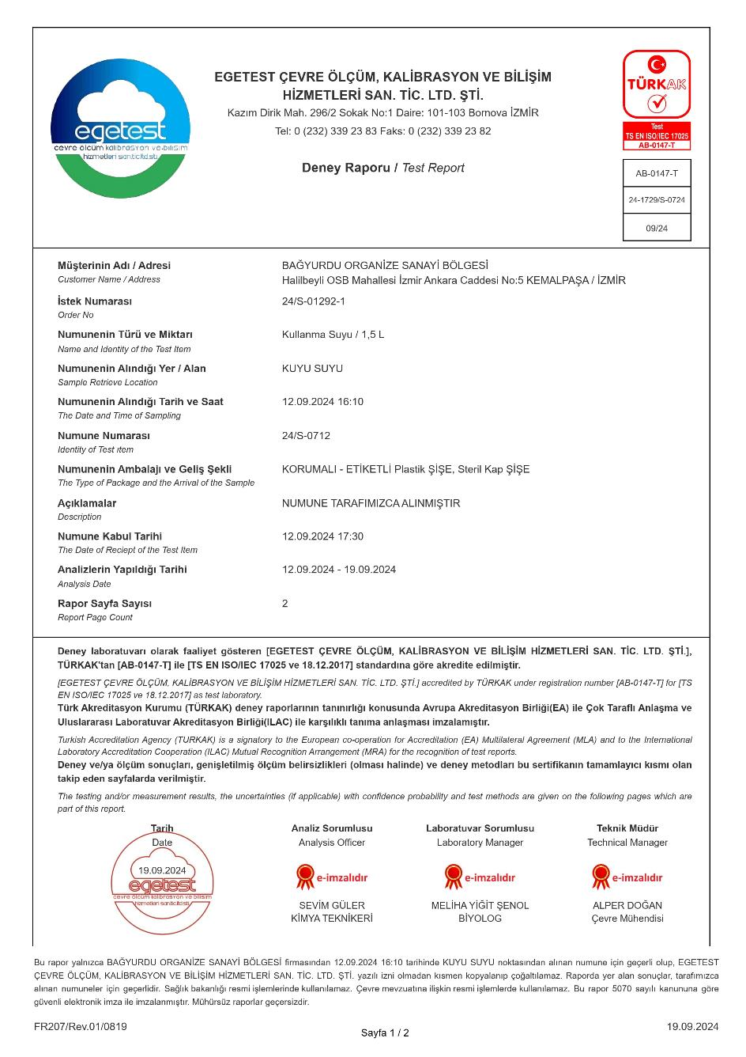
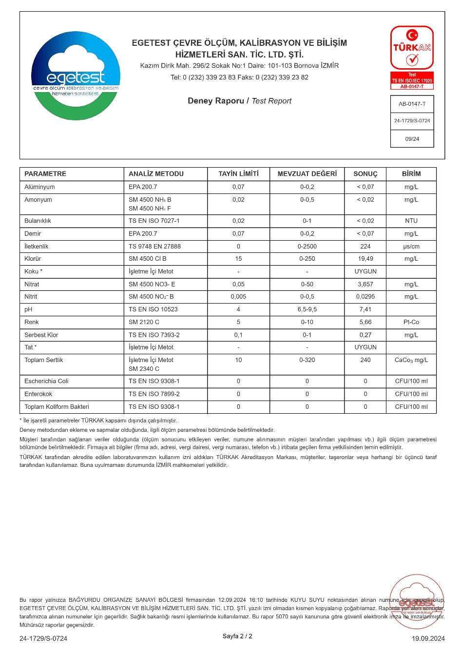

Appendix-I Calculations of Environmental Impact of the Project

Air Quality and Odour
Construction Phase
During the Land Preparation and Construction phases of the Project, BOIZ assumes that excavations will be carried out in a total of 60 days of construction period in eight (8) months (see Table 2-4).
According to the information obtained from the BOIZ, a total of approximately 18,500 m³ of excavation and (unloading) 4,500 m³ of backfilling are expected with 4 vehicles/trailers (see Table 13-8) in these 60 days during the land preparation period. All other excavation material will be used for backfilling within the BOIZ Area, these excavated soil wastes will be used in the levelling process for the disposal of rough terrain and excavation material will not be transported outside the BOIZ.
During the land preparation of the Project, since the measures specified in Annex-1 of the Regulation on Control of Industrial Air Pollution (RoCIAP) will be taken in removal, loading, transportation, unloading and temporary storage operations (watering, loading, and unloading without skidding, etc.) will be taken, the controlled emission factors in Annex-12, Table 12.6 of the RoCIAP have been used for the calculation of the mass flowrate of dust emission resulting from these operations. These emission factors are shown in the below, and emission calculations, and sources are shown in Table 13-1.
Table 13-1. Dust Emission Factors Used in the Mass Flowrate
Operation | Uncontrolled | Controlled
Stripping | 0.025 kg/ton | 0.0125 kg/ton
Loading | 0.010 kg/ton | 0.005 kg/ton
Unloading | 0.010 kg/ton | 0.005 kg/ton
Transport (Round-trip total distance) | 0.7 kg/km-vehicle | 0.35 kg/km-vehicle
Storing/Backfilling/Laying | 5.8 kg/ha-day | 2.9 kg/ha-day
Dust emission mass flowrates calculated for controlled and uncontrolled conditions are summarized in Table 13-2, Table 13-3 and Table 13-4.
Excavation Phase Dust Emissions
While Topsoil Stripping
Excavation work will be carried out in an area of approximately 9,700 m² (0.97 ha) area with assuming that 20 cm of topsoil will be stripped. Average height of topsoil stacks will be 1.5 meters. Side slope of these stacks will not exceed 3:1 (h:v). By calculation, a topsoil storage area with a floor area of approximately 2,587 m² (0.2587 ha) is required. According to the data obtained from the project representative, 1,000 m³ topsoil will be stripped within two (2) weeks and temporarily stored within the Project Area.
$$Topsoil Density= 1.6 {tonnes}/{m^{3}}(assumed as soft soil)$$
$$Topsoil Quantity= 1,000 m^{3}×1.6 {tonne}/{m^{3}}=1,600 tonnes$$
$$Daily Topsil Quantity= 1,600 ton÷14 days≌114 {tonnes}/{day}$$
$$Hourly Excavation= 114 {tonnes}/{day}÷8 {hour}/{day}≌14.3 {tonnes}/{hour}$$
$$Average Distance in the Project Area= 75 m$$
$$Capacity of the Truck Carrying= 40 {tonnes}/{vehicle}$$
$$Daily Onsite Transportation= 114 {tonnes}/{day}÷40 {tonnes}/{vehicle}≅3 {vehicle}/{day}$$
$$Daily Trip for Onsite Transportation = 3 {vehicle}/{day} ÷4 {trips}/{vehicle-day} ≅1 trip$$
Table 13-2. Calculation of Dust Emission Flowrate that May Occur Regarding Topsoil
Operation Time |  |  |  | Quantity of
 |  |  | Time | Excavation | Unloading/Laying
Excavation Period | 14 | days | Daily | 114 tonnes | 2,114 tonnes
Daily | 8 | hours
Shift | 1 |  | Hourly | 14.3 tonnes | 14.3 tonnes
- Stripping of Topsoil
Generation quantity (tonne/hour) x Emission factor (kg/tonne)
1.a Uncontrolled |  |  | 14.3 tonnes/hour x 0.025 kg/tonne = 0.3575 kg/hour
1.b Controlled |  |  | 14.3 tonnes/hour x 0.0125 kg/tonne = 0.17875 kg/hour
- Loading of Topsoil
Generation quantity (tonne/hour) x Emission factor (kg/tonne)
2.a Uncontrolled |  |  | 14.3 tonnes/hour x 0.010 kg/tonne = 0.143 kg/hour
2.b Controlled |  |  | 14.3 tonnes/hour x 0.005 kg/tonne = 0.0715 kg/hour
- Transportation of Topsoil (114 tonnes/day) (4 vehicles of 40 tonnes, 1 trip)
Number of trips (trips/day) x Transport Distance (km) x Emission Factor (kg/km) x day/hour
3.a Uncontrolled |  |  | 1 trip/day x 0.075 km/trip x 0.70 kg/km x 1 day/8 hours = 0.0065625 kg/hour
3.b Controlled |  |  | 1 trip/day x 0.075 km/trip x 0.35 kg/km x 1 day/8 hours = 0.00328125 kg/hour
- Unloading of Topsoil
Generation quantity (tonne/hour) x Emission factor (kg/tonne)
4.a Uncontrolled |  |  | 14.3 tonnes/hour x 0.010 kg/tonne = 0.143 kg/hour
4.b Controlled |  |  | 14.3 tonnes/hour x 0.005 kg/tonne = 0.0715 kg/hour
- Laying of Topsoil (with the calculation of 0.2587 ha topsoil storage area within the Project Area)
Area (Ha) x Emission factor (kg/Ha-day)
5.a Uncontrolled |  |  | 0.2587 ha/24 hours/day x 5.8 kg/Ha-day = 0.06252 kg/hour
5.b Controlled |  |  | 0.2587 ha/24 hours/day x 2.9 kg/Ha-day = 0.03126 kg/hour
While Land Preparation Phase
$$Excavation Volume= 18,500 m^{3}$$
$$Excavation Material Density= 1.6 {tonnes}/{m^{3}}(assumed as soft soil)$$
$$Excavation Material Quantity= 18,500 m^{3}×1.6 {tonne}/{m^{3}}=29,600 tonnes$$
$$Daily Excavation= 29,600 ton÷46 days≅644 {tonnes}/{day}$$
$$Hourly Excavation= 644 {tonnes}/{day}÷8 {hour}/{day}≅80.4 {tonnes}/{hour}$$
$$Average Distance in the Project Area= 75 m$$
$$Capacity of the Truck Carrying= 40 {tonnes}/{vehicle}$$
$$Daily Onsite Transportation= 644{tonnes}/{day}÷40 {tonnes}/{vehicle}≅16 {vehicle}/{day}$$
$$Daily Trip for Onsite Transportation = 16 {vehicle}/{day} ÷4 {trips}/{vehicle-day} ≅4 trips$$
During the Unloading of the Excavation Material to Onsite
$$Unloading Material Quantity= 4,500 m^{3}×1.6 {tonnes}/{m^{3}}=7,200 tonne$$
$$Daily Unloading= 7,200 tonnes÷46 days≅157 {tonnes}/{day}$$
$$Hourly Unloading= 157 {tonnes}/{day}÷8 {hour}/{day}≅20 {tonnes}/{hour}$$
Table 13-3. Calculation of Dust Emission Flowrate that May Occur Regarding Excavation Material
Operation Time |  |  |  | Quantity of
 |  |  | Time | Excavation | Unloading/Laying
Excavation Period | 46 | days | Daily | 644 tonnes | 157 tonnes
Daily | 8 | hours
Shift | 1 |  | Hourly | 80.4 tonnes | 20 tonnes
- Stripping of Excavation Material
Generation quantity (tonne/hour) x Emission factor (kg/tonne)
1.a Uncontrolled |  |  | 80.4 tonnes/hour x 0.025 kg/tonne = 2.01 kg/hour
1.b Controlled |  |  | 80.4 tonnes/hour x 0.0125 kg/tonne = 1.005 kg/hour
- Loading of Excavation Material
Generation quantity (tonne/hour) x Emission factor (kg/tonne)
2.a Uncontrolled |  |  | 80.4 tonnes/hour x 0.010 kg/tonne = 0.804 kg/hour
2.b Controlled |  |  | 80.4 tonnes/hour x 0.005 kg/tonne = 0.402 kg/hour
- Transportation of Onsite Excavation Material (2,619 tonnes/day) (66 vehicles of 40 tonnes, 7 trips)
Number of trips (trips/day) x Transport Distance (km) x Emission Factor (kg/km) x day/hour
3.a Uncontrolled |  |  | 4 trips/day x 0.075 km/trip x 0.70 kg/km x 1 day/8 hours = 0.02625 kg/hour
3.b Controlled |  |  | 4 trips/day x 0.075 km/trip x 0.35 kg/km x 1 day/8 hours = 0.013125 kg/hour
- Unloading of Excavation Material
Generation quantity (tonne/hour) x Emission factor (kg/tonne)
4.a Uncontrolled |  |  | 20 tonnes/hour x 0.010 kg/tonne = 0.2 kg/hour
4.b Controlled |  |  | 20 tonnes/hour x 0.005 kg/tonne = 0.1 kg/hour
- Storing/Backfilling of Excavation Material (with the calculation of 0.2587 ha excavation area of the Project)
Area (Ha) x Emission factor (kg/Ha-day)
5.a Uncontrolled |  |  | 0.2587 ha/24 hours/day x 5.8 kg/Ha-day = 0.06252 kg/hour
5.b Controlled |  |  | 0.2587 ha/24 hours/day x 2.9 kg/Ha-day = 0.03126 kg/hour
Table 13-4. Mass Flowrate of Dust Emission from Land Preparation and Construction Phases
Stage | No | Process | Uncontrolled (kg/hour) | Controlled (kg/hour)
Quantity of dust that may occur for topsoil | 1 | Stripping of Topsoil | 0.3575 | 0.17875
Quantity of dust that may occur for topsoil | 2 | Loading of Topsoil | 0.143 | 0.0715
Quantity of dust that may occur for topsoil | 3 | Transportation of Topsoil | 0.0065625 | 0.00328125
Quantity of dust that may occur for topsoil | 4 | Unloading of Topsoil | 0.143 | 0.0715
Quantity of dust that may occur for topsoil | 5 | Laying of Topsoil | 0.06252 | 0.03126
Total |  |  | 0.7125825 | 0.35629125
Quantity of dust that may occur for excavation material | 6 | Stripping of Excavation Material | 2.01 | 1.005
Quantity of dust that may occur for excavation material | 7 | Loading the Excavation Material on Trucks | 0.804 | 0.402
Quantity of dust that may occur for excavation material | 8 | Transportation of the Excavation Material | 0.02625 | 0.013125
Quantity of dust that may occur for excavation material | 9 | Unloading the Excavation Material with Trucks | 0.2 | 0.1
Quantity of dust that may occur for excavation material | 10 | Storing of Excavation Material | 0.06252 | 0.03126
Total |  |  | 3.10277 | 1.551385
General Total |  |  | 3.8153525 | 1.90767625
Controlled dust emissions from all emission sources are given above. The concerned value (≌1.9 kg/hour) is more than 1 kg/hour, which is the limit value outside the chimney specified within the scope of Annex-2 of the RoCIAP, nevertheless since the duration of the construction is limited, and the potential receptors are out of the reach of dust quality distribution modelling for dust emissions will not be required.
On the other hand, as a source of other emissions from fuel combustion, diesel will be used in the construction machines to be used during the construction works of the Project. Diesel, whose characteristics are given in Table 13-5, will be supplied from the nearby fuel sales stations.
Table 13-5. Specification of Diesel
Specification | Unit | Value
Density (at 15 ⁰C) | kg/m³ | 820-845
Polycyclic aromatic hydrocarbons | % weight | 11
Flash Point | ⁰C | 55
Cold Filter Plugging Point | ⁰C
Winter (a) |  | -15
Summer (b) |  | 5
Distillation
Obtained at 250 ⁰C | % volume | 65
Obtained at 350 ⁰C | % volume | 85
The temperature at which 95% (volume/volume) is achieved | ⁰C | 360
Sulphur | mg/kg | 10
Carbon Residue | % volume | 0,3
(at 10% distillation residue) | % volume | 0,3
Viscosity (at 40 ⁰C) | cst | 2,0-4,5
Copper Strip Corrosion |  | No.1
(3 hours at 50 ⁰C) |  | No.1
Ash | % weight | 0,01
Cetane number |  | 51
Cetane Index | calculated | 46
Water | mg/kg | 200
Total Pollution | mg/kg | 24
Oxidation Stability | g/m³ | 25
Lubrication feature at 60 ⁰C | µm | 460
Corrected wear scar diameter | µm | 460
Emission factors developed by the United States Environmental Protection Agency (U.S.EPA) and given in Table 13-6 were used to calculate the possible emissions from vehicles to be used during the construction works of the Project.
Table 13-6. Emission Factors Originating from Diesel Vehicles (kg/ton)
Pollutant | Diesel
Carbon Monoxides | 7.2
Hydrocarbons | 16.3
Nitrogen Oxides | 26.6
Sulphur Oxides | 4.8
Source: Compilation of Air Pollution Emission Factors Volume I: Stationary Point and Area Sources”, 4th ed., AP-42, U.S. EPA, Office of Air Quality Planning and Standards, 1985, with updates through September 1991
According to the information obtained from the project representative, all excavation works are planned to be carried out by total of 10 machinery and equipment. All machine and equipment used throughout the construction phase of the Project are listed in Table 13-8.
As previously stated, it is planned to use maximum 10 construction machines operating at the same time during the construction phase of the Project and there will be no use of construction equipment during the operation phase. With the worst-case assumption that these vehicles will operate at the same time, it is predicted that the maximum amount of diesel fuel a vehicle will consume will be 5 L/hr-vehicle. In this regard, mass flow calculations have been made for exhaust emissions and the calculations are given below.
$$Density of Diesel= 0.830 {kg}/L$$
$$Due to Diesel Usage= 5L/{hour-vehicle}×0.830 {kg}/L×10 vehicles=41.5 {kg}/{hour=0.0415 {tonne}/{hour}}$$
$$Carbon monoxides= 7.2 {kg}/{tonne×0.0415 {tonne}/{hour=0.2988{kg}/{hour}}}$$
$$Sulphur Oxides= 4.8 {kg}/{tonne×0.0415 {tonne}/{hour=0.1992{kg}/{hour}}}$$
$$Nitrogen Oxides= 26.6 {kg}/{tonne×0.0415 {tonne}/{hour=1.1039{kg}/{hour}}}$$
$$Hydrocarbons= 16.3 {kg}/{tonne×0.0415 {tonne}/{hour=0.67645{kg}/{hour}}}$$
The mass flowrates of the exhaust emissions that will arise from the vehicles that will operate during the construction works (lower limit values determining the modelling work requirement in the Annex-2 Table 2.1 of the RoCIAP together with the calculated mass flowrates of the emissions originating from the locations outside the chimney) are presented in Table 13-7. All concerned calculated exhaust emission mass flowrate values for the parameters are below the corresponding limit values specified in the RoCIAP.
Table 13-7.Lower Limit Values of Modelling Study with Calculated Exhaust Emissions Mass Flowrates
Emissions | Calculated Exhaust Emissions Mass Flowrates (kg/hour) | Annex-2 Table 2.1 of the RoCIAP  Lower Limit Values for the Locations Outside the Chimney (kg/hr)
Carbon Monoxide (CO) | 0.2988 | 50
Sulphur Oxide (SO_{x}) | 0.1992 | 6
Nitrogen Dioxide [NO_{x} (as NO₂)] | 1.1039 | 4
Total Organic Compounds (TOC)s | 0.67645 | 3
All the calculations were made with the worst-case scenario, with the principle of operating all equipment and vehicles at the same time and considering the related emission values. Moreover, since all calculated emission values is below the modelling limit values specified in the related local legislation, the Project will not be required to conduct a modelling study.
According to the European Environment Agency (EEA), it is recommended that the average PM_{2.5} content of PM₁₀ should be assumed to be 10%. As the calculated dust emission value of the Project is 1.9 kg/day, PM_{2.5} value is calculated as 0.19 kg /day.
Noise
Noise generation will be caused by vehicles, machinery, and equipment to be used during the land preparation and construction phase within the scope of the activities of the Project. Equivalent noise levels (Leq) of the machinery and equipment to be used at this stage have been determined in accordance with the provisions of the " Regulation on the Ambient Noise Emission Caused by Equipment Used Outdoors (2000/14/EC)" published by the Ministry of Industry and Trade of the Republic of Türkiye and referenced from the "Noise Control Industrial and Environmental Noise" document published by the Turkish Acoustics Association, and these values are given in Table 13-8 together with the number of equipment to be used.
Table 13-8. Number of Machinery/Equipment to be Used During the Construction Phase and Noise Levels
Machineries and Equipment | Maximum Number of Machineries and Equipment Operating at the Same Time | Noise Level (dBA)
Excavator | 2 | 101
Grader | 1 | 103
Backhoe Loader | 1 | 103
Trucks/Trailers | 4 | 83
Road Roller | 1 | 82
Water Truck (Sprinkler) | 1 | 82
Noise calculations were carried out using the following formulae. While calculating the noise values, the worst-case scenario where all vehicles will operate at the same point at the same time has been taken into consideration.
Atmospheric absorption has been neglected in the noise calculations; therefore, it is predicted that under real conditions, noise levels will be much lower than the noise levels obtained by calculation.
The total equivalent noise level generated by the noise sources was calculated with the help of the formula (1) given below. In this formula, it is assumed that the noise sources are in the same plane.
………………………………… (1)
In this formula
N : Number of noise sources
Li : Sound power level of each source (dB(A))
: Total equivalent noise level
$$L_{eq}=10×\log\left(2x10^{{101}/{10}}+1x10^{{103}/{10}}+1x10^{{103}/{10}}+4x10^{{83}/{10}}+1x10^{{82}/{10}}+1x10^{{82}/{10}}\right)$$
$$L_{eq}=108.21 dBA$$
The sound power level (L_{p}) arising from the machinery/equipment and travelling a certain distance is calculated by means of the formula (2) given below.
…………………………….... (2)
L_{p} : Sound power (noise) level (dBA)
Q : Reduction factor selected according to whether the terrain is flat or hilly, which is taken as 2
r : Distance (m)
The change in sound level depending on the distance is presented in Table 13-9 and
Table 13-9. Values of Noise Level from Machinery/Equipment according to Distance
r (m) | L_{p} (dBA)
0 | 111.27
10 | 80.23
25 | 72.27
45 | 67.16
58 | 64.96
100 | 60.23
200 | 54.21
300 | 50.68
500 | 46.25
750 | 42.73
1000 | 40.23
Distribution of noise from machinery/equipment by distance for the Project is presented in Figure 13-14.
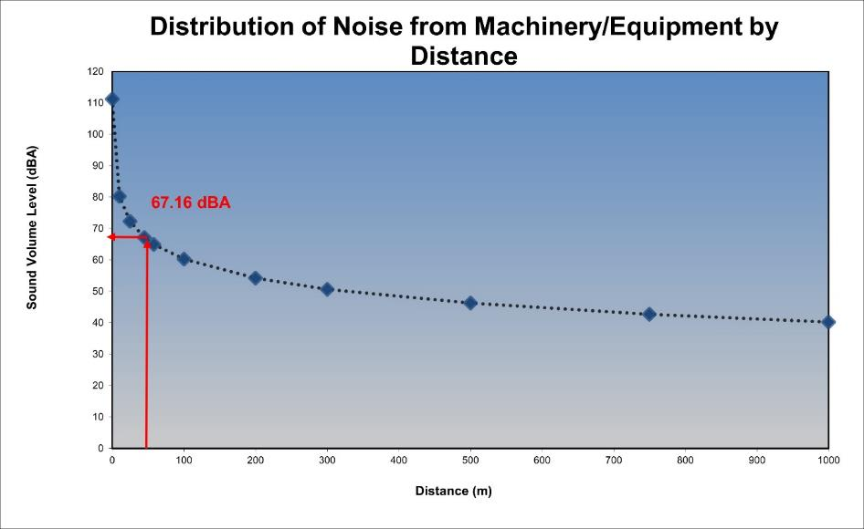
Figure 13-14. Distribution of Noise from Machinery/Equipment by Distance
Environmental noise limit values are in Annex-2 Table 1 of the Regulation on the Control of Ambient Noise (RoCAN) and WBG General EHS Guidelines. The sensitive receptor is the industrial facility located in BOIZ Area, 45 metres away from the Project Area. The highest noise level expected at this distance is 67.16 dBA. According to the specified limit values in the RoCAN, although the noise level that may occur in the worst case (simultaneous operation of all machinery/equipment) at the sensitive receptor remains slightly above the day time limit value as 65 dBA, due to limited duration of noise generated during the Project’s construction works, (particularly during land preparation activities), limited adverse noise impact is expected on sensitive receptor as industrial facility within the BOIZ Area.
Water Resources and Use
Water needs for toilets and baths will be met from the licenced well. In this context, the water currently supplied to the facilities after chlorination by the BOIZ will be used during the construction phase of the Project. In addition, it is planned to meet the drinking water need from bottled water.
Construction Phase
Water will be required in the Project’s Construction Phase for domestic use and dust suppression. Daily average water consumption of 50 people working for the construction phase is calculated below.
$Daily water requirement for construction phase =person×avg. water consumption = 50 people × 210{lt}/{person-day}=10,500 {lt}/{day =10.5 {m^{3}}/{day}}$
In addition, the quantity of water to be used per day for dust suppression during the construction phase is calculated below. (The quantity of water to be used for an area of m² is taken as 1.5 lt/day-m² ).
$$The maximum total area where the dust emission will be=9,700 m^{2}$$
$$Maximum quantity of water to be used per m^{2} area=9,700 m^{2}×1.5{lt}/{day-m^{2}}×1 {m^{3}}/{1,000 lt=} 14.55 {m^{3}}/{day}$$
$$Total quantity of water to be used=10.5 {m^{3}}/{day}+ 14.55 {m^{3}}/{day}={{25.05 m}^{3}}/{day}$$
In addition to this, 50,000 tons/year of water withdrawal from the licensed well is allowed by the concerned authority. If one ton of water is 1.0416 cubic meters, it will have a volume of 52,080 m³. This corresponds to about 17.5% of the total amount of water, with a daily water use capacity of about 143 m³.
Operation Phase
Likewise in construction phase, water demand for toilets and baths will be met from the licenced well, and it is planned to meet the drinking water need from packaged water.
Water will be required in the Project’s Operation Phase for domestic use. The daily average water consumption of 4 people to be employed for the operation phase is calculated below.
$$Daily water requirement for operation phase =person×avg. water consumption = 4 person × 210{lt}/{person-day}=840 {lt}/{day =0.84 {m^{3}}/{day}}$$
In addition, the irrigation water is planned to be met from rainwater harvesting within the scope of Project operation.
According to a similar calculation during the construction phase of the Project, the approximate amount of water required for the operation phase corresponds to about 1% of the total permitted groundwater consumption capacity.
Wastewater Management
Construction Phase
Daily average wastewater (WW) generation of 50 people working for the construction phase is calculated below.
$Daily WW generated for construction phase =person×avg. WW generation = 50 people × 181{lt}/{person-day}=9,050 {lt}/{day ≅9.1 {m^{3}}/{day}}$
The quantity of wastewater calculated as 9.1 m³/day during the construction phase, which will be collected in the septic tanks to be sent to the WWTP of Kemalpaşa OIZ, will be negligible.
WWTP of Kemalpaşa OIZ has a capacity of 20,000 ton/day. Discharged peak quantity of WW from the Project calculated as about is 0.5 ‰ of the WWTP of Kemalpaşa OIZ. Hence, it can be completely negligible.
Operation Phase
Daily average WW generation of 4 people working for the operation phase is calculated below.
$Daily WW generated for operaiton phase =person×avg. WW generation = 4 people × 181{lt}/{person-day}=724 {lt}/{day ≅1 {m^{3}}/{day}}$
The quantity of wastewater calculated as 1 m³/day during the operation phase will be negligible. The wastewater to be generated during the operation phase will be directed to the Project that will operate as a WWTP.
Waste Management
Construction Phase
Wastes that are expected to be generated during the construction phase of the Project are follows.
Domestic Solid Wastes
It is planned that 50 people will work during the peak time of the construction phase of the Project.
$$Total generated domestic waste will be=50 people ×1.22 {kg}/{person-day} =61 {kg}/{day}$$
The municipal wastes to be generated should be collected in containers within the Project Area. The collection of the wastes accumulated in the containers should be carried out by the Municipality of Kemalpaşa and should be transferred to the nearest Izmir Metropolitan Municipality Solid Waste Landfill at certain periods.
Packaging Waste
The ratio of recyclable packaging waste is in metropolitan cities in Türkiye as follows. 48 kg/P-year paper and board, 14 kg/P-year plastic, 6 kg/P-year nylon, 8 kg/P-year metal, 8 kg/P-year glass, in total 84 kg/P-year.
$$Total generated packaging waste will be=50 people ×84 {kg}/{person-year}×1{year}/{365 day}≅11.5 {kg}/{day}$$
Packaging wastes made of plastic, metal, glass, paper and board, composite and similar materials should be collected separately from other wastes and given to Packaging Waste Collection, Segregation and Recovery Facilities licensed by the MoEUCC.
Excavation Waste
According to the calculation of excavation quantity, 29,600 tonnes of excavation material will be transported with 4 vehicles/trailers and stored temporarily within the Project Area. All excavation material will be used for backfilling within the BOIZ Area. Also, 1,600 tonnes of topsoil will be temporarily stored within the Project Area (see air quality section of this Chapter for details).
Construction Waste
As there are no structures requiring demolition in the Project Area, construction waste generation is not expected. In the case of construction waste generation, management of these wastes should be conducted in compliance with the provisions of the Regulation on the Control of Excavation Soil, Construction and Demolition Wastes.
Hazardous Wastes
Hazardous wastes will be transported to licensed haulers and provided to be delivered to licensed recovery and disposal companies. If any asbestos is identified, mitigation measures are identified in the Chapter 8.
During the construction phase of the Project, also paint etc. empty containers of materials to be used due to processes, paint, etc. gloves etc. contaminated with chemicals. waste is likely to be generated. Therefore, collection and disposal of these hazardous wastes should be carried out based on the Regulation on Waste Management.
Waste Tires
It is possible that the end-of-life tire will be formed due to the construction equipment and vehicles to be used during the construction processes. Since the construction machinery and vehicles to be used during the construction works will belong to the contractor companies, the maintenance, repair, and service operations of these vehicles should be carried out by the contractor company. Maintenance, repair, and service operations should not be carried out at the Project Area, and if, for any reason, expired tires occur, the tires should be sent to authorized companies or to licensed tire intermediate storage/recovery facilities.
Waste Batteries and Accumulators
It is probable that waste accumulators will occur due to construction machinery and vehicles to be used during construction processes. Since the construction machinery and vehicles to be used during the construction activity will belong to the contractor company, the maintenance, repair, and service operations of these vehicles should be carried out by the contractor company. Maintenance, repair, and service should not be performed at the Project Area, and in case of any waste accumulator formation for any reason, the waste accumulators should be sent to authorized companies or licensed hazardous waste recycling facilities.
Medical Wastes
The medical needs of the personnel who will work during the construction phase will be met in the health institutions outside the Project Area. Simple first aid equipment to be used in the first response in emergency and important situations will be available at the Project Area, and in case of medical waste resulting from interventions due to a possible accident, it will be sent to licensed medical waste sterilization facilities.
Waste Oils
It is probable that waste oil will be generated from the construction machinery and vehicles to be used during the construction activities. Since the construction machinery and vehicles to be used during the construction activity will belong to the contractor company, the maintenance, repair, and service operations of these vehicles will be carried out by the contractor company. No maintenance, repair and service operations should be carried out at the Project Area, and if waste oil occurs for any reason, waste oil will be sent to authorized institutions and licensed waste oil recovery facilities.
Waste Vegetable Oils
Since the food needs of the personnel who will work during the construction processes will be provided outside the Project Area and the catering will not be carried out in the Project Area, waste vegetable oil is not expected to be generated.
Operation Phase
Wastes that are expected to be generated during the Project’s operation phase are follows.
Domestic Solid Wastes
4 people are planned to be employed for the operation phase of the Project.
$$Total generated domestic waste will be=4 people ×1.22 {kg}/{person-day} ≅4.9 {kg}/{day}$$
Packaging Waste
The ratio of recyclable packaging waste is in metropolitan cities in Türkiye as follows. 48 kg/P-year paper and board, 14 kg/P-year plastic, 6 kg/P-year nylon, 8 kg/P-year metal, 8 kg/P-year glass, in total 84 kg/P-year.
$$Total generated packaging waste will be=4 people ×84 {kg}/{person-year}×1{year}/{365 day}≅1 {kg}/{day}$$
Packaging wastes made of plastic, metal, glass, paper and board, composite and similar materials should be collected separately from other wastes and given to Packaging Waste Collection, Segregation and Recovery Facilities licensed by the MoEUCC.
Hazardous Wastes
These wastes such as oily gloves and clothes, broken pipes, end-of-life print cartridge and led bulbs will be generated due to maintenance and repair works of the Project. Also, analysis kits of samples taken for control purposes in the plant laboratory will be generated. It should be classified according to its characteristics, and on the temporarily stored waste, there will be a hazardous waste label, waste code, amount of stored waste and storage date. Therefore, collection and disposal of these hazardous wastes will continue to be carried out based on the Regulation on Waste Management.
Waste Batteries and Accumulators
During the operation phase of the Project, it is possible that waste batteries may occur due to battery use in areas in Office etc. These wastes will be sent to concerned institutions. Since the maintenance, repair, and service operations of the vehicles to be used during the operation phase of the Project will be carried out at authorized services, no waste accumulators will be formed in the plant area. If, for any reason, waste accumulators occur, they will be sent to authorized companies or licensed intermediate storage/recovery facilities.
Medical Wastes
The medical needs of the personnel who will work during the operation phase will be met in the health institutions outside the plant area. Simple first aid equipment to be used in the first response in emergency and important situations will be available at the plant area, and in case of medical waste resulting from interventions due to a possible accident, it will be sent to licensed medical waste sterilization facilities.
Waste Tires
Since the maintenance, repair and service operations of the vehicles and equipment to be used during the operation phase of the Project should be carried out in authorized services, no tires that have completed their life will be formed in the plant area. If, for any reason, expired tires occur, the tires should be sent to authorized companies or to licensed tire intermediate storage/recovery facilities.
Waste Vegetable Oils
Since the food needs of the personnel who will work during the construction phase will be provided outside the plant area and the catering will not be carried out in the plant area, waste vegetable oil is not expected to be generated.
Waste Oils
There will be waste oil from the maintenance, repair and service of the machinery-equipment and vehicles to be used in the Project operational activities. Since these operations of the vehicles to be used during the operation phase will be carried out at authorized services, no waste oil will be generated in the plant area. Also, as a result of the WWTP operation activities, oil-grease collected on the WW surface in the grit and grease removal process will be generated. If for any reason waste oil occurs, waste oil will be sent to authorized institutions and licensed waste oil recovery facilities.
Electronic Waste
In the plant area, due to maintenance, repair or replacing activities, there will be generation of electronic wastes such as especially cable components and mechanical equipment. According to whether it is hazardous or non-hazardous waste, they will be disposed of with the relevant licensed or authorized companies.
Waste Sludge
According to the information in the Process Report of the Project, the amount of solid waste sludge generated as a result of WW treatment is estimated as 1,170.93 kg/day. Hence, about 1.7-ton dried waste sludge with higher than 70 % solid content will be sent the cement factory named Süreko Waste Management Inc. after being carried out its analyses.

Appendix-J Chance Find Procedure

INTRODUCTION
This document is intended to avoid potential impacts of the Project on any cultural heritage during land preparation works, including excavation. At the baseline studies, field survey and literature review were conducted for the Project and its vicinity to identify potential archaeological and immovable cultural properties. No archaeological or immovable cultural property was encountered during the study.
This Procedure is a part of the general package as an appendix to the Environmental and Social Management Plan (ESMP) developed for the Project.
SCOPE
Types of Cultural Heritage Covered by This Procedure
Tangible Cultural Heritage
Tangible (physical) cultural heritage refers to movable or immovable objects, sites, structures, groups of structures, and natural features and landscapes that have archaeological, paleontological, historical, architectural, religious, aesthetic, or other cultural significance.
ROLES AND RESPONSIBILITIES
Roles | Responsibilities
Contractors | - Compliance with the Chance Find Procedure provided in contractor agreements  - Provide appropriate training and information to the worksite personnel who work in the projects and who may disturb the cultural heritage so that they understand their responsibilities for cultural heritage
Project Owner (BOIZ) | - Ensure compliance of the project with the Project Standards and other requirements given in this Plan  - General responsibility for the scope and implementation of the Plan  - Development, monitoring and revision of this Plan  - Fulfilment of cultural heritage evaluation processes  - Ensure that the operations do not disturb cultural properties and sites without the approval of the relevant authority  - Investigation, reporting and monitoring of unauthorized damages to the worksite as well as of procedure violations  - Management of amendments to laws or policies  - Coordination with the organizations involved in the implementation and other stakeholders
All Workers | - Learn about the Chance Find Procedure through induction training and any other training provided
PROJECT STANDARDS
- Law on the Conservation of Cultural and Natural Properties (LCCNP) (No: 2863),
- World Bank Protection Policy on Physical Cultural Resources (ESS-8),
- Convention Concerning the Protection of the World Cultural and Natural Heritage (World Heritage Convention).
CHANCE FIND PROCEDURE
Initial Approach Adopted by the Contractor
- Action 1: Immediately stop all construction works in the vicinity of the chance find, in case of discovery of archaeological finds,
- Action 2: Immediately notify the project manager and/or environmental department,
- Action 3: Take photographs or make technical drawings,
- Action 4: Record the location by keeping all remains in their position (without moving them);
- Action 5: Prevent damage to or loss of movable objects by encircling the area,
- Action 6: Contact an archaeologist from a local university for guidance,
- Action 7: Prepare the Chance Find Form.
Approach Adopted by the Archaeologist
Based on the description of the find, the archaeologist will make recommendations on actions to be taken by phone/e-mail or visit. The Project team will take into account the following possible strategies, if the archaeologist(s) confirm(s) the presence of archaeological finds/remains/sites:
Strategy 1: Avoidance by partial or full project redesign or relocation
In case of any archaeological find or discovery, BOIZ will provide the relevant information to authorities. This responsibility will apply even if the project is redesigned or relocated. In any case, the relevant governmental body will be informed of the archaeological find or discovery.
Strategy 2: Implementation of worksite protection measures
This option includes the implementation of site protection measures such as fencing or blockage. As per LCCNP No. 2863, any archaeological find is the property of the Republic of Türkiye, and governmental bodies will decide on the geographical scope and implementation of site protection measures.
Strategy 3: Rescue or emergency excavation
If BOIZ fails to relocate or redesign the Project, this may require rescue or emergency excavation works. If notification is stipulated by LCCNP, an application will be lodged to governmental bodies. If an official application is lodged, the relevant Regional Board will be allowed to make a decision.
After the permit is obtained, archaeological excavations will be performed with the attendance of scientific consultants from the archaeological departments of universities. Following the completion of archaeological excavations, the results will be submitted to relevant governmental bodies for the final decision to be taken for the progress of the Project.
Procedure for the Discovery of Potential Human Remains
Identification of human remains is very clear in terms of graves or burial sites. If a grave or burial site is found, the procedures to be followed are not different from the procedure applicable to archaeological finds as per Article 6 of LCCNP. Modern burials or forensic human remains will not be addressed within the scope of LCCNP.
KEY PERFORMANCE INDICATORS
The key performance indicators to be used during the implementation of this Procedure are set out below.
Key Performance Indicators (KPIs)
No | KPIs | Target | Monitoring Measure
1 | Non-conformities reported during the year with respect to key management controls identified in this Plan | Minimization of reported non-conformities, aiming at zero | Database  Reporting  Inspection Reports
2 | Number of complaints lodged by local communities during the year regarding cultural heritages | - Investigation of complaints about cultural heritage (disrespect, destruction, removal, sale of artefacts) and fulfilment of relevant actions.  - Provision of prompt response to complaints from local communities regarding the misbehaviour of personnel regarding cultural properties | Database  Grievance Mechanism Records  Reporting
Sample Chance Find Form
Place: | Chance Find No: | Date:
Location Data:
Coordination:
Elevation:
Brief Area Description:
Chance Type: | Archaeological Items  Metal Finds  Terracotta Finds  Pottery Shards  Glass Finds | Sculpture etc.  Human / Animal Bone  Unidentified
Temporary Measures
Photograph

Discoverer's Name-Last Name:
Signature:

Appendix-K Gap Analysis of the World Bank ESSs and the National Legislation

Gap Analysis of between the World Bank ESSs and the National Legislation
WB Environmental and Social Standards (ESS) | Gaps between the Turkish EIA Regulation and WB’s ESF | Measures to bridge the identified Gap
ESS1: Assessment and Management of Environmental and Social Risks and Impacts | The major gaps between national EIA and ESS1 are as follows:  - The absence of an executive summary and information on the legal and institutional framework in the Turkish EIA (Technical level of information in the non-technical summary required in the Turkish EIA may not meet WB requirements)  - possible discrepancies with regard to the level at which the project’s environmental and social impacts, its alternatives, and mitigation measures for the impacts are discussed (such as lack of discussions on residual impacts, limited discussion on indirect and induced impacts  - there are limited requirements to cover risks and impacts related to (i) community health and safety; (ii) occupational health and safety; and (iii) labour and working conditions.  - Limited emphasis on the associated facilities.  Nevertheless, the project specific format for Turkish EIA may require more details under some of these headings than indicated in the general format. Consequently, a case-by-case review of the Turkish EIAs is necessary to identify gaps with WB requirements. | Project specific Environmental and social assessment studies regarding ESMP will be completed in line with ESS1. In this respect, as it is defined in Term of Reference provided in Annex 2 of Environmental and Social Management Framework (ESMF) that was approved by WB for the TOIZsP, potential social impacts of the Projects — including those associated with the construction and operation of a wastewater treatment plant such as odor, sludge handling, potential impacts on groundwater and surface water quality, and proximity to sensitive receptors — will be the part of the assessment. This ESMP has been prepared in line with ESS1 to bridge the gap.  In this context, according to E&S Screening report, Environmental and social risks —such as potential discharge-related impacts, public health concerns, and construction-related nuisances (e.g., dust, noise, traffic, and waste) — are determined within the scope of the WB ESSs and ESMF of the Project. The overall environmental and social risk of the subproject were rated in “Moderate” risk group. Sub-project specific Environmental and social assessment studies regarding ESMP will be prepared in line with ESS1. As part of the mitigation measures, management plans and procedures on different subjects should be developed.  A list of required management plans for the related phases of the Project are listed in the Executive Summary Section.
ESS2: Labour and Working Conditions | In general, Turkish national laws and regulations regarding labour and working conditions satisfies ESS2 requirements. Worker grievance mechanism is the main gap between national legislative requirement and ESS2. Per the Turkish national legislation on labour and working conditions, there is no specific requirement related to grievance mechanism that allow workers to communicate their complaints to the employer. | During the construction and operation phases, Labour Management Plans (LMP)s will be developed according to the Labour Management Procedures of the TOIZsP, including GM, Code of Conduct (CoC), written contracts etc. stipulated by ESS2 for providing guidance on the required mitigations or management measures in relation to workers and employees.  The LMP will also address potential occupational health and safety risks specific to the construction and operation of a wastewater treatment plant, such as exposure to hazardous substances, confined space entry, biological risks, and use of heavy machinery.  The GM will provide all project workers, including contractor and subcontractor employees, with accessible, transparent, and confidential channels to raise workplace concerns. Records of grievances and resolutions will be maintained and regularly reported to the PMU and the World Bank.
ESS3: Resource Efficiency and Pollution Prevention and Management | Most of the relevant national legislations regarding laws and regulations are in line with EU directives. There is no major gap between ESS3 and legislative requirements.  According to the current EIA Regulation, many plans such as Zero Waste Plan, Greenhouse Gas Reduction Plan, Impacts on Climate Change, Environmental Monitoring Plan, Environmental and Social Management Plan, etc. are required to be included in EIA Reports under "Sustainability Plan". | Sub-management plans will be developed as a part of ESIA/ESMP. These management plans also provide requirement stipulated in relevant WB EHS Guidelines.  In addition to general resource efficiency and pollution prevention measures, the ESMP will include specific mitigation strategies for wastewater discharge quality, sludge management, and chemical storage and handling in accordance with national legislation and WB standards.  In case a requirement, additional studies (i.e. WSVA, GHG etc.) will be performed in the scope of ESIA/ESMP.
ESS4: Community Health and Safety | In general, there is no gap in terms of policy level. On the other hand, project level management of specific risks such as labour influx, sexual exploitation and abuse and sexual harassment are the key gaps in terms of ESS4. | The OIZ has its own security personnel and provides security within the ESS4 framework. No new security personnel will be hired for the project. However, the “Community Health, Safety, and Security Management Plan” and the “Transportation and Traffic Management Plan,” which will be prepared in accordance with ESS4, will be developed and implemented by the PMU for the operational phase of the project.
ESS6: Biodiversity Conservation and Sustainable Management of Living Natural Resources | In general, there is no gap in terms of policy level. On the other hand, in some cases, level of the considerations of not legally protected sensitive ecological areas such as Key Biodiversity Areas in National EIA Process do not sustain the requirements stipulated by ESS6. In general, there is a lack of details on the requirements for the management and monitoring of potential impacts, the implementation of mitigation measures, and the assessment of residual impacts. | Depending on the location of the project and project level of the impact, Biodiversity Management Plans can be annexed to the ESIA/ESMP.  For wastewater treatment plant projects, special attention will be given to the protection of aquatic ecosystems at the discharge point, surrounding natural habitats, and any potential impact on biodiversity due to sludge disposal or chemical leakage.
ESS8: Cultural Heritage | National EIA legislation addresses cultural heritage primarily through requirements related to known and officially registered archaeological sites and cultural assets. However, there are no explicit provisions for Chance Find Procedures or for the protection of unregistered cultural heritage resources discovered during project implementation. Furthermore, intangible cultural heritage is not considered within the scope of the Turkish EIA process. | The ESMP includes a Chance Find Procedure consistent with ESS8. Contractors will be contractually required to stop work immediately upon discovery of any potential cultural heritage resource and notify the relevant authorities and the Project Management Unit (PMU). Workers and supervisors will be trained on the procedure, including reporting responsibilities. Where relevant, consultations will also be conducted with local stakeholders to identify intangible cultural heritage that may be affected, ensuring compliance with ESS8 requirements.
ESS10: Stakeholder Engagement and Information Disclosure | Effective and transparent stakeholder engagement is the main gap in terms of ESS10 requirement. Within this scope, a Stakeholder Engagement Plan required to identify the different stakeholders (project-affected parties and other interested parties including disadvantaged or vulnerable). Stakeholder engagement should be a continuous process. An improved grievance mechanism would help bridge the gap between EIA legislation and ESS10. | The TOIZsP’s SEP implementation will be prepared for effective and transparent stakeholder engagement throughout project duration in line with ESS10. Establishment of Public GM

https://documents1.worldbank.org/curated/en/604561468170043490/pdf/602530WP0worke10Box358316B01PUBLIC1.pdf
https://www.worldbank.org/en/projects-operations/environmental-and-social-framework/brief/environmental-and-social-framework-resources
Source Website. https://yesilosb.sanayi.gov.tr/projedokumanlari
Source: https://www.who.int/publications/i/item/9789241549950
The TOIZsP Stakeholder Engagement Plan (SEP) will be used for this subproject, and that all project parties (including the contractor, Organized Industrial Zone (OIZ), and the Ministry of Industry and Technology (MoIT) PIU) will be responsible for ensuring compliance with the TOIZsP SEP.
Nitrate Sensitive Area: Drainage areas including agricultural and non-agricultural lands where nitrate is formed affecting natural freshwater lakes, other freshwater resources, estuaries and coastal waters that are determined to be eutrophic or may become eutrophic in the near future if necessary measures are not taken.
Urban Sensitive Area: Refers to the drainage area of a sensitive water body and the urban wastewater drainage areas located upstream of the sensitive water body that put pressure on the sensitive water body and cause water quality objectives not to be met.
Source website: https://tdth.afad.gov.tr/TDTH
Specified in the IFC General EHS Guidelines, Table 1.1.1: WHO Ambient Air Quality Guidelines
Specified in the Annex-2 Table 1 of the Regulation on the Control of Ambient Noise (RoCAN) (The Project is identifeid as a noise source in the ROCAN as industrial facilities, transport resources)
Specified in Table 19 (Discharge Standards of Mixed Industrial Wastewaters to the Receiving Environment (Small and Large Organized Industrial Zones and Other Industries for which Sector Determination cannot be Made)) of the Regulation on Control of Water Pollution
https://yesilosb.sanayi.gov.tr/projedokumanlari
Source: https://documents1.worldbank.org/curated/en/290471530216994899/ESF-Guidance-Note-4-Community-Health-and-Safety-English.pdf
The American Conference of Governmental Industrial Hygienists (ACGIH), 2006
ACGIH: American Conference of Government Industrial Hygiene, 2005
The American Conference of Governmental Industrial Hygienists (ACGIH), 2006
Land acquisition covers displacement of people, change in livelihoods, and seizure of private properties. This applies to acquired/assigned lands, and affects the residents and/or slum dwellers and business owners on the lands acquired in the said way.
Toxic/hazardous materials include asbestos, toxic paints, harmful solvents, lead paint removal, etc.
https://www.bayosb.org/iletisim.html
Source: Chamber of Civil Engineers Website: https://www.imo.org.tr/resimler/dosya_ekler/27abe7a7df24f39_ek.pdf
Source: Chamber of Civil Engineers Website: https://www.imo.org.tr/resimler/dosya_ekler/27abe7a7df24f39_ek.pdf
EEA Air Pollutant Emission Inventory Guidebook 2023 / 2.A.5.b Construction and Demolition / Section 3.2.2 Default Emission Factors(EF PM₁₀) (Page 7)
Environmental Noise Assessment and Management, Type a Certificate Programme Seminar Notes- METU Continuing Education Centre, ANKARA, 2007
TurkStat, Daily Quantity of Water Usage Per Capita (Liters/Person-Day) Data (Izmir), 2022
Prof.Dr.İzzet Öztürk, Dr. Hacer Timur, Dr. Ufuk Koşkan 2005, Principles of Wastewater Treatment, MoEUCC
The construction area specified in the E&S form of the Project
TurkStat, Daily Qantity of Water Usage Per Capita (Liters/Person-Day) Data (Izmir), 2022
TurkStat, Daily Quantity of Wastewater Discharged in Municipalies Per Capita (Liters/Person-Day) Data (Izmir), 2022
TurkStat, Daily Quantity of Wastewater Discharged in Municipalies Per Capita (Liters/Person-Day) Data (Izmir), 2022
TurkStat, Daily Amount of Municipal Waste Per Capita (Kg/Person-Day) Data (Izmir), 2022
Solid Waste Management and Recovery, Environmental Protection and Packaging Waste Recovery and Recycling Foundation (ÇEVKO) Publications
TurkStat, Daily Amount of Municipal Waste Per Capita (Kg/Person-Day) Data (Izmir), 2022
Solid Waste Management and Recovery, Environmental Protection and Packaging Waste Recovery and Recycling Foundation (ÇEVKO) Publications

